ROBOTICS CLUB REPORT

Activities:

- Aquabotics Workshop: Government college of Engineering, Nagpur’s Robotics Club in association with St. Vincent Palloti College of Engineering, Nagpur conducted anAquabotics workshop. The trainers for HT India lab Delhi trained the students. Workshop was of two day with 4hour’s 4 slot. In which the participants were provided with aquabotics kit. The knowledge helpedstudents to participate many inter colleges events.

- Image Processing Workshop: With the view of inculcating technical knowledge of image processing amongst the students about robotics, Robotics club conducted a workshop on image processing (MATLAB) on 23rd September 2017. This workshop received overwhelming response from every branch of our college. It received a wide spread response from every branch. This workshop was helpful to the students in their academics in their upcoming semesters.The trainers from ‘Makxenia' (a VNIT graduate start-up) trained all the interested candidates about image processing impressively. All the participants were benefited with the knowledge and experience of speaker.

- Workshop by Eduquis: Club organized a workshop by Eduquison wireless communication technology for robotics. It was like an introduction for the students about various basic concepts related to building a robot.

- E-yantra Lab: GCOE Robotics Club Nagpur has setup E-yantra laboratory, under The National Mission on Education through Information and Communication Technology (NMEICT) of IIT, Mumbai. Four faculties of our college have completed task based training and stood in B category award winner.

- Paper Presentation cell: In order to enhance the research activity in club member this cell was established under the guidance of Prof.S.P.Jolhe.
- Team’s Paper presentation(PPT) on topic “necessity of pulverization of coal in Thermal Power Generation Station” got 1st prize at inter college competition at Dr. Babasaheb Ambedker college of Engineering and Research.

- Essay Writing Competition:Our club conducted essay writing competition whose main aim was to enable their thoughts in the field of Robotics.

- Projects: Club memberswere involved in many projects for betterment of society & to inculcate technical skill in club members.

- Device for Blind: We often come across the visually impaired persons trying to find their ways by hitting the object on the road or on the object. The stick is the only source for them while walking. Of course, the stick is the only source for them when the object is at front but the things become difficult for them if the thing is placed on left, right or if something is coming from behind. Hence, Our club members have developed a device that would resolve the above discussed problems being faced by the visually impaired people. They developed a device that can help blind people to detect obstacles without the use of their stick. The group comprising of Priyank Umratkar, Devashish Sontakke, Ameya Vyas and Akhilesh Chinchamalatpure ensured that the device which consists of an ultrasonic sensor can detect object or obstacle upto a distance of one metre which can be varied as per the requirement. When an obstacle upto a distance of one metre is detected the buzzer is triggered which in turn gives the indication to the user about proximity to an obstacle. The ultrasonic sensor being mounted on top of servo motor allows the sensor to scan the surrounding at different angles. They further added that instead of using a conventional lithium ion battery, a solar panel can also be used; a move that can eliminate the problem of periodic charging of battery. They further claimed that the components can be compactly placed around the glove as well which could ease up the use of it.

- Biped Robot: Students of GCOEN Robotics club worked on a robot which can walk like humans. Under the guidance of Prof. Yarasu(Asso. Professor, Mechanical Dept). This Bipedal robot has 6 degrees of freedom controlled by 6 servo motors which are synchronized according to the movement required with the help of a micro-controller.

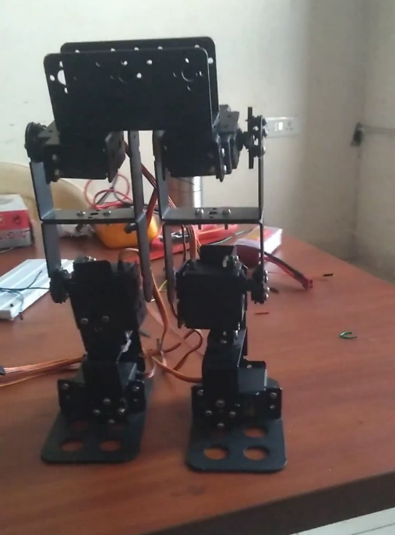 | 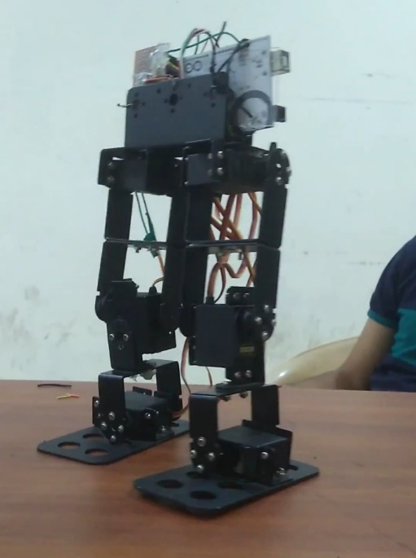

- Achivements:
- 1st prize at inter college PPT Presentation competition at Dr. Babasaheb Ambedker college of Engineering and Research by Club Member (Priyank Umratkar & Devashish Sontakke).
- Participation of aquabotics in inter colleges events at Ramdeobaba College of Engineering and Manegment,Nagpur& St. Vincent Palloti College of Engineering, Nagpur.
- Participation in Robosoccer in inter colleges events at Ramdeobaba College of Engineering

- Events conducted - Robotics club conducted robo soccer in Adhaaya, the technical symposium of GCOENfor two consecutive years which included participation from all over the reputed colleges of the State.Enthusiasts had built a soccer robot which was either wireless remote controlledor wired.
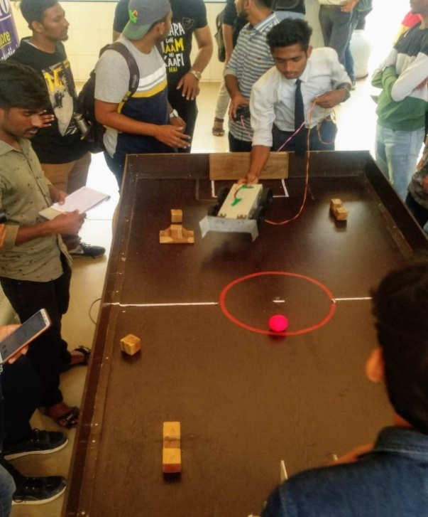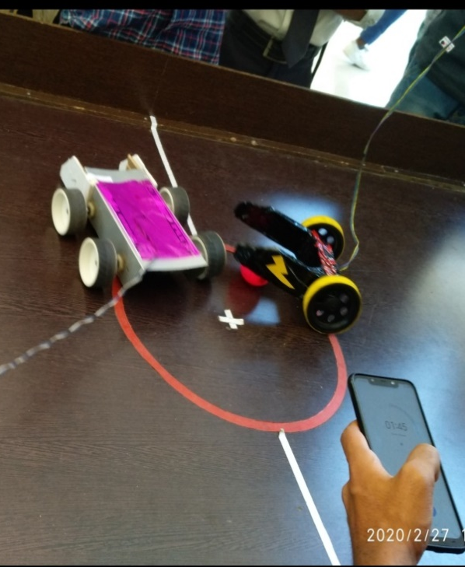
- Weekly sessions - Students in Robotics club conduct weekly sessions on basic to coding languages like C, python and embedded programming.
Students are introduced to the robotics kit available in the E-yantra lab and personally work on the robots and other equipment.
- Escalade and our Robotics club – Escalade is a robotics competition held at IIT Guwathi and its selection round from vidarbha region was conducted at our college with association with the robotics club. It was a one day event where various team from vidarbha region gathered at our college where preliminary round was conducted by the students of our club.

Webinar Report on
“Trends in Industrial Robotics& Automation” on dated 22/01/2021

Recently Robotics club of Govt.Engg.College in association with Department of Robotics & Cloud Technology, RTM Nagpur University, has successfully organized a one day webinar on Trends in Industrial Robotics & Automation on 22/01/2021.Eminent speaker Mr.Anil Tatode, Training Officer, Deptt.of Robotics& Cloud Technology, RTM Nagpur University has guided the students of Final and Third year students of Mechanical and Electronics &Telecommunications Engg. of Govt.college of Engg. Nagpur. The webinar was conducted on online plateform of Google meet under the effective coordination of Prof.Alokkumar A.Uplap, Faculty coordinator of Robotics club. Student coordinators Yuktasawalkar has given the vote of thanks while MitaliPotode has done the anchoring of program.Prof.A.A.Uplap has initially told the activities of Robotics club since its inception while Honorable Principal Dr.N.D.Ghawghawe have explained the importance of Automation,robotics and cloud Technology in this era of Industry 4.0 . Mr.MaheshYelkar,TrainingCoordinator,Roboticsdeptt,Rtmnu has taken all the efforts along with Prof.A.A.Uplap for successful and graceful conduction of the webinar.
Under the able guidance of present Principal Dr.N.D.Ghawghawe and Robotics club Faculty Coordinator Prof A.A. Uplap, our new generations of Gcoen students will definitely bring laurels for the institute and nation in the coming academic years.
