DEPARTMENT OF ELECTRICAL ENGINEERING
1) EESA TEACHERS’ DAY CELEBRATION

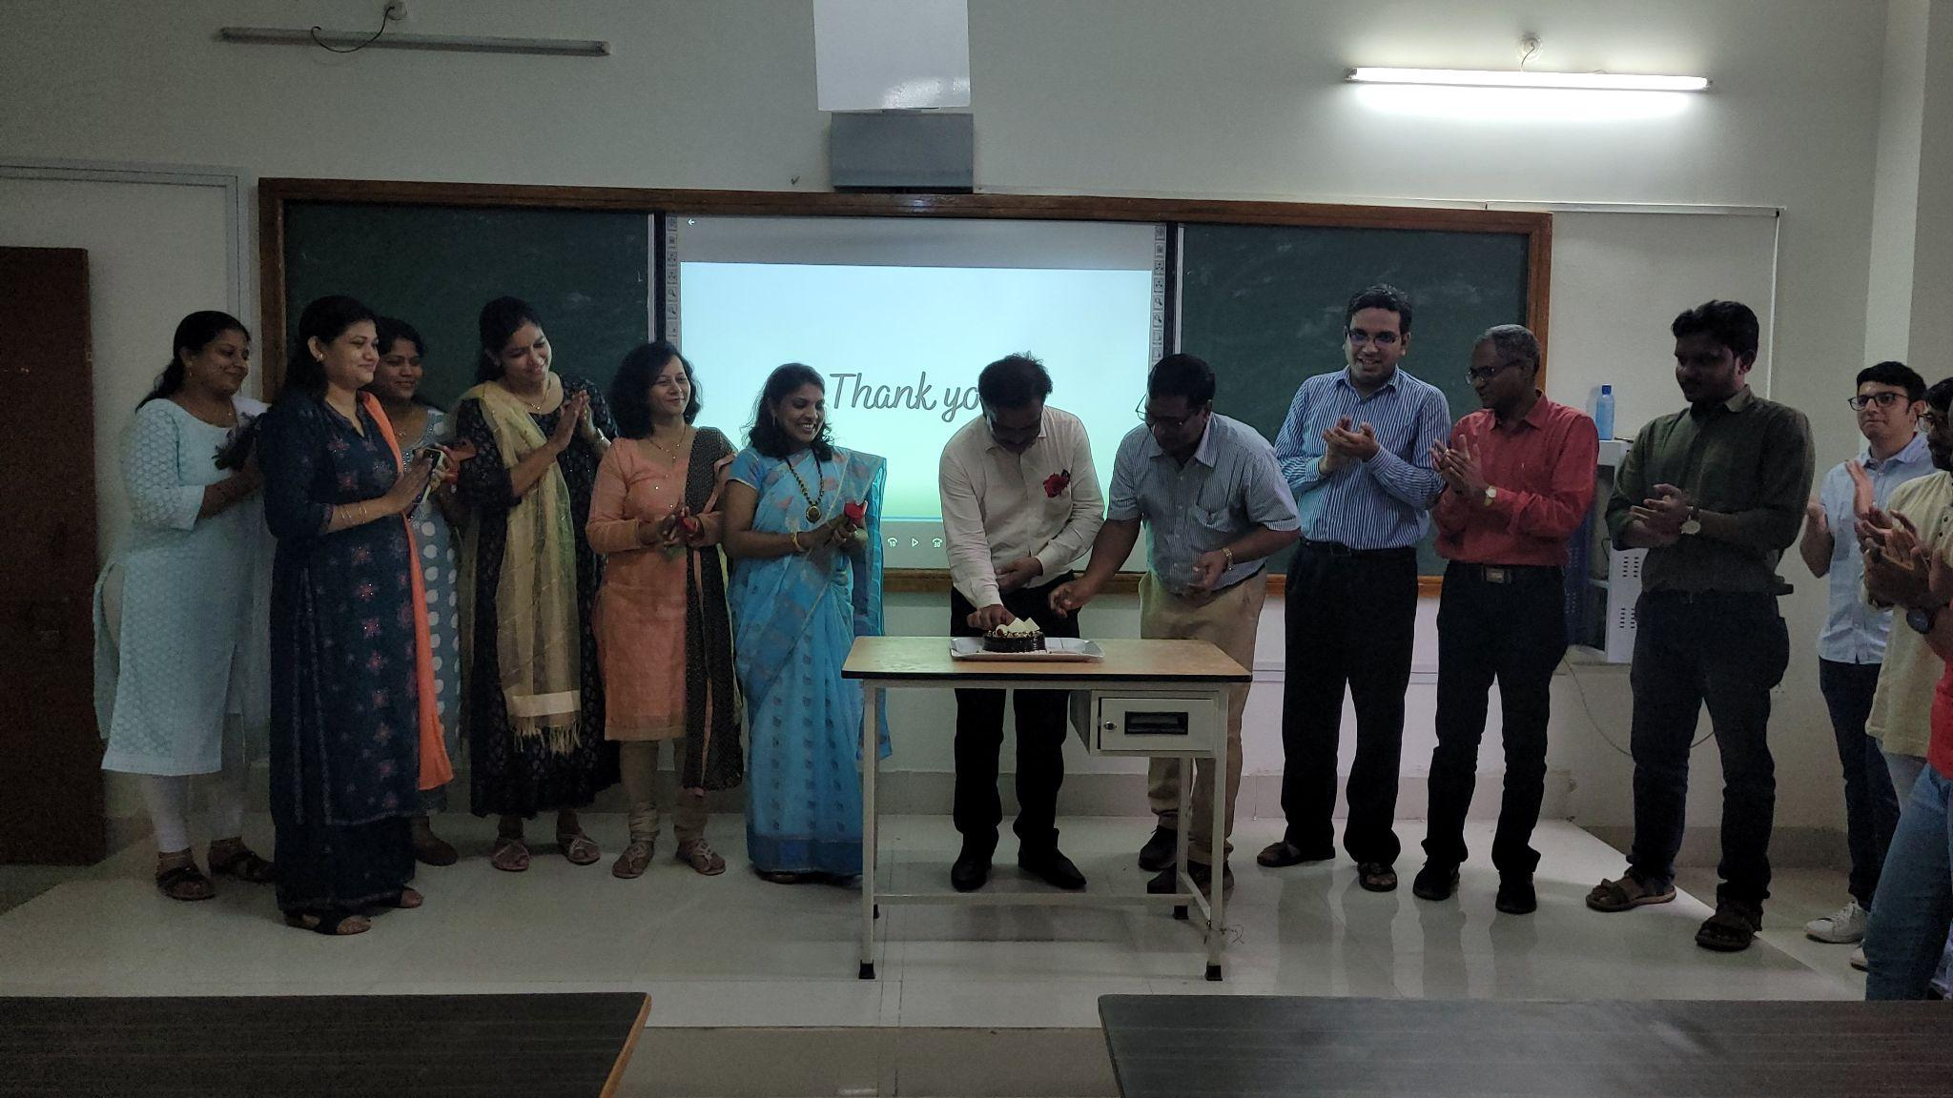

Report:
Title: Teachers’ Day celebration
Conducted by: EESA
Mode of activity: Offline in room 110
Date and time: 5th September, 1pm-2pm

Introduction: 5th September is celebrated as teachers’ day throughout the nation to remember the first vice-president and the second president of India Dr. Sarvepalli Radhakrishnan. EESA wanted to do something special for the wonderful faculties of the Electrical Engineering department who have always taught us with great dedication.

Summary:

- The event started with the General Secretary of EESA Sakshi Mahajan welcoming the teachers with a lovely shloka and talking about the nicknames given to various Professors followed by the speech of the current EESA President Atharva Raghorte on the importance of teacher’s day.
- After his speech the EESA President, Vice-President and Technical head proceeded to greet the teachers with some fresh roses. This was followed by an enlightening speech from our respected HoD Dr. N.D. Ghawghawe sir spoke about the student’s success being the best gift to a teacher.
- After his speech the Vice-President of EESA Laksh Bahl proceeded to share his good experiences with the teachers where he shared how grateful he was to have such teachers who did not just help him with academics but also grow into a more confident person along the way.
- After this the faculties cut the cake and we proceeded to have the games and activities planned for the teachers. In the first game the teachers had to throw a ping-pong ball from a certain distance into cups then we moved on to tongue twisters and finally the highlight being musical chairs which was won by Professor Praful Nandankar sir.
- The faculties and students then took a picture to conclude the event.

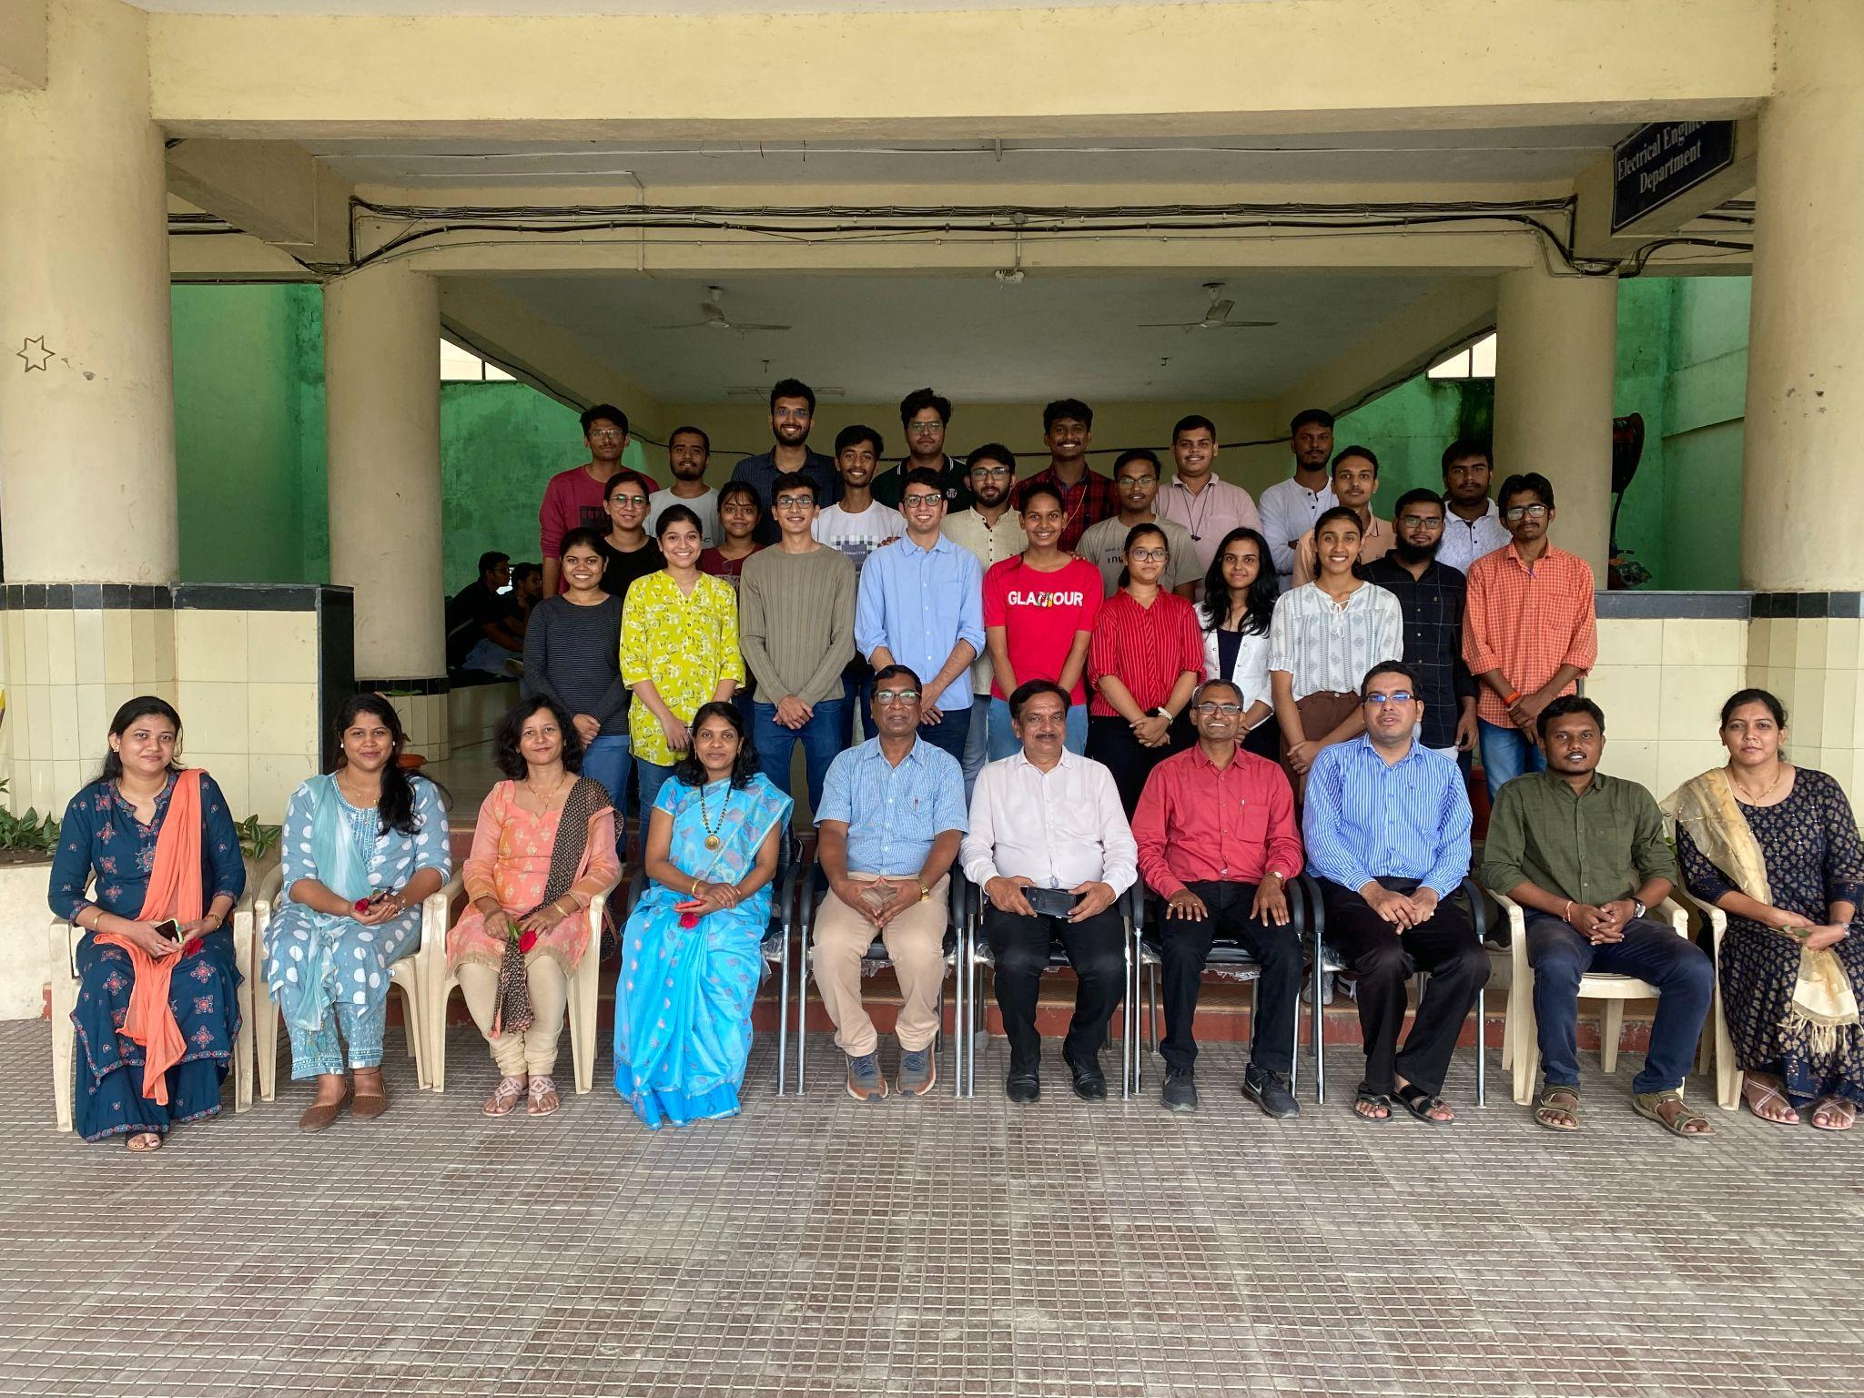

2) Technical Quiz organized by EESA
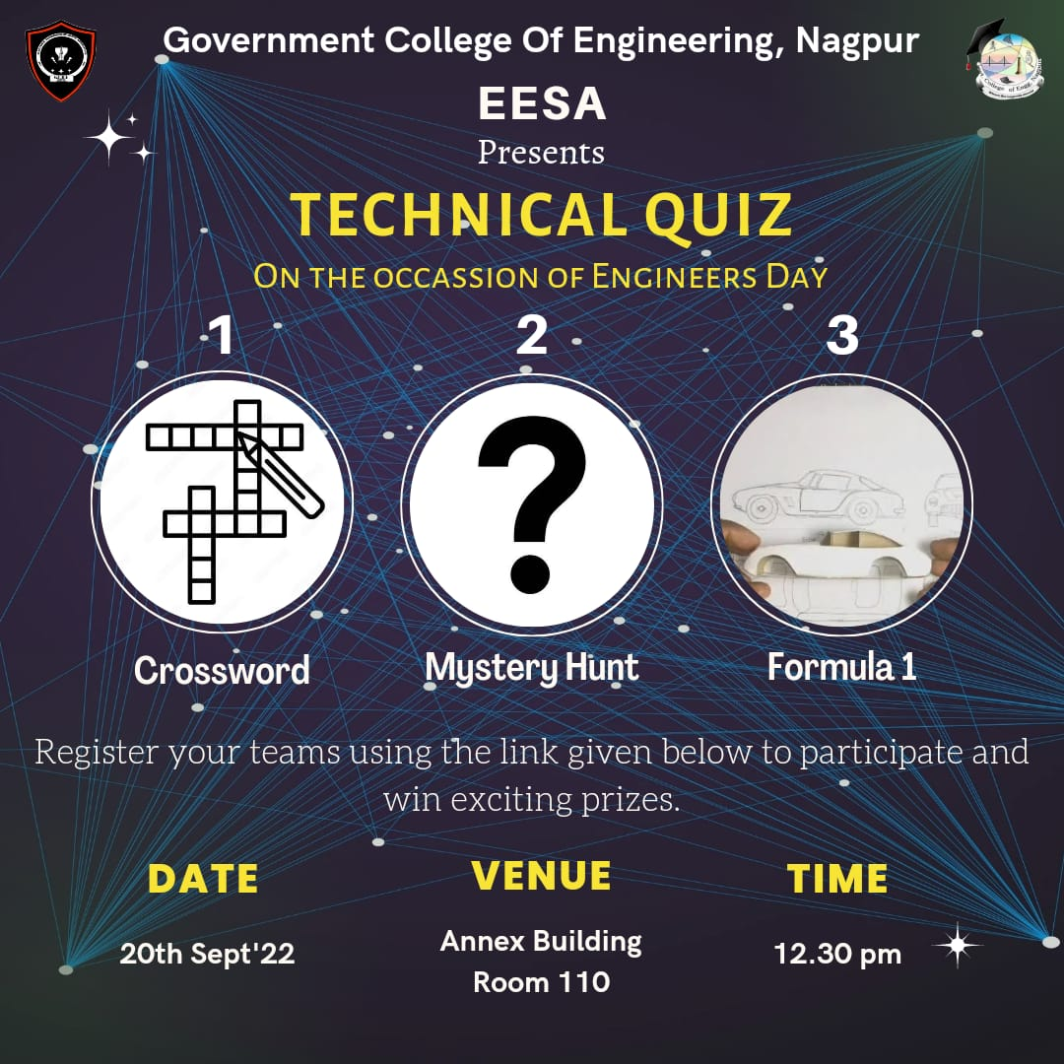

Report:
Title: Engineers Day Celebration
Conducted by: EESA
Mode of Activity: Offline (Room 110)
Date: 20th Sept, 2022 (Tuesday)
Timing: 12:30 to 3:30 pm
No. of Participants: 76 (22 teams)

Introduction:
Engineers play a vital role in the development of a nation and we all have chosen that for ourselves to be in the future. We would joyfully celebrate this day. EESA conducted a technical event as well, which received a great response from the students. It awakened the hidden logistics and skills inside of all future engineers. It was a great platform that provided insights into the real life of an engineer, comprising qualities like problem-solving, skill development and practical thinking.
Summary:
Faculty Coordinator: Prof. Praful Nandankar (Assistant Professor, Electrical Engg. Dept., Govt. College of Engineering, Nagpur)
Student Coordinator: Yash Khandelwal and Tejashree Apturkar
- The event started at 12.30 sharp, 20 teams were present. The event was divided into 3 parts:
- Round 1 - Crossword Puzzle
- Round 2 - Mystery Hunt
- Round 3 - Formula 1
- The first round was a crossword puzzle with hints about basic ancient world history. It was an elimination type round and got the participants’ knowledge about world history all tingling. 5 out of 20 teams were eliminated from this round based on their points.
- Round 2 was a murder mystery with a hint of technical into it. It was about finding the murderer from some provided clues. While the clues were wrapped around some problems on the infinite circuit series, it gave some teams a hard time trying to solve the question. This was an elimination-type round as well and 5 teams with the lowest points were eliminated.
Link to Murder Mystery:
https://docs.google.com/document/d/1jO8-6yLIVmQXE0quciUn9upzcmmyaXrv-YuJ3qAUJKQ/edit?usp=sharing
- Round 3 was a model making round. Each team was provided with kits containing basic components to make a small car from scratch using sticks, rubber bands and balloons. The participants were asked to put around their thoughts and implement different principles to make a small model car which will later compete against other team’s cars to win the final prize.
- This model-making round involved a lot of exercising of the brain in different ways as it comprised several physics principles to execute the working of the model. It brushed up lots of basic knowledge and contributed to the overall skill development of the participants. It helped build confidence among the students and develop critical thinking skills in them. This event was a fun-filled activity-based learning time for the students which helped expand their ability to think and design their own easy-to-use affordable scientific and mathematical models.
- Later after all the car models were made, they were put together in a line and made to compete. The first three car teams were declared to be the winners.
Video: : https://drive.google.com/file/d/1zBEGtN_qk48JTuQ8NHINGfIfgXB6R6EG/view?usp=sharing
Conclusion:
- The event organized by EESA was conducted successfully, aching its motive of brushing us the qualities like skill development and critical thinking in the students. It was fun-filled, yet very helpful for all the students in several ways.
Event Photographs:
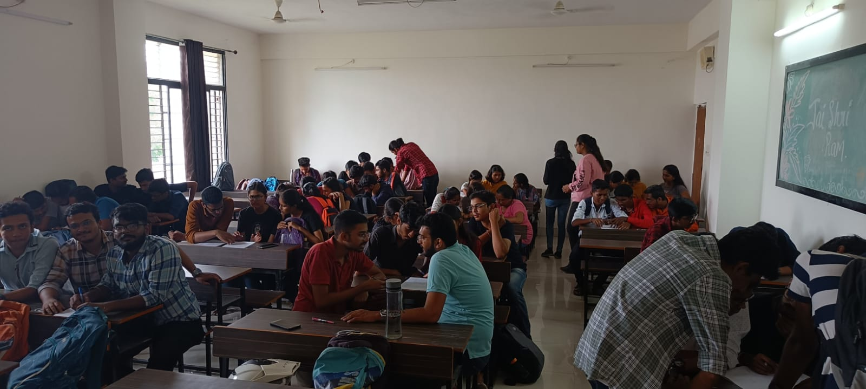
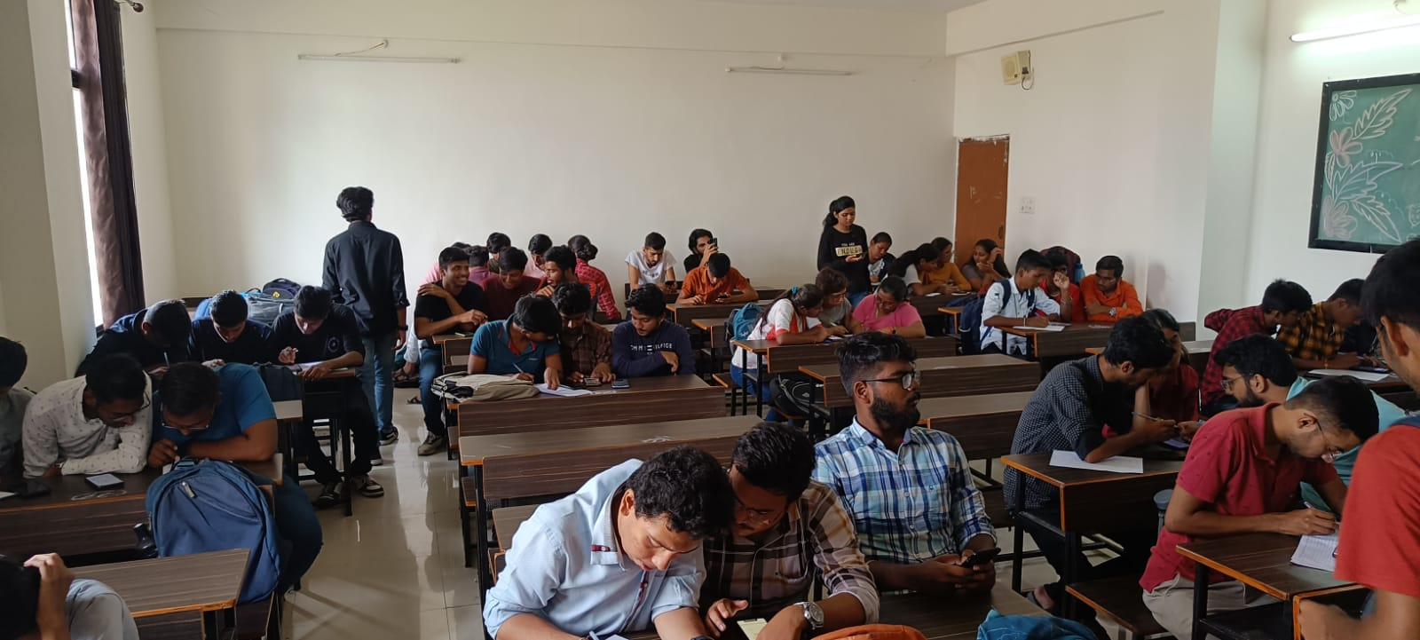
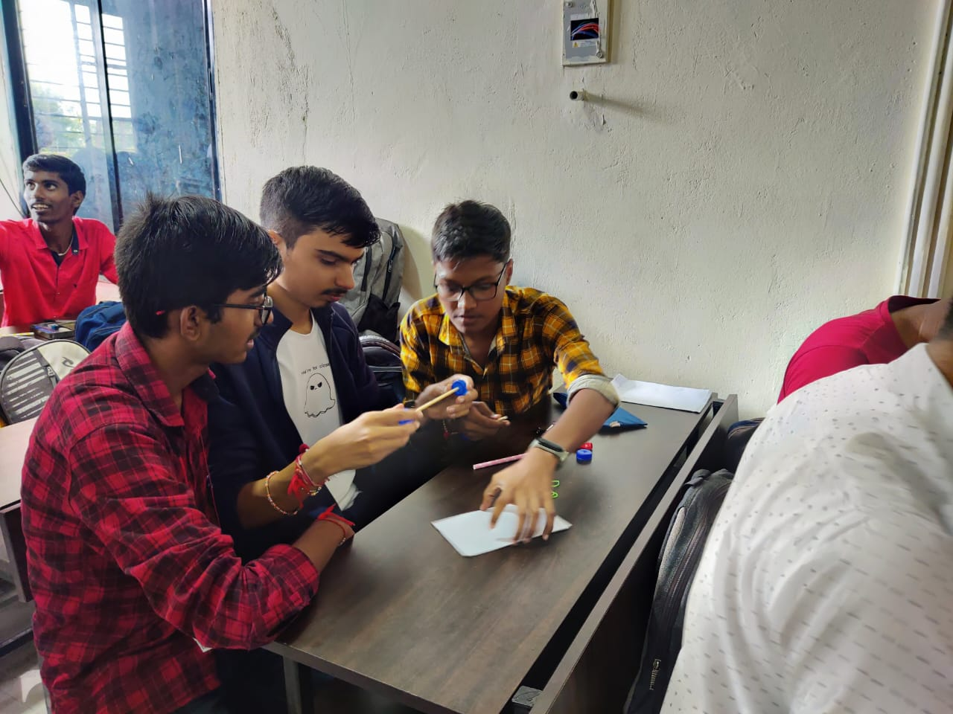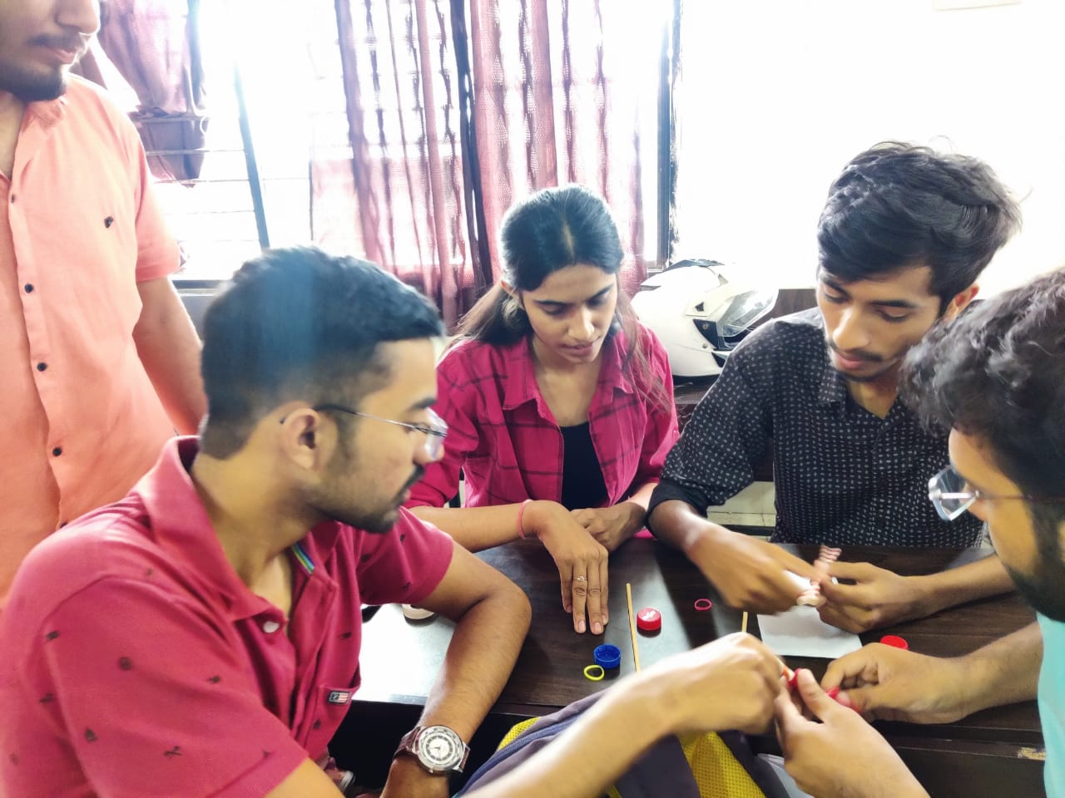
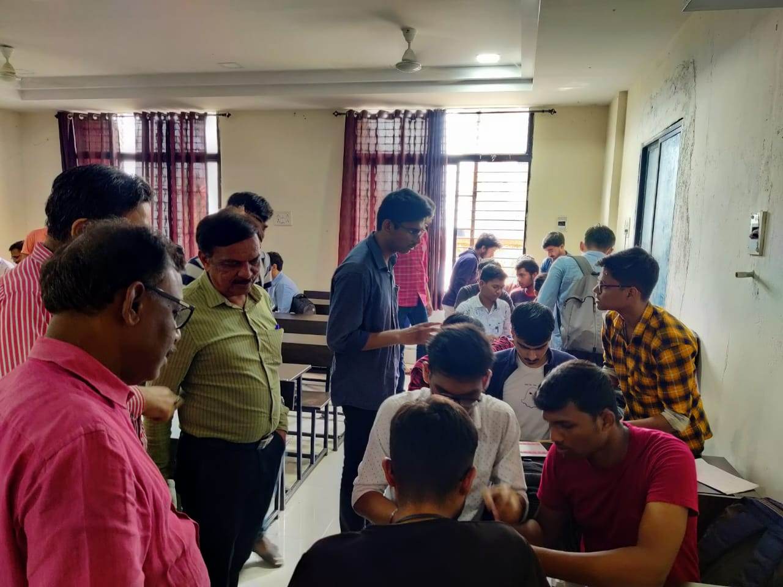

3) “CYBER SECURITY WORKSHOP”
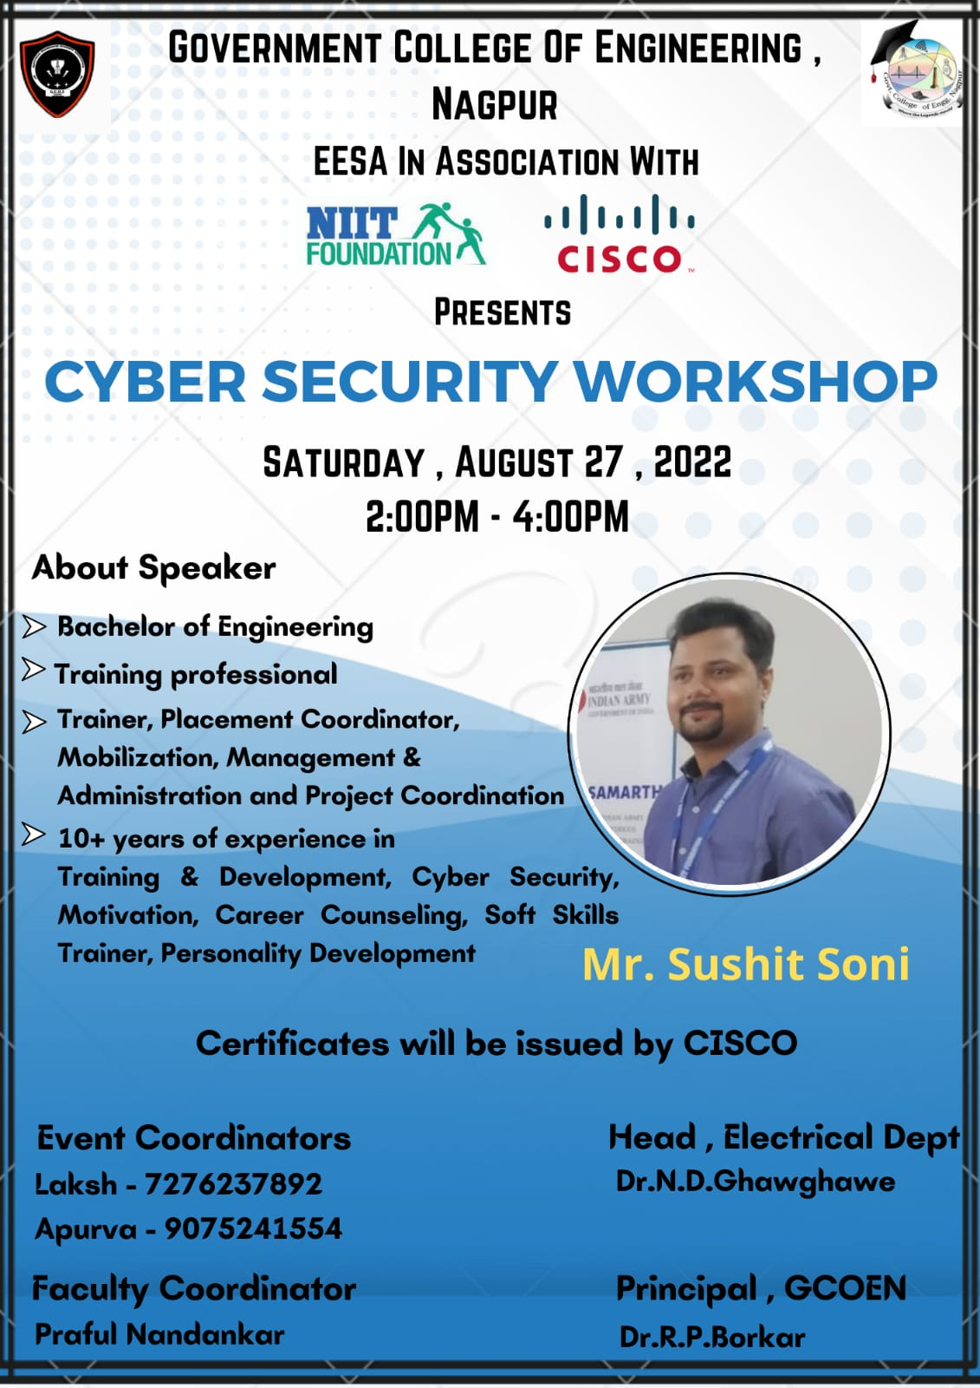

Report:
Title: Cyber Security Workshop
Conducted by: EESA
Mode of Activity: Google meet (https://meet.google.com/jwu-iswj-hop)
Date & Time: 28th August 2022, 2 PM to 4:30 PM
No. of participants: 179
Recording Link: https://drive.google.com/file/d/1I7zPOAjaxuQ8qeqy96Of8j8L_XJGerRV/view?usp=sharing
Introduction: Look around today's world, and you'll see that daily life is more dependent on technology than ever before. The benefits of this trend range from near-instant access to information on the Internet to the modern conveniences provided by smart home automation technology and concepts like the Internet of Things. With so much good coming from technology, it can be hard to believe that potential threats lurk behind every device and platform. Yet, despite society's rosy perception of modern advances, cyber security threats presented by modern tech are a real danger. A steady rise in cybercrime highlights the flaws in devices and services we've come to depend on. This concern forces us to ask what cyber security is and why it's essential. Cyber security is a discipline that covers how to defend devices and services from electronic attacks by nefarious actors such as hackers, spammers, and cybercriminals. While some components of cyber security are designed to strike first, most of today's professionals focus more on determining the best way to defend all assets, from computers and smartphones to networks and databases from attacks.
Summary:
Guest speaker: Mr. Sushit Soni, Trainer at CISCO Networking Academy NIIT Foundation, Delhi
Faculty Coordinator: Prof. Praful Nandankar (Assistant Professor, Electrical Engg. Dept., Govt. College of Engineering, Nagpur)
Student Coordinator: Laksh Bahl and Apurva Khati
- Before the start of the event, resource person has shared Pre-check point quiz where participants have been asked to check their knowledge related to field of Cyber security. The resource person and his team has created accounts of all 179 registered participants and they have been asked to activate their account by clicking on the verification link forwarded on their registered mail-ids.
- The workshop on Cyber Security started after a small inaugural program at 2 PM. The resource person started his explanation with their platform which they have shared with participants. He has given insights about CISCO and NIIT foundation. He has also highlighted the importance of completing Cyber security courses in today’s modern technology world.
- The resource person explained the threats which can occur due to cyber-crimes and how our useful data can be lost within a fraction of a second. Before that, he provided the inputs of various types of data which are at risk of Cyber-crimes.
- He also pointed out various security principles like confidentiality, integrity and availability and how one can prevent the access of data to hackers. He also stressed the impact of a security breach by citing various examples.
- The resource person has also given a practical demonstration of how login credentials and IP addresses can be accessed by just sharing the link. In order to give impetus, he has also shown some videos that how cyber-crimes are a bigger threat in today’s world and how one can safeguard his useful data from hackers.
- In his session, he explained different types of hackers and various types of malwares which can creep into our system without our permission. After explaining the need for Cyber Security, he highlighted the progress made in IoT, Artificial intelligence and in various other fields etc.
- In the end, the resource person has answered the queries posed by participants and attendance of all participants have also been recorded. Some participants have given real-time feedback. After the session, the resource person asked participants to go to their registered accounts for the final exam. All participants attempted the Final quiz and they received certificates from CISCO Networking Academy.
- In this way, a Cyber security workshop has been organised successfully by EESA Govt College of Engineering, Nagpur in association with NIIT foundation and CISCO Networking Academy.
Conclusion:
- The guest speaker explained the various ways to secure & protect our data from hackers and how to prevent our system from different types of malwares.
- He stressed the importance of Cyber Security in today’s world and motivate all the participants to get the education of Cyber Security.
Photos:
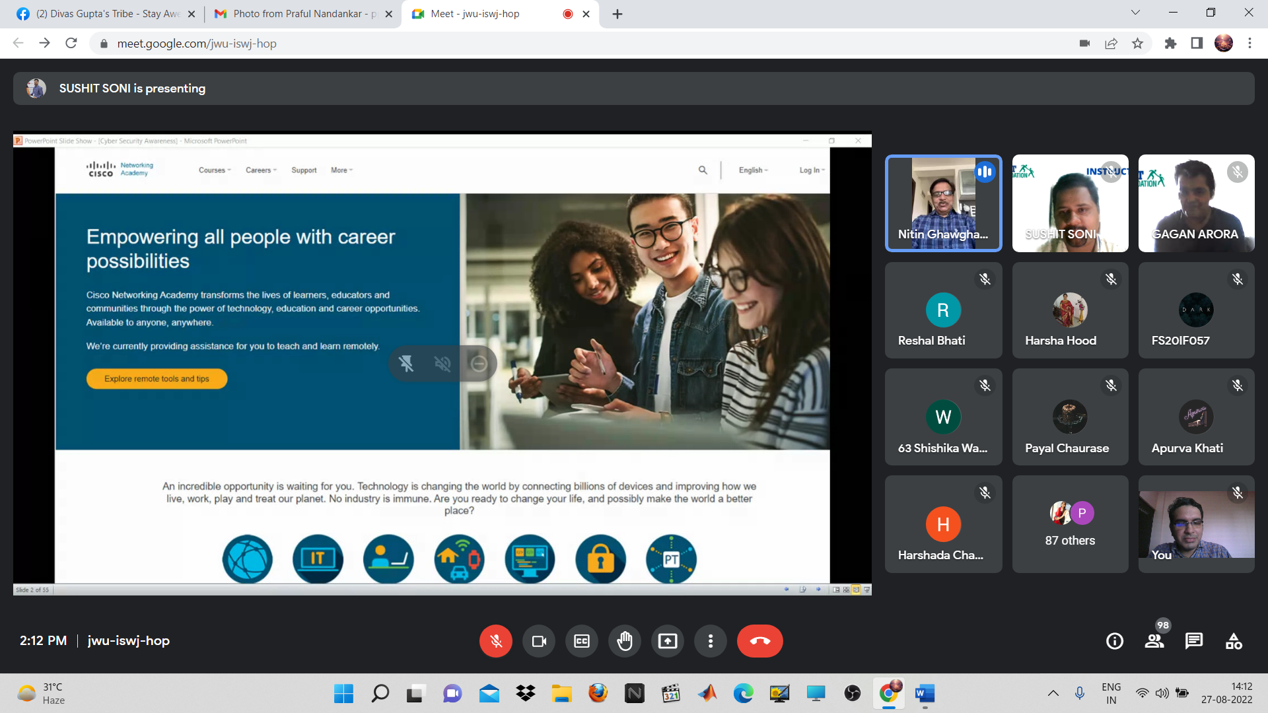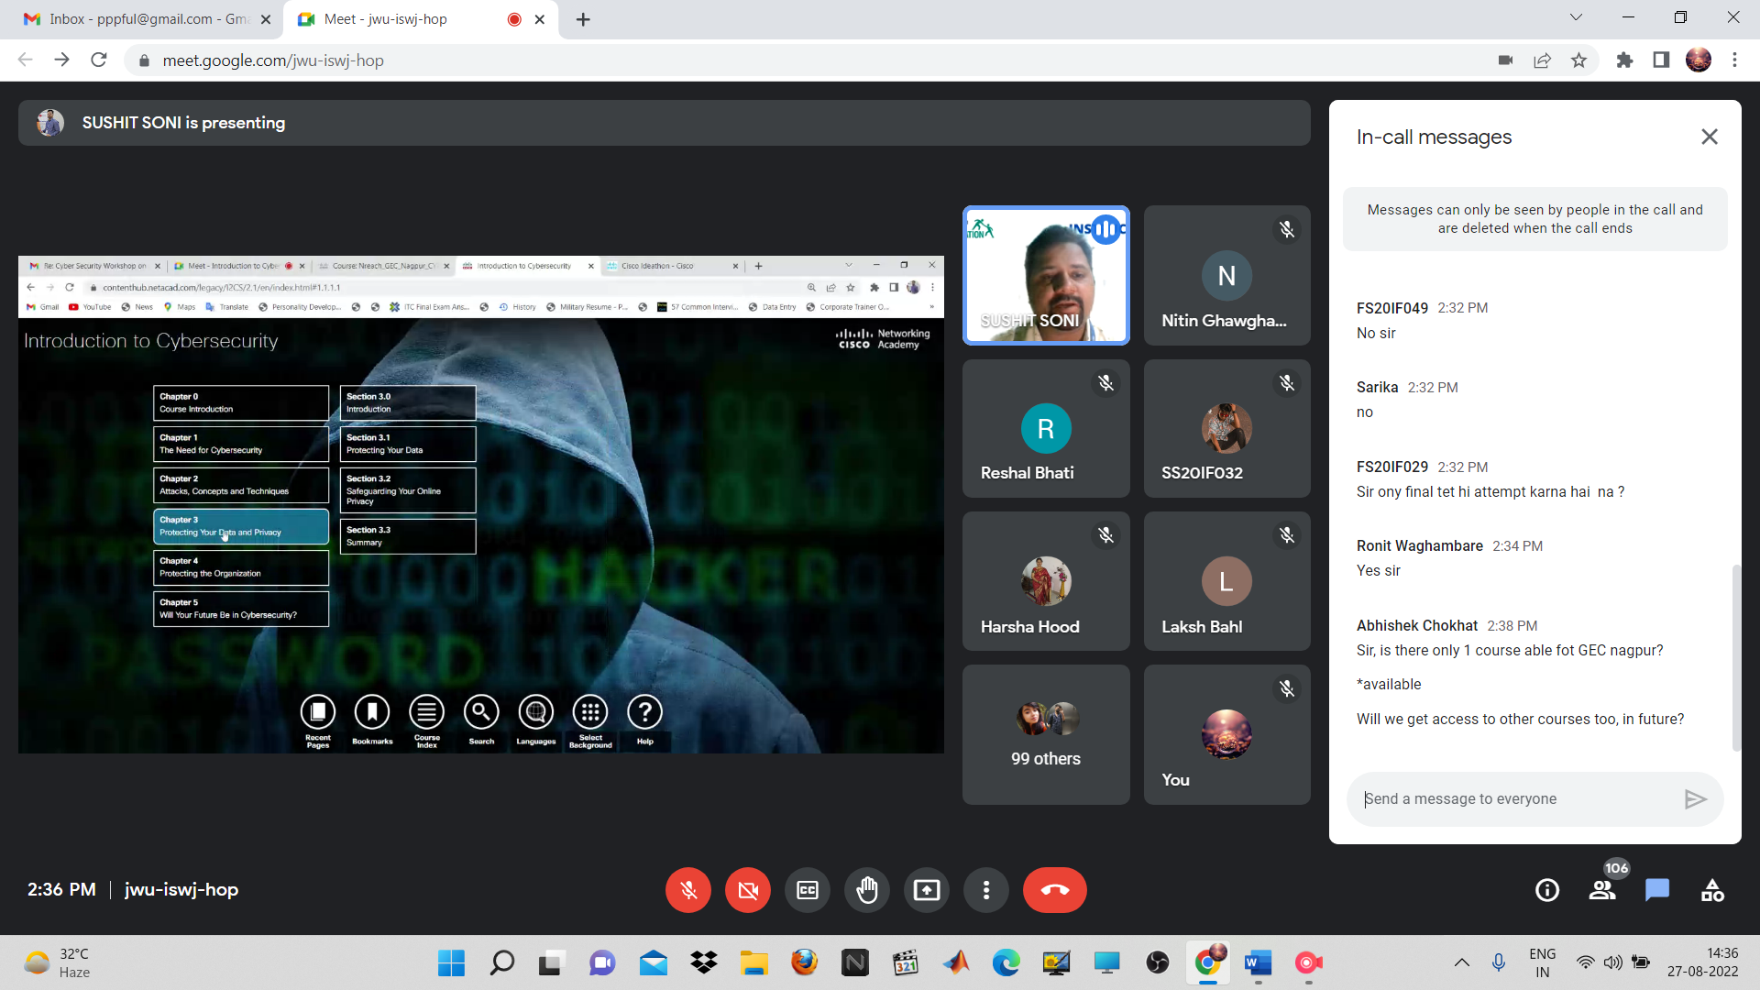
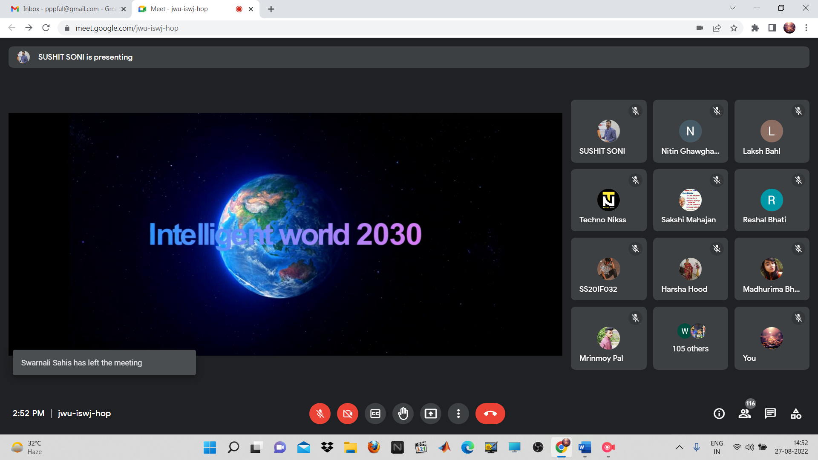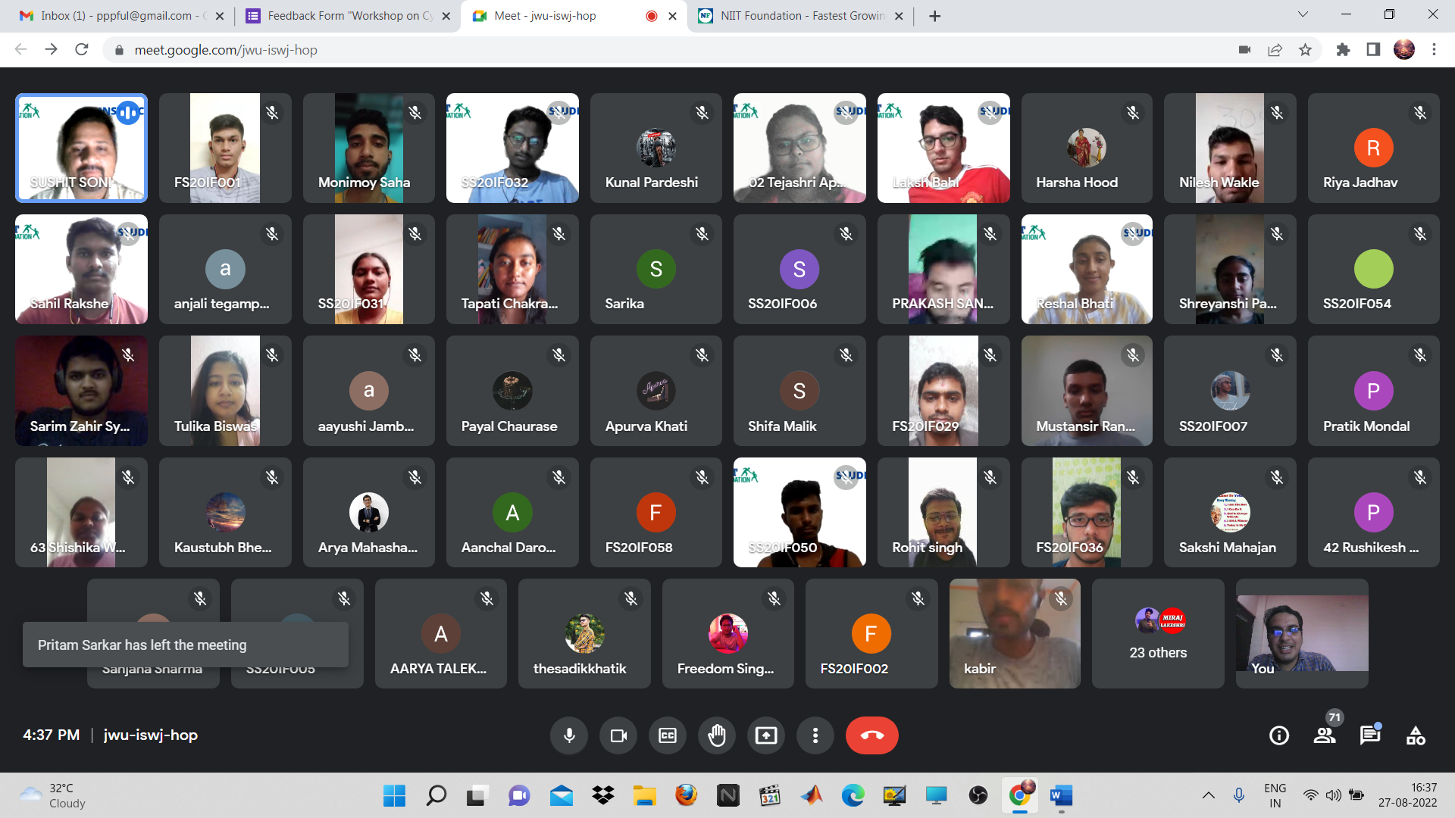
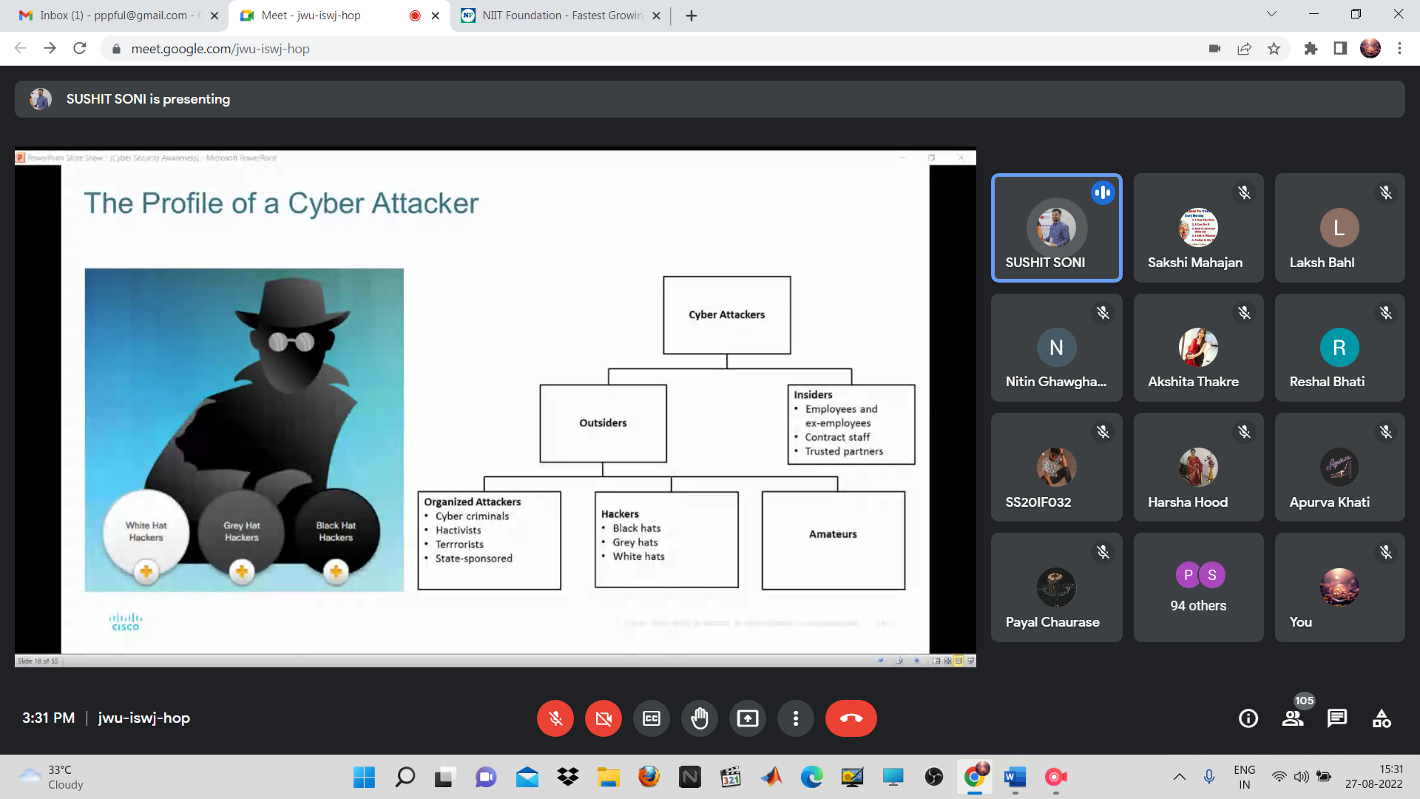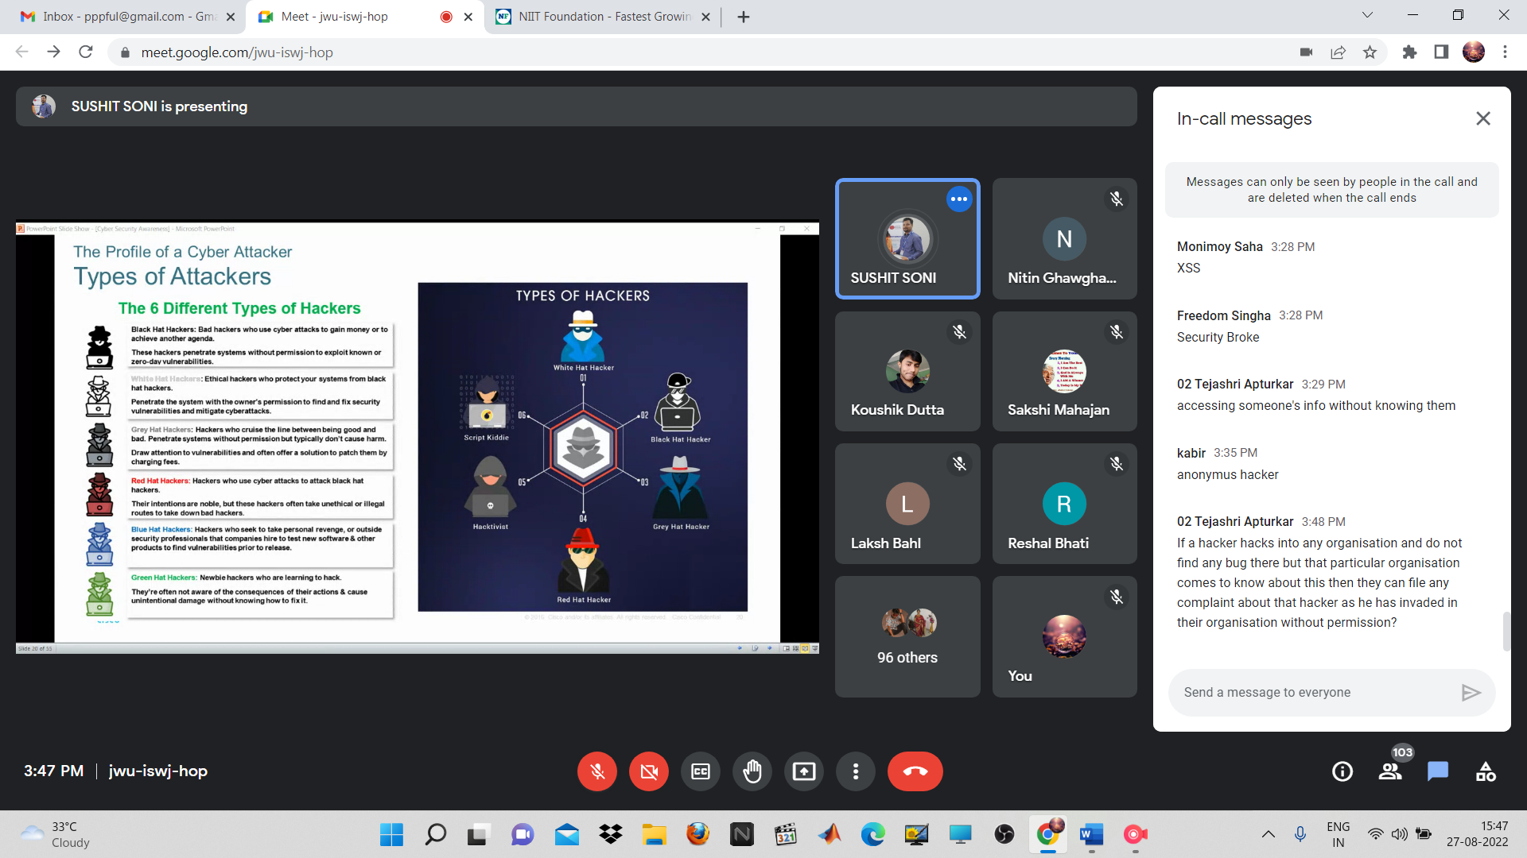
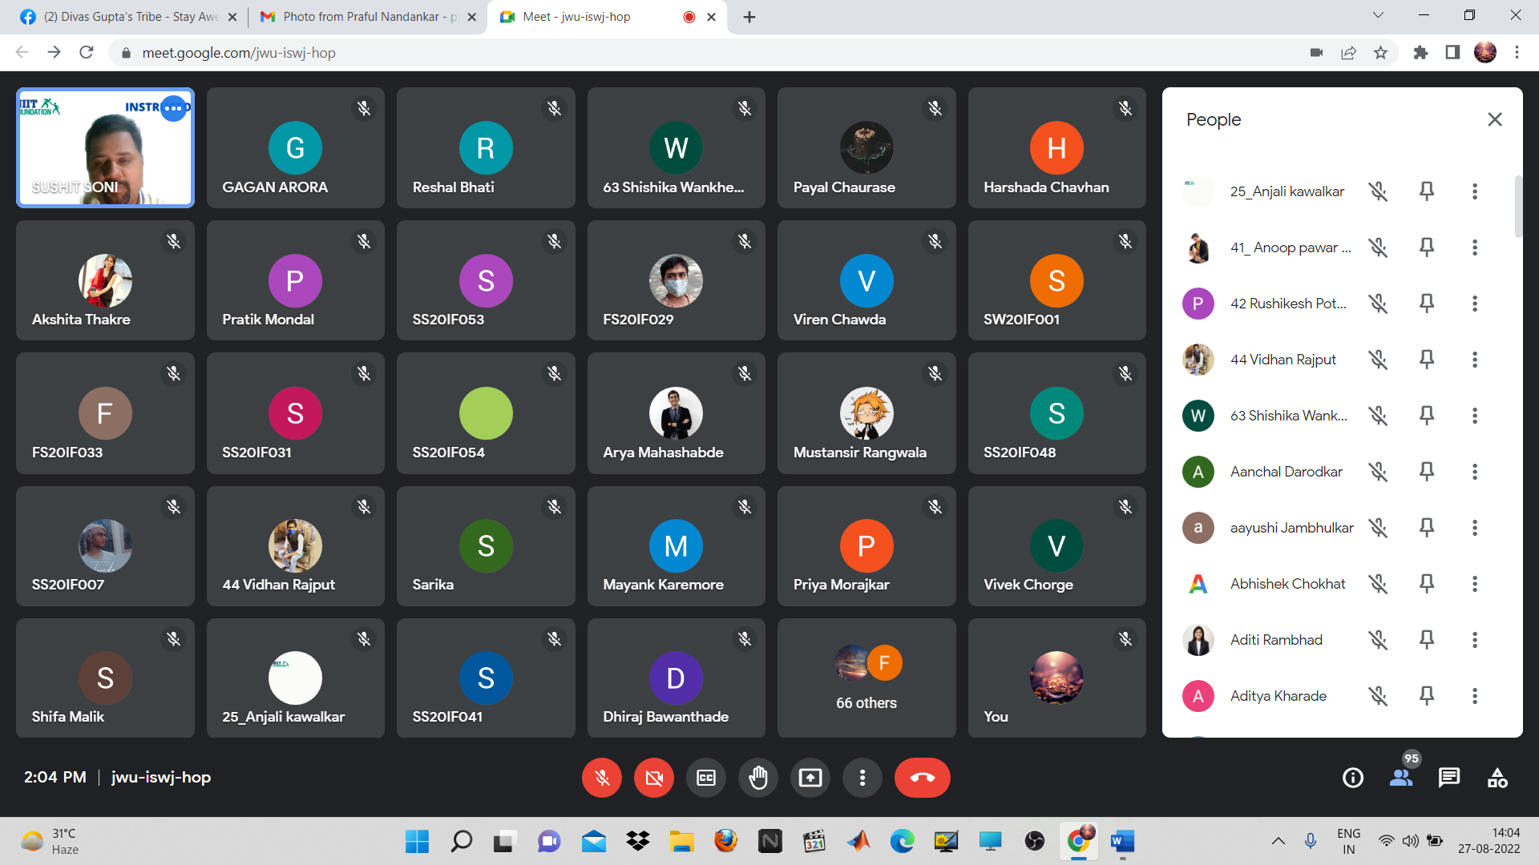
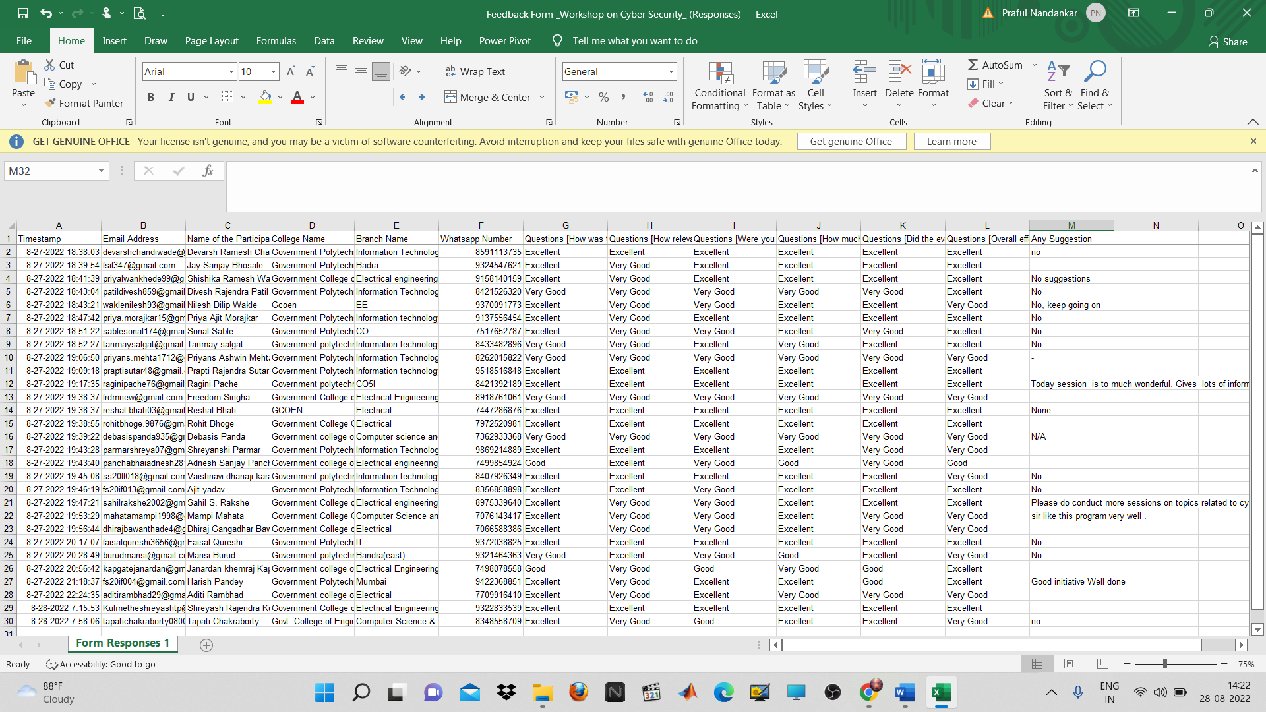
4) Skill Development Programme on “Identification and Testing of Electrical Components”
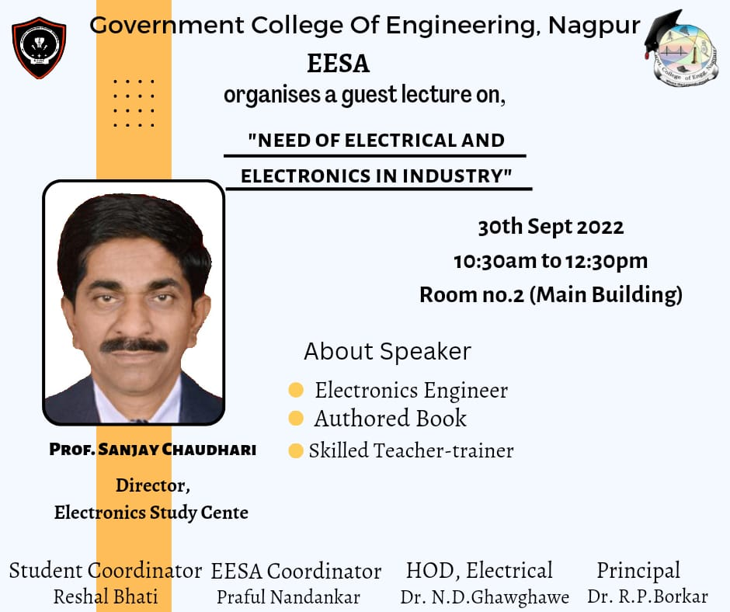
Report:
Title: Skill Development Programme on “Identification and Testing of Electrical Components”
Conducted by: EESA
Mode of Activity: Offline (Auditorium, GCOEN)
Date: 30th Sept 2022 (Friday)
Timing: 10:30 to 12:30 pm
No. of Participants: 130

Introduction:
Electrical engineering is a profession that uses science, technology and problem-solving skills to design, construct and maintain products, services and information systems. So, considering the career that we've chosen for ourselves, it becomes very essential to have a strong foundational and basic knowledge of the core subject. In this lecture, the expert shared his thoughts and knowledge with the 2nd and 3rd-year students of the electrical engineering branch, about the primary fundamentals of the subject. He explained the key elements that formulate the subject as a whole.
Summary:
Guest Speaker: Mr. Sanjay Chaudhari, Director of Electronics Study Center
Faculty Coordinator: Prof. Praful Nandankar (Assistant Professor, Electrical Engg. Dept., Govt. College of Engineering, Nagpur)
Student Coordinator: Reshal Bhati
- The session enhances the knowledge of the students regarding the basics of Electrical engineering and enlightens the mindset of students regarding the modernization of control systems used in steam turbines. The session started with some fun icebreakers by making the students realize the importance of the basics and telling them how they lack them.
- He started by explaining the history of electronics and how this subject emerged as a whole, though being a part of physics in the past. He told the students about his own experience of getting into this field, although he was an electronics engineer, elaborating on the difference between electronics and electrical engineering
- This was followed by his explaining the rating and testing logic for numerous devices such as resistors, diodes, transistors etc. He gave some shortcuts to remember the forward bias and reverse bias rules and testing logic that will be easy to memorize for future use. He also showed the students pictures of some common components used in circuits and explained their features and applications.
- The session was made very interactive and easy to understand. The speaker proposed several real-life examples to explain the working and application of devices. He randomly threw in questions and students giving the right answers were applauded. This encouraged the students to participate and get involved in the session and made them think differently.
- Later he explained the working of several devices, such as the multimeter and executed some circuits in front of the students. This involved a lot of practical understanding.

Video Link: https://drive.google.com/file/d/1hd6kknb2Qvaqze3Y9WPDhOmytMOYWy_8/view?usp=sharing
Conclusion: The session was a great way to enhance basic knowledge in all forms. It helped students brush up on their fundamentals in the subject. It helped them gain a practical perspective on all devices as well.
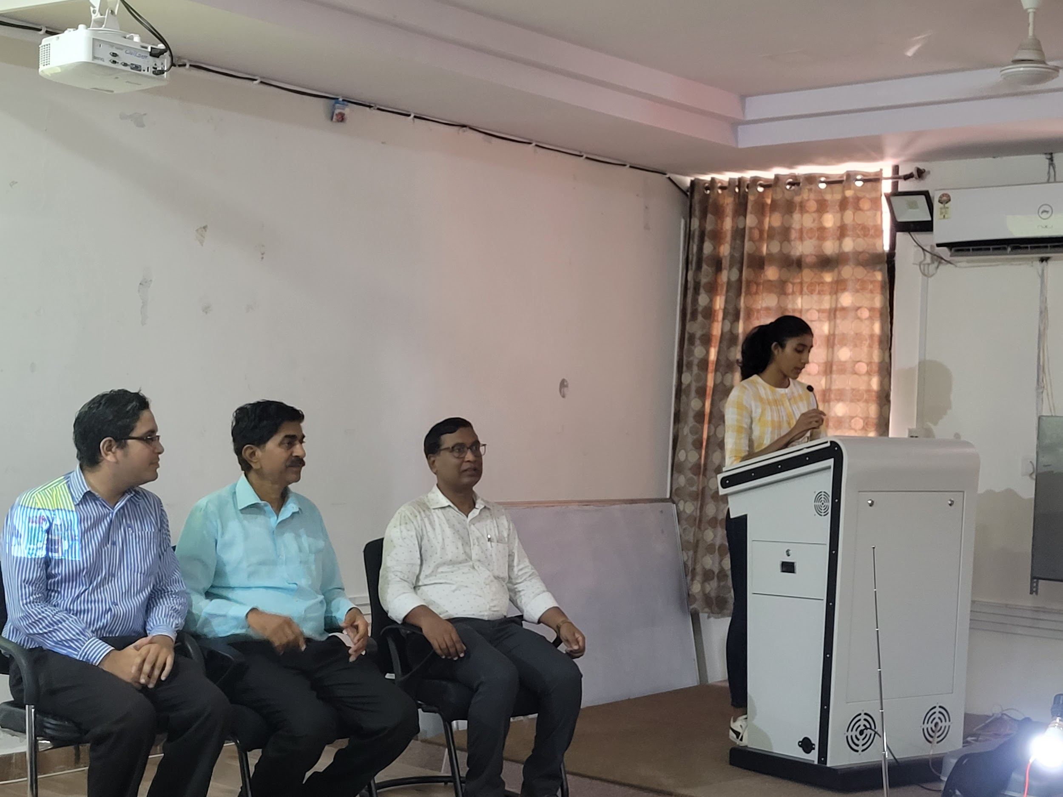
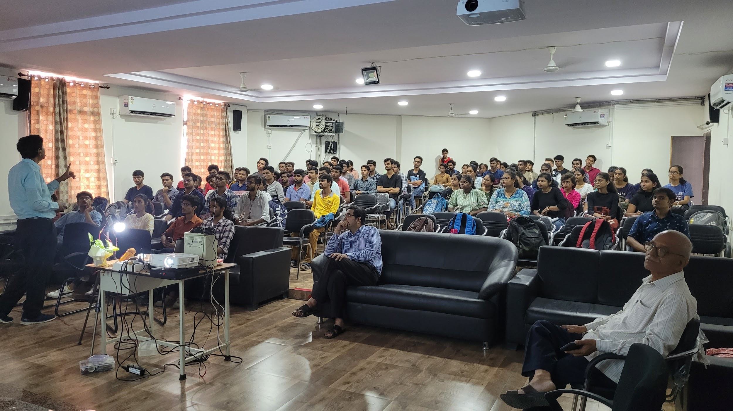
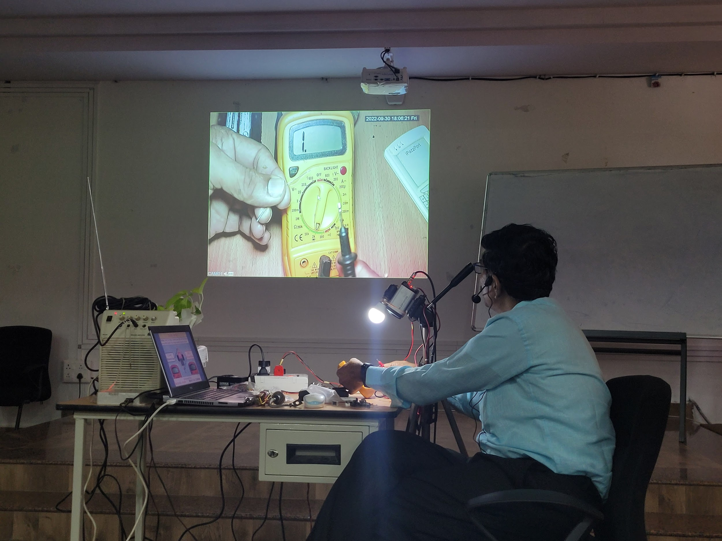

Feedback from Participants:
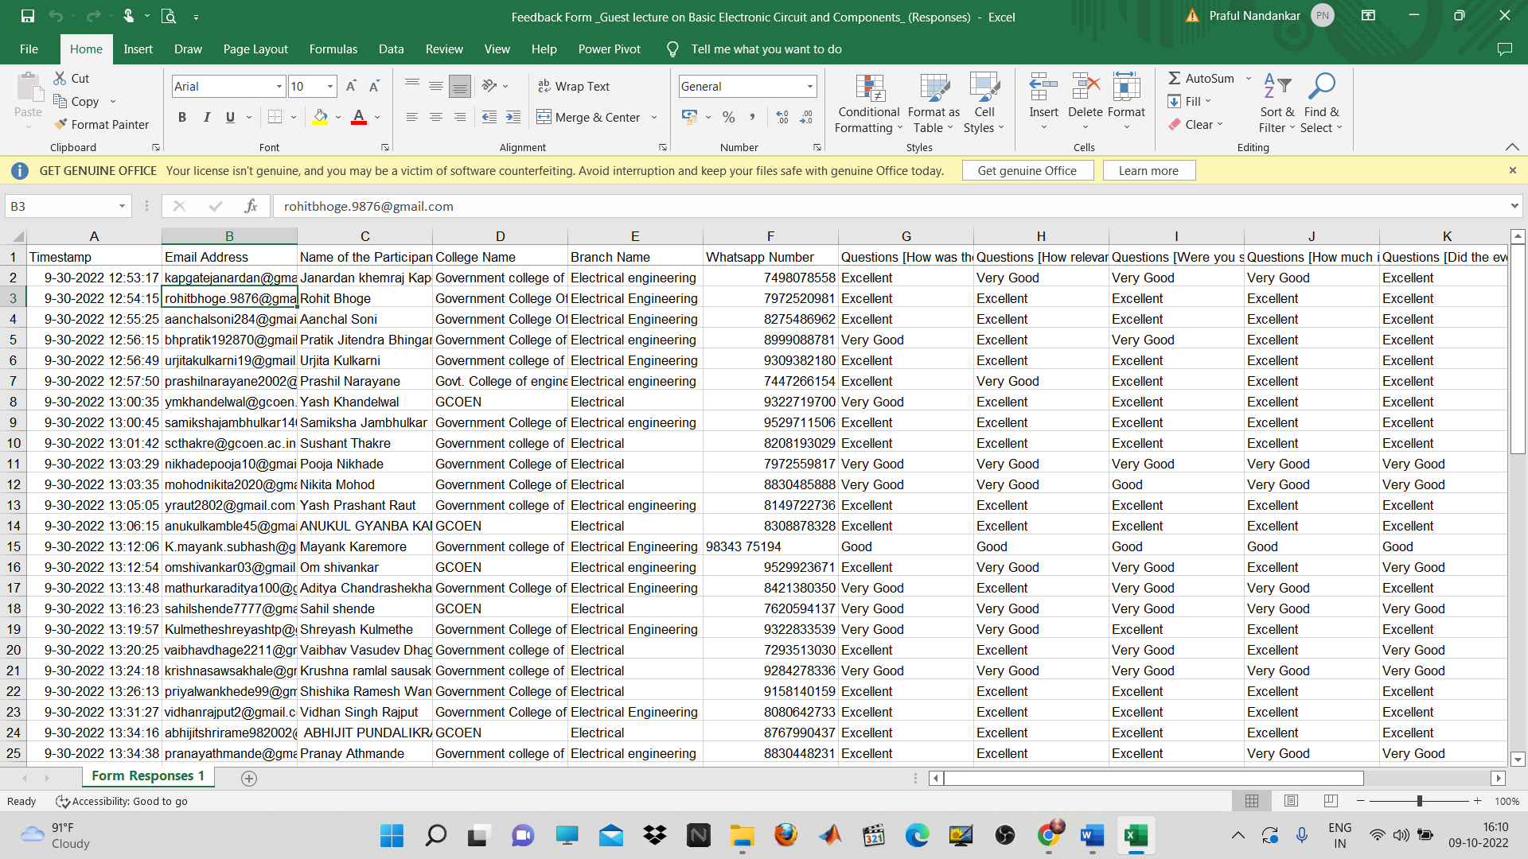

5) Yoga Photo Competition
Electrical Engineering Student Association, GCOEN has organised a “Yoga for Mind, Body & Spirit - Yoga Photo Competition” on 21st June 2022 (International Yoga Day). The purpose of this Yoga Photo Competition is to encourage all faculties and students to practice yoga & Pranayama in their homes, to stay fit. In this competition, participants were asked to click their pictures depicting their Yoga Spirit. The participants were asked to submit only one photograph and the photograph should be original and in landscape orientation. Best Yoga Pose Images were displayed on EESA Instagram and LinkedIn page and certificates have been given to all the participants and winners. Around 40 participants have submitted their Yoga pose photos depicting their Yoga Spirit.
Some pics related to Yoga Photo Competition
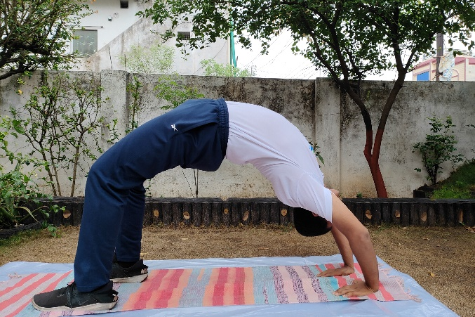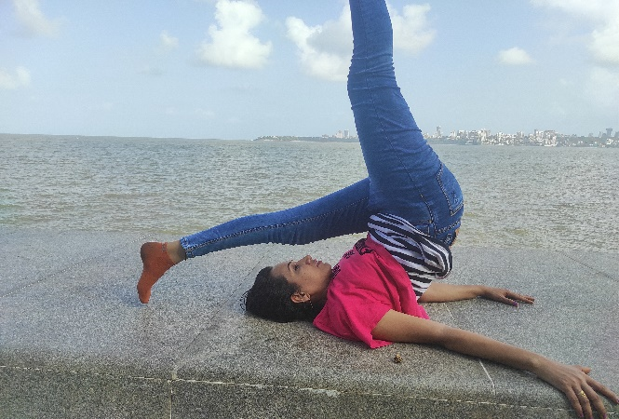
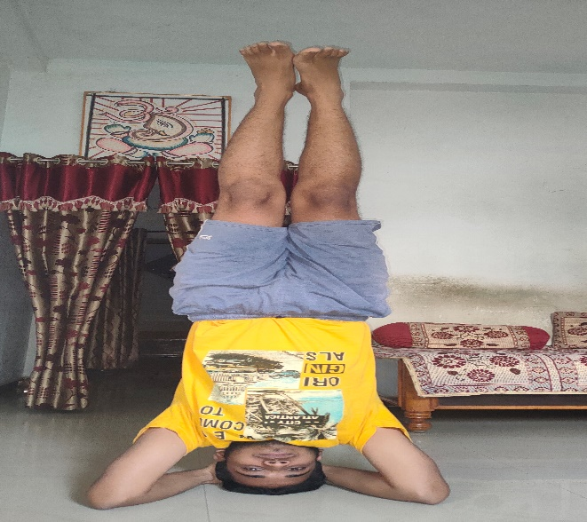

6) ONLINE WEBINAR: How to be Corporate Ready
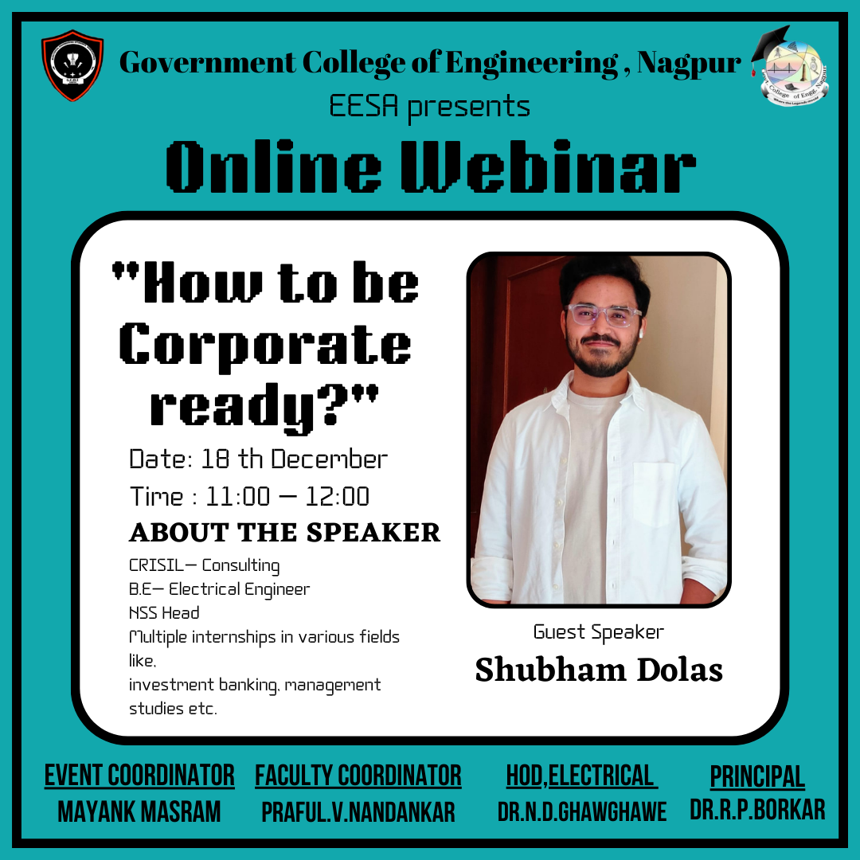
Report:
Title: How to be Corporate Ready?
Conducted by: EESA
Mode of Activity: Online (Google Meet)
Date: 18th Dec, 2022 (Saturday)
Timing: 11:00am to 12:00 noon
Participation:
Total Registrations: 77

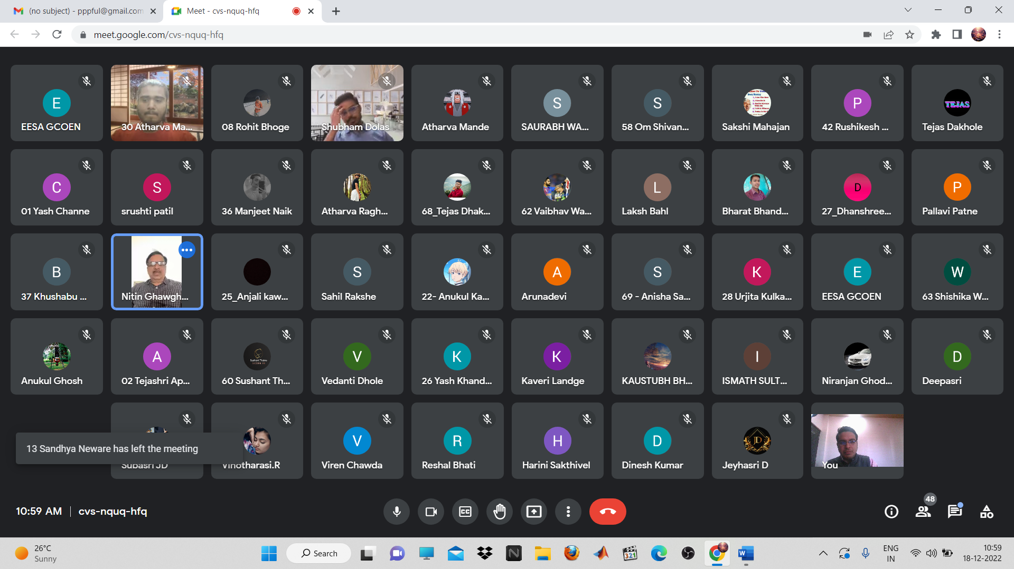
Introduction:
Campus to corporate is a life-changing transformation. It is not a simple chore for students to initiate a smooth stride in the corporate world just after ending their campus life. From the carefree campus world to corporate routine, many changes mark all the responsibilities and duties that come with a job. The transition is an ongoing process in everyone’s life which happens at different stages. However, the transition from campus to career, where an individual begins to work in an organization, is a distinctive and crucial phase of a student’s life. Their day-to-day schedule and social lives endure the changes once they enter the Corporate World. Indeed, this requires a unique institutional perspective and approach to be successful.
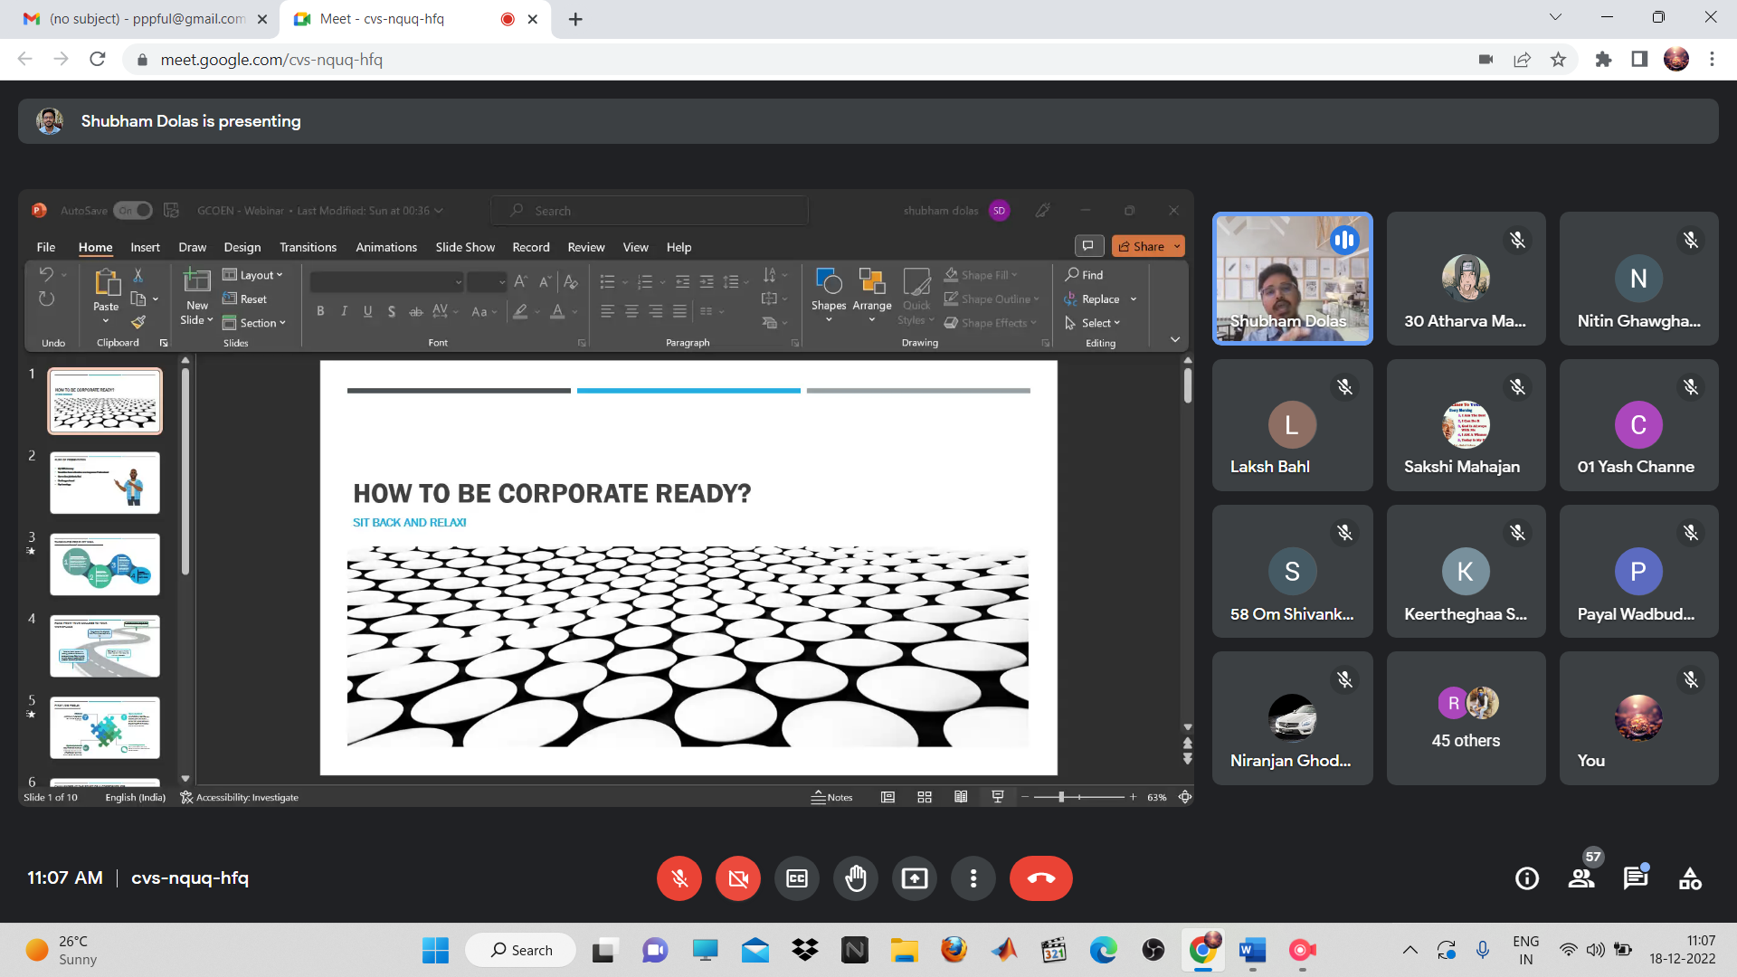Summary:
Guest Speaker: Mast. Shubham Dolas, (CRISIL, Consulting)
Faculty Coordinator: Prof. Praful Nandankar (Assistant Professor, Electrical Engg. Dept., Govt. College of Engineering, Nagpur)
Student Coordinator: Mayank Masram
- The speaker started off by making the students realize that the gap between campus and corporate life is enormous, as both lives are profoundly different and how one could deal with the change if pursuing a corporate life.
- He gave a roadmap into employability and shared his own personal experience as an example to inspire the students.
- It was an interactive session and the speaker moved forward with introducing various steps into the corporate world by giving life-like examples.
- After the session was over, a small quiz was also conducted to test the awareness and the presence of mind of the students and gift cards were given to the top 3 winners.

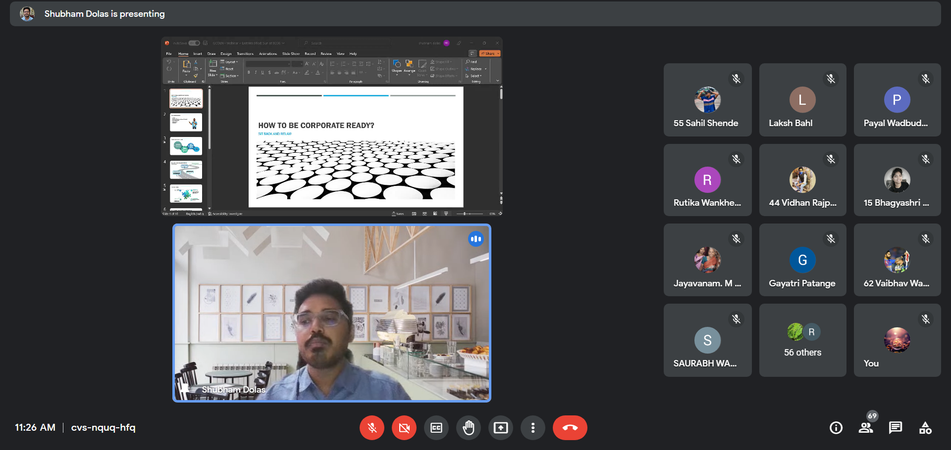
Conclusion:
- The session concluded with a small doubt session and the feedback session.
- The speaker very well gave an insight into to corporate world and gave the students an idea of how to prepare themselves if pursuing the respective field.

7) ONLINE WEBINAR: Personal Knowledge Management
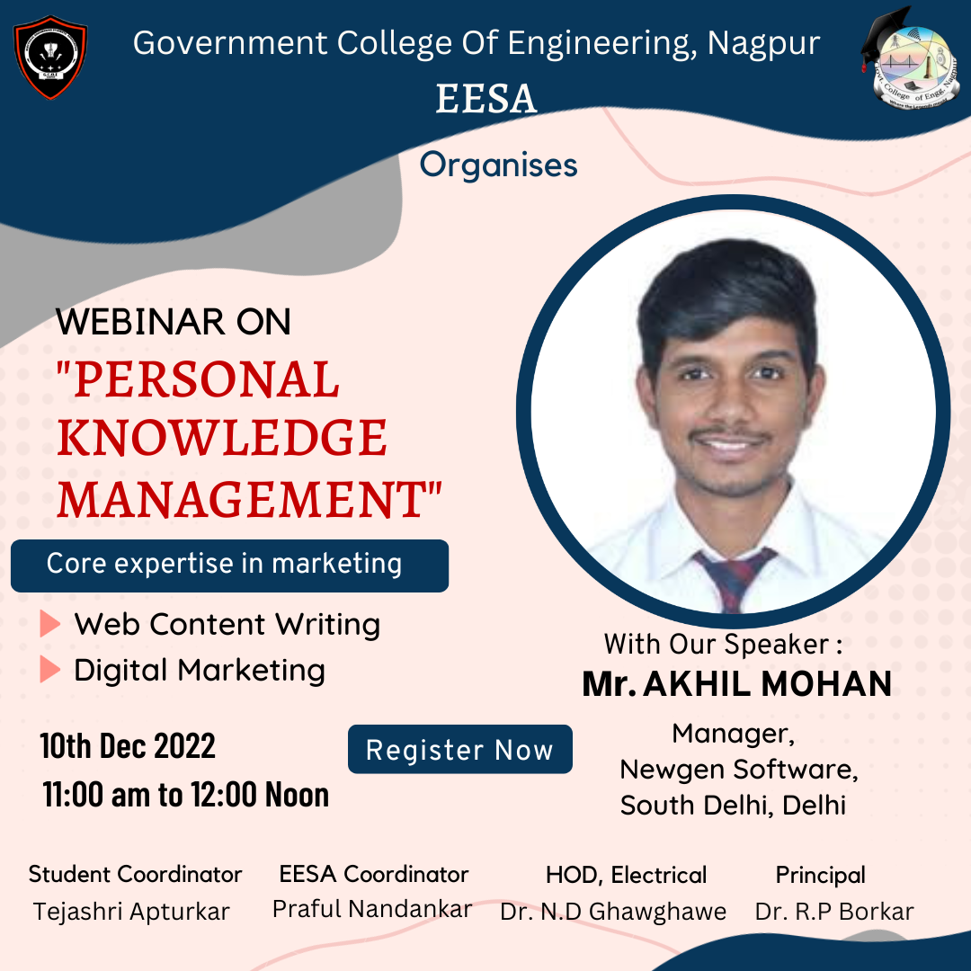

Report:
Title: Personal Knowledge management
Conducted by: EESA
Mode of Activity: Online (Google Meet)
Date: 10th Dec 2022 (Saturday)
Timing: 11:00 am to 12:00 noon
Participation:
- Total Registrations: 207
- Peak Viewers and Attendees: 142

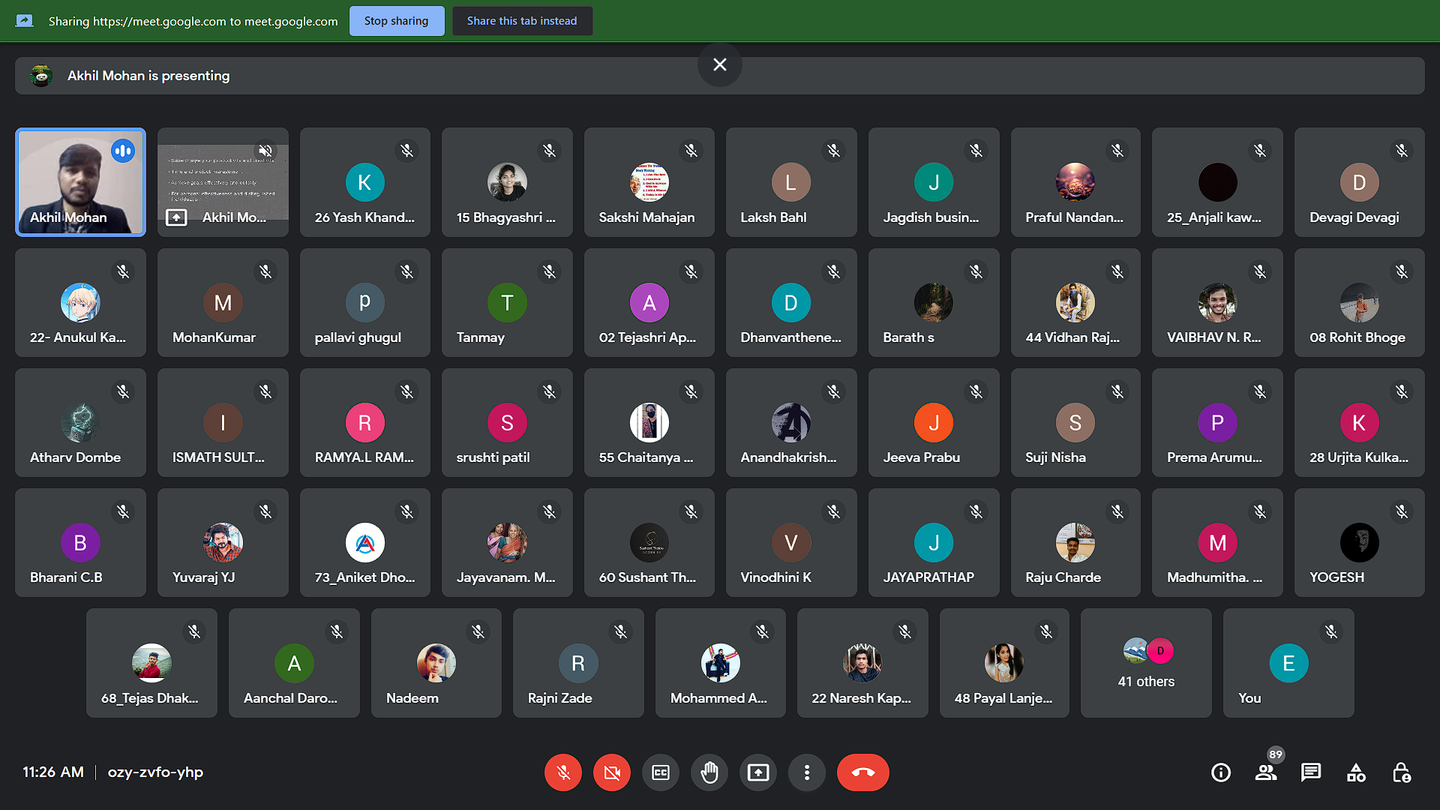
Introduction:
Personal knowledge management (PKM) is a collection of processes that a person uses to gather, classify, store, search, retrieve and share knowledge in their daily activities. It is a response to the idea that knowledge workers need to be responsible for their own growth and learning. PKM is considered to be a life-long investment of time and effort into capturing and organizing information. That can include the things you experience, read about, and listen to. It’s a premeditated and systematic collection of information.
Summary:
Guest Speaker: Mr. Akhil Mohan, (Manager at Newgen Software, South Delhi, Delhi)
Faculty Coordinator: Praful Nandankar (Assistant Professor, Electrical Engg. Dept., Govt. College of Engineering, Nagpur)
Student Coordinator: Tejashree Apturkar
- The application of PKM in engineering is that it assesses the basis of design decisions, whether they are internal or external and generalizes these into guidance for engineers.
- The speaker started off by sharing some information about his life and his Job. the speaker emphasized how PKM has helped him get better in various aspects of life.
- The speaker gave an insight into the benefits of PKM and how it supports overall development. It helps with improved organizational agility and supports any business process as well.
- He added how PKM would be beneficial for the students pursuing the technical field as it enhances a person's problem-solving skills and one is able to make better and faster decisions.
- The speaker also highlighted the importance of time management and how it plate a crucial role in a proper PKM.
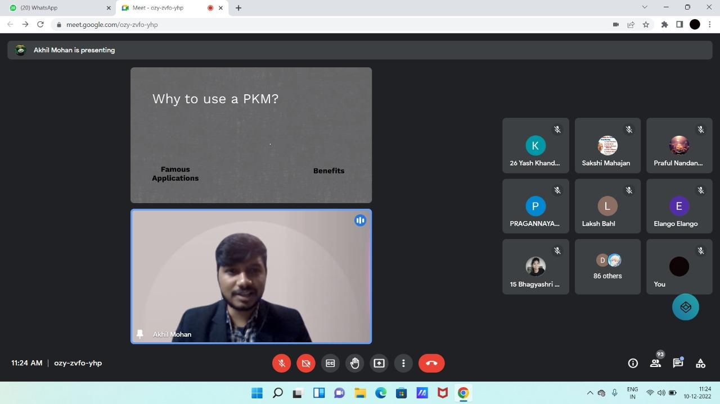
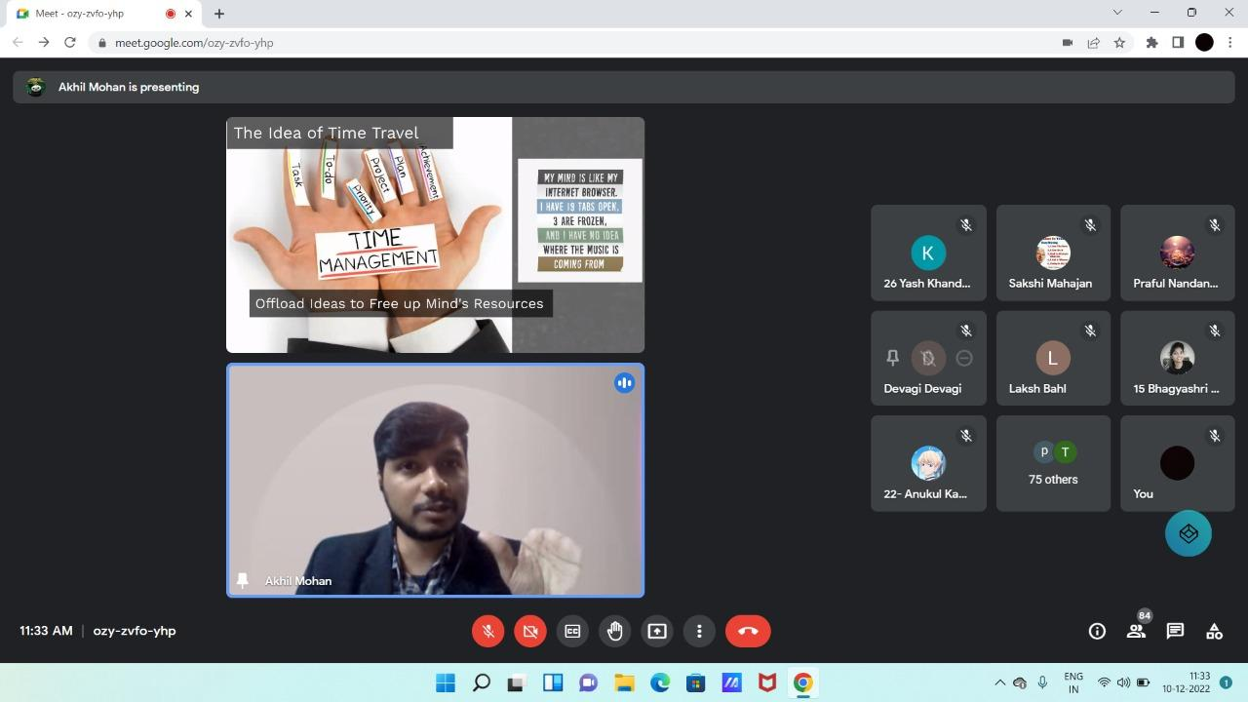

Conclusion:
- Overall, it was a very helpful session as it introduced a more strategic way of living to the students, which the speaker explained to the students through a lot of quotes and successful sayings by famous personalities.
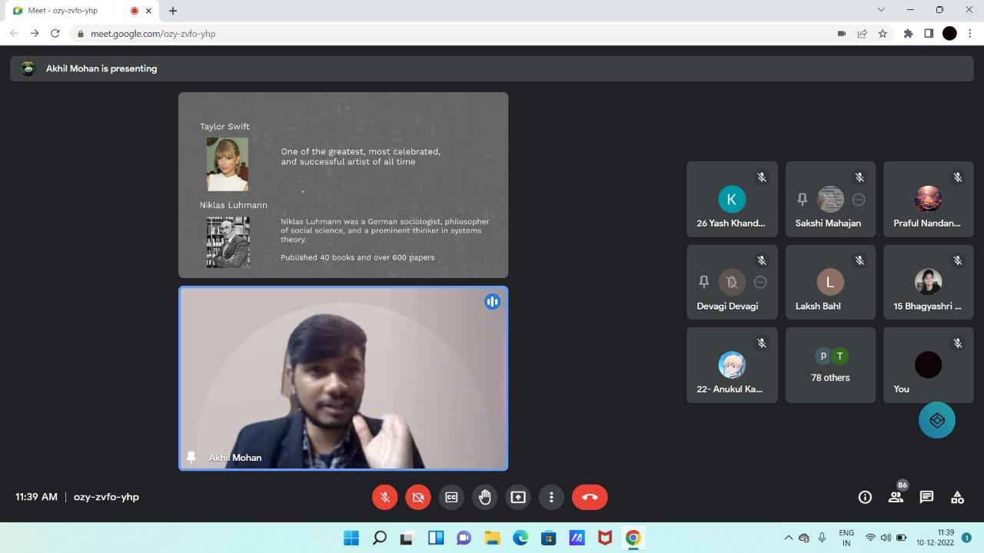
- Personal Knowledge Management should be viewed as a set of problem-solving skills that have both a logical or conceptual as well as physical or hands-on component.
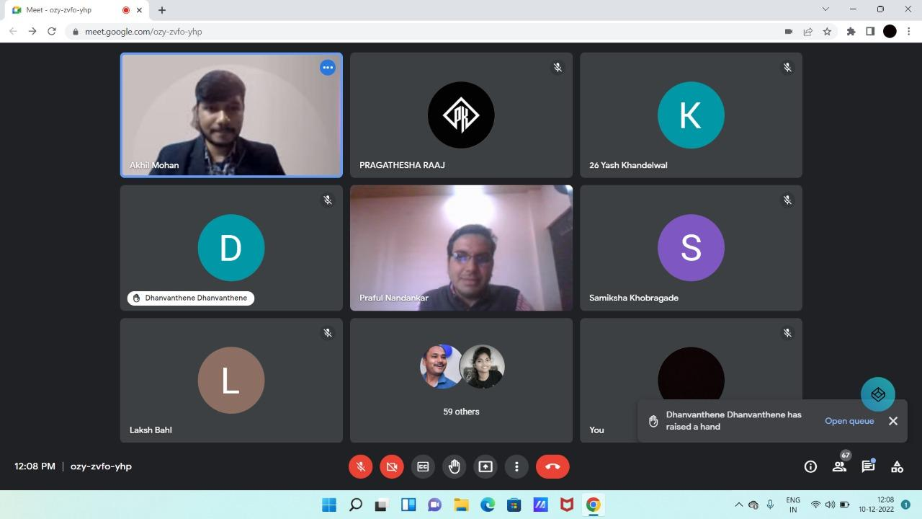

8) “INVENTRIX 5.0”
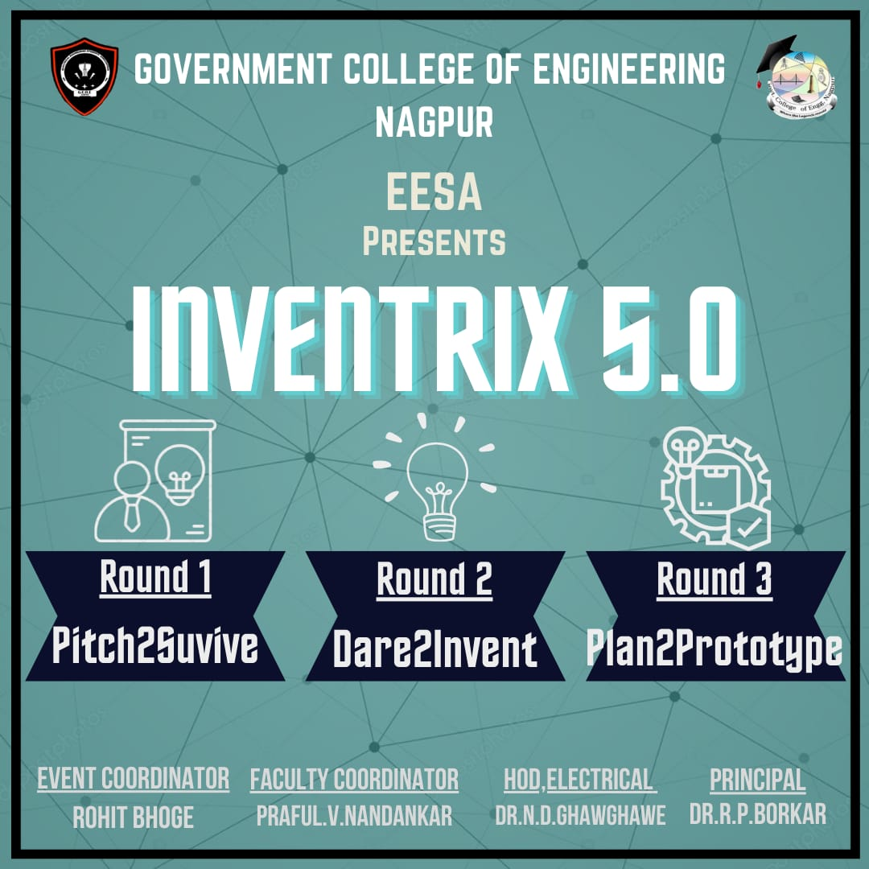

Report
Title: INVENTRIX 5.0
Conducted by: EESA in collaboration with IIC, GCOEN
Mode of Activity: Online on Google Meet
Date: 21st Jan, 2023
No. of Participants: 30 teams
Recording: https://drive.google.com/file/d/1rkMhRbxn5AniZhVHyC02GjL8SBfSuOYi/view?usp=sharing
Introduction: INVENTRIX 5.0 was an innovation-based event organized to stimulate the minds of young students. The main goal of the event was to inspire young students to think creatively and come up with innovative solutions to real-world problems. The event was organized in three different rounds, each with its own unique set of challenges.
Summary:
Faculty Coordinator: Prof. Praful Nandankar (Assistant Professor, Electrical Engg. Dept., Govt. College of Engineering, Nagpur)
Student Coordinator: Rohit Bhoge
- ROUND 1: The first round of INVENTRIX 5.0 was all about collecting problem statements from the outside world. The organizers collected 30 problem statements and classified them into five different themes. This round provided an opportunity for students to understand real-world problems and come up with solutions that could make a difference. This round was crucial in setting the stage for the next rounds, as it provided the students with a clear understanding of the problems they needed to solve.
- ROUND 2: In round 2, the students presented their ideas in the form of a PPT. The students who got selected in this round had to prepare a hardware prototype or simulation of their presented idea. This round challenged the students to think creatively and come up with innovative solutions to the problems they had identified in round 1. The presentations were evaluated by a panel of judges, and the selected students were given the opportunity to move on to the next round.
- ROUND 3: The final round of INVENTRIX 5.0 was a showcase of the innovative ideas and prototypes that the students had developed in the previous rounds. The students were given the opportunity to demonstrate their prototypes and explain their ideas to a panel of judges and other attendees. This round provided an opportunity for the students to showcase their innovation skills and creativity.
- INVENTRIX 5.0 was attended by around 120 beneficiaries, mainly young students who were interested in innovation and creativity. The event provided an excellent opportunity for these students to learn about real-world problems and develop innovative solutions.
- Overall, INVENTRIX 5.0 was a successful event that provided an excellent opportunity for young students to develop their creativity and innovation skills. The event was well-organized and had a clear objective, which helped the students understand the importance of innovation in solving real-world problems. The event was attended by around 30 teams who were able to learn about different approaches to innovation and develop their own innovative solutions.

Outcome:
- One of the primary outcomes of the event was the development of several innovative ideas and prototypes by the students. The students were able to identify real-world problems and come up with solutions that had the potential to make a significant impact. The event provided a platform for the students to showcase their creativity and innovation skills, and several impressive ideas and prototypes were presented.
- The other positive outcome of the event was the development of a spirit of collaboration and teamwork among the students. The event required the students to work together in teams, and this helped them develop their interpersonal and communication skills. The students were able to learn from each other and collaborate effectively to come up with innovative solutions to the problems they had identified.
- The event also helped to raise awareness about the importance of innovation and creativity among young students. By providing a platform for the students to develop their innovation skills and showcase their creativity, the event helped to inspire and motivate them to think creatively and come up with solutions to real-world problems.
Photos:
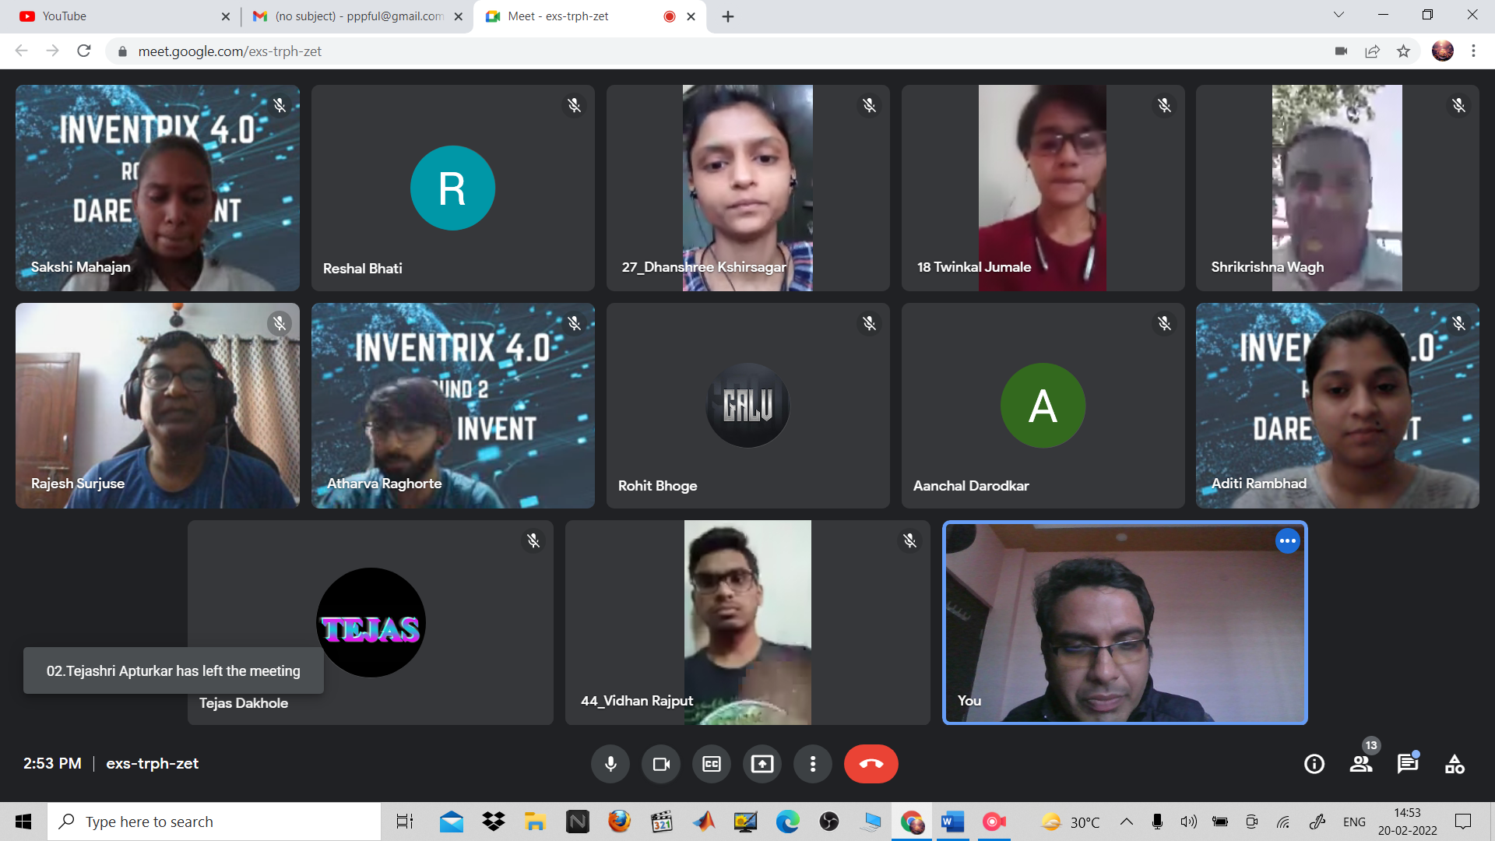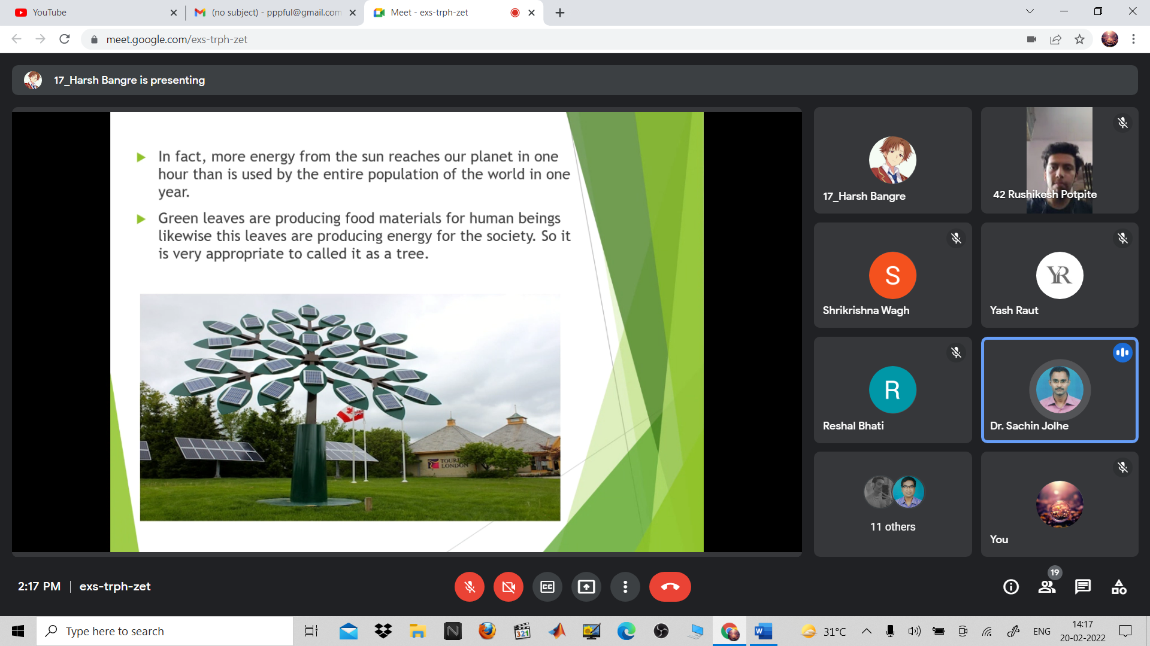
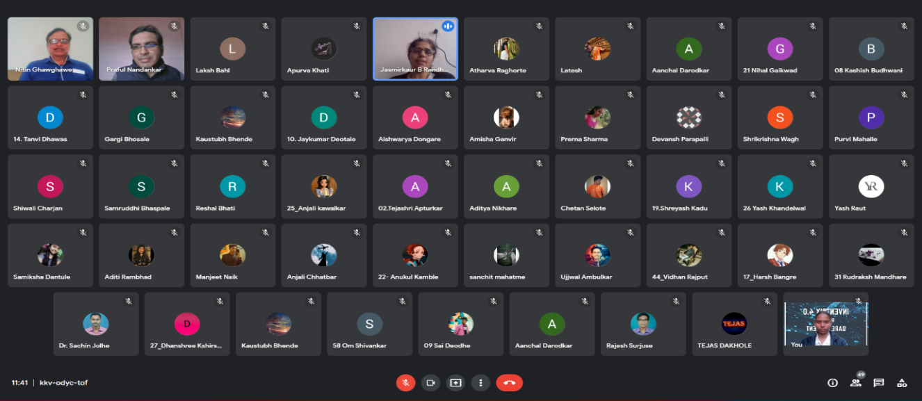

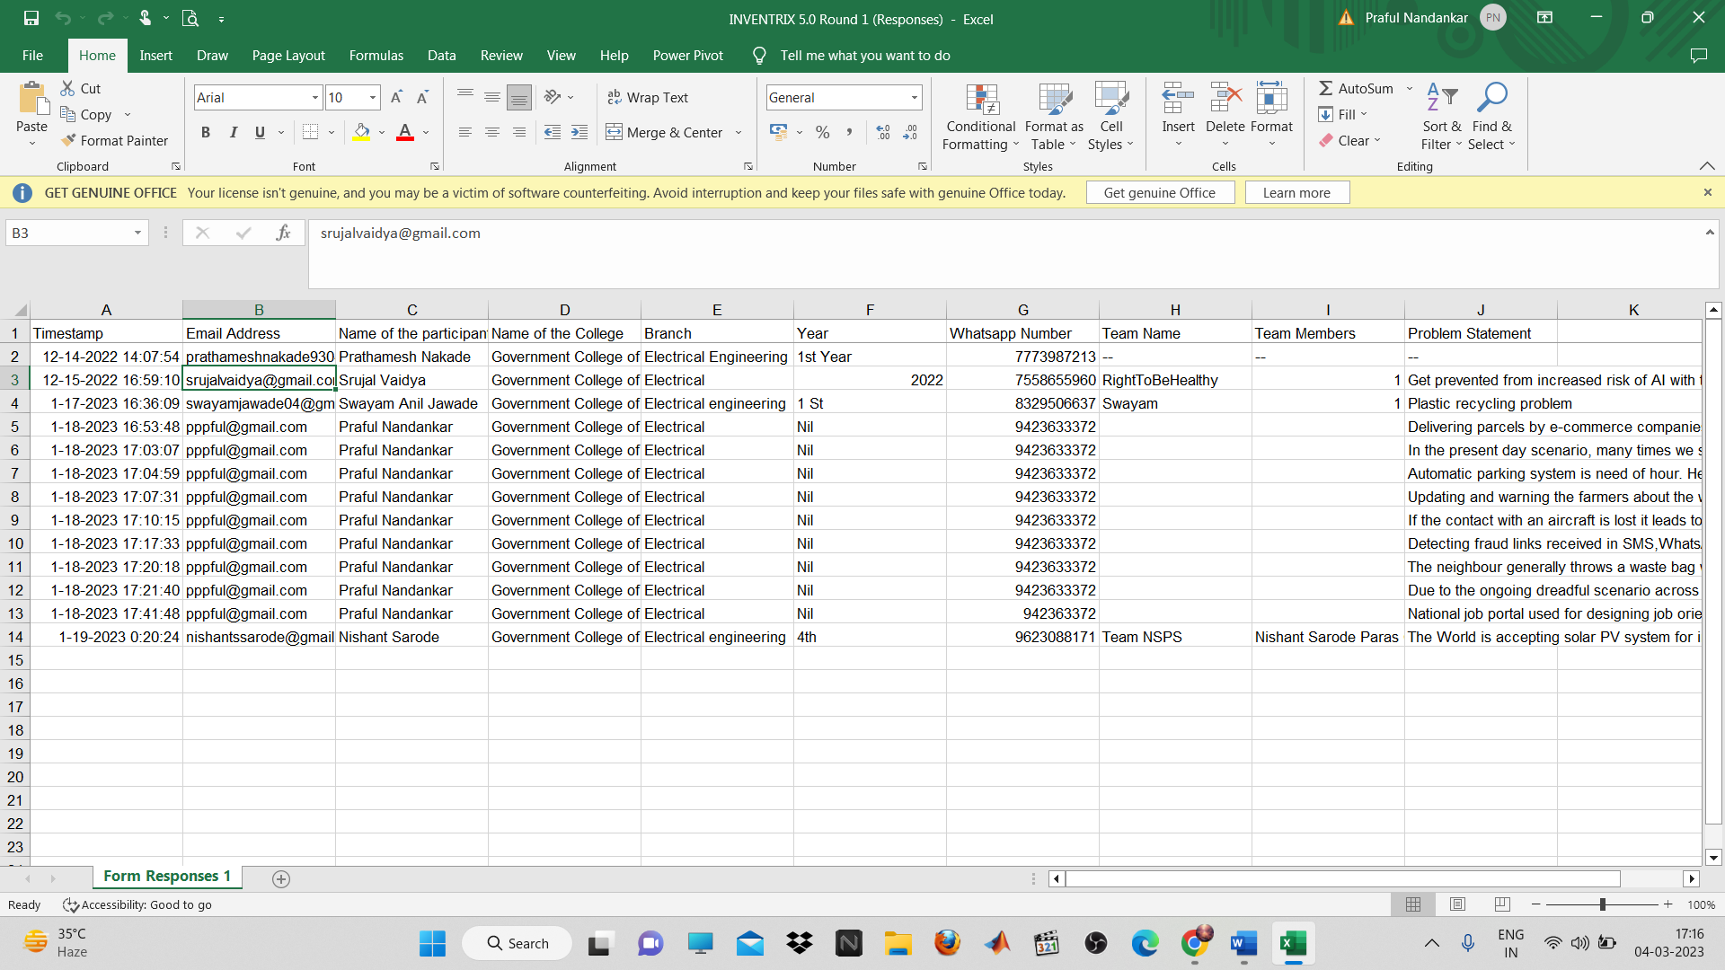
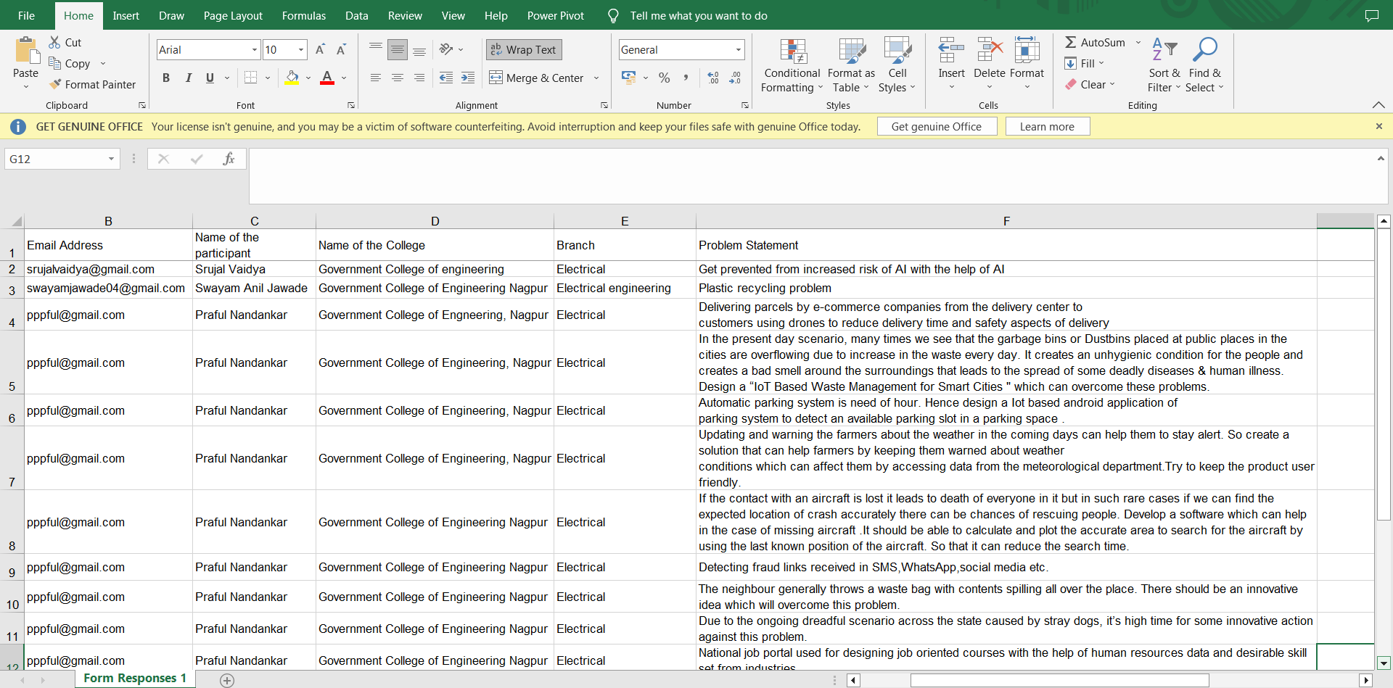

9) Poster Competition
On August 15th, 2022, the Electrical Engineering Students Association of Government College of Engineering, Nagpur organized a poster competition to celebrate India's 75 years of independence, with the theme "Azadi ka Amrit Mahotsava". The competition was held in the Government College of Engineering, Nagpur and was open to all students studying in electrical engineering. The event saw a large number of participants showcasing their creative skills and patriotism through their posters. The posters were judged based on their creativity, originality, and relevance to the theme. The judges for the competition were experts in the field of art and design.
The winners of the competition were announced at the end of the event. The first prize was awarded for their outstanding poster that depicted the journey of India from pre-independence to the present day. The second prize was awarded for their poster that highlighted the diversity and unity of India. The third prize went to the poster that showcased the achievements of India in various fields since independence. The event was a grand success, with enthusiastic participation from students, faculty members, and guests. It provided an excellent platform for students to showcase their creativity and express their love for the country. The Electrical Engineering Students Association expressed their gratitude to all the participants, judges, and guests who made the event a grand success.
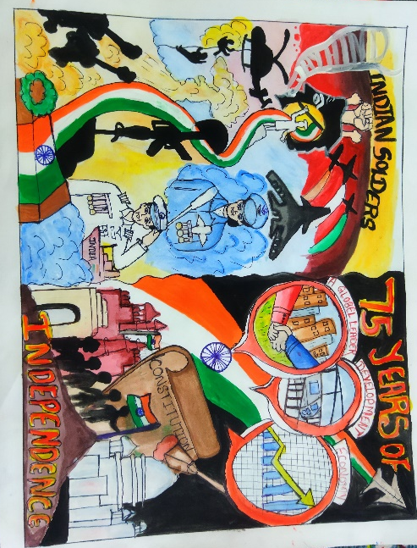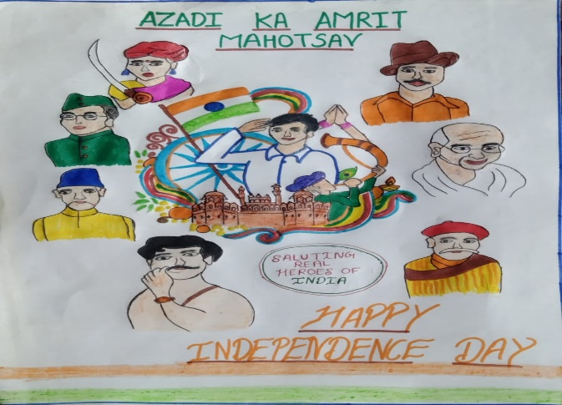

10) Essay Writing Competition
On August 15th, 2023, the Electrical Engineering Students Association of Government College of Engineering, Nagpur organized a writing competition to celebrate India's 75 years of independence, with the theme "Azadi ka Amrit Mahotsava". The competition was held in the Government College of Engineering, Nagpur and was open to all students studying in electrical engineering. The event saw a large number of participants showcasing their writing skills and patriotism through their essays. The essays were judged based on their relevance to the theme, originality, and creativity. The judges for the competition were experts in the field of literature and language.
The winners of the competition were announced at the end of the event. The first prize went for the outstanding essay that depicted the journey of India from pre-independence to the present day. The second prize was awarded to the essay that highlighted the contributions of the freedom fighters towards India's independence. The third prize went to the essay that showcased the importance of unity and diversity in India.
The event was a grand success, with enthusiastic participation from students, faculty members, and guests. It provided an excellent platform for students to showcase their writing skills and express their love for the country. The Electrical Engineering Students Association expressed their gratitude to all the participants, judges, and guests who made the event a grand success.
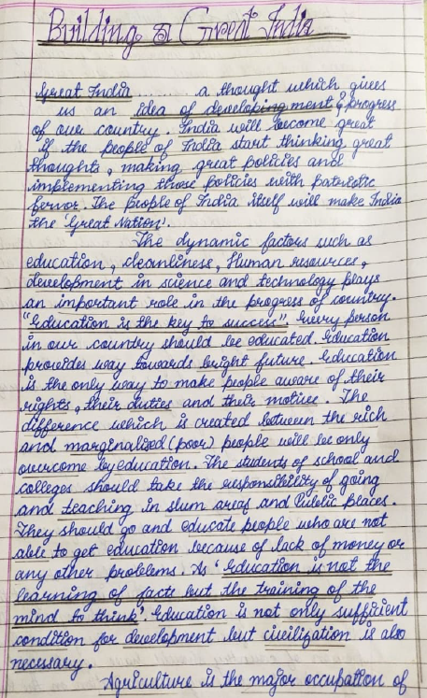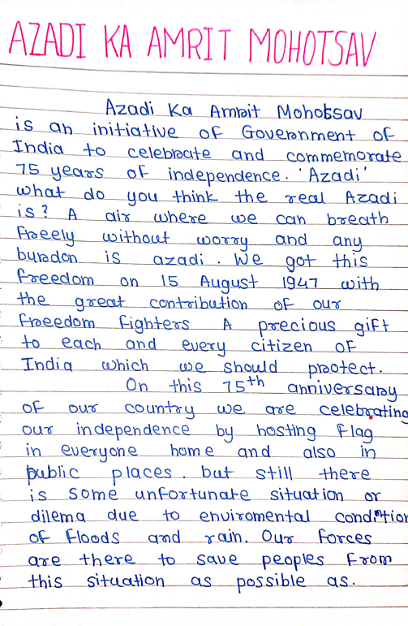

11) “Video Editing Competition”
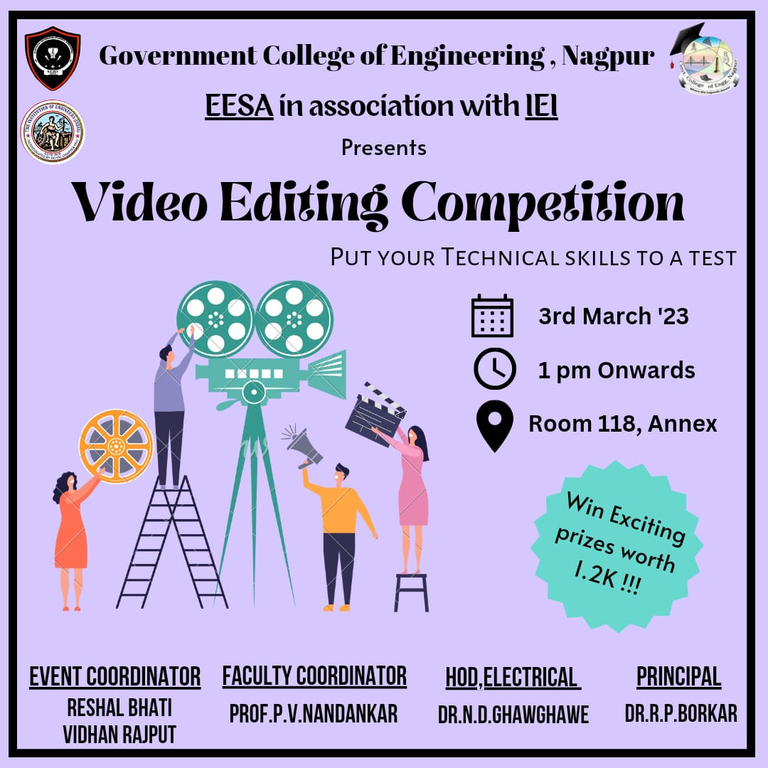

Report
Title: Video Editing Competition
Conducted by: EESA in collaboration with IEI
Mode of Activity: Offline (Room 118, Annex Building)
Date: 3rd March 2023 (Friday)
Timing: 3 PM Onwards
No. of Participants: 10
Video Editing Competition Recording: https://drive.google.com/file/d/15PLNKCXvAWu8oL9r2Nl3JjEk20wtikI8/view?usp=sharing

Introduction: Video Editing Competitions are events that allow participants to showcase their video editing skills and creativity. These competitions usually require participants to edit a purposeful video that conveys a specific message, such as a motivational message or a social issue. The participants are judged on their editing, innovation, and accuracy in conveying the intended message. These competitions provide a platform for young graduates to showcase their talent and creativity and can be a great way to encourage and promote video editing as an art form.
Summary:
Faculty Coordinator: Prof. Praful Nandankar (Assistant Professor, Electrical Engg. Dept., Govt. College of Engineering, Nagpur)
Student Coordinator: Reshal Bhati and Vidhan Rajput
- On 3rd March 2023, a Video Editing Competition was organized to unleash the editing skills of young graduates. The purpose of the competition was to create a motivational message in today's context. The competition was a great opportunity for participants to showcase their talent and creativity.
- There were around 10 participants who took part in the competition. The participants were required to edit a purposeful video that conveyed a motivational message. The participants were given 1 minute to edit the video and display their skills.
- The competition was judged on editing, innovation, and accuracy. The two best inspirational videos were selected for the winners and runners-up positions. The first prize was awarded to the participant who displayed the message of the importance of meditation in today’s technological life. The second prize was awarded to the participant who emphasized the importance of education to the child and highlighted the condition of child labour.
Outcome:
- The competition helped to encourage and promote video editing as an art form, as well as providing a platform for young graduates to showcase their skills. The participants showed impressive creativity and innovation in conveying their intended messages, and the judges were impressed with the quality of their work.
- Overall, the Video Editing Competition was a great success, and the participants appreciated the opportunity to showcase their talent and share a motivational message with the audience. The event provided a valuable platform for young graduates to explore their creativity and showcase their video editing skills, and it is hoped that similar competitions will be organized in the future to continue to promote video editing as an art form.
Photos:
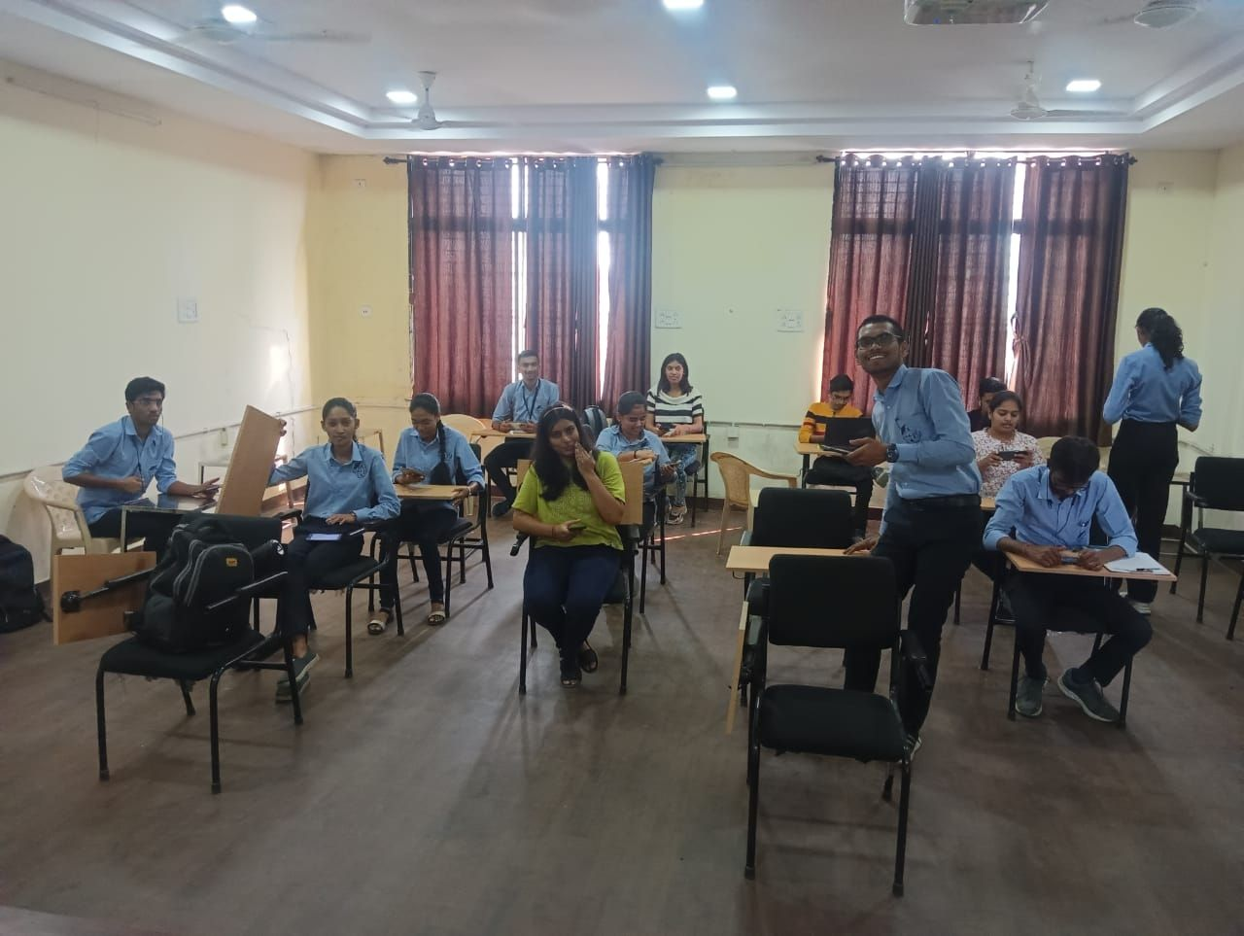
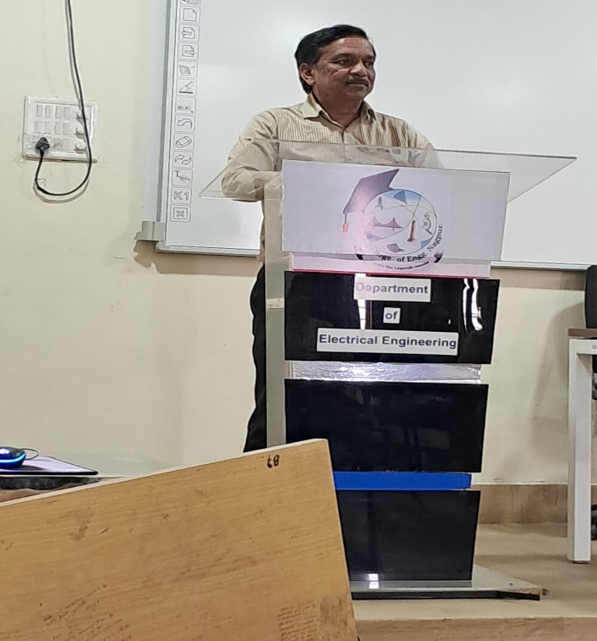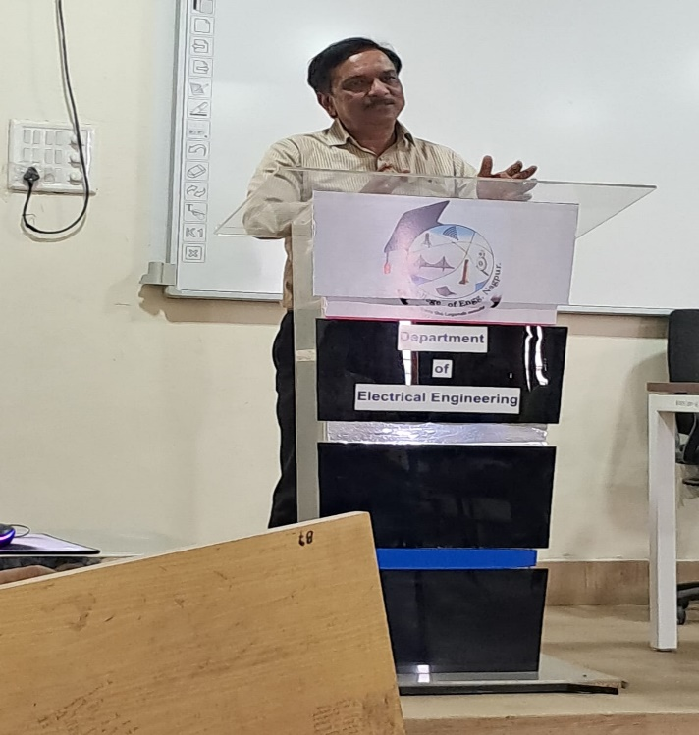

Prize Winners:
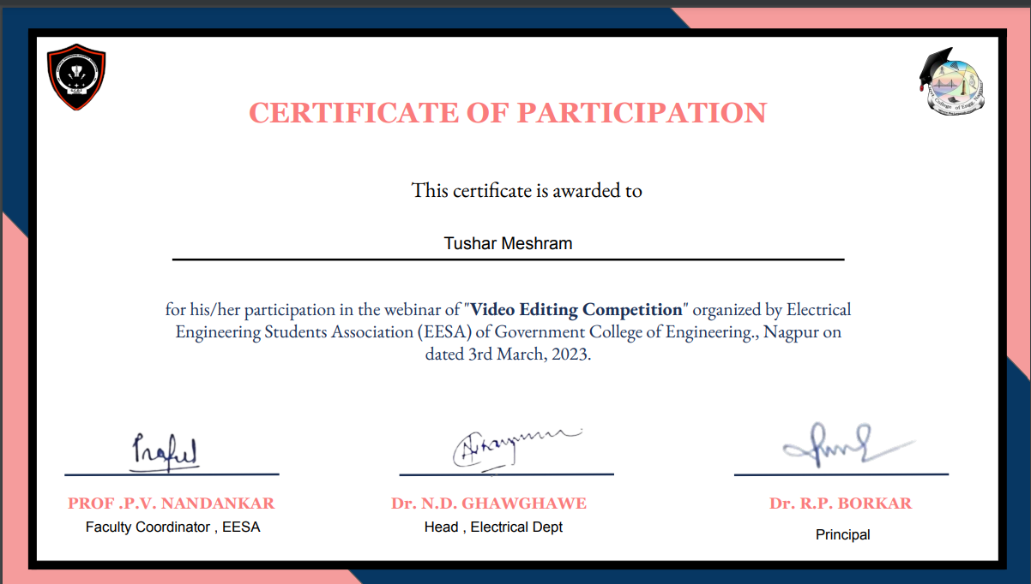

12) “INVENTRIX 5.0” PLAN 2 PROTOTYPE
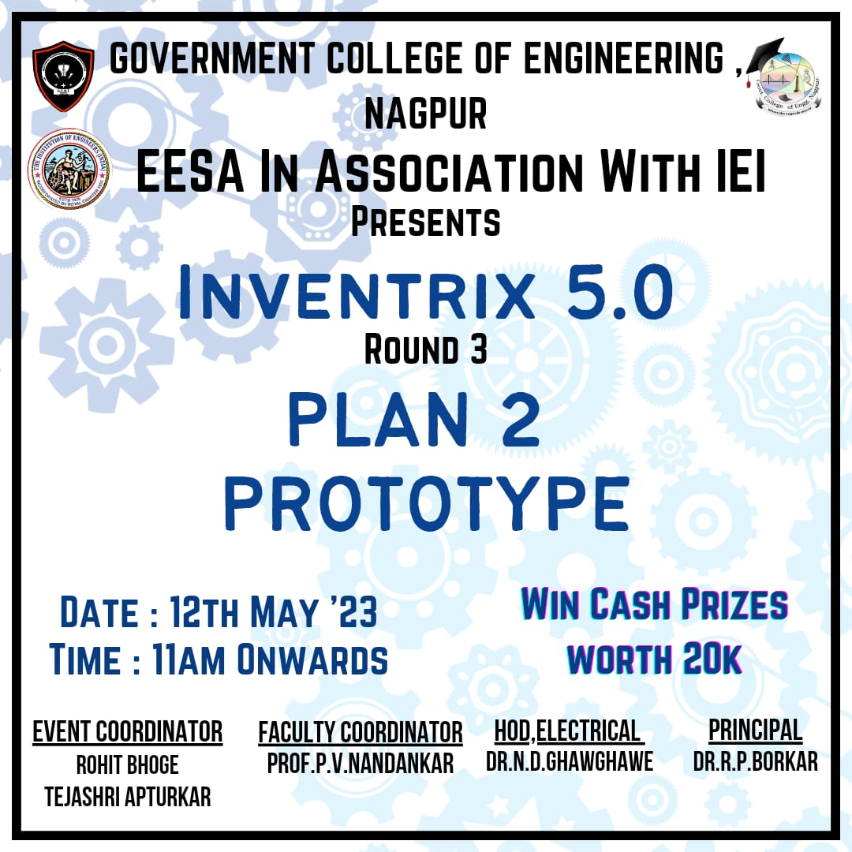

Report

Title: Plan 2 Prototype
Conducted by: EESA in collaboration with IIC and IEI, GCOEN
Mode of Activity: Offline + Online session for “Non-Localite” teams
Offline Session: Auditorium, GCOEN
Online Meeting link : https://meet.google.com/zqr-cpty-ydg
Date: 12th May 2023 (Friday)
Timing: 11:00 AM to 2:30 PM
No. of Participating Teams: 8 (Shortlisted and qualified from Round2)

Plan 2 Prototype Images and Presentation Recording: https://drive.google.com/drive/folders/1Dx4d2iWLlWRBRDeRs9TsGe8ssC5rO5nN?usp=drive_link

Introduction:
Plan 2 Prototype is organized by EESA in association with IIC and IEI, GCOEN. This round in Inventrix event aimed to foster innovation and problem-solving skills among students. The event consisted of three rounds, namely Pitch2Survive, Dare2invent, and Plan2Prototype. Round 1 involved the submission of problem statements and ideas, which were narrowed down to six themes for Round 2. In Round 2, teams presented their optimal solutions through PowerPoint presentations. The best ideas were selected to advance to Round 3, where teams were required to present their ideas in the form of hardware prototypes.Round 3 of Inventrix, titled "Plan to Prototype," showcased the practical implementation of the ideas proposed in the previous rounds.
Summary:
Evaluators: Dr. Nitin Ghawgahwe (HoD, Electrical), Prof. Shrikrishna Wagh (Assistant Professor, Mechanical), Dr. J.B Randhawa, Jayant Paranjpe (External Jury).
Faculty Coordinator: Prof. Praful Nandankar (Assistant Professor, Electrical Engg. Dept., Govt. College of Engineering, Nagpur)
Student Coordinator: Rohit Bhoge & Tejashri Apturkar
Winners:
- 1st Position: Nishant Sarode and team
- 2nd Position: Sakshi Mahajan and team
- 3rd Position: Paras Shorte and team
Sequence of the Event:

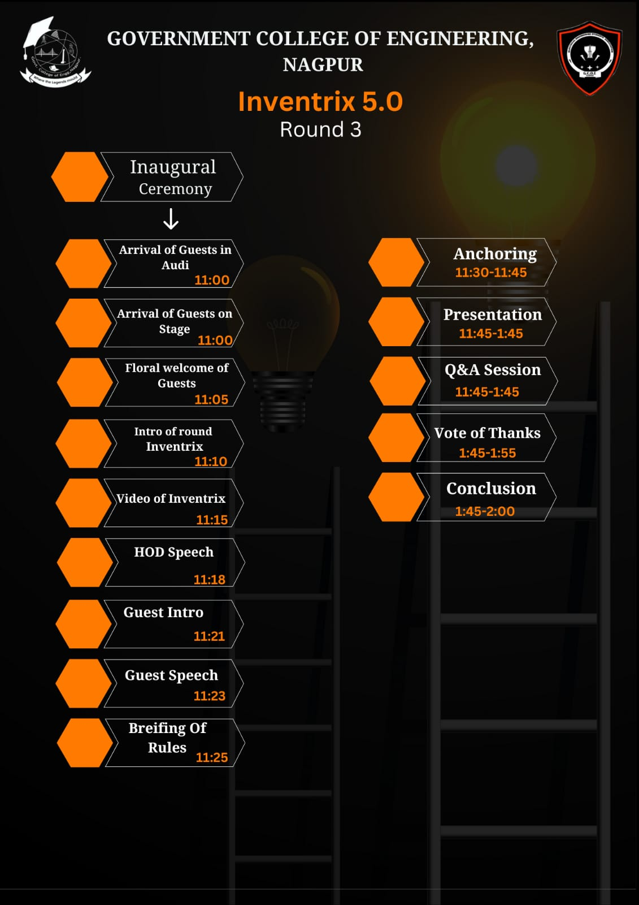

Description:

- Plan2Prototype started at 11:00 AM on 12th May 2023 with an inauguration ceremony. This is followed by an inspirational speech by Dr. Nitin Ghawghae, HoD Electrical. He explained the importance of innovation in today’s scenario. He also pointed out various stages of Design thinking as Plan2Prototype competition is analogous to Design creation events.
- Jayant Paranjpe, respected External Jury for the event, was also invited to encourage the participants.
- After a motivational speech, the rules and regulations of this competition have been explained to participants.
- Participants have selected their problem statement and they have given their solutions. The solutions of the participants are evaluated based on parameters like concept novelty, practicability, hardware presentation, potential social impact and scalability.
- The participants received valuable feedback, suggestions from evaluators after their hardware presentation.

Conclusion

The Plan to Prototype round of Inventrix was a resounding success, allowing participants to delve deeper into the engineering aspects of their ideas. By converting their concepts into functional hardware prototypes, the students gained valuable insights into the practical challenges and intricacies of product development. This phase of the event facilitated the students' growth as engineers in several ways:

- Practical Application: The participants had the opportunity to apply their theoretical knowledge to real-world problems. They encountered the technical challenges and learned how to overcome them, fostering their problem-solving abilities.
- Collaboration and Teamwork: working in teams,the students developed an essential teamwork skill, including effective communication, task delegation and conflict resolving. The collaborative environment encouraged innovation through diverse perspectives.
- Engineering Skill Development: The process of creating hardware prototypes required students to utilize engineering principles, such as design, analysis and optimization. They gained hands-on experience in prototyping, testing, iterating their ideas.
- Presentation and communications: Presenting their hardware prototypes allowed the students to enhance their communication and presentation skills. They learned how to articulate their ideas, demonstrate the functionality of their prototypes and address questions and feedbacks from the judges.

Photos:
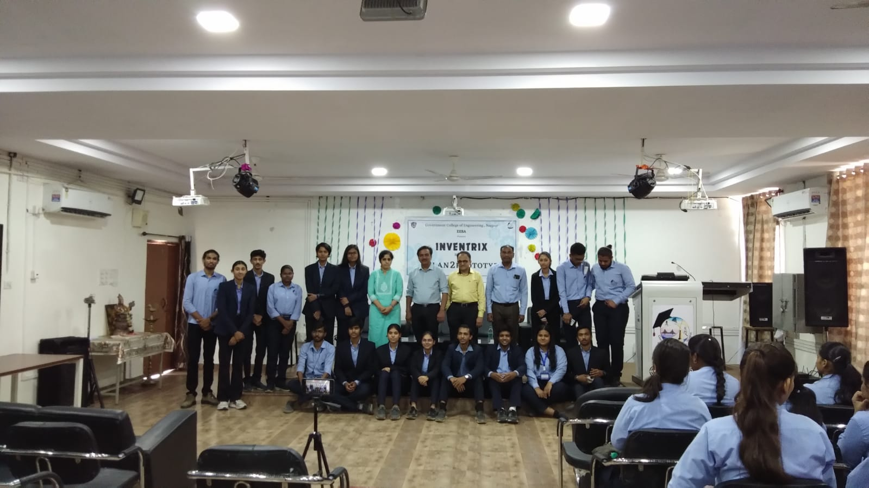
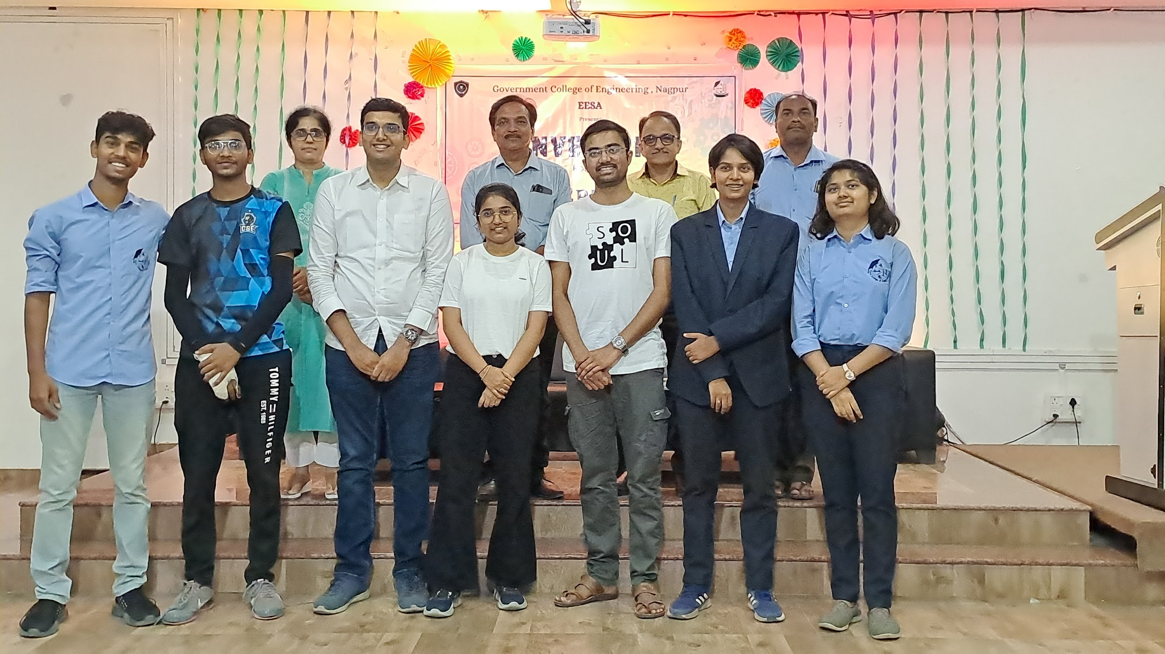
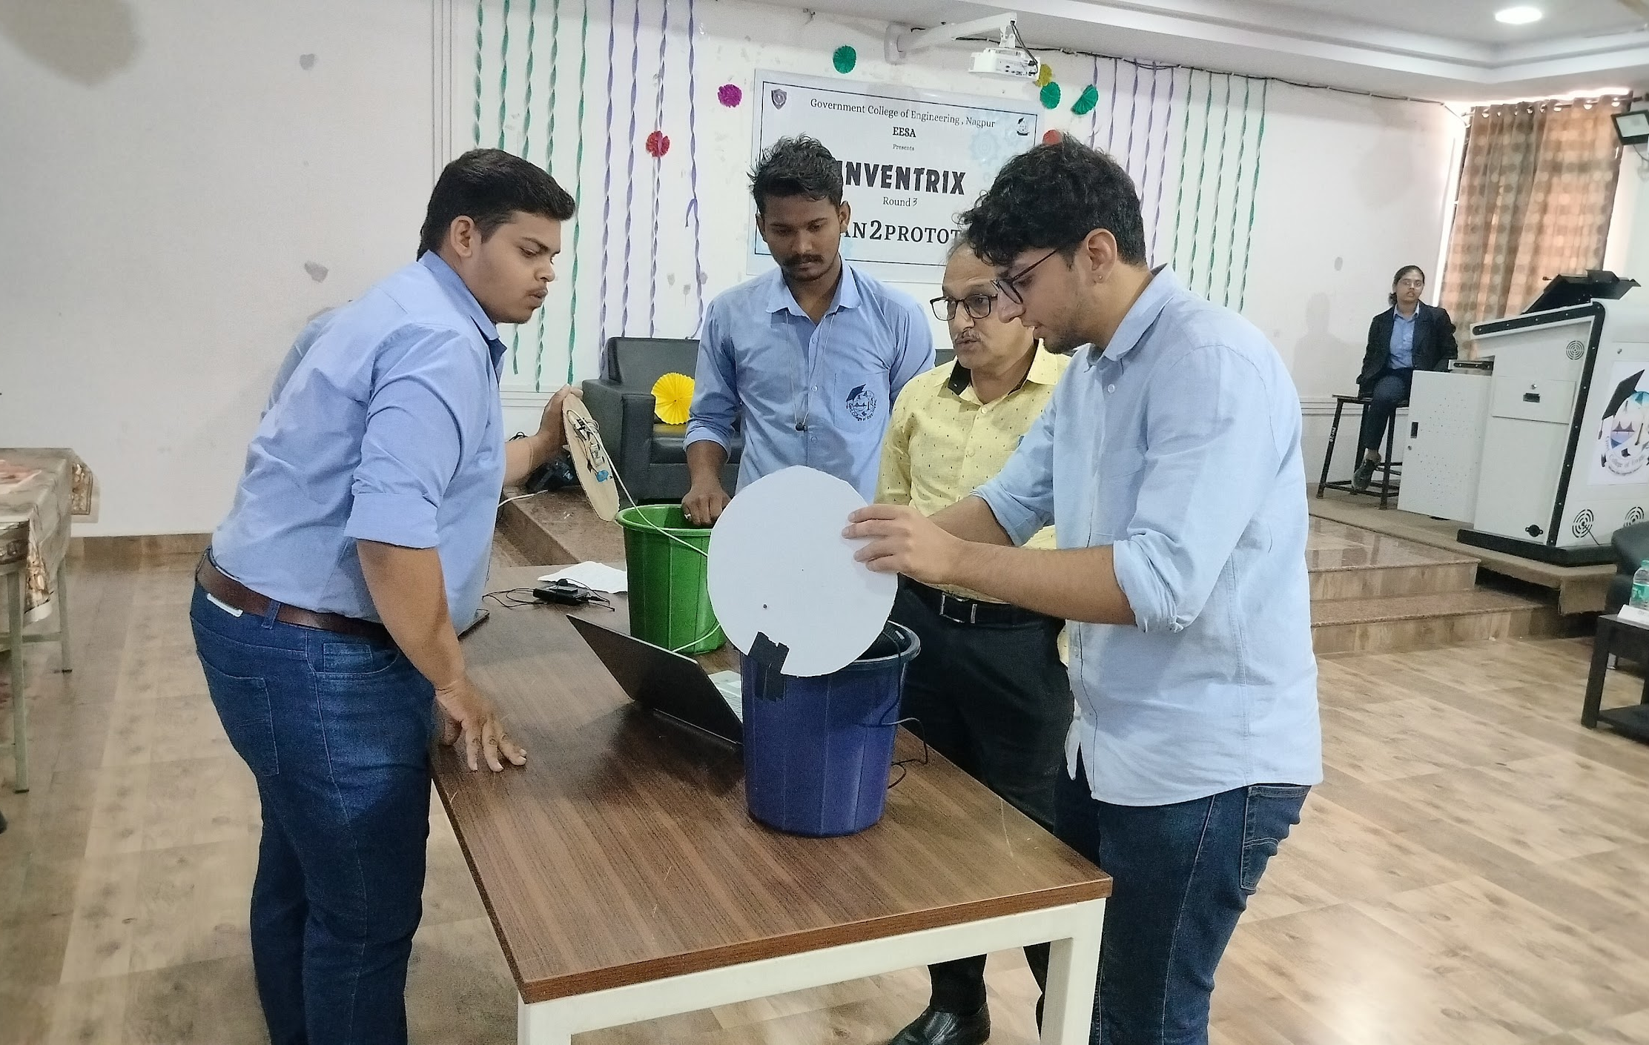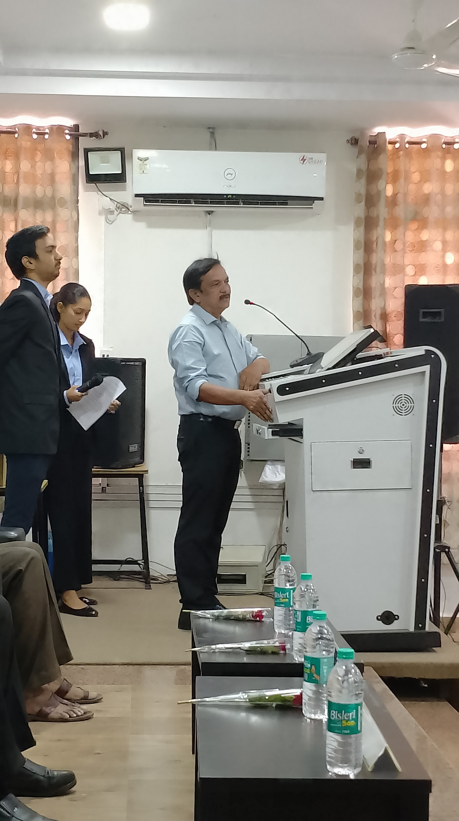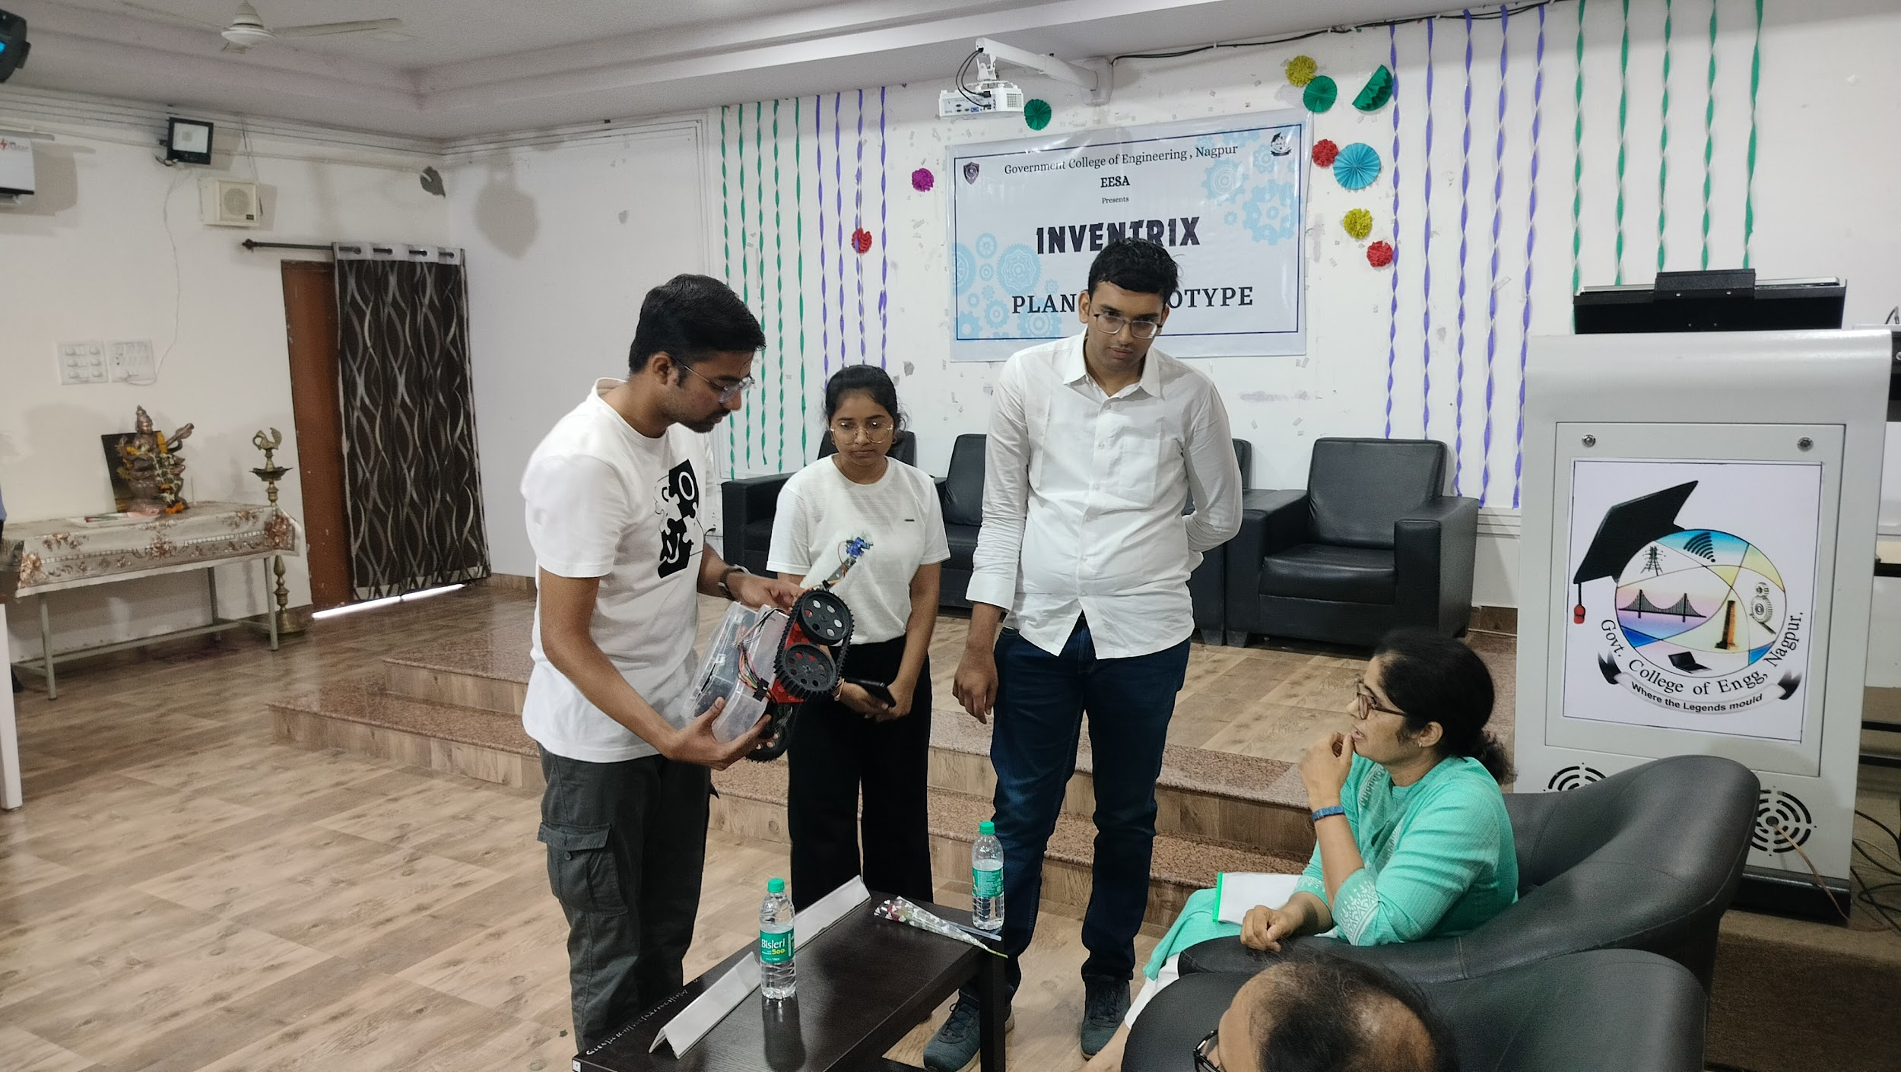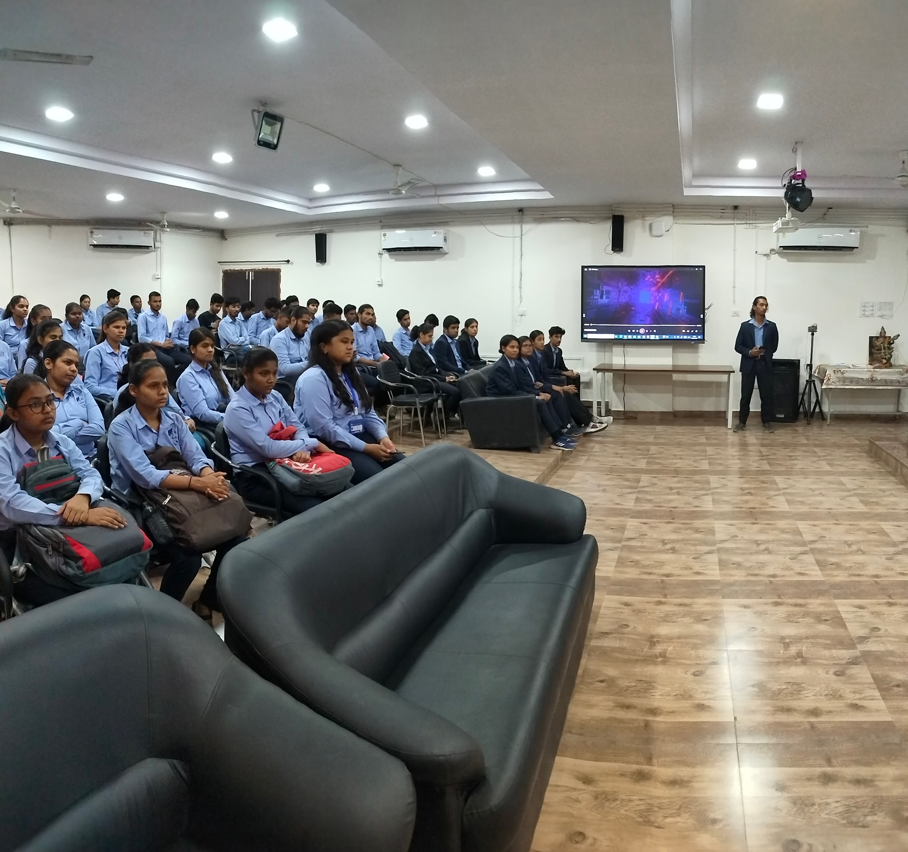
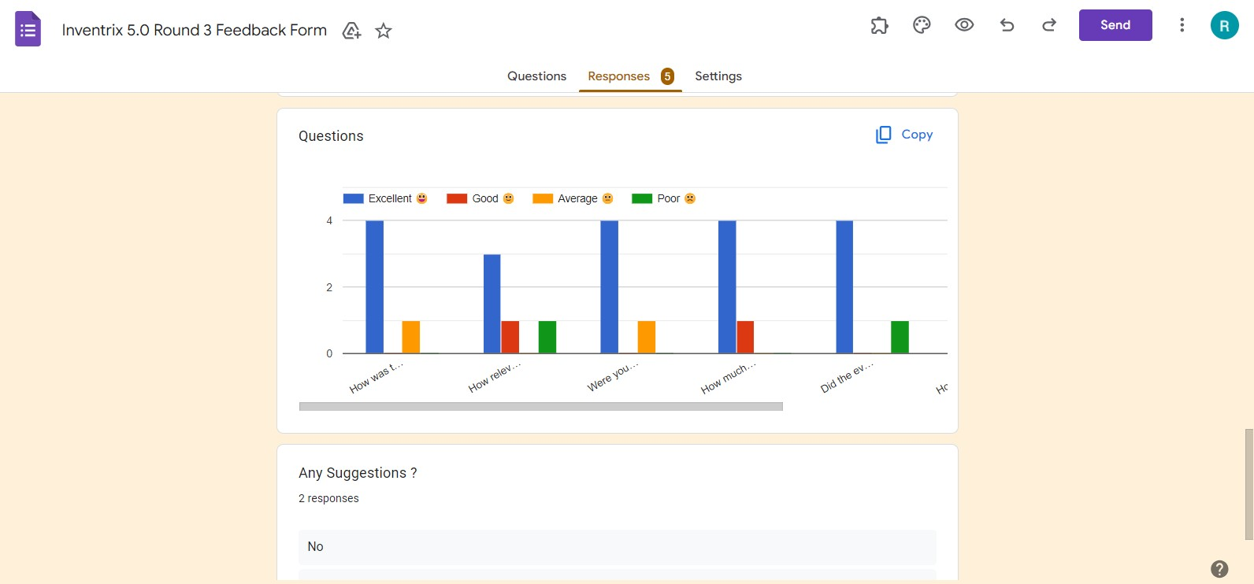

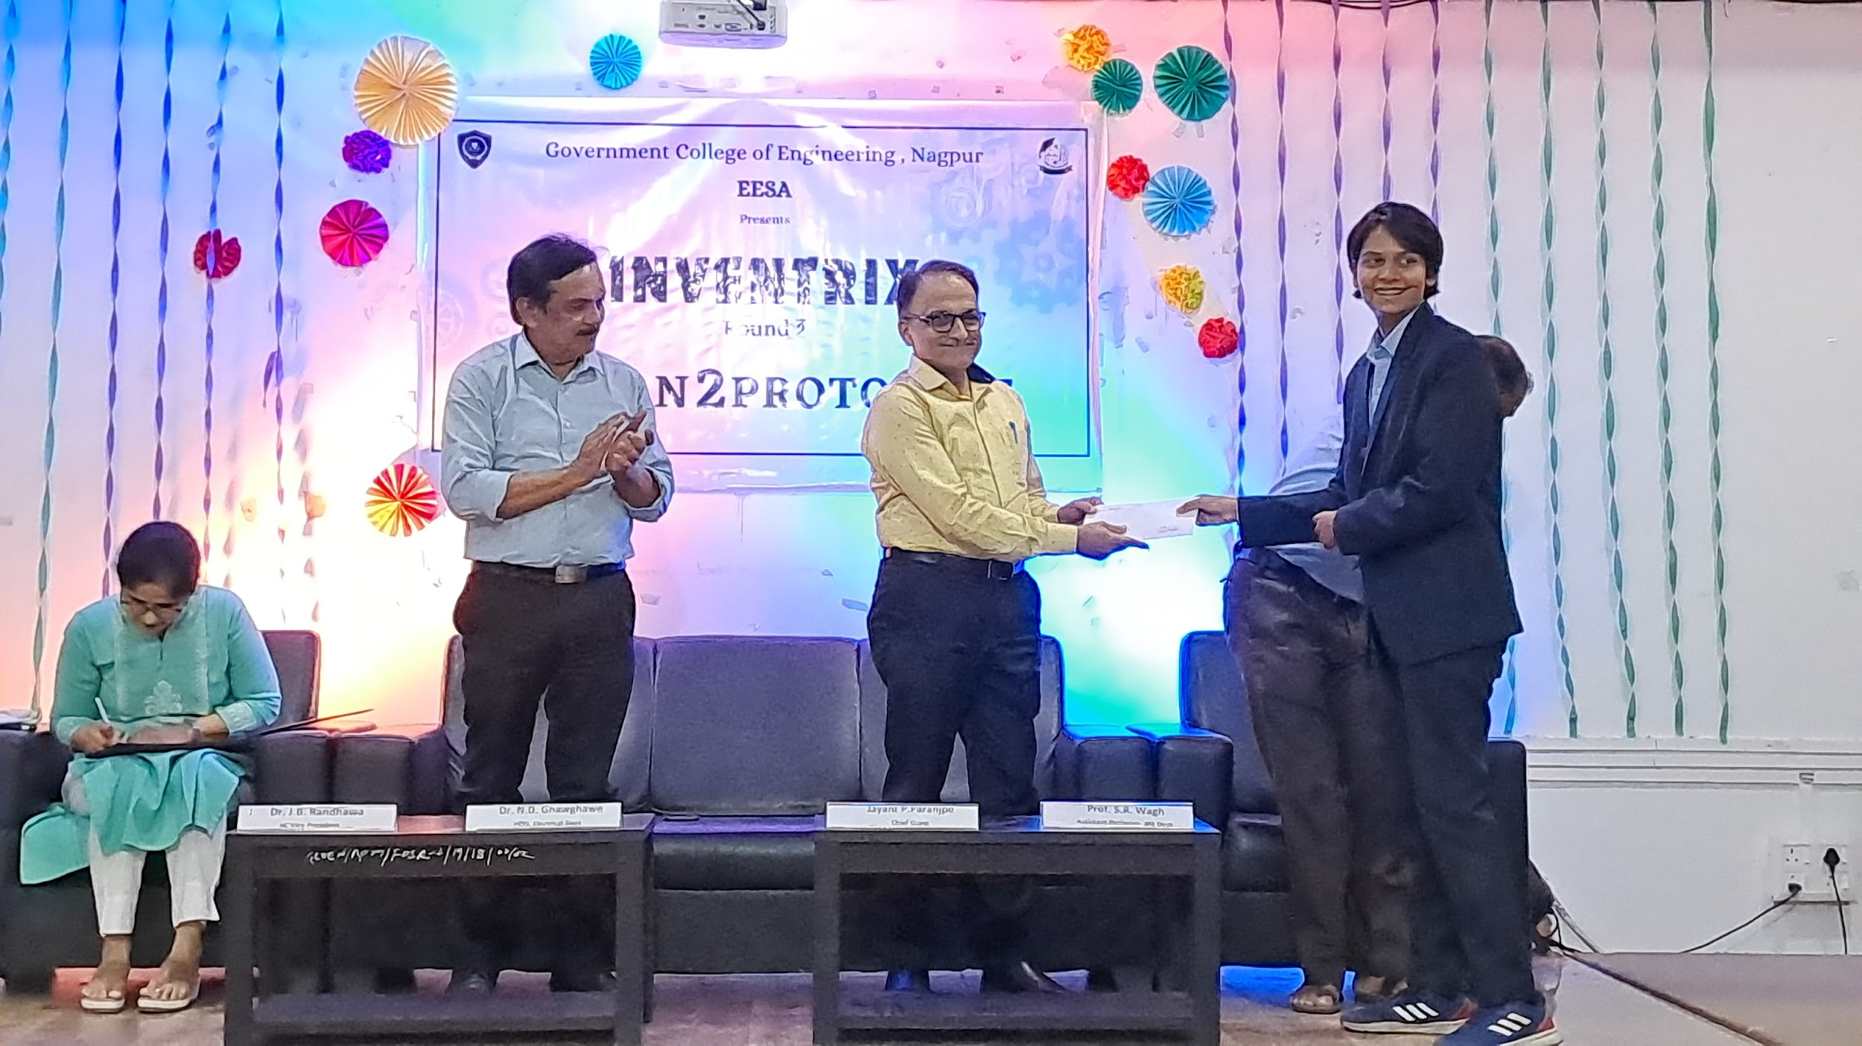

13) “Visit to a 110 kW Grid Connected Solar PV Power Plant”
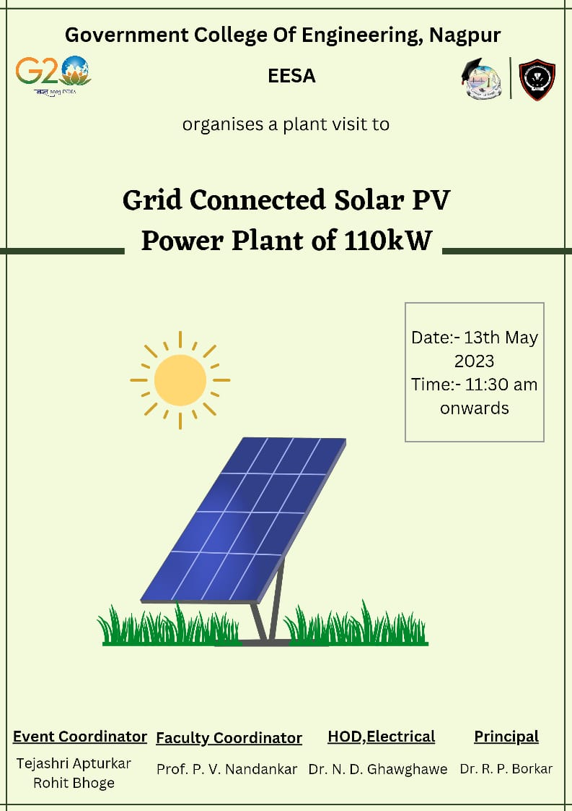

Report
Title: A Visit to a 110 kW Grid-Connected Solar PV Power Plant
Conducted by: EESA
Mode of Activity: Offline
Venue: Main building Roof Top
Date: 13th May 2023 (Saturday)
Timing: 11:30 AM
No. of Participants: 27
Introduction
This report documents a visit to a 110 kW Grid connected Solar PV power plant on May 13th, 2023, at 11:30 am. The visit was guided by HoD Electrical, Dr. N.D. Ghawghawe Sir. The purpose of the visit was to understand the design, operation, and maintenance of a solar PV power plant and to gain insights into the benefits and challenges of solar energy.
Summary
The visit began with a brief introduction by Dr. N.D. Ghawghawe Sir about the power plant's capacity, location, and objectives. The students were then taken on a tour of the power plant, where they observed the solar panels, inverter, switchgear, and other components. The power plant consisted of solar panels, each with a capacity of 250 Wp. The panels were mounted on a fixed structure facing south at an angle of 25 degrees to maximize their exposure to sunlight. The inverter used in the plant was a 110-kW central inverter, which converted the DC power generated by the solar panels into AC power that can be fed into the grid. The power plant was connected to the grid through a 110 kVA transformer, which stepped up the voltage from 415V to 11 kV. The electricity generated by the power plant was fed into the grid, and the power plant operator received a feed-in tariff from the local utility. They also observed that the power plant was well-maintained, and the operators regularly monitored the plant's performance and carried out preventive maintenance activities such as cleaning the solar panels and checking the wiring connections.
Outcomes
The visit provided valuable insights into the benefits of solar energy. Solar energy is a clean, renewable energy source that can help reduce carbon emissions and mitigate climate change. Solar power plants are also easy to install and can be located in remote areas, making them an ideal solution for off-grid power generation. However, the initial investment cost of solar PV power plants is high, and the payback period can be long. Moreover, the performance of solar panels can be affected by weather conditions such as cloud cover and dust accumulation, which can reduce the plant's efficiency. The visit to the 110 kW Grid connected Solar PV power plant was an informative and educational experience. The students gained valuable insights into the design, operation, and maintenance of a solar PV power plant and learned about the benefits and challenges of solar energy. The visit highlighted the potential of solar energy as a clean and sustainable energy source and the importance of maintaining and optimizing the performance of solar PV power plants.
Visit Photos
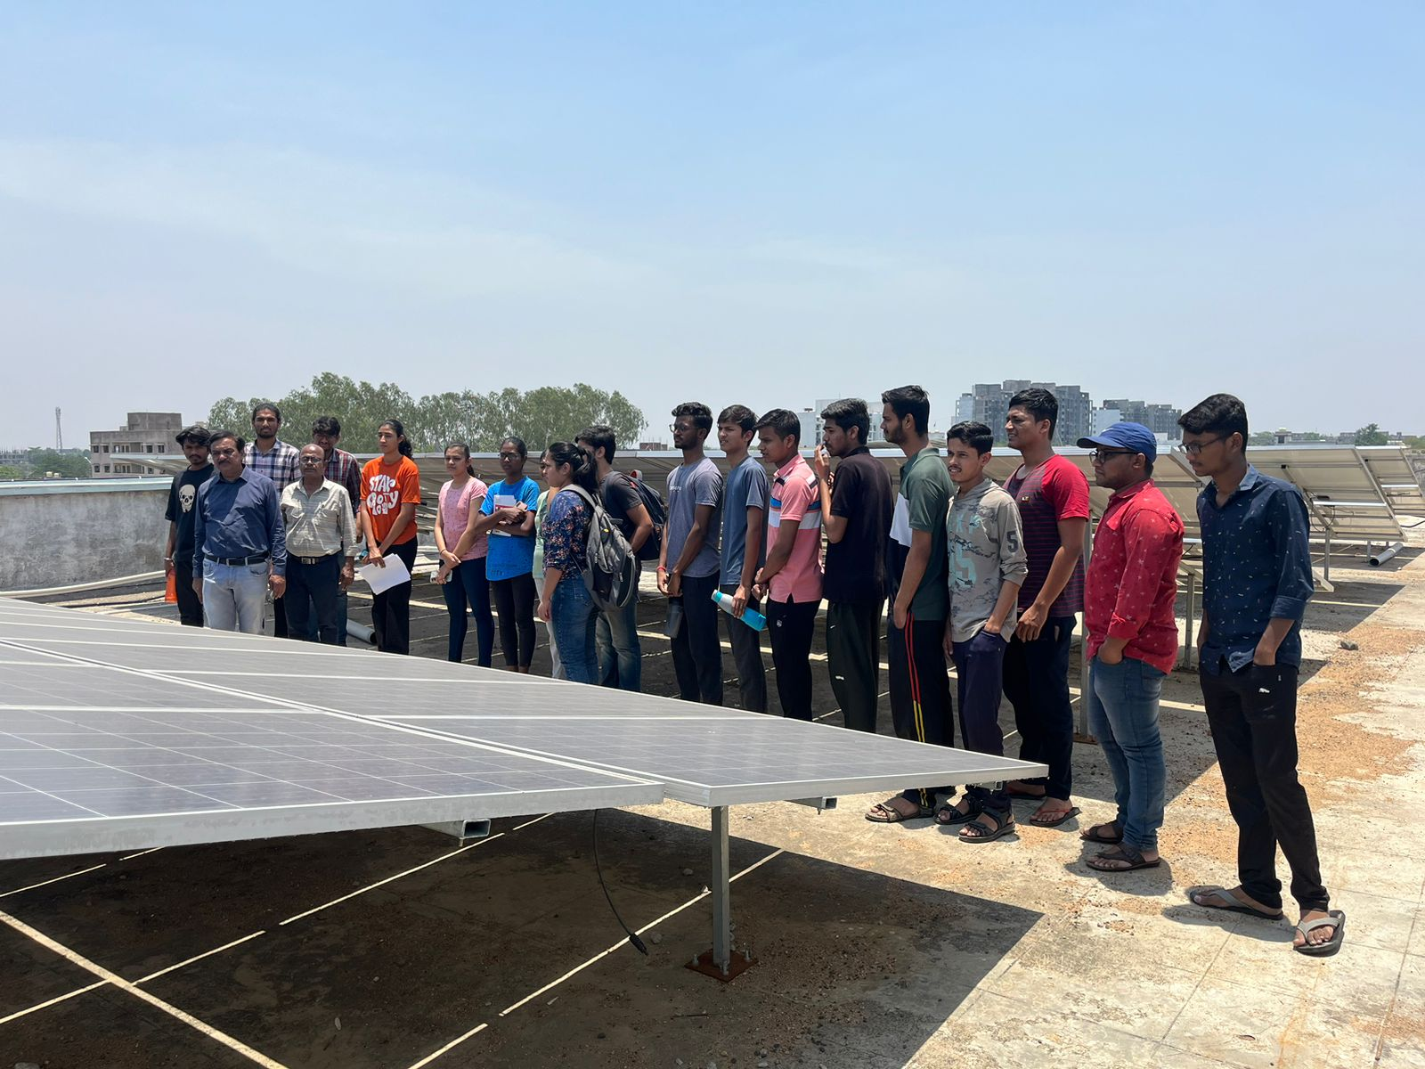
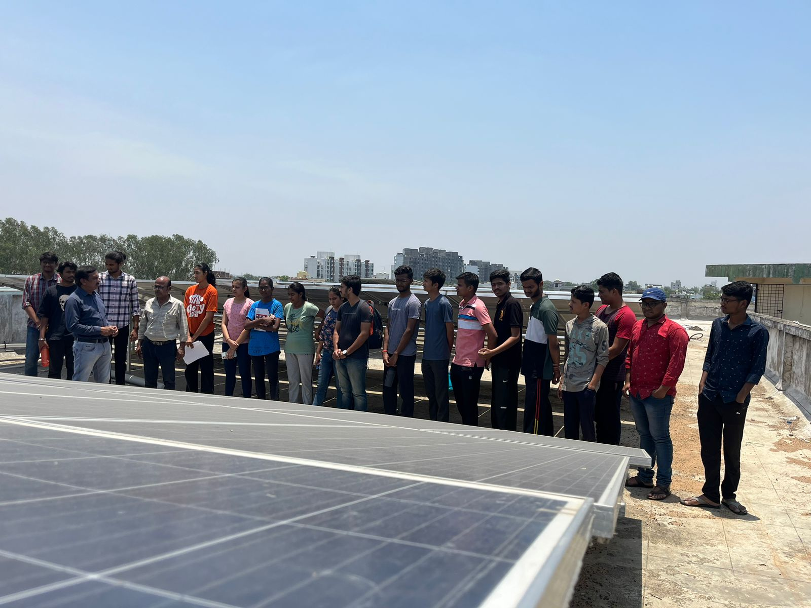
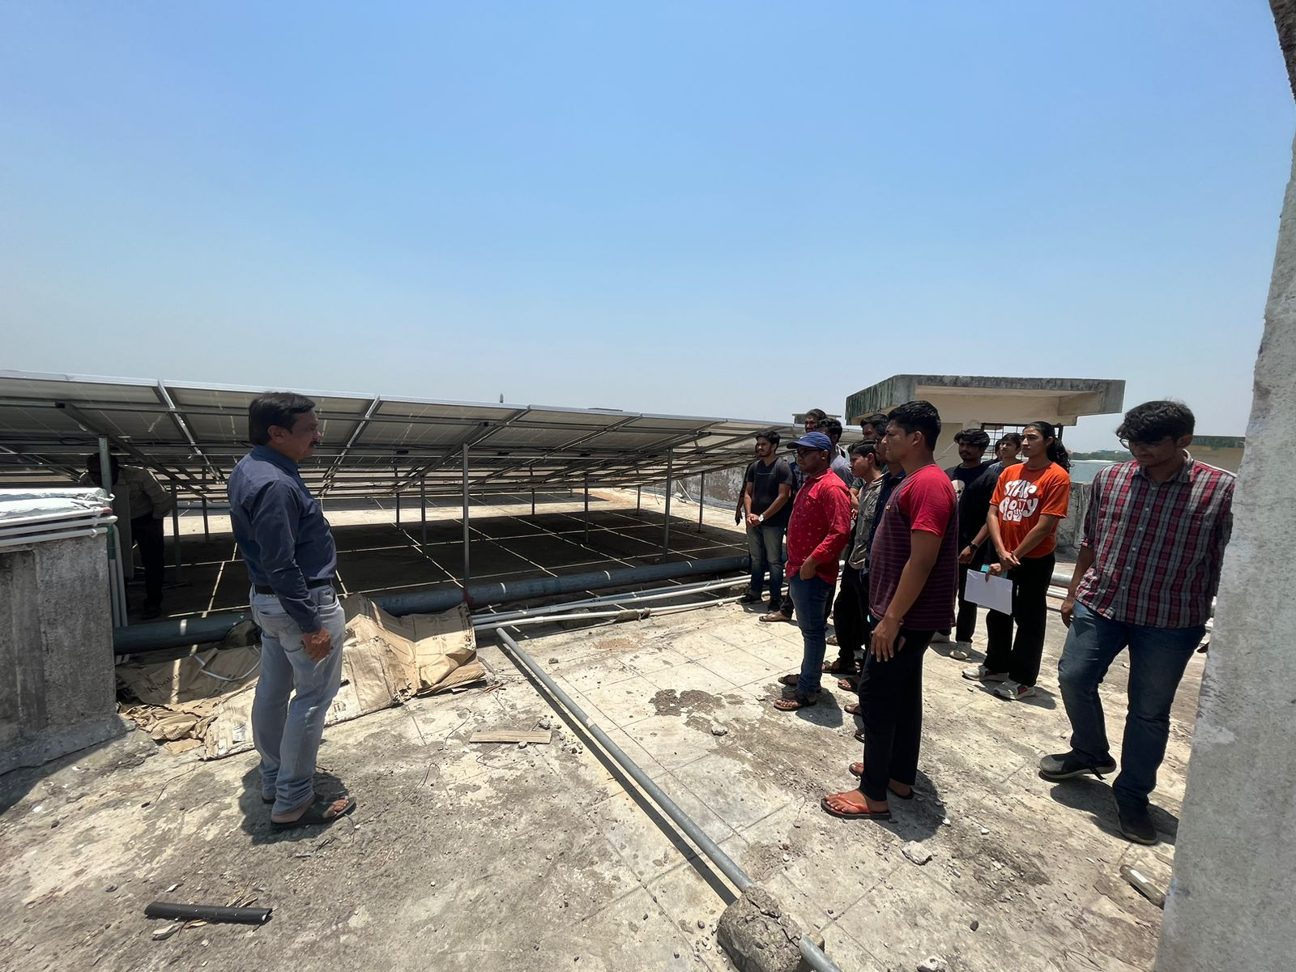
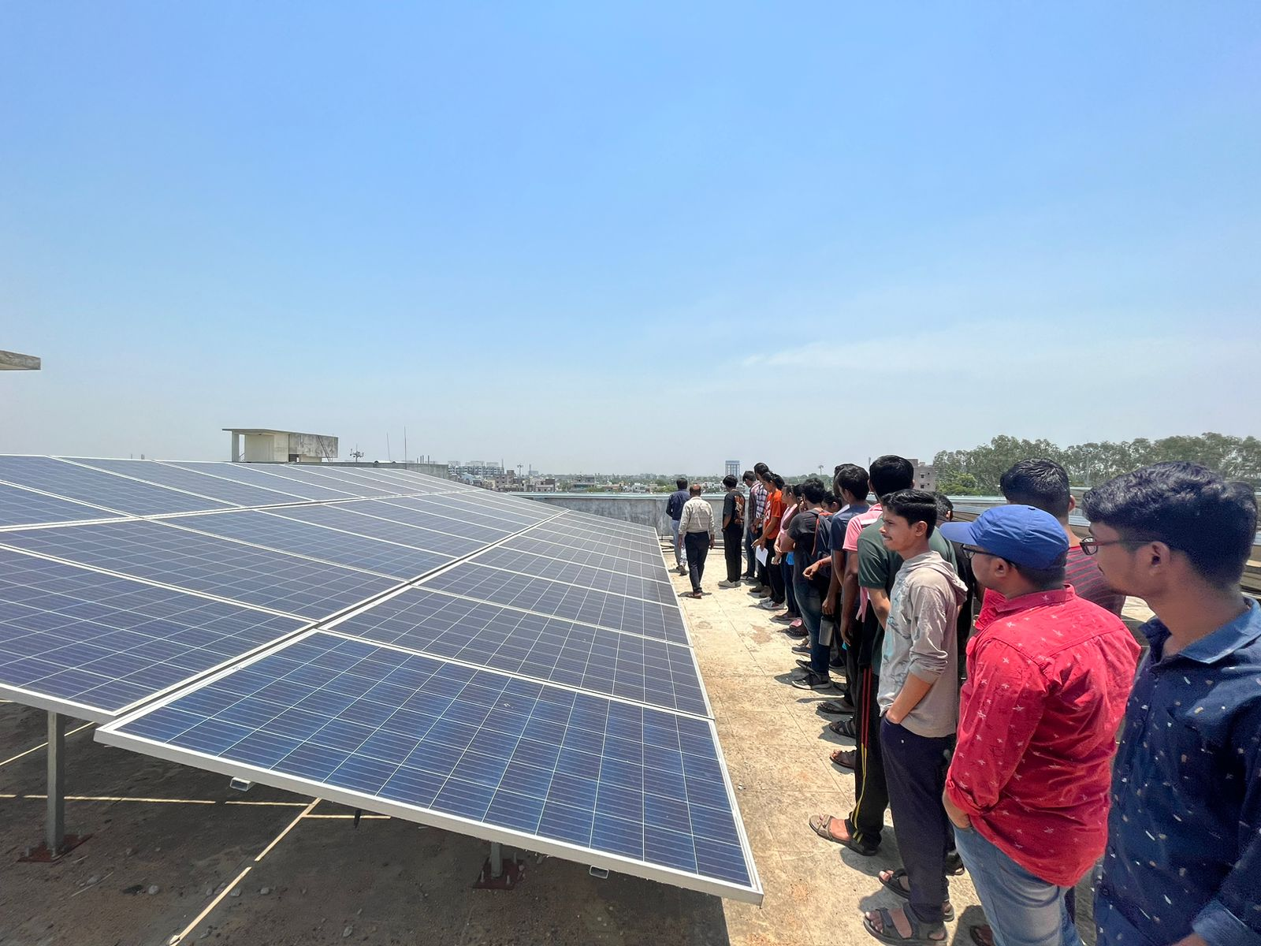
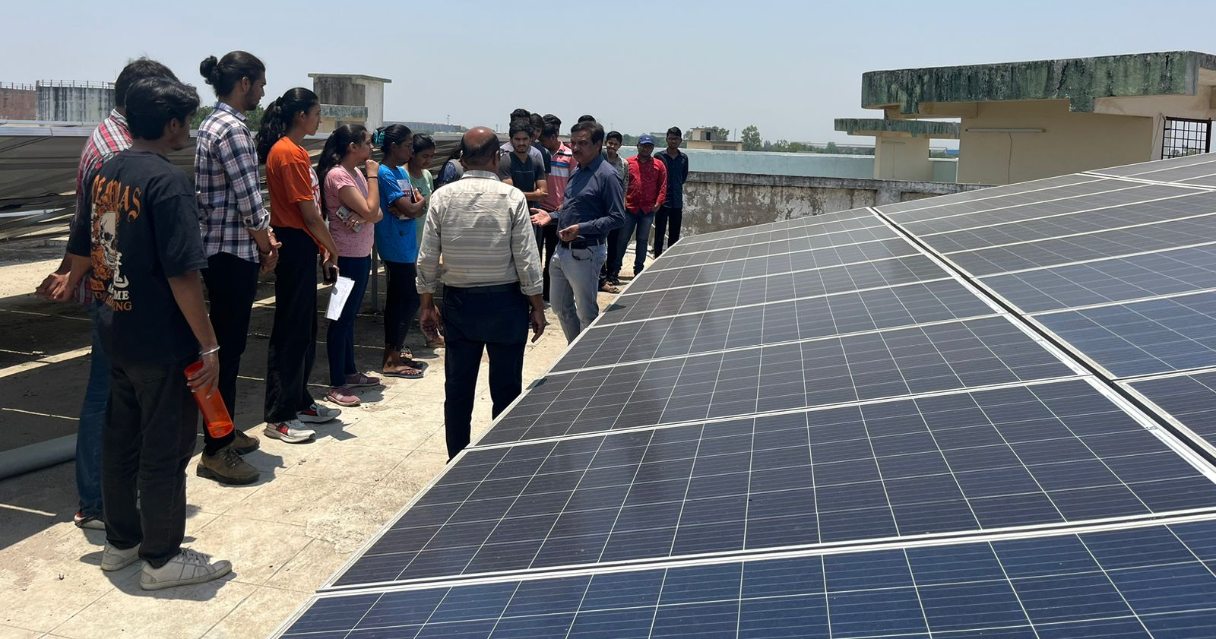
Visit Attendance
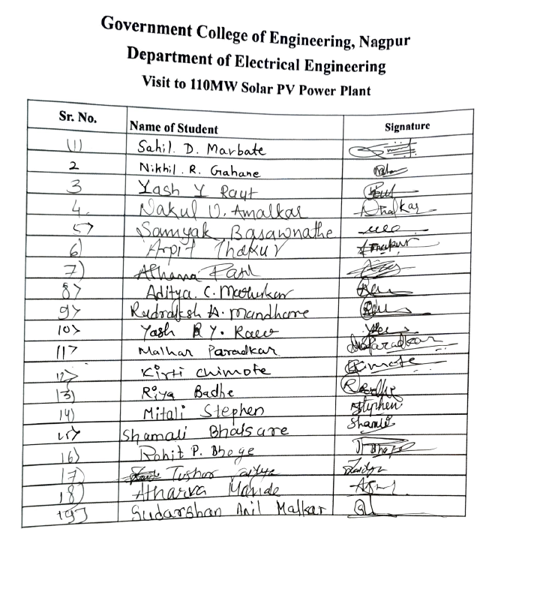
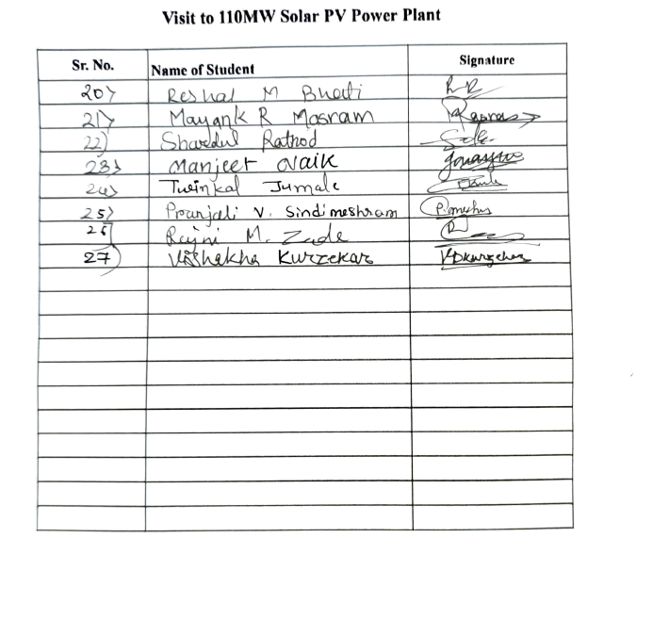

14) “ENERGY CONSERVATION”
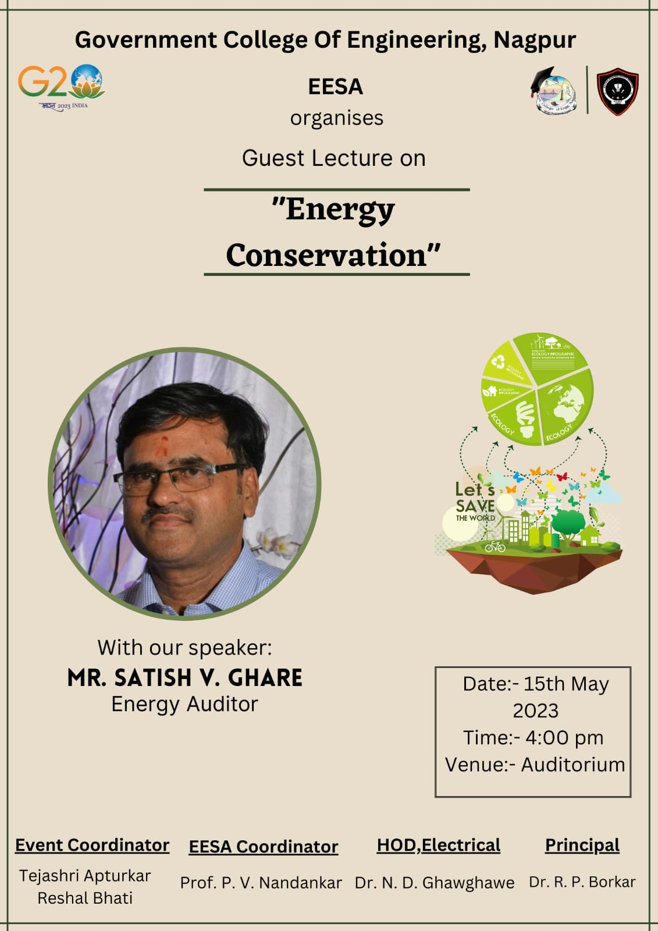
Report:
Title: Energy Conservation
Conducted by: EESA
Mode of Activity: Offline
Venue: Auditorium (Room No. 2), Main Building, GCOEN
Date & Time: 15th May 2023 at 4 PM
No. of participants: 51
Meeting Recording: https://drive.google.com/file/d/1IgmWl2Tl1xb7TqXmYEDpYWQWcCHYKQbH/view?usp=share_link
Introduction: The expert lecture on energy conservation, held on 15th May 2023, aimed to raise awareness about the importance of conserving energy and provide practical insights for individuals and organizations. Mr. Satish V Ghare, an experienced energy auditor, was the distinguished speaker for the event.
Event Highlights:
- The event commenced with Prathamesh Nakade, a first-year EESA student, serving as the anchor. Prathamesh's engaging and confident demeanour set the tone for the lecture. He introduced Mr. Satish V Ghare and the significance of energy conservation, capturing the audience's attention from the start.
- Mr. Satish V Ghare delivered an enlightening lecture on energy conservation, covering various aspects of the subject. He emphasized the need to reduce energy consumption and highlighted the benefits of adopting energy-efficient technologies. With his expertise as an energy auditor, Mr. Ghare provided practical strategies and real-life examples of successful energy conservation initiatives in different sectors.
- Mr. Ghare emphasized the critical need to conserve energy in today's world. He highlighted the environmental and economic benefits of reducing energy consumption. He discussed the global energy crisis and the urgency to adopt energy-efficient practices. Mr. Ghare discussed the advantages of energy conservation, including reduced greenhouse gas emissions, cost savings, and improved energy security. He addressed the challenges faced in implementing energy conservation measures, such as lack of awareness, initial investment costs, and resistance to change. He provided insights on how these challenges can be overcome through education, incentives, and supportive policies. Mr. Ghare encouraged the audience to ask questions and engage in interactive discussions. He addressed queries related to specific energy conservation challenges and provided tailored recommendations. He fostered a collaborative learning environment, allowing participants to share their experiences and ideas.
- Dr. R.P. Borkar Sir, Principal GCOEN and Dr. N.D. Ghawghawe Sir, Head Electrical also shared their valuable insights during the lecture, further enriching the event. Their presence and support added immense credibility to the occasion, emphasizing the importance of energy conservation in academic and professional spheres.
- Prathamesh Nakade, the anchor for the event, also proposed the vote of thanks. He expressed heartfelt gratitude to Mr. Satish V Ghare for sharing his expertise and enlightening the audience with his knowledge on energy conservation. Prathamesh extended his appreciation to Dr. R.P. Borkar Sir and Dr. N.D. Ghawghawe Sir for gracing the occasion with their presence and demonstrating their support for the event. Prathamesh acknowledged the attendees for their active participation and emphasized the role of individual actions in making a significant impact on energy conservation efforts. He thanked the organizing team, including the event coordinators and volunteers, for their dedicated efforts in arranging the lecture successfully.

Conclusion:
- The expert lecture on energy conservation, featuring Mr. Satish V Ghare as the speaker, was a resounding success. The presence of esteemed guests, the engaging anchoring by Prathamesh Nakade, and the insightful presentation by Mr. Ghare created a positive and inspiring environment. The event successfully raised awareness about energy conservation and provided practical guidance for implementing energy-saving practices in daily life.
- The event served as a catalyst for promoting energy conservation and fostering a sustainable future.
Photos:
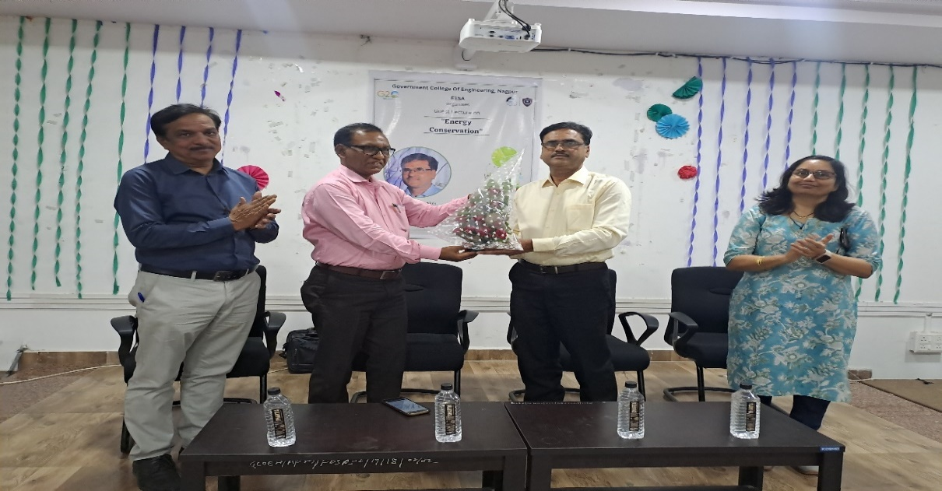
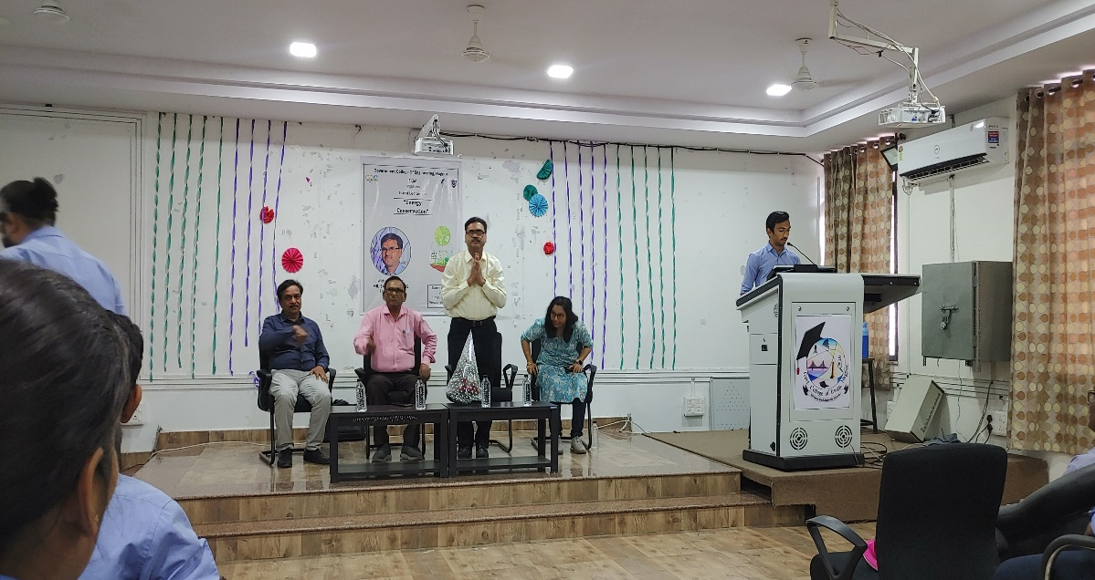

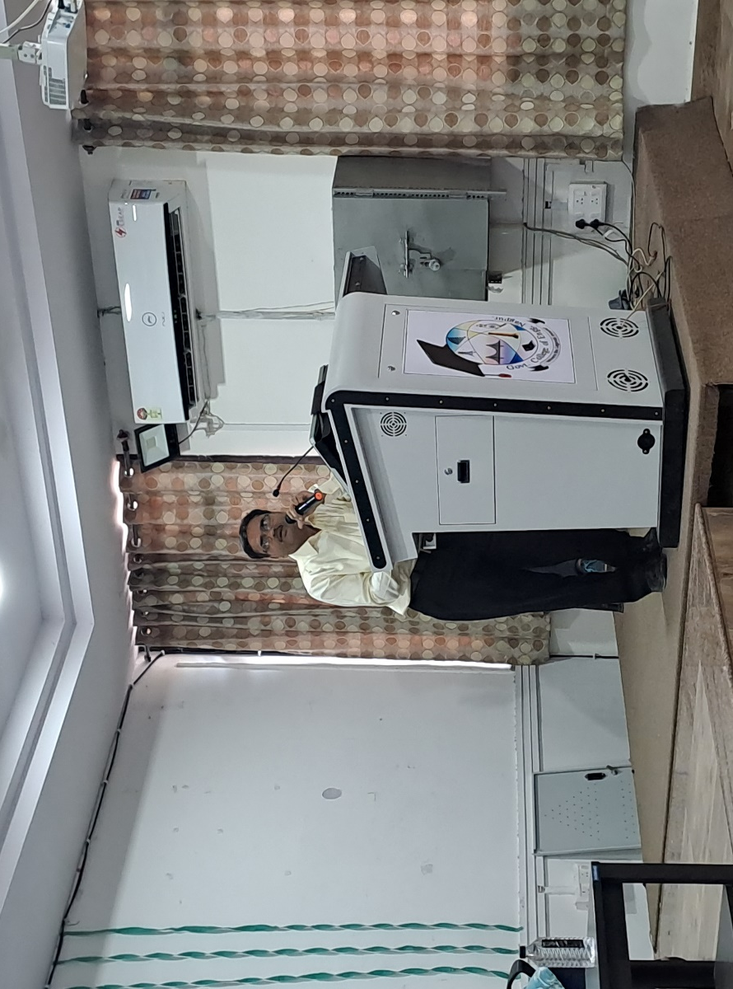

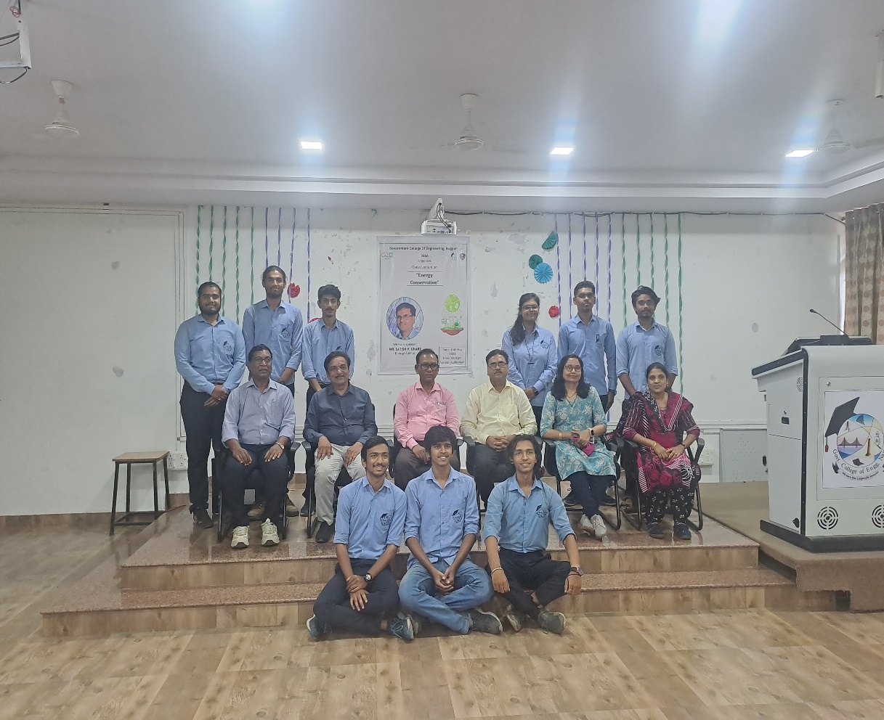

Event Feedback:
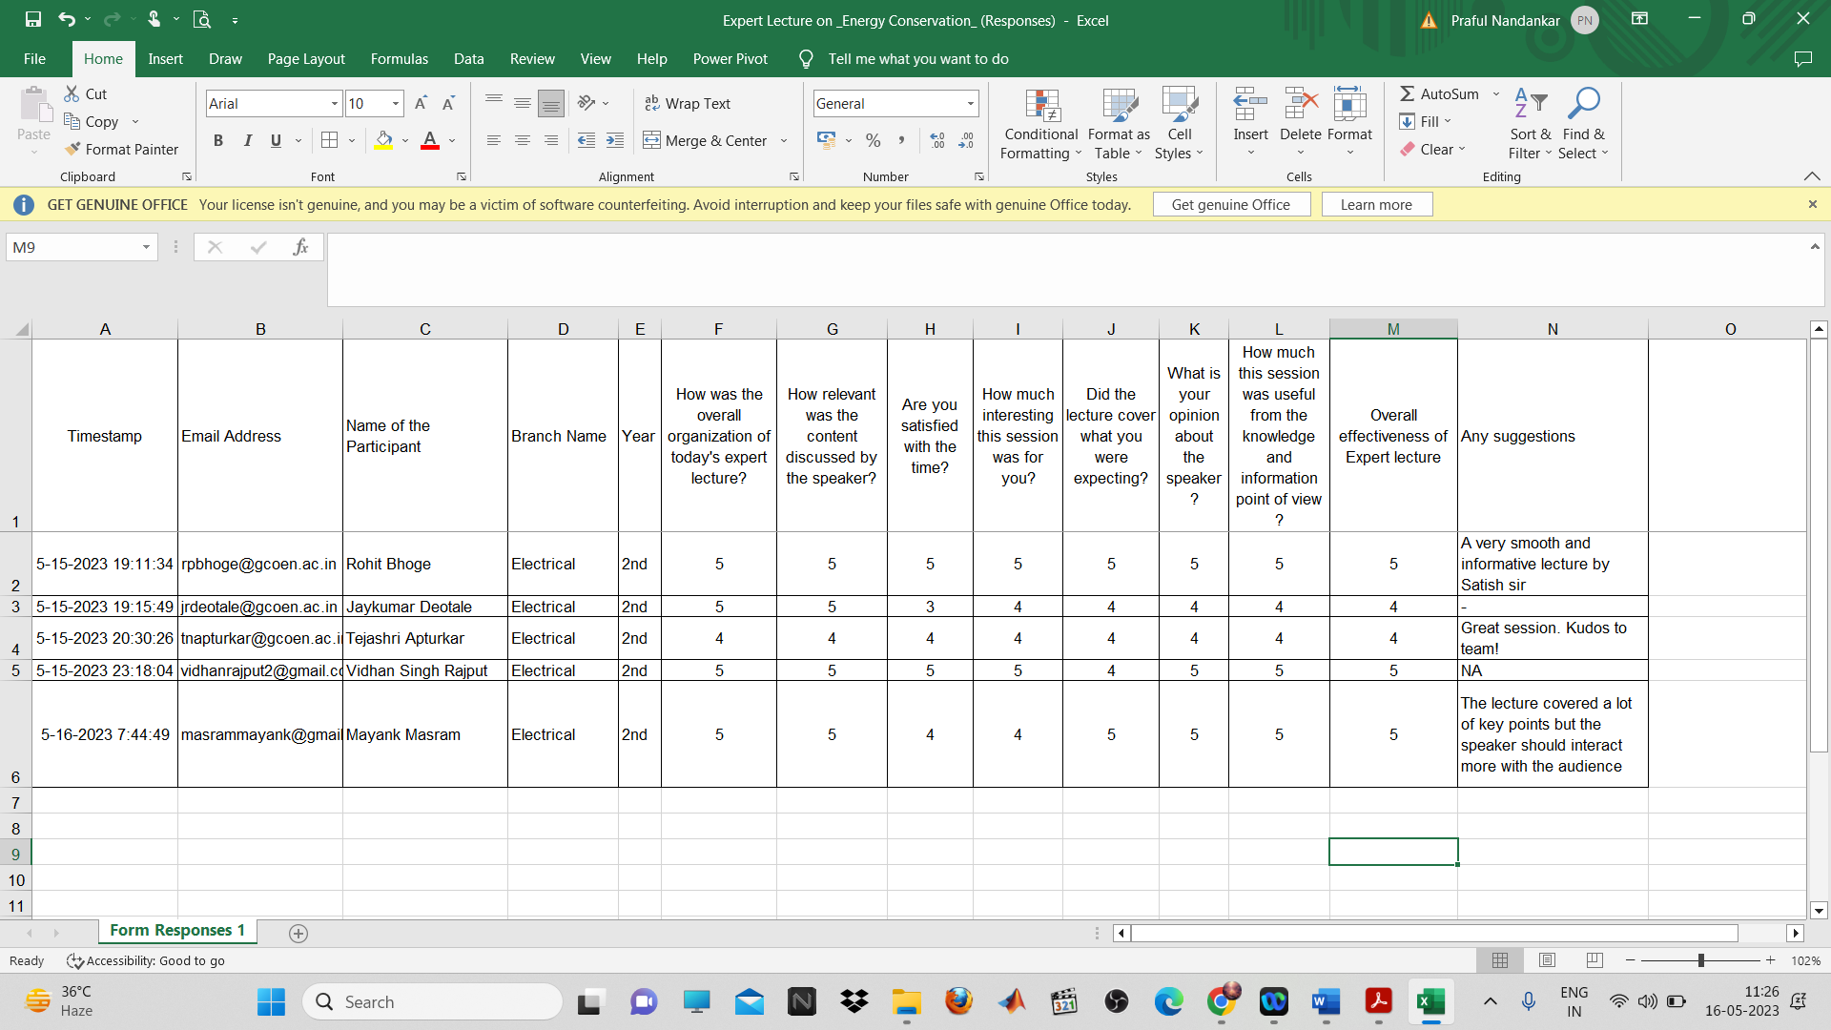
Event Attendance:
