DEPARTMENT OF ELECTRICAL ENGINEERING
Detailed Reports organized by EESA from Sept 2021 to Dec 2021

1) MODERNISATION OF CONTROL SYSTEM OF STEAM TURBINE
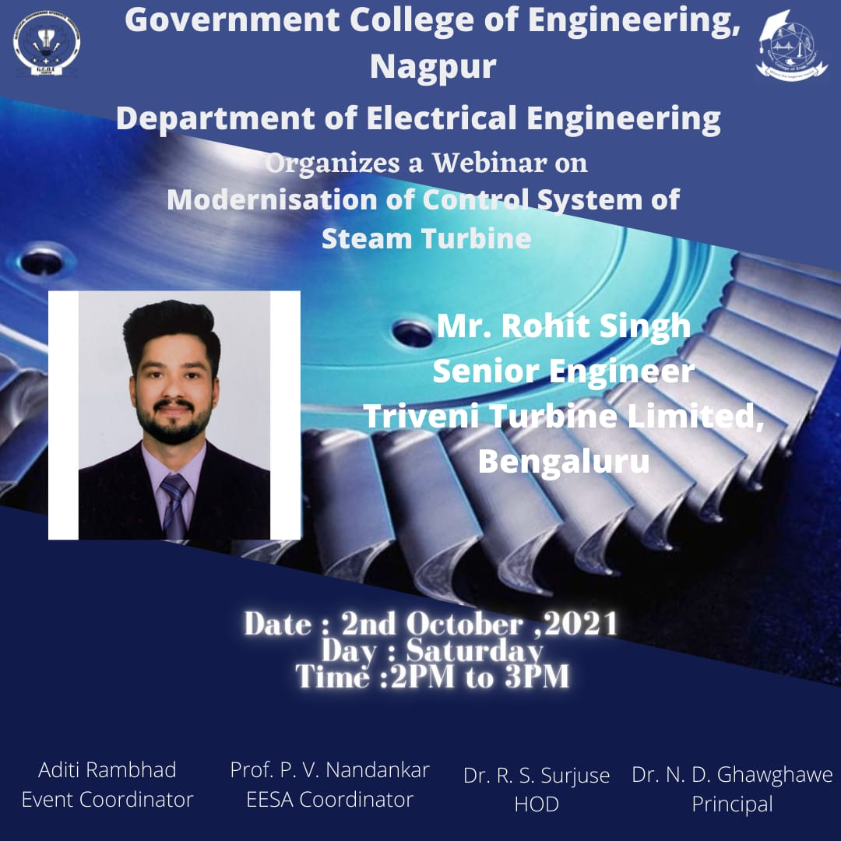

Report:
Title: Modernization of Control system of steam turbine
Conducted by: EESA
Mode of Activity: Online on Google Meet
Date: 2nd Oct, 2021 (Saturday)
Timing: 2 PM to 3 PM
No. of Participants: 65

Introduction: Steam turbines have been a staple of industrial facilities for more than a century. They enable production processes across a range of industries, including oil and gas, real estate heating, ventilation, food and beverage, chemical processing, power generation, etc. Thoroughly planned modernizations and upgrades help you to keep downtime and production losses to a minimum. At the same time, your turbine can be optimized in terms of efficiency or steam consumption by implementing state-of-the-art technology and innovative solutions. In this expert talk, the expert speaker has provided insights about the modernization of control systems of steam turbines. He also explained the key mechanism used in the operation of steam turbines.
Summary:
Guest Speaker: Mr. Rohit Singh, Senior Engineer, Triveni Turbines Limited, Bengaluru
Faculty Coordinator: Prof. Praful Nandankar (Assistant Professor, Electrical Engg. Dept., Govt. College of Engineering, Nagpur)
Student Coordinator: Aditi Rambhad

- The session enlightens the mindset of students regarding the modernization of control systems used in steam turbines. The session started with the introduction of the operation of steam turbines used in power plants.
- He also explained the fundamentals required to understand the steam turbines. He laid an emphasis on how steam is generated and how it is fed onto the turbines which help to convert further into electrical energy.
- He also added various control mechanisms used to control the operation of steam turbines in order to achieve the highest efficiency, reliability of the entire system.
- In the end, he also talked about his successful journey and how he entered the field of steam turbines.

Conclusion:
- The guest speaker explained various control system mechanisms for the operation of steam turbines. He also motivated all the participants to join this core field of steam turbines.
- All the concepts related to Steam turbines and their important mechanisms have been deeply explained by the guest speaker. Hence, the amazing session on “Modernisation of control systems of steam turbines” was organized and successfully conducted.

Photos:
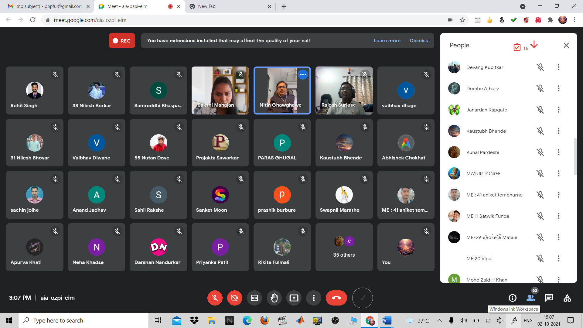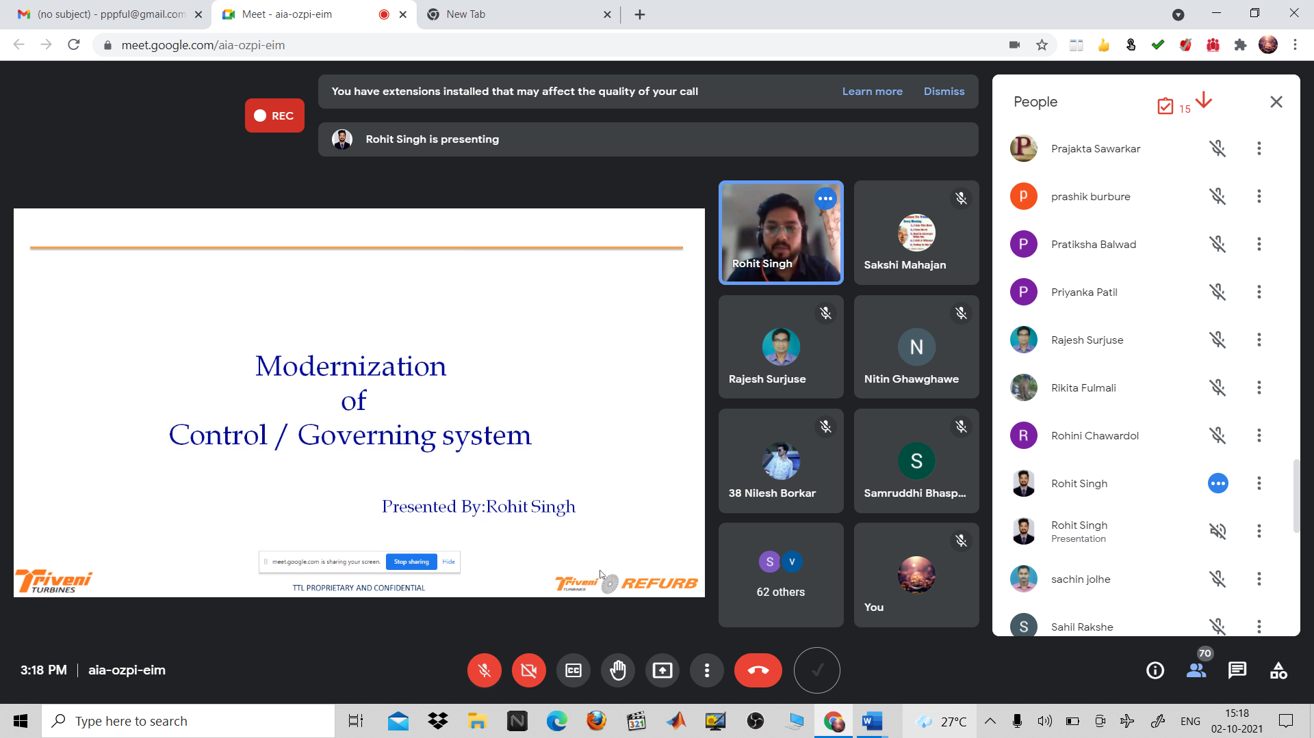
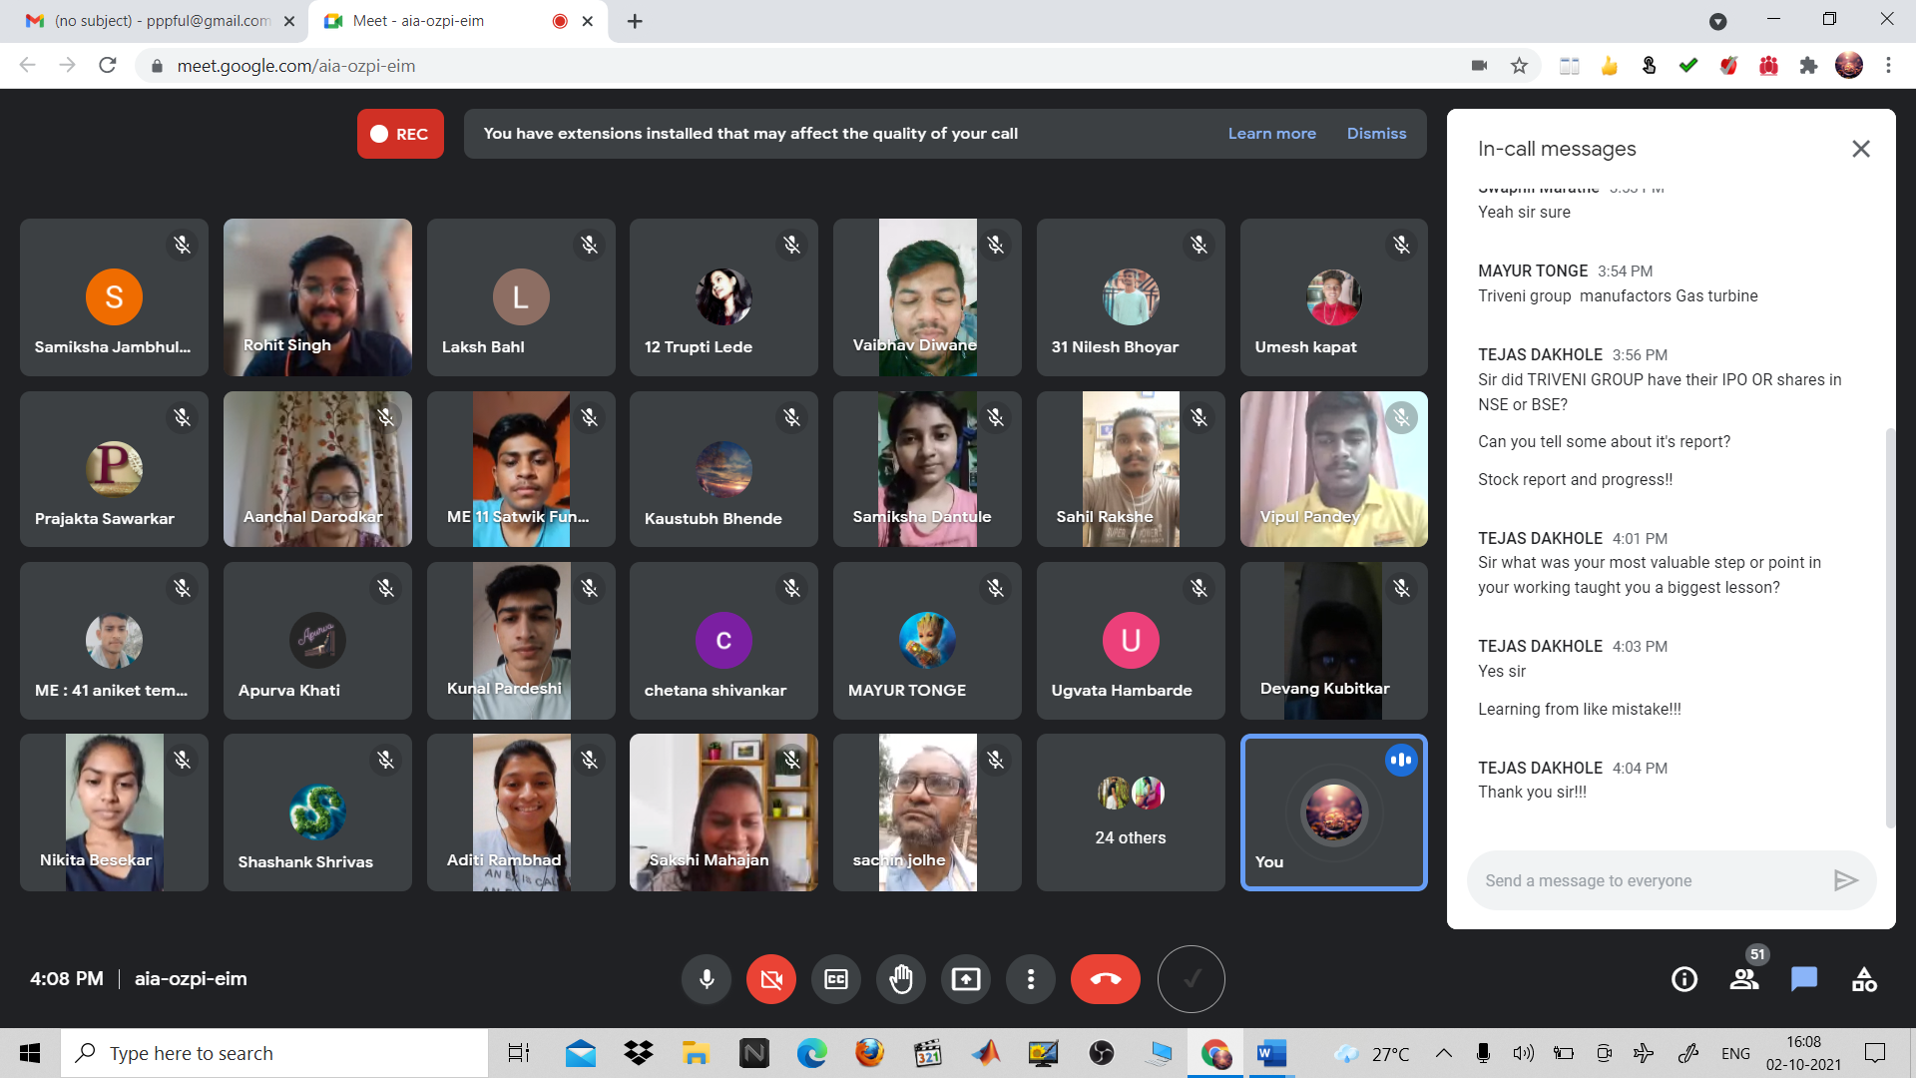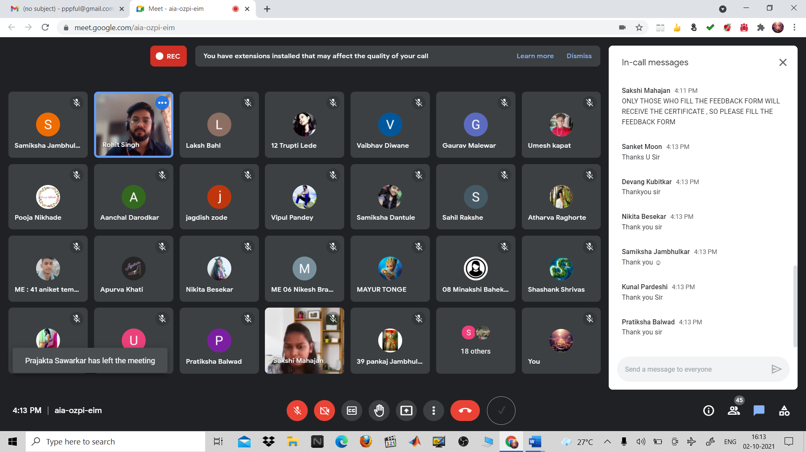

2) WAY TO ENTREPRENEURSHIP
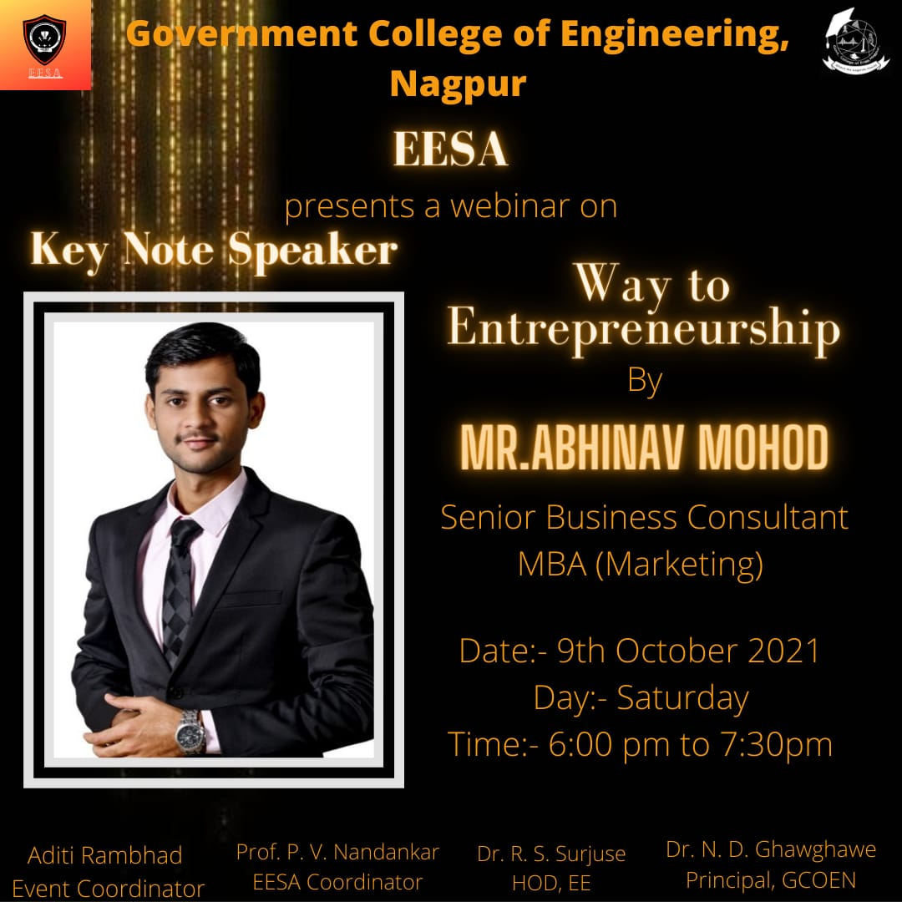

Report:
Title: Way to Entrepreneurship
Conducted by: EESA
Mode of Activity: Online on Google Meet
Date: 9th Oct, 2021 (Saturday)
Timing: 6PM onwards
No. of Participants: 85

Introduction: Whether you are just starting out or an old pro, who doesn’t want to be a more successful entrepreneur? Owning a business gives you a sense of freedom and empowerment. You can build things and watch them grow. Entrepreneurs make decisions for themselves, realize their creative visions, and develop lasting relationships with other entrepreneurs, customers and vendors. It’s a great way to live and therefore one has to understand the different shades of entrepreneurship. In this expert talk, guest speaker provides the insight about startups and entrepreneurship. He also highlighted various aspects of entrepreneurship and key factors essential to run a successful business.
Summary:
Guest Speaker: Mr. Abhinav Mohod (Senior Business Consultant, MBA Marketing)
Faculty Coordinator: Prof. Praful Nandankar (Assistant Professor, Electrical Engg. Dept., Govt. College of Engineering, Nagpur)
Student Coordinator: Aditi Rambhad

- The session enlightens the mindset of students regarding the field of entrepreneurship. Sir also shared some tips like enjoy what you do, plan out things, manage your resources wisely, become a self-promoter, level the playing field of technology and much more.
- He shared his views like you can be your own boss, high satisfaction towards what you do, financial independence, allows you for experimenting and also there is high level of possibilities for growth.
- Sir told about the struggles every start-ups face in the beginning of their establishment, only 10% start-ups succeeds in their first attempt. He also highlighted the fact that all of them should be prepared for failures with a firm and determined mind. He asked the students to become an entrepreneur who is approachable and can communicate.
- He also highlighted the importance of funding being totally based on a perfect business plan, substantiating a plan is really important and one’s passion, creative thinking and ability to make decisions is what drives them towards success.
- At the end, sir highlighted the important factors that are needed to be an entrepreneur like passion, dedication and hard work. He concluded his session by advising students to identify opportunities through problem and try solving those problems, find gaps in the existing markets and fill those gaps.

Conclusion:
- Right from the definition of entrepreneurship to the complete journey of entrepreneur is nicely explained. The guest speaker advised students to identify opportunities through problem and try solving those problems, find gaps in the existing markets and fill those gaps.
- All the concepts related to Entrepreneurship and its importance was briefly explained by the guest speaker. Hence, the amazing session on “Way to Entrepreneurship” was organised and successfully conducted.

Photos:

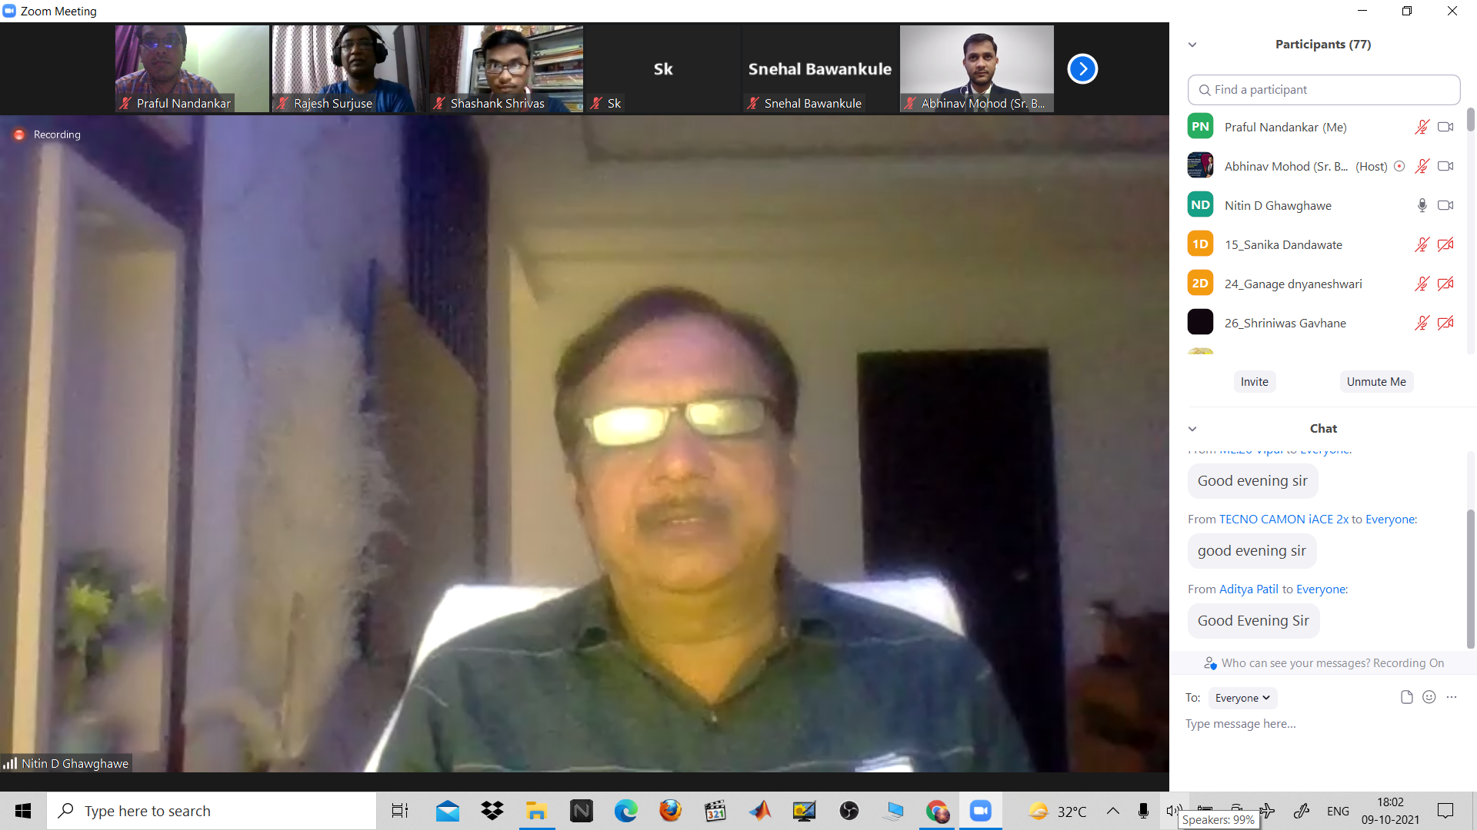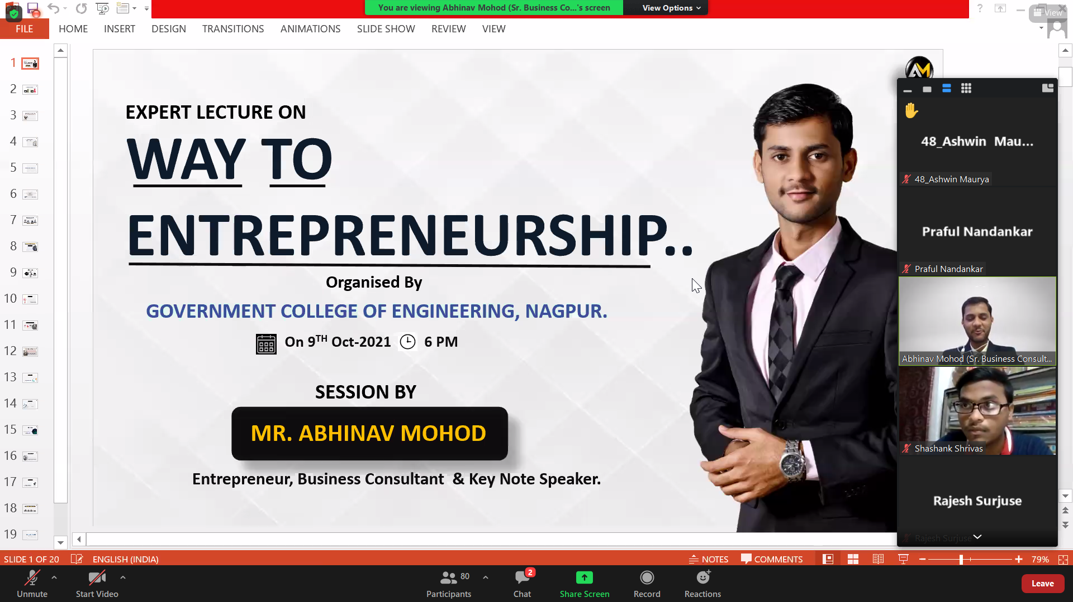

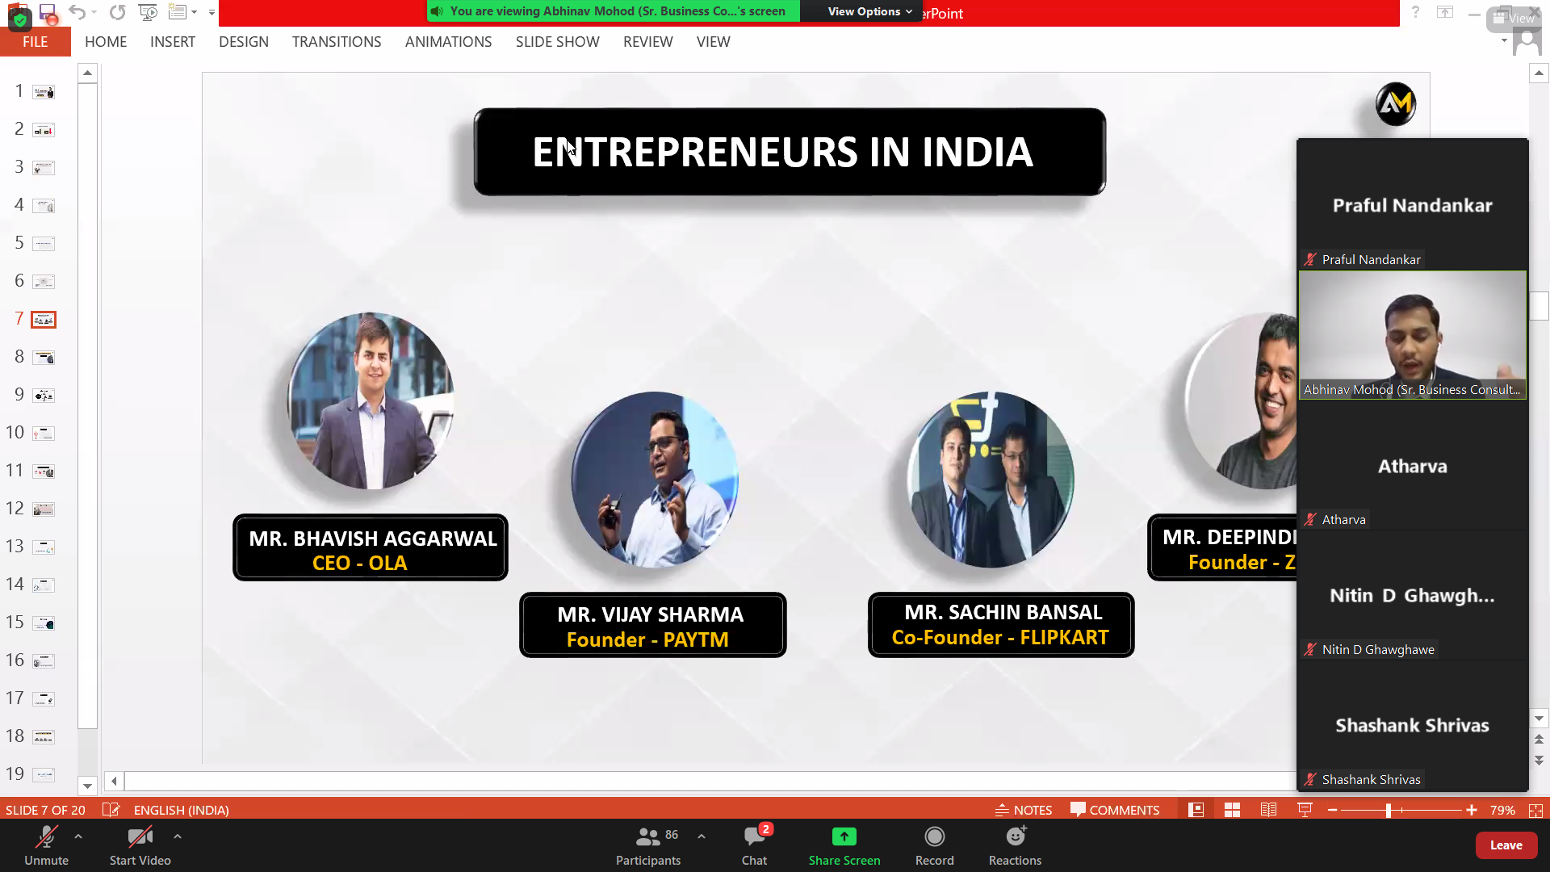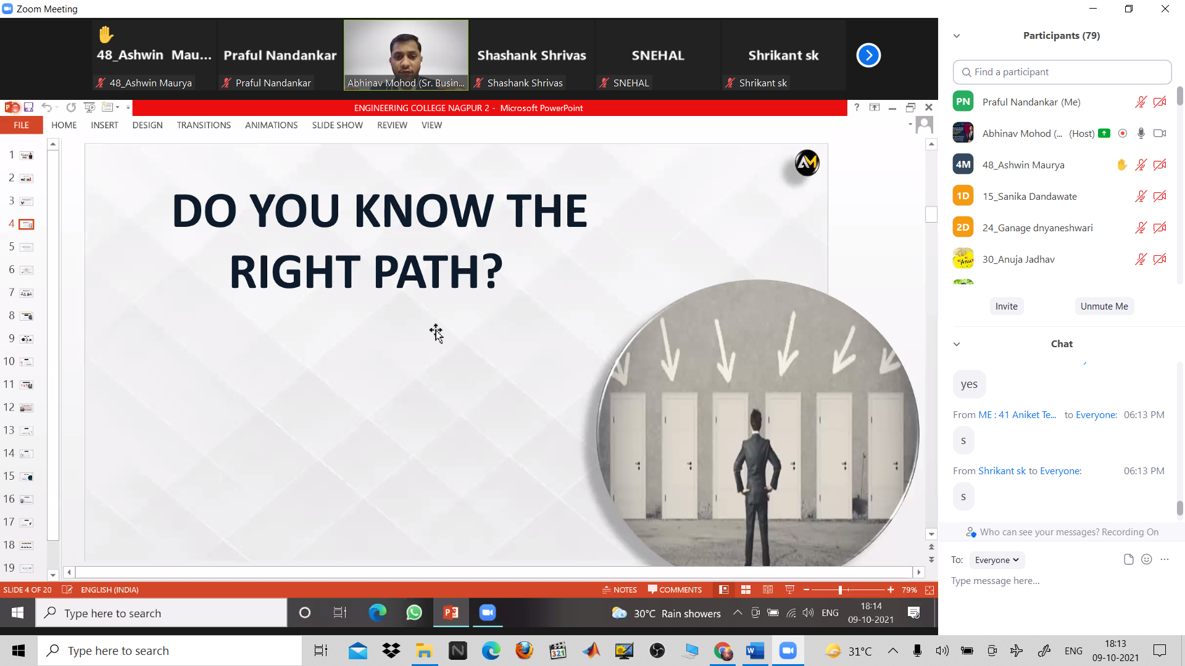

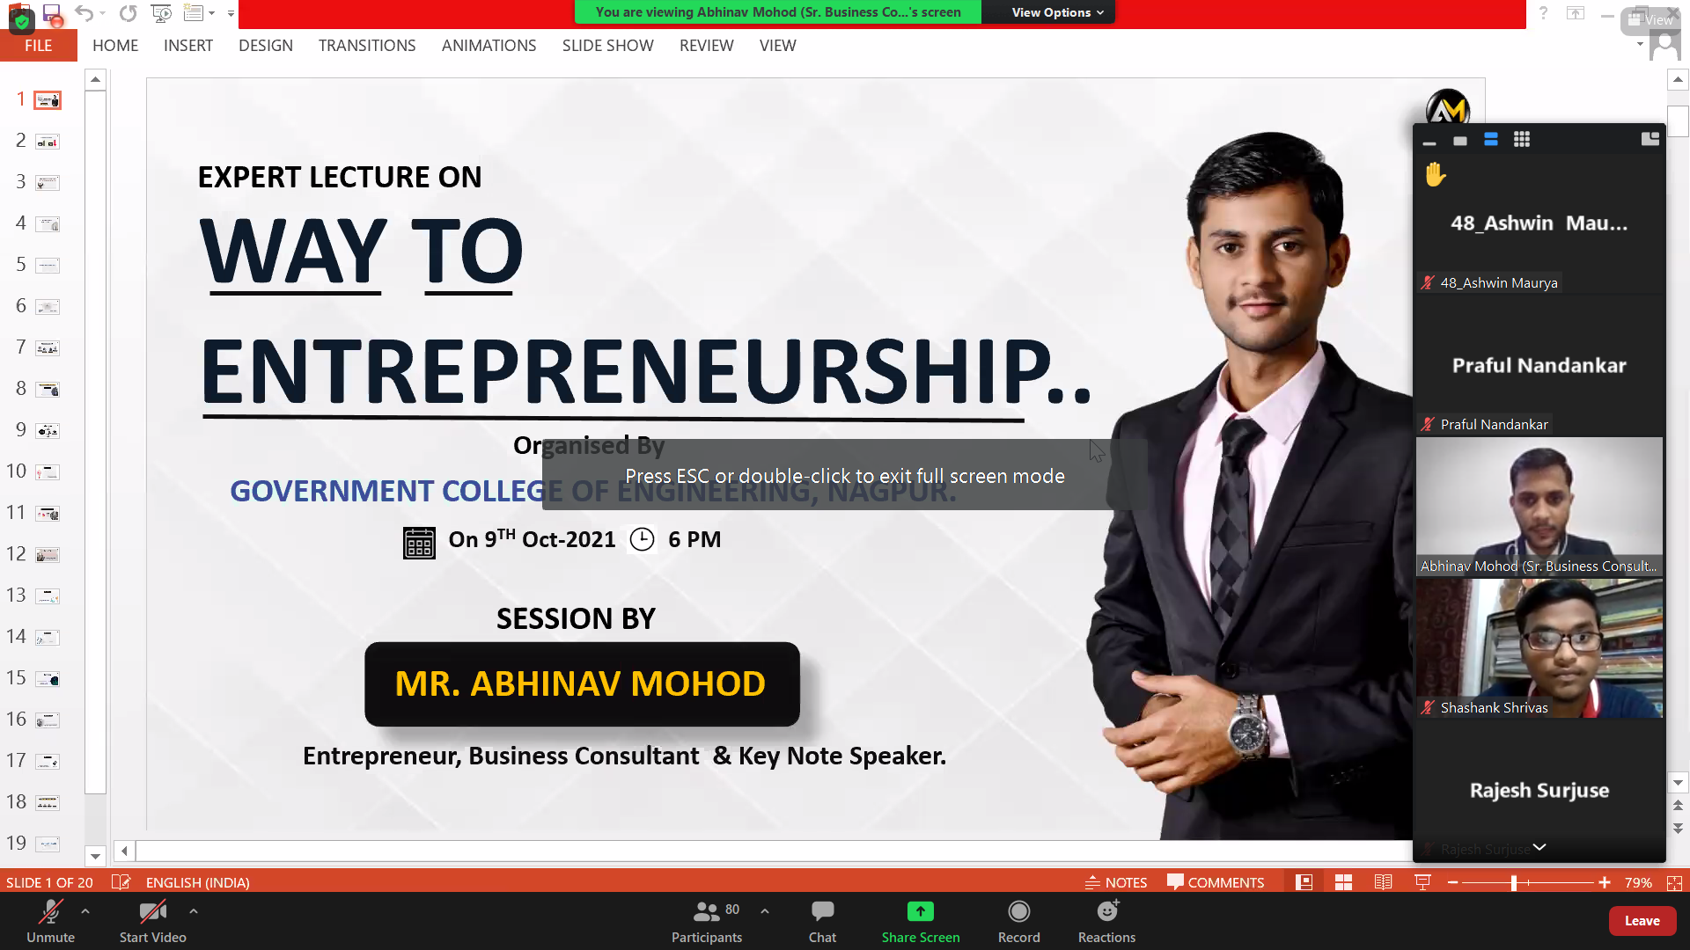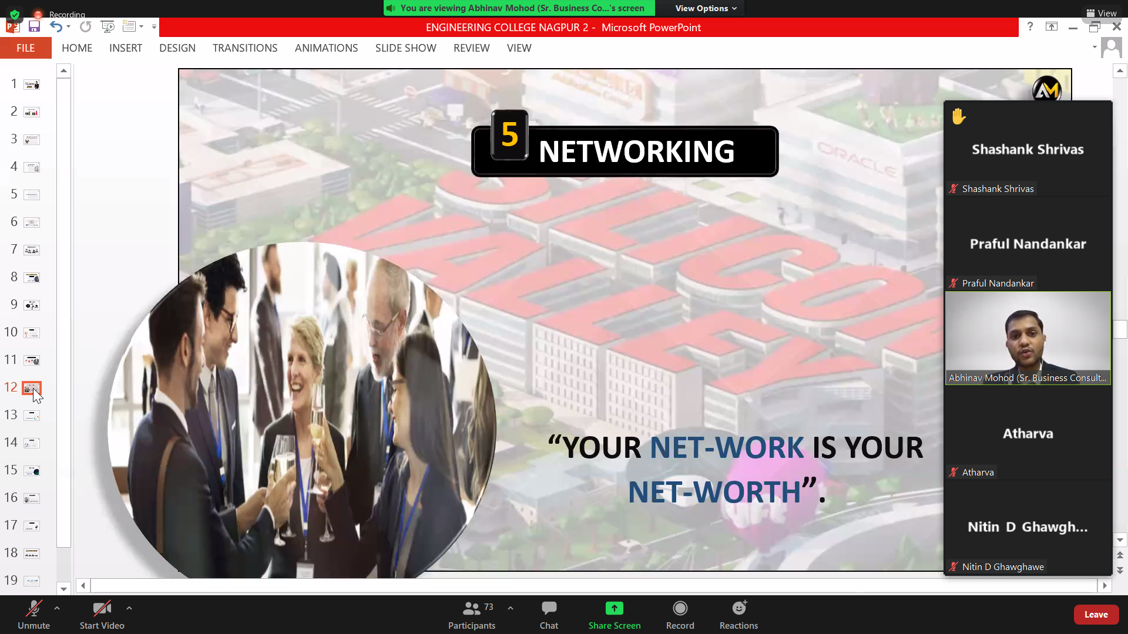

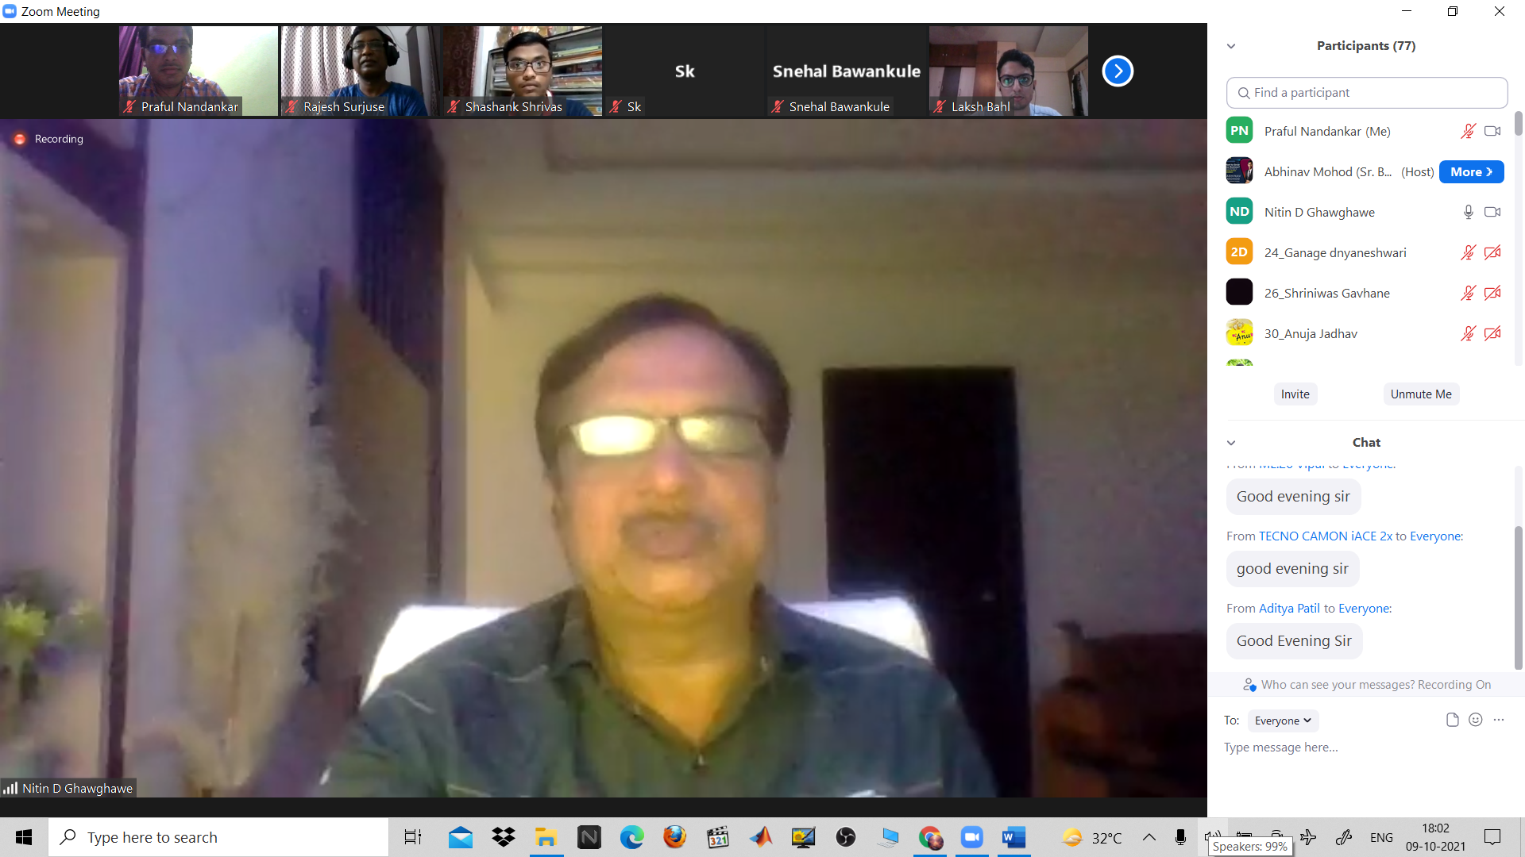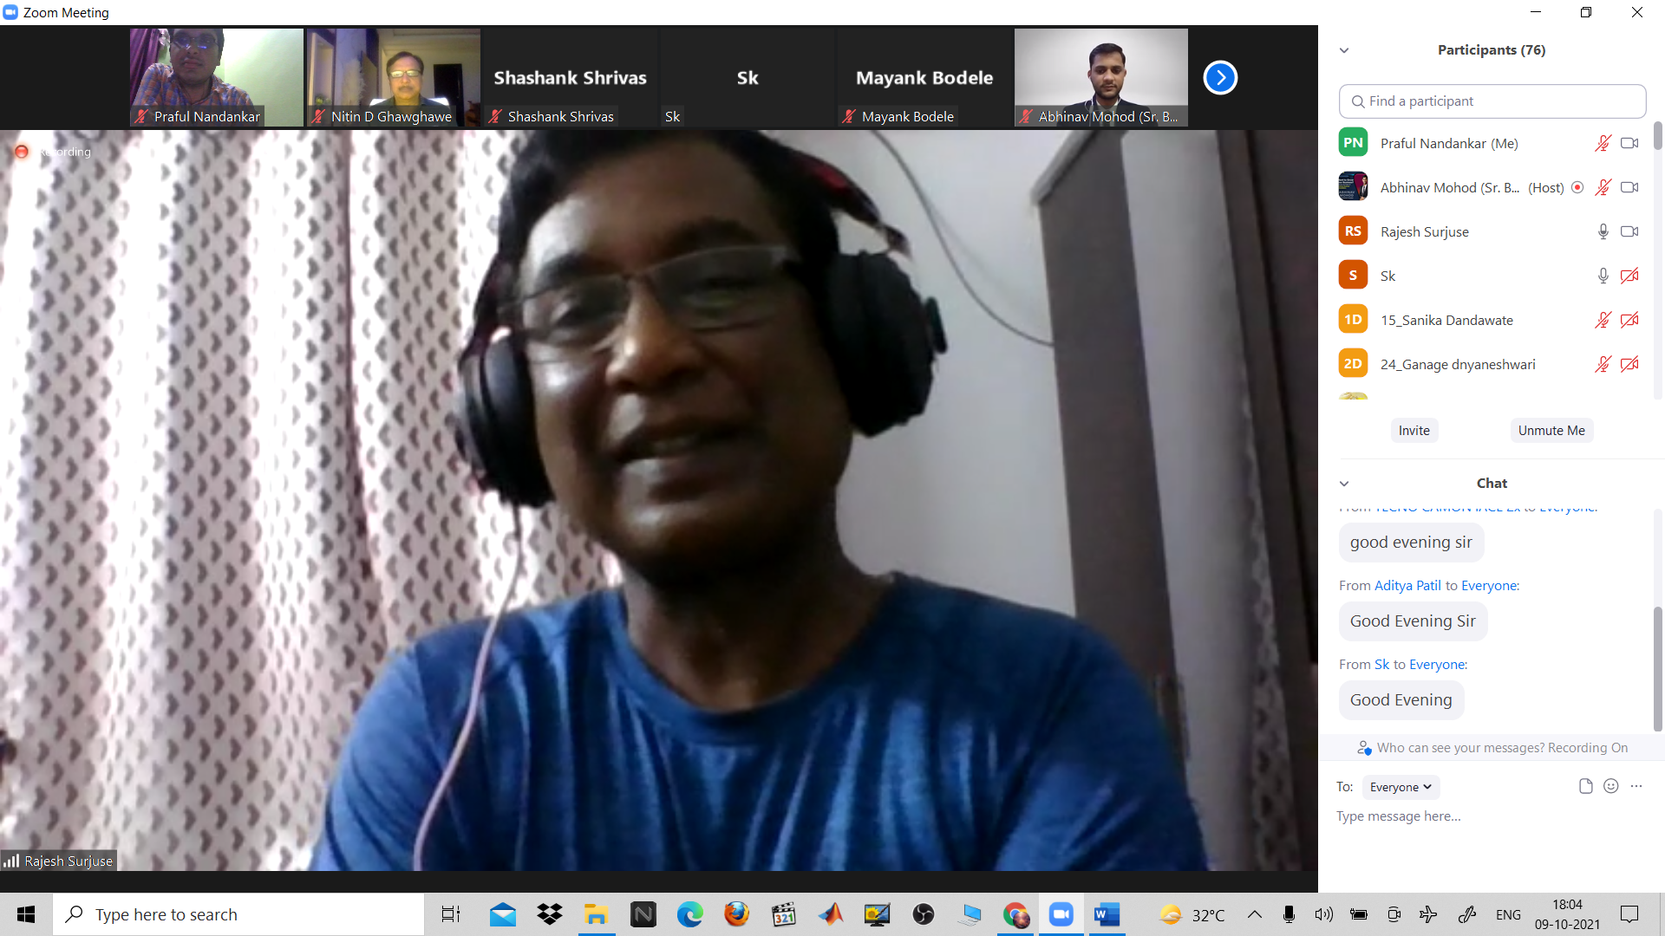

3) BUILDING A NETWORK AND SOFT SKILL DEVELOPMENT
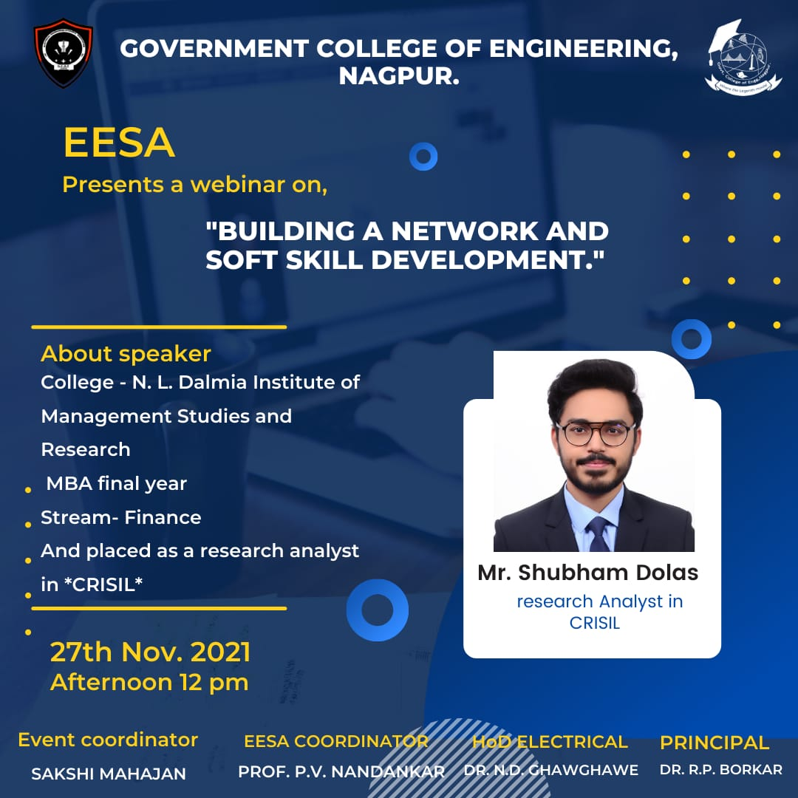
Report:
Title: Building a network and soft skill development
Conducted by: EESA
Mode of Activity: Google meet
Date & Time: 27th November 12 noon
No. of participants: 65
Introduction: Networking involves establishing and building professional relationships that you will maintain over a significant period. Networking with leaders and peers in your field helps you to get tips and gain advice from others who are successful. You can even learn about important news and upcoming changes that may be happening within your field. Networking also teaches you how to properly interact with others.
Soft Skills are the foundation of building good relationships and are integral in one's personal as well as professional life. Be it with the people at the workplace or our loved ones, these skills make it easier to form relationships, create trust and dependability, and lead teams.
Summary:
Guest speaker: Mr. Shubham Dolas, Research analyst at CRISIL
Faculty Coordinator: Prof. Praful Nandankar (Assistant Professor, Electrical Engg. Dept., Govt. College of Engineering, Nagpur)
Student Coordinator: Sakshi Mahajan
- This informative session taught students about the various ways in which students can network with professionals working at various companies in different fields through LinkedIn and how students can inculcate various soft skills like effective communication and command over the English language.
- At first, he explained the need for networking and why a student must start networking early. He then moved on to how a student can effectively use LinkedIn and the various things he/she must put on their profile. He went on to explain how students can connect with professionals from various companies by telling them what should be written in a personalized connection request and how to ask them for advice in a polite manner.
- This was followed by multiple questions from the students asking him various questions about the networking platform and questions based on the past experiences they had with it. The speaker answered all the questions very patiently.
- He then came on to the topic of soft skills and mentioned how certain activities during his college years helped him improve his soft skills and especially English skills. He advised that reading books isn’t the best way to build one’s grammatical skills in the beginning and newspapers are extremely helpful for that purpose. He then stressed the importance of the language.
- Overall, the session was longer than expected as the speaker and students engaged in many QnAs.

Summary:
- The guest speaker explained the various ways a student can grow his/her network to prepare for the future and how it is helpful to make a network in the early years.
- He explained how soft skills are necessary and how the command over English can be beneficial for a student, He also spoke of how one can build their English skills.
Photos:
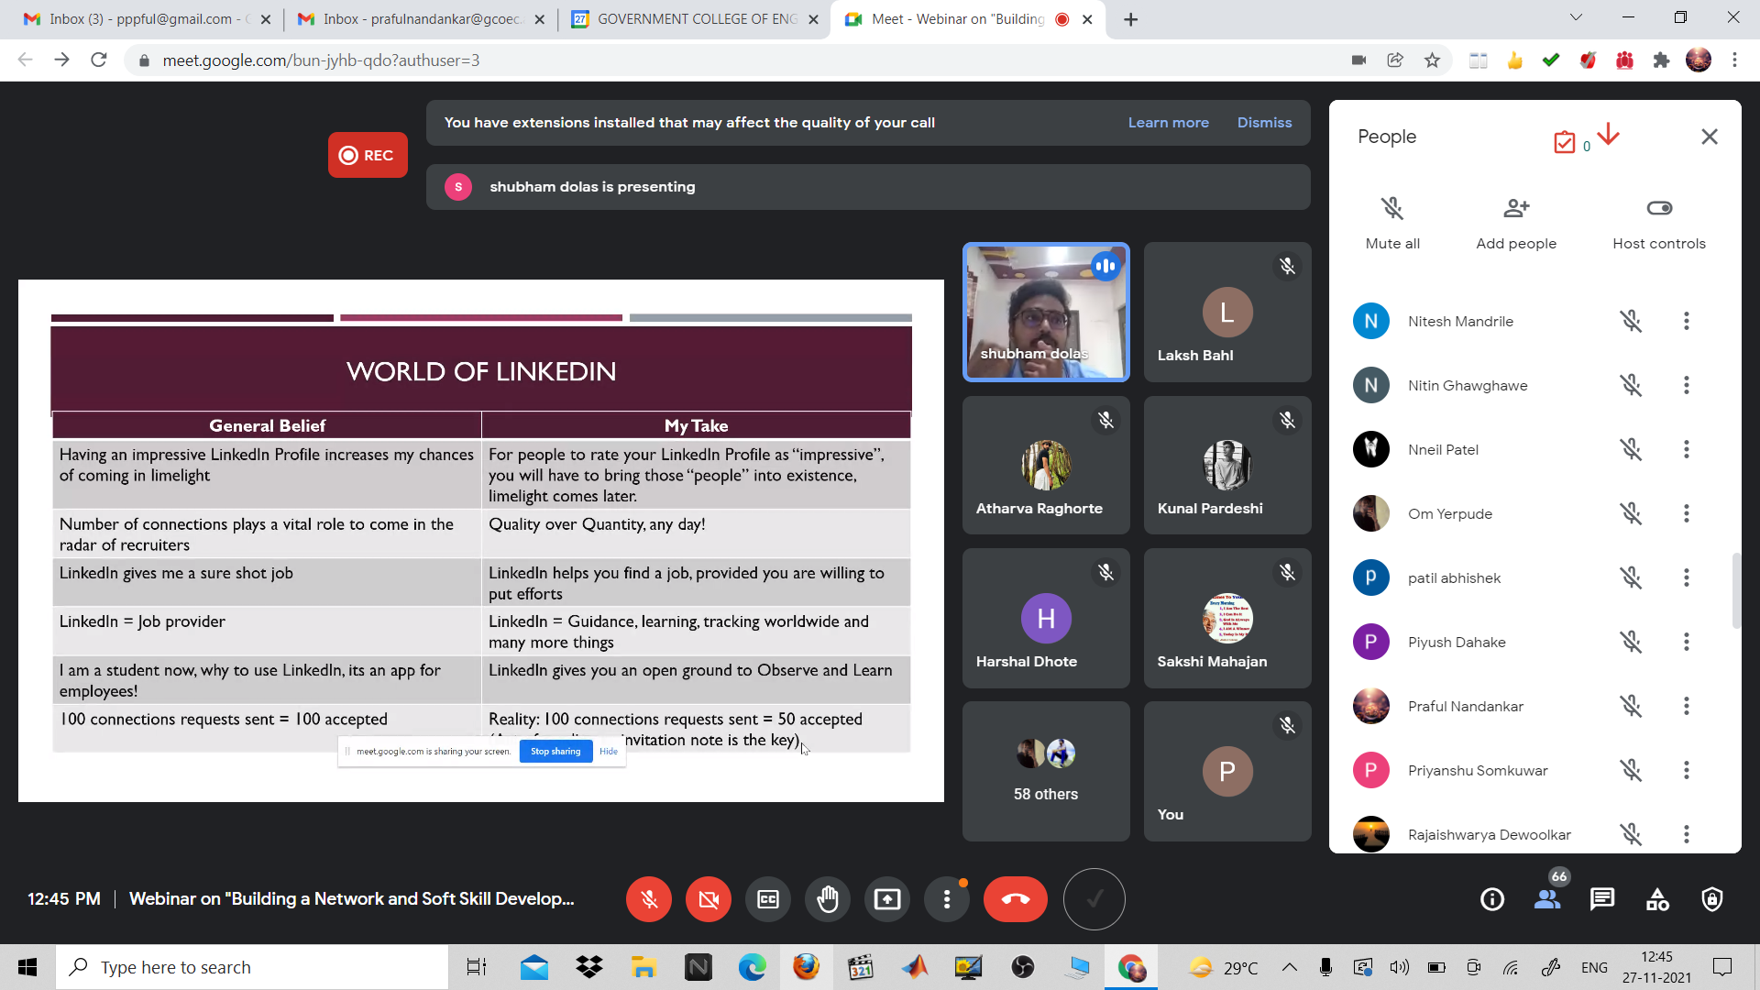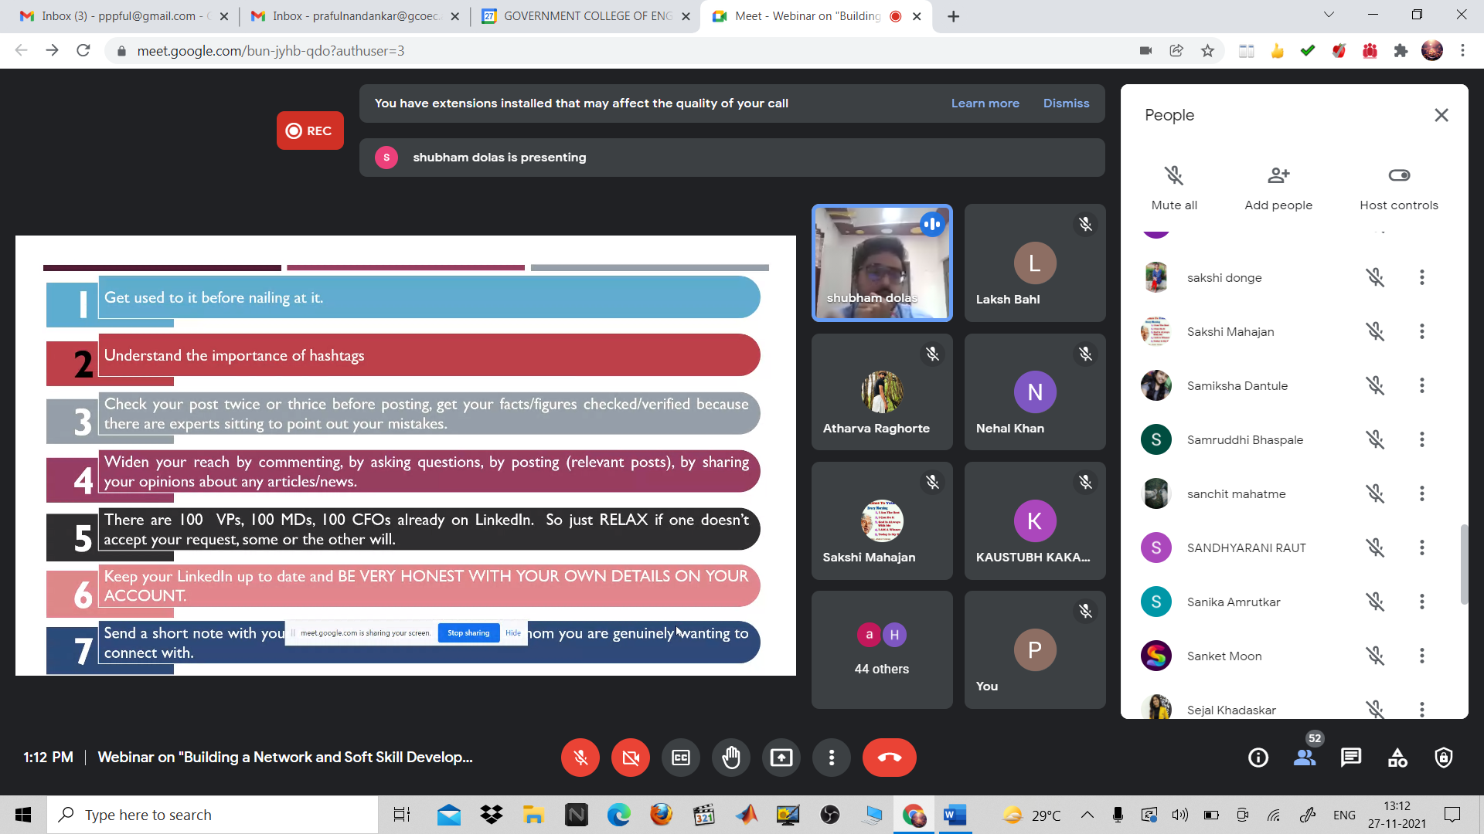
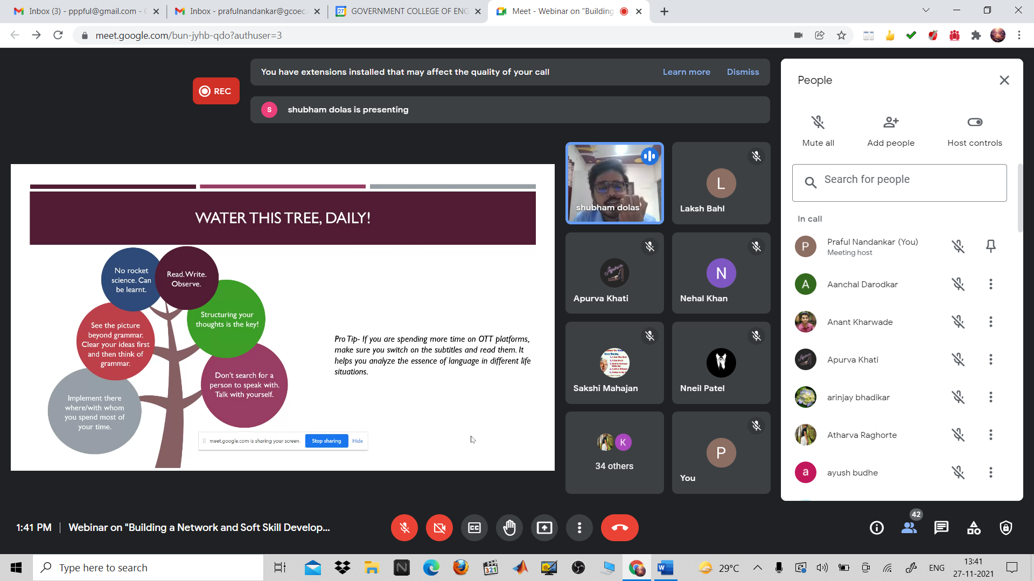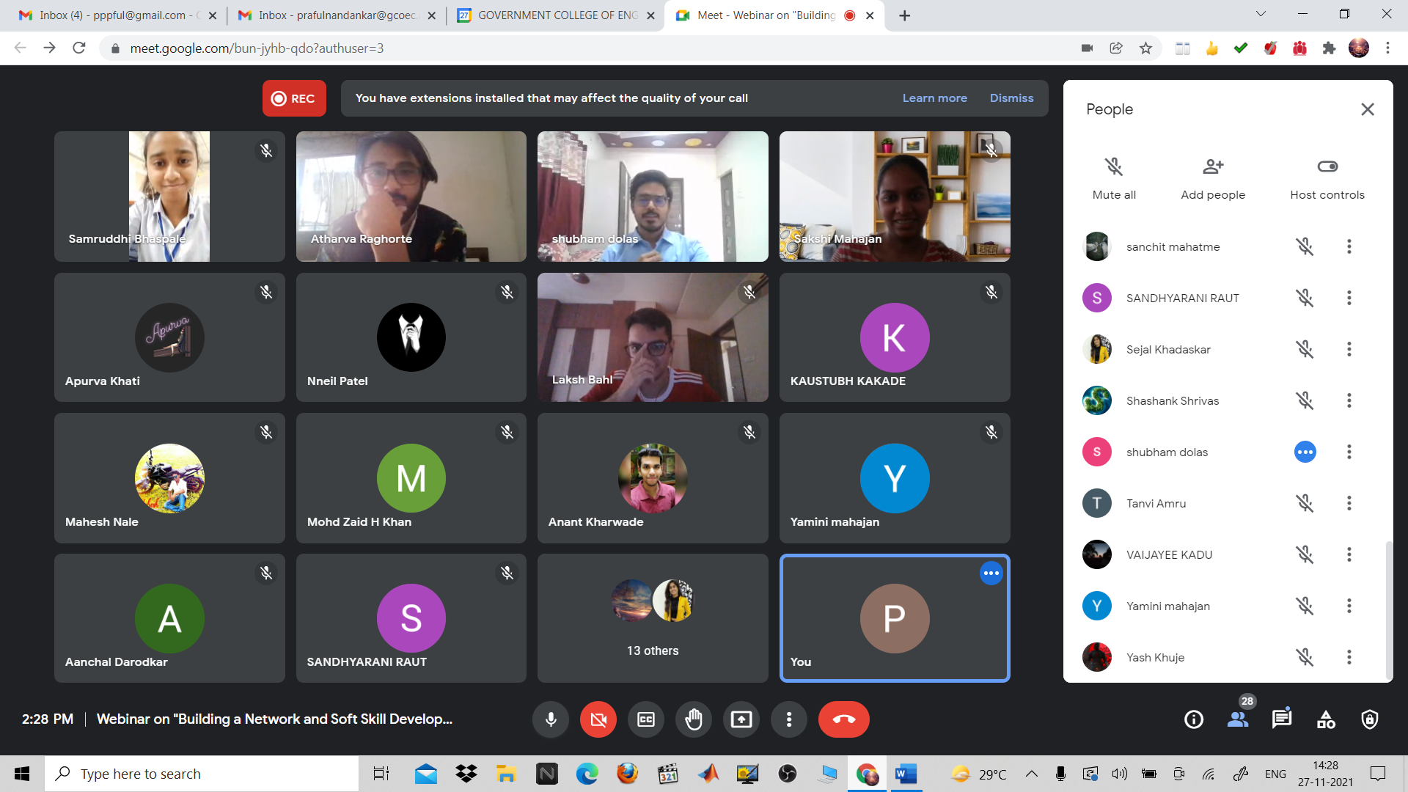

4) LAST MONTH STRATEGY FOR GATE PREPARATION
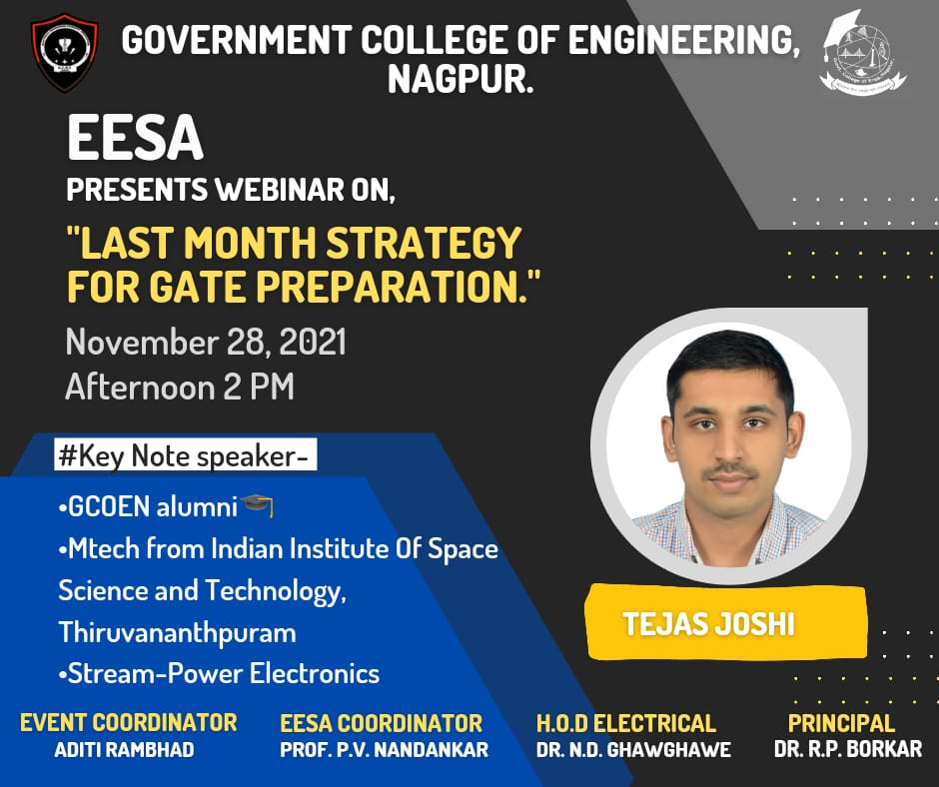

Report:
Title: Last Month Strategy for GATE Preparation
Conducted by: EESA
Mode of Activity: Online on Google Meet
Date: 28nd Nov, 2021 (Sunday)
Timing: 2 PM to 3 PM
No. of Participants: 75

Introduction: In today’s time every single competitive exam is way more competitive and getting tough day by day. In engineering, after you complete Bachelor's Degree if you want to get admission to Masters’s Program or get a job in PSUs or much more, good scores in GATE are a compulsory thing. The objective of this webinar was also to address the changes made in GATE Exam. To help students understand the available opportunities through GATEand to groom the students for preparing for GATE Exam.
Summary:
Guest Speaker: Mr. Tejas Joshi, Indian Institute of Space and Technology, Thiruvananthapuram
Faculty Coordinator: Prof. Praful Nandankar (Assistant Professor, Electrical Engg. Dept., Govt. College of Engineering, Nagpur)
Student Coordinator: Aditi Rambhad

- In starting, guest speaker Mr. Tejas Joshi who cleared GATE in Feb 2021 and scored enough to secure admission in Master’s program at Indian Institute of Space and Technology, Thiruvananthapuram, explained why GATE is important and why one should give GATE.
- After that, Mr. Tejas Joshi shared the details about the syllabus for GATE and explained how to go with every subject. He also shared the details about the resources that one should go to if he opts for self-study. After that, the in-depth details about each subject were followed.
- An in-depth session about each subject the strategy to crack the GATE exam also took place.
- He highlighted the ways of preparation and gave tips to the student for GATE preparation. He also gave ideas for solving Mathematics, Aptitude, and General ability.
- He shared his own experience and different ways of preparation. He presented some videos regarding the student’s motivational speech, who cracked the GATE exam with AIR rank. He discussed various possibilities in order to gate exam and the credits of this exam.
- Later for our enthusiastic participant, the Q n A session took place and queries from participants were also discussed in Webinar.

Conclusion:
- The guest speaker explained different tricks and techniques to crack GATE Exam. He also highlighted the importance of the GATE exam for our future.
- The guest speaker has answered all the queries raised by participants and he has also thrown light on how he has prepared for the GATE exam. He also shared his experience of learning at the Indian Institute of Space and Technology, Thiruvananthapuram. The participants have also expressed their views on the conduction of the webinar.

Photos:
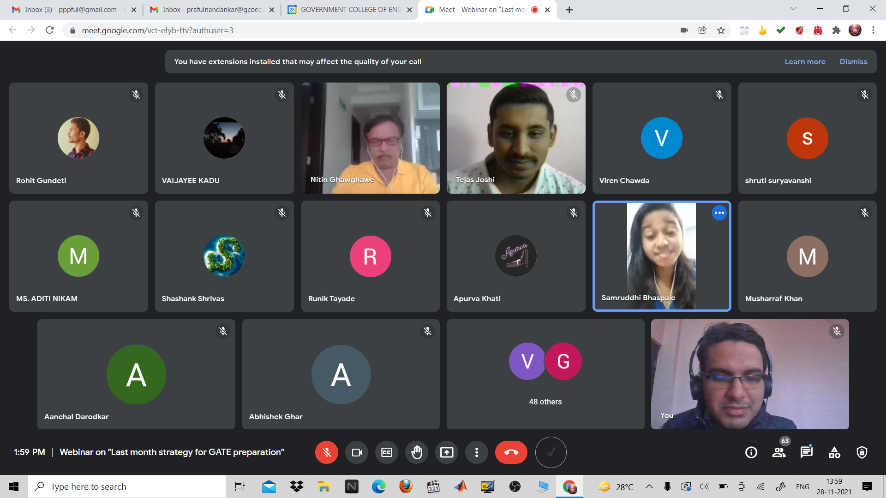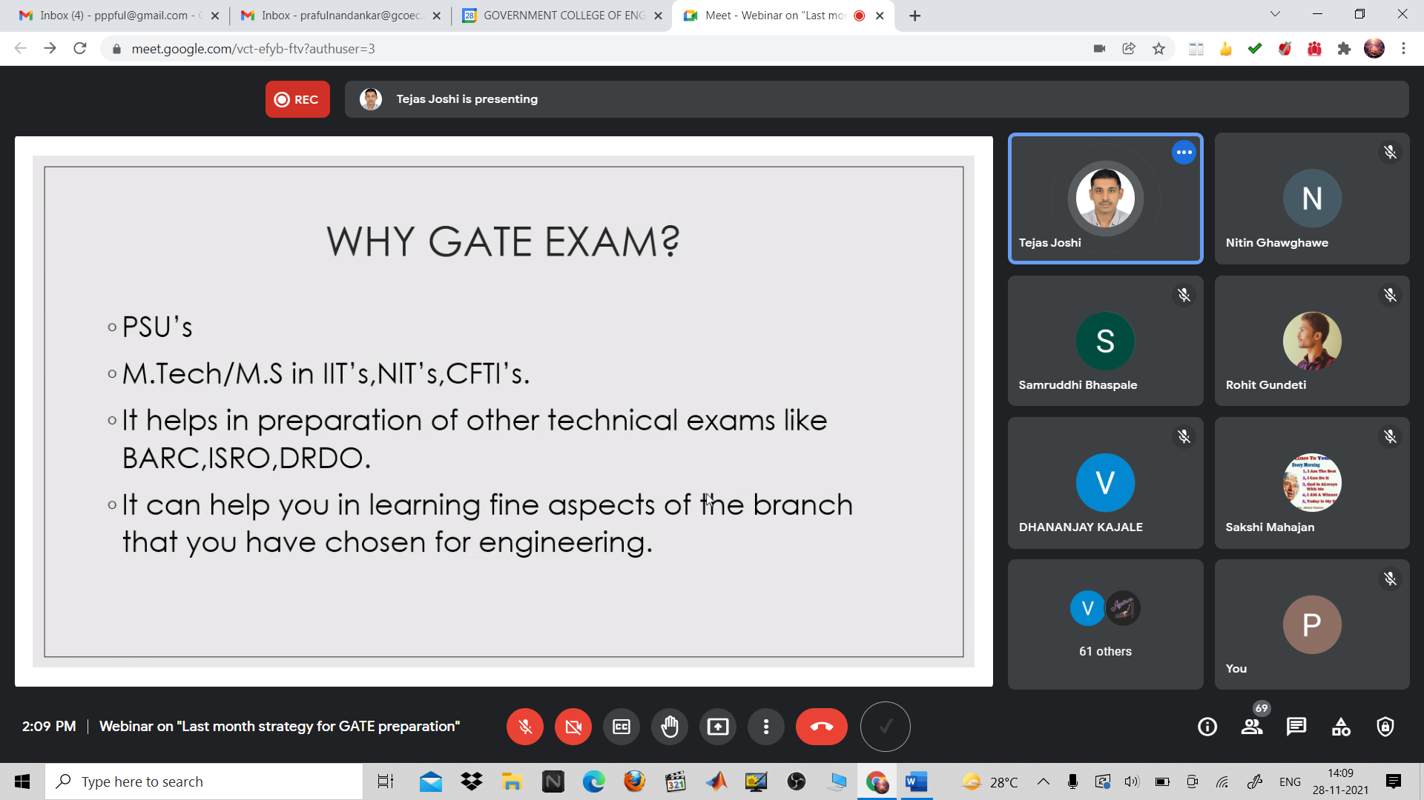
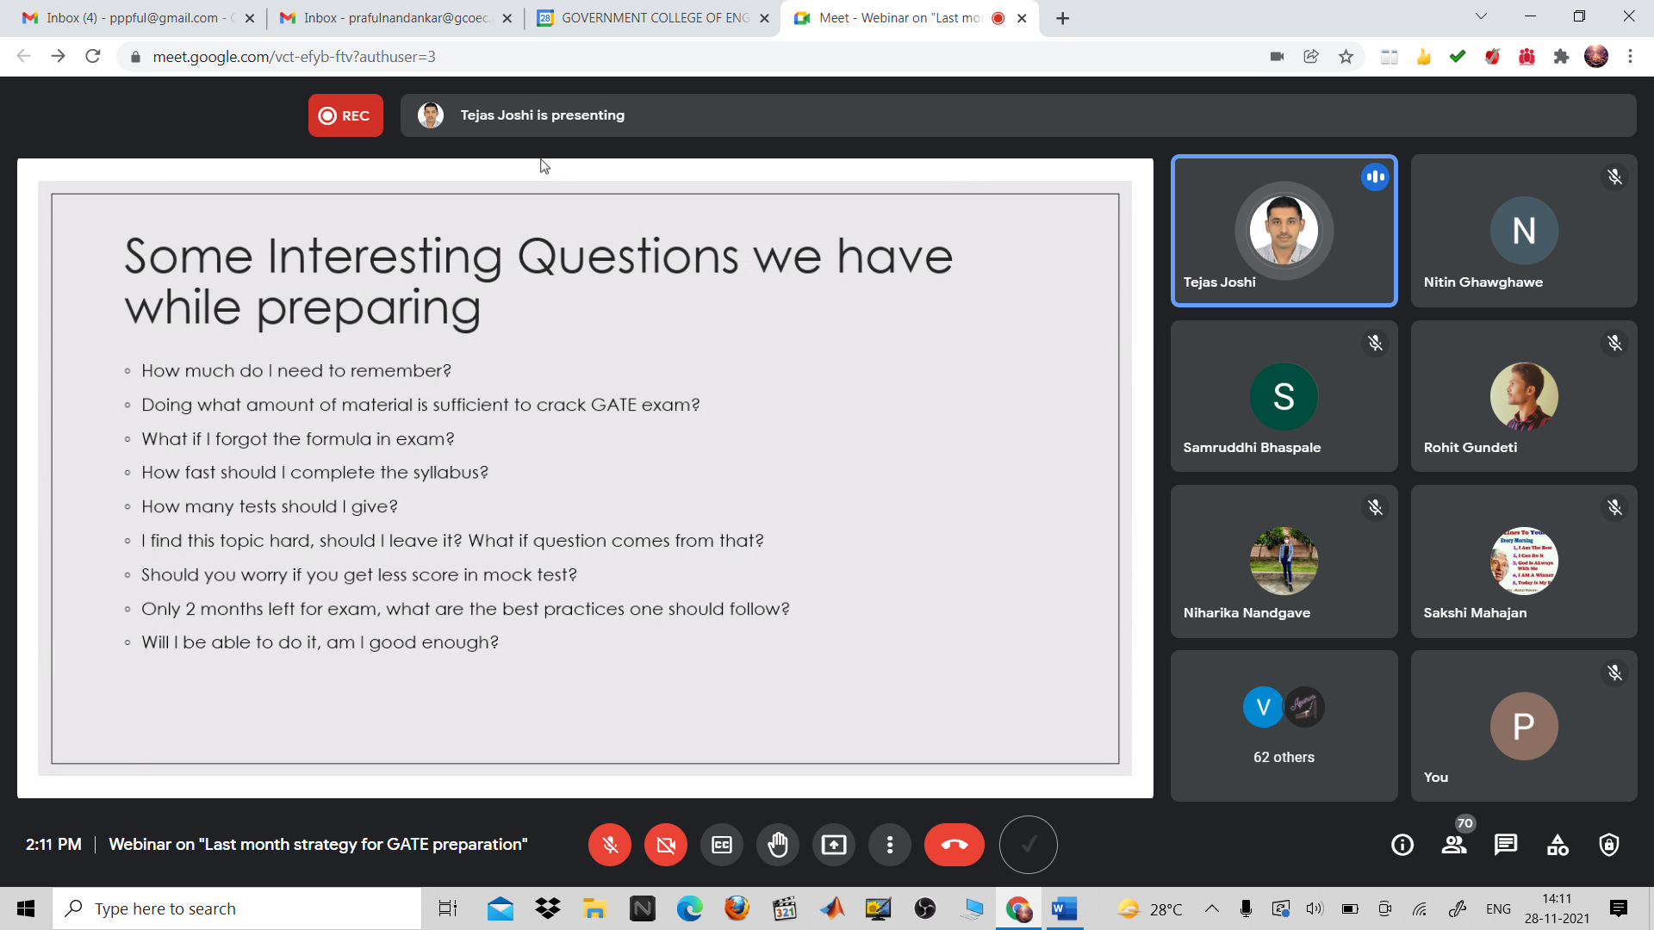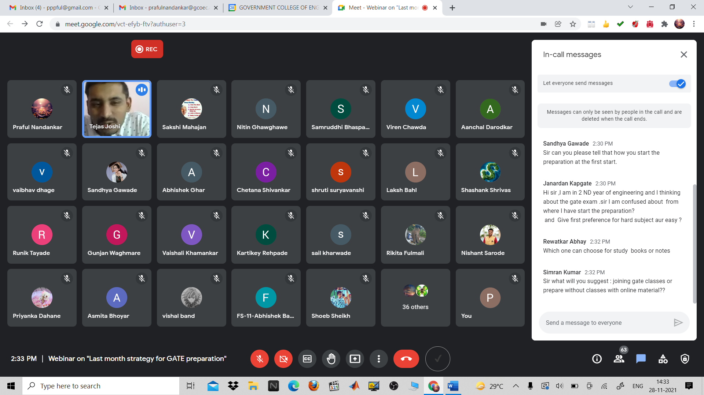

5) WAYS TO JOIN THE FORCES AND LIFE IN THE INDIAN NAVY
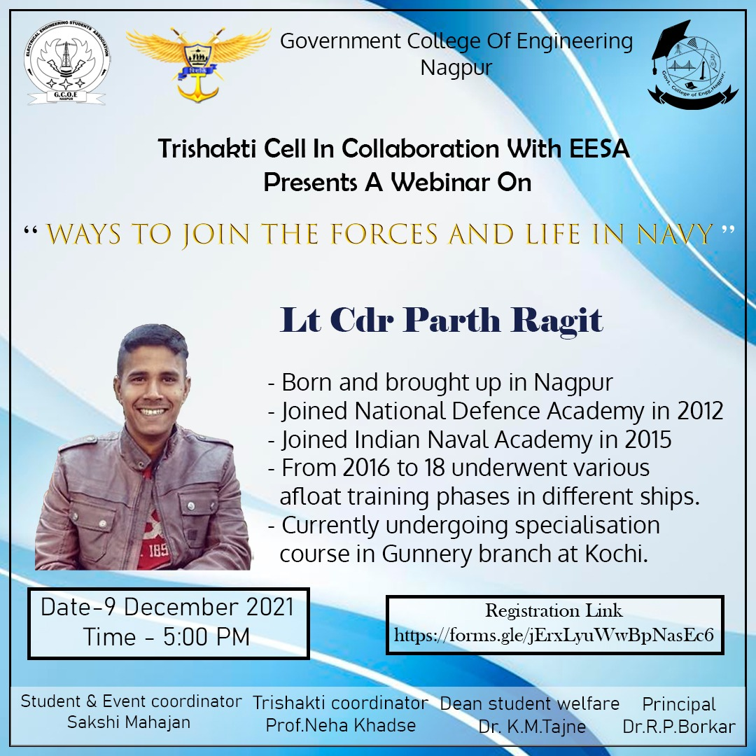
TRI-SHAKTI CELL in collaboration with EESA at Government College of Engineering, Nagpur had organized an online webinar for defence enthusiasts on 9th December 2021 at 5:00 PM on the occasion of Indian Navy Day. The webinar - “Ways to Join the Forces and Life in Navy” was adorned by speaker and resource person Lt. Cdr. Parth Ragit. The audience participated actively and were curious to know about the journey of the Speaker.
The event began with a minuscule tribute to CDS General Bipin Rawat and 12 other personnel who lost their lives in a devasting helicopter crash, which stunned the whole world. A homage was also paid to the great Cpt MN Mulla, first-ever Cpt on the Indian Navy to go down with warship, INS Khukri, when the Indian navy suffered a great loss on 9 Dec 1971.
The session began with the greetings to and by the Captain. Before beginning how he got into NDA, he elucidated that pursuing a 9-5 job marred his mood and wanted to do something different. His preparation for NDA, being associated with Prahar, began with the guidance of its faculties, and the success mantra for his immaculate goal was self-preparation. Reading newspapers surely became an asset for his general knowledge and improving English. He concurred to the fact that focusing on an individual step which included syllabus and written exam as well as solved PYQs and mocks played a humongous role at clearing in the first attempt. He mentored the audience that how an aspirant can get into defence services after being an engineering graduate and also advised to use online sources efficiently.
Once he got into INA, he got commissioned in 2016 and was appointed at Port Blair, Chennai and now at Kochi. He shared his experiences and life in the navy and also briefed about how the navy functions, being the only branch of defence, which works in all three arenas (surface, subsurface, air), subsequently claiming that the ocean plays a great role in our lives. Informed us about the 4 major roles of the Navy- military, diplomatic, constabulary, demine and its commands at Mumbai, Vishakhapatnam, Kochi, Andaman and Nicobar Islands as well as about headquarters in Delhi.
After sharing a few more interesting facts about the Navy, he humbly answered the inquisitive questions by the audience which were on aviation, killers’ squadron, President Standard Award, MARCOS, coast guards and many more. He assured the aspirants that he’ll always be available for guidance and on this note, this amusing session ended with a vote of thanks

Photos:
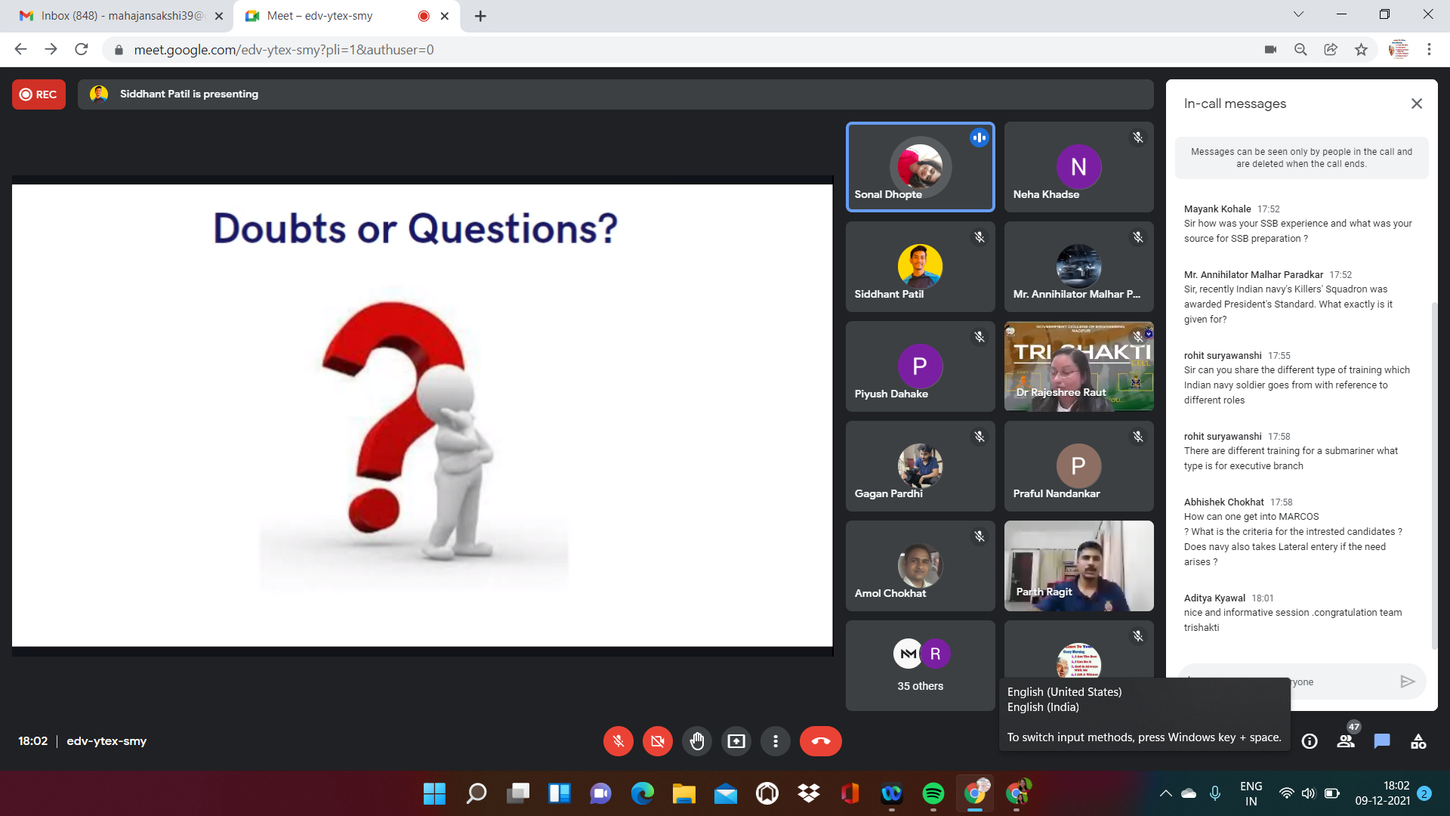
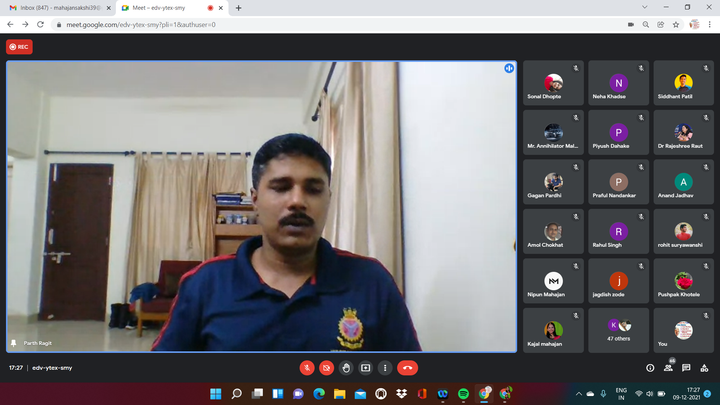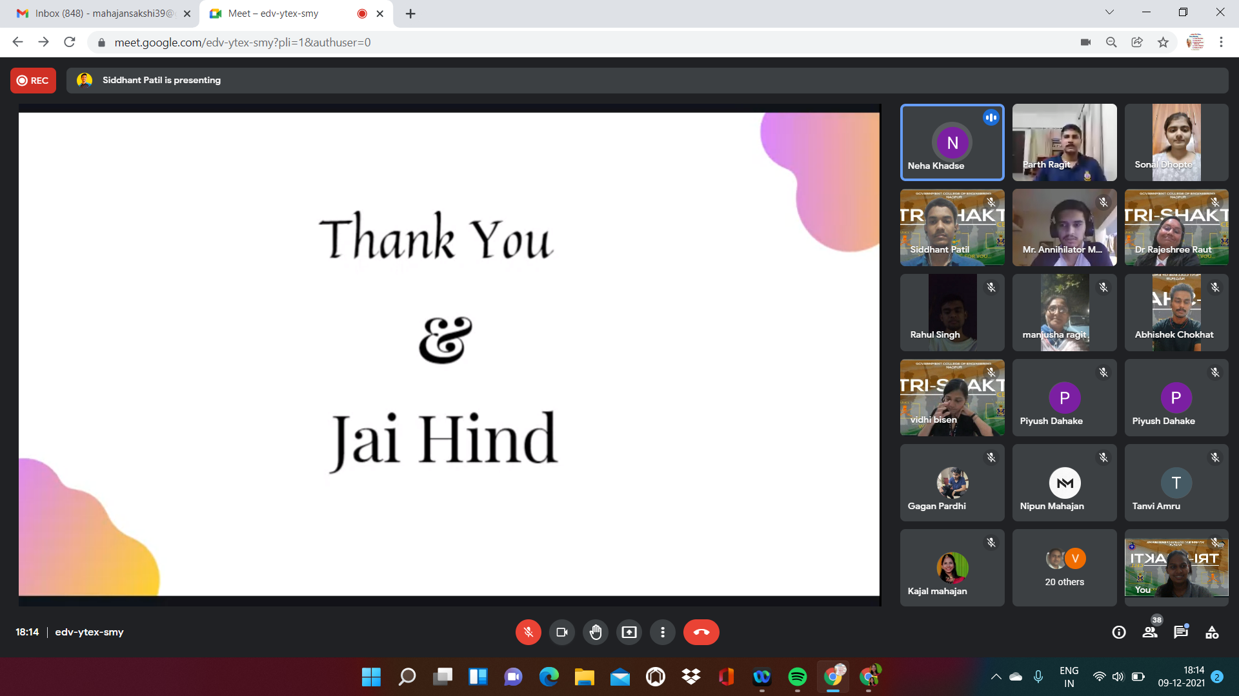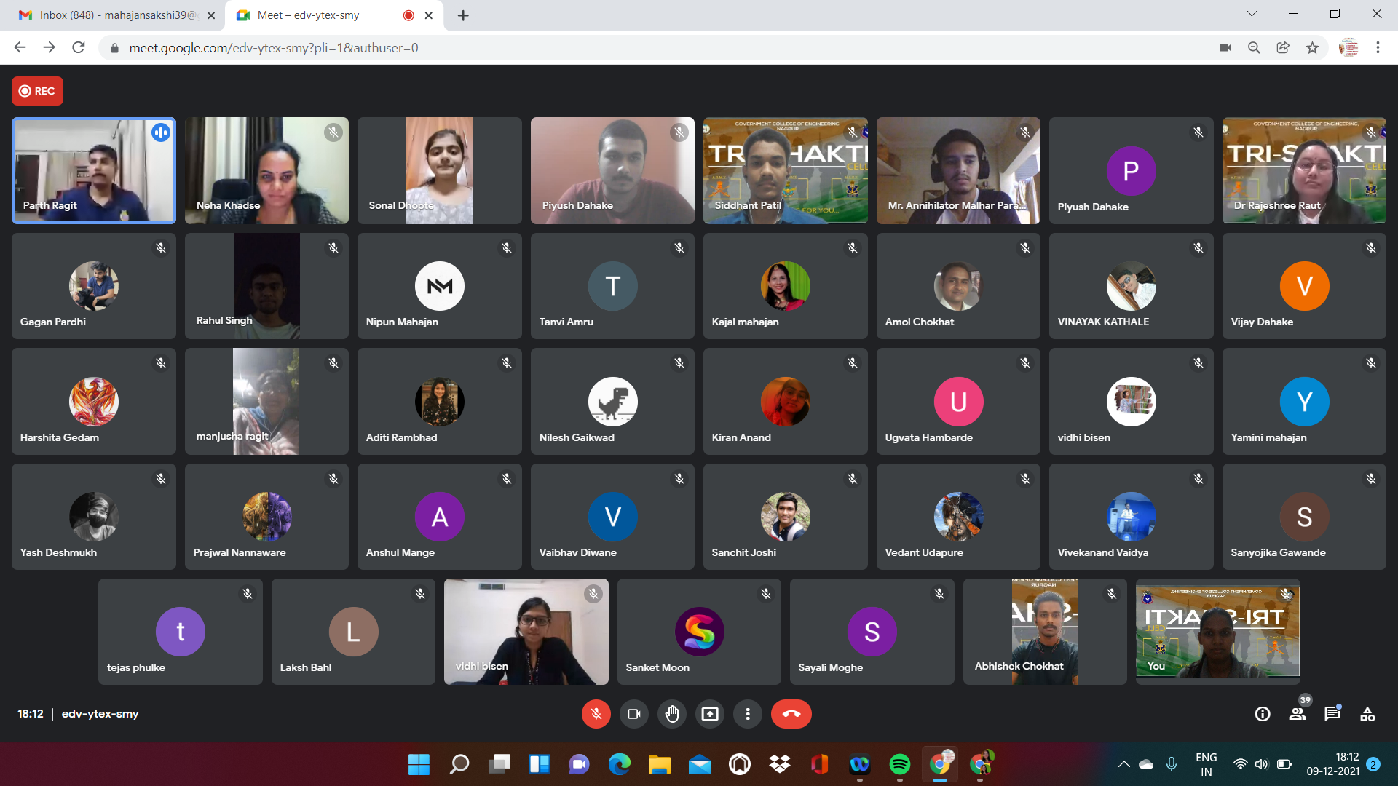
REVIEW OF FEEDBACK FORM
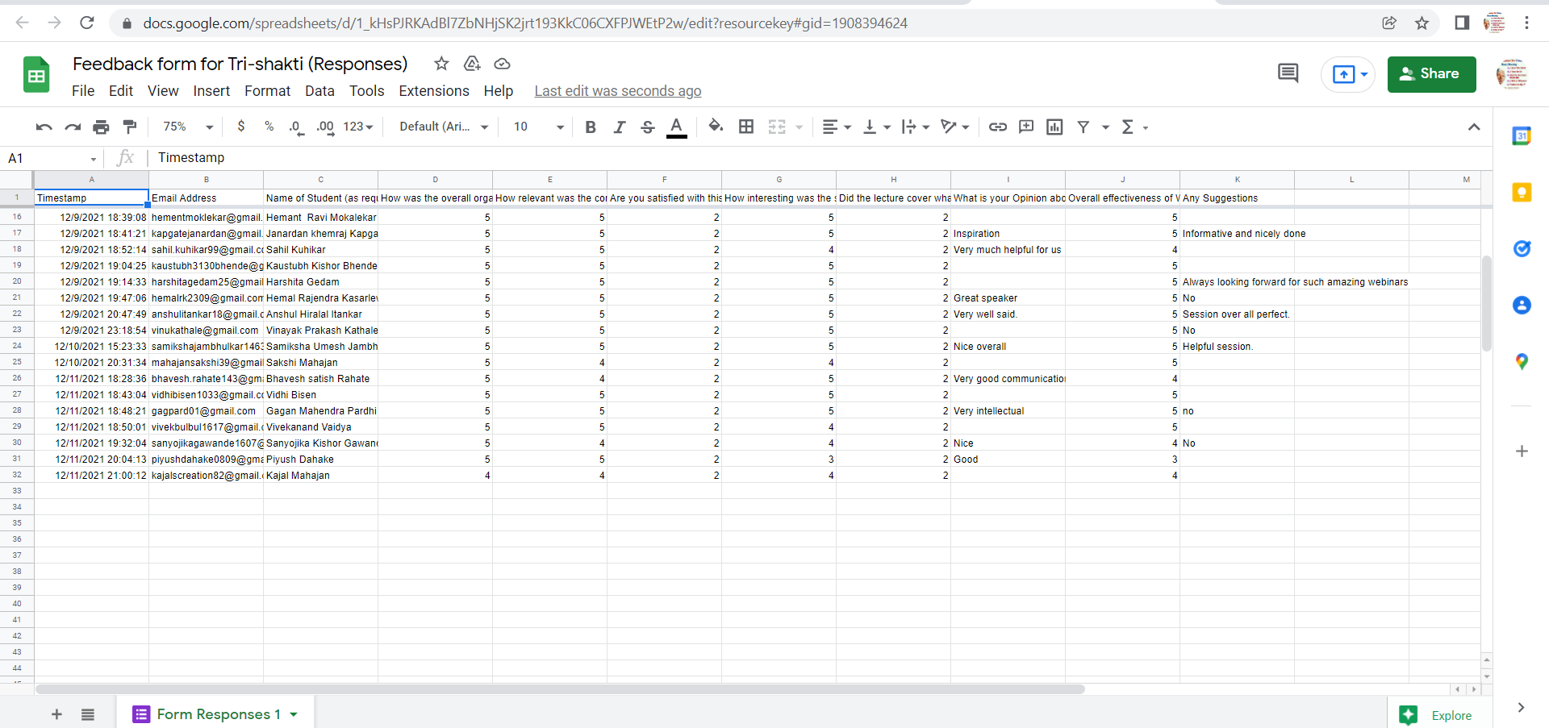

6) ABCD (AnyBody Can Do Digital Marketing)
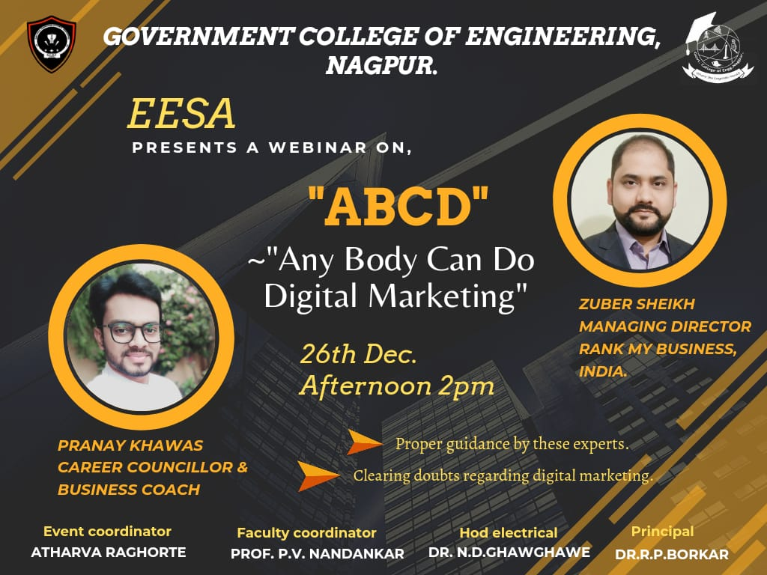

Title: “ABCD”-Anybody can do digital marketing
Mode of activity: Google Meet
Date:26th December
Timing: 2 PM
No. of participants: 55

Introduction: In this GEN z era where technology is creating milestones every day and modernizing not only our lifestyle but also the mediums of work and education too. Thus, with this fast-growing cyberlife, people tend to get clouded in between these cyphers and thereby don’t get to explore the never-ending knowledge of this digital world. In India we grow in society to run a rat race from the beginning this has grown from a habit to a culture thus resulting in reduced job opportunities even after there are surplus seats vacant in those unexplored parts of the digital world.
SUMMARY:
Guest speaker: Mr. Zuber Sheikh (Managing director Rank my Business Pvt. Ltd., India)
Mr. Pranay Khawas (Career Counselor and Business Coach)
Faculty coordinator: Prof. Praful Nandankar (Assistant professor, Electrical Engg dept., Govt college of engineering Nagpur)
Student coordinator: Atharva Raghorte
- The session guided students about the depths of digitalization and how one can be benefited from it and explore various job opportunities that could be hustled by each student easily after graduation.
- The session was comprised of various sections initially it began from various fields which students don’t know after their graduation which can be a helpful career option, which was followed up by the skills required to start a career in this field.
- Speaker focused on digital marketing which was his field of expertise and domain of his company
- Skills such as Digital analysis, Content creation, Search engine optimization, CRM, Basic design skills, etc. were introduced to students so that they could know and try to explore these fields in their future as a career option.

Conclusion:
- Speaker emphasized the vast domain of digital marketing and the digital skills that are required to sustain this digital world. The speaker elaborated the skills like search engine optimization that why it has become such an important part of today’s time and working on it as a career option is an ideal deal.
- Session also comprised of various social media communication techniques (Linkedln) to improve its reach and ways to communicate with various top position holders of companies so that we could improve our corporate knowledge and reach.

Photos:
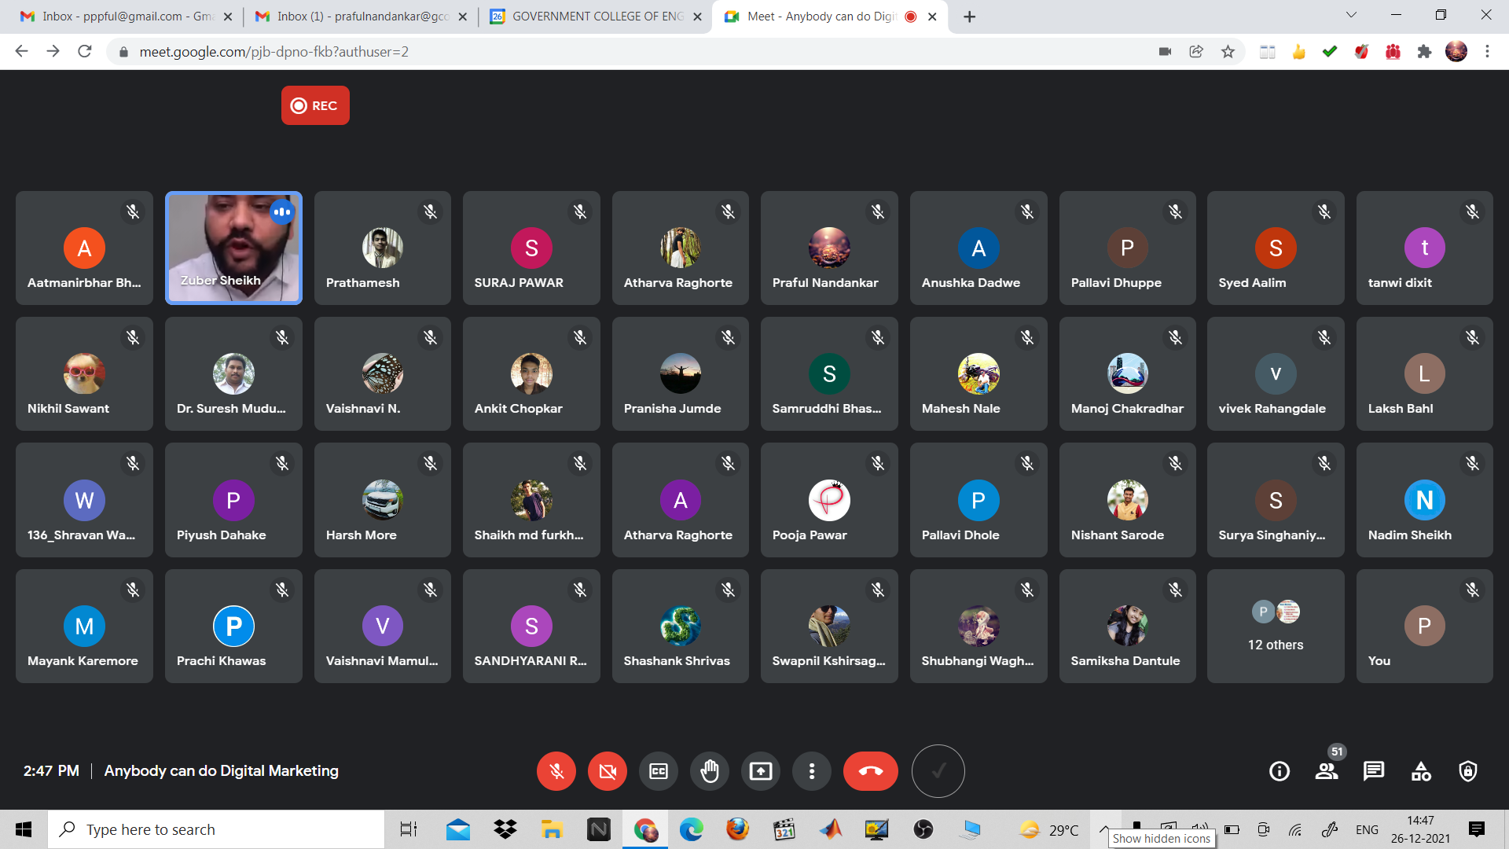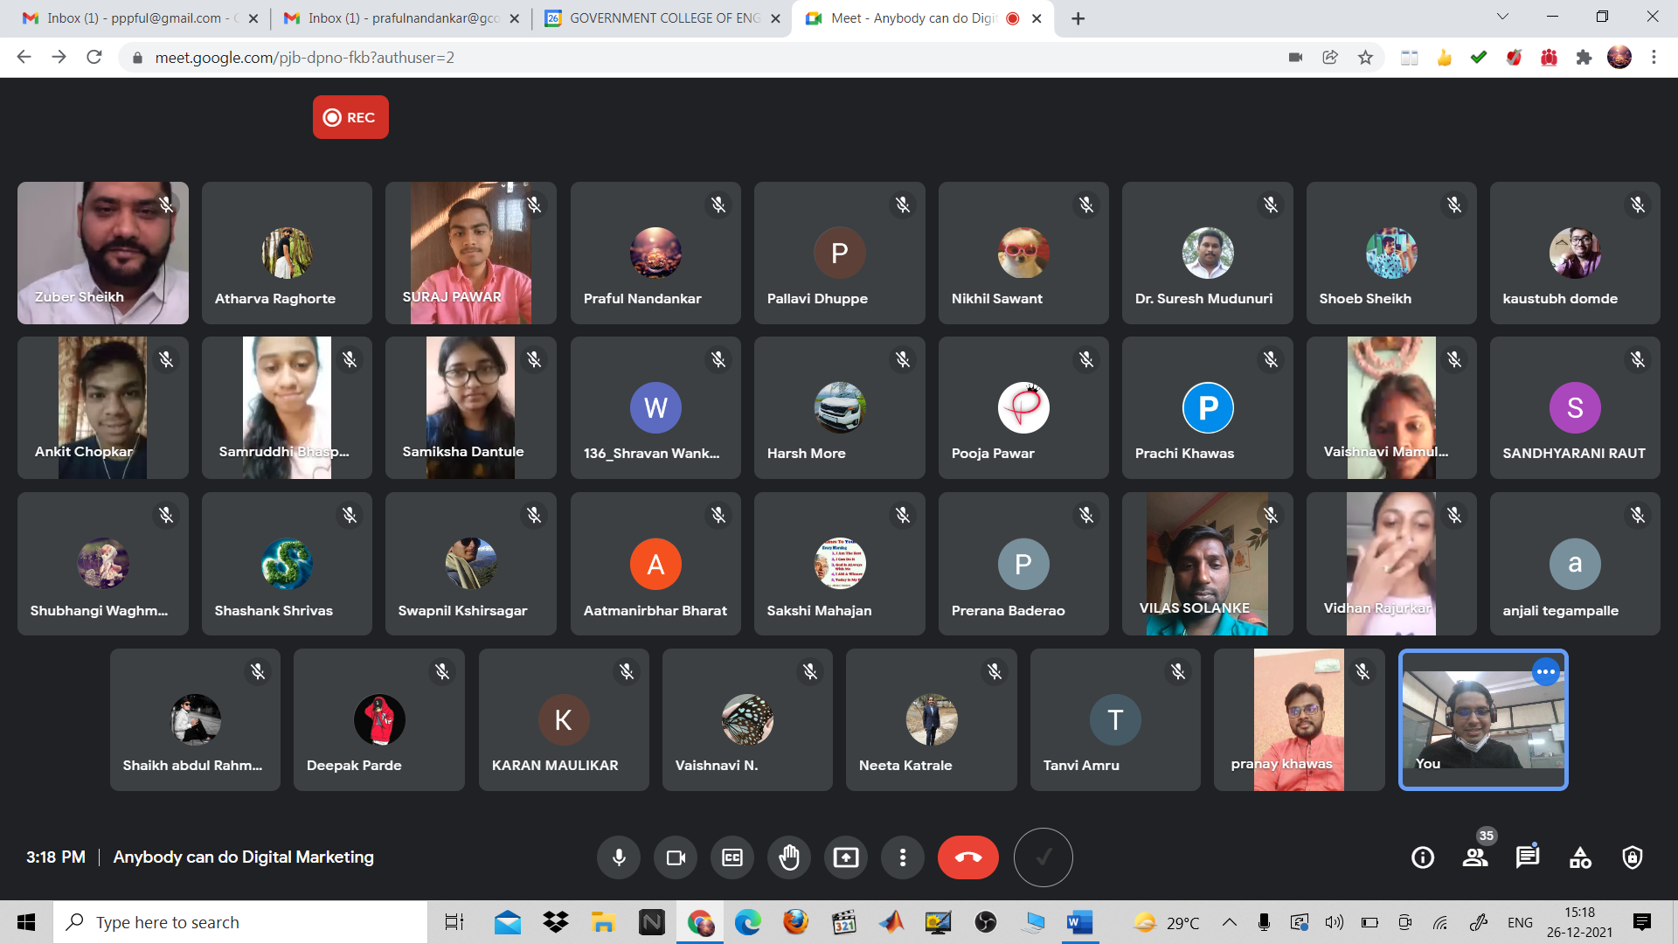

7) Online Chess Tournament
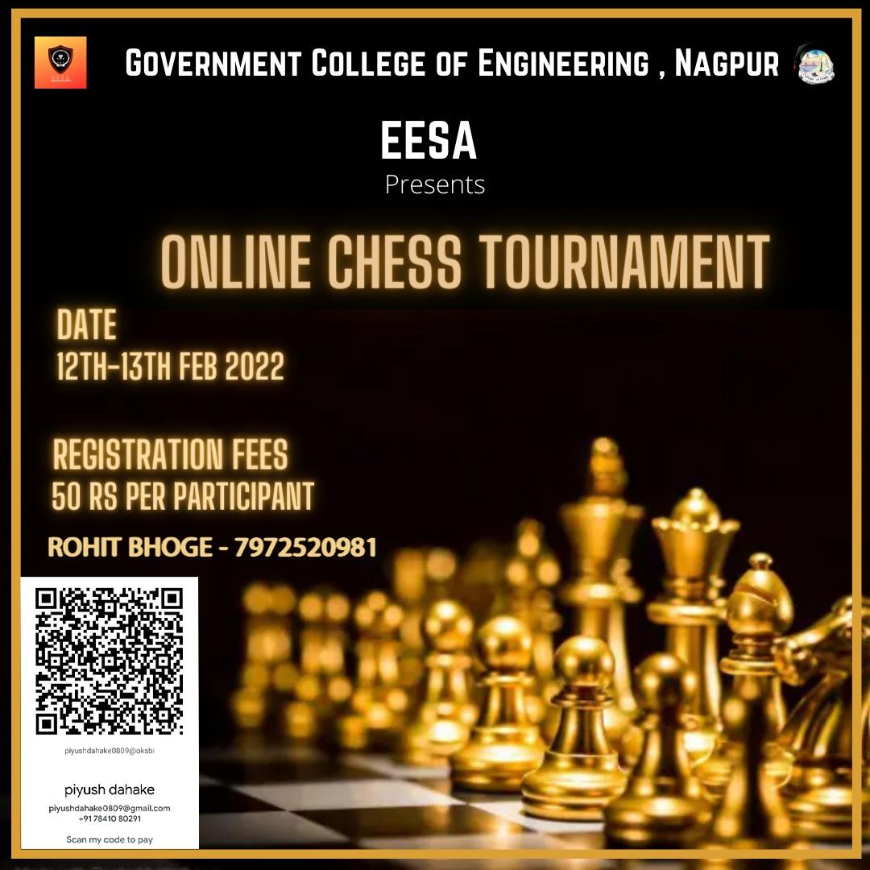

Report:
Title: Online chess tournament
Conducted by: EESA
Mode of activity: Google meet and Chess.com
Date & Time: 13th February 3pm to 7:30pm
No. of participants: 18

Introduction: Chess is a game enjoyed by people worldwide for multiple years. It is a game that teaches you to combine problem-solving, pattern recognition and creative thinking. It even gives us the lesson to be decisive and take risks. The game has been enjoyed by Indians from all walks of life for ages and has become an integral part of our great nation which has produced 75 grandmasters and 124 international masters.
Summary:
Faculty Coordinator: Prof. Praful Nandankar (Assistant Professor, Electrical Engg. Dept., Govt. College of Engineering, Nagpur)
Student coordinator: Rohit Bhoge
Entry fee: Rupees 50
Prize:800
- The event started at 3 pm sharp. The participants had already been briefed on the rules beforehand on the WhatsApp group. We segregated people based on their ratings on the platform.
- People with a rating under 600 were in one group and above 600 were in the other.
- Round 1 was a rapid 10-minute round where people of each group were randomly matched with each other. In group 1 each player played 4 matches and the top 4 players moved to the next round. A Similar was done with group 2 but each player played 3 games.
- In round 2 we moved to the 20 minutes format where only 2 players from each group.
- The final round was played in a 20 minutes format but the top players from each group played each other. After some exciting matches, the winner was Angad Tadekar.

Conclusion:
The participants had a really good experience. We had participants from a vast extent of ages ranging from age 7 to participants in their mid-50s. The feedback of each participant was positive and the main purpose of the event was achieved which was to make sure that all participants had a great time playing chess.

8) Drawing Competition (चित्रकला स्पर्धा)
An Online Drawing Competition on the occasion of National Voters Day is organized on 23rd Jan 2022 from 3 to 5 pm. The objective of this Online Drawing competition is to highlight the importance of voting and every vote. This day also marks the foundation of the Election Commission of India. It not only encourages the youth to participate in the electoral process but also focuses that the Right to vote is a basic right. This competition is organized for college students. In this competition, the students were asked to submit their respective drawings in the allotted time. The prize winners of this competition were also declared on 23rd Jan 2022. Around 17 entries have been received for the Drawing competition. The efforts of the students were highly praised by the college authorities. The topics for the Drawing competition given to participants were १८ वर्ष पूर्ण झालेल्यांना मतदार नोंदणी करण्याचे आवाहन, स्त्रियांना मतदार नोंदणीचे आवाहन, अपंगांच्या मताधिकाराचे महत्व आणि आवाहन, तृतीय पंथीयांच्या मताधिकाराचे महत्व आणि आवाहन. The drawings were assessed based on rubrics such as Interpretation and the clarity of the theme, creativity, uniqueness, and originality of the depicted theme. Participants and winners were awarded E-certificates and prizes. The faculty coordinator of this event is Prof. Praful Nandankar.
Some pictures related to Drawing Competition (चित्रकला स्पर्धा)
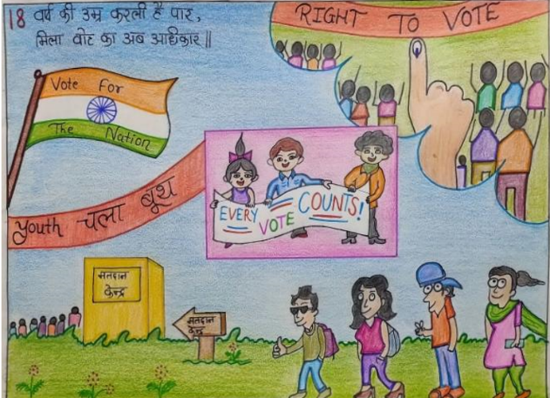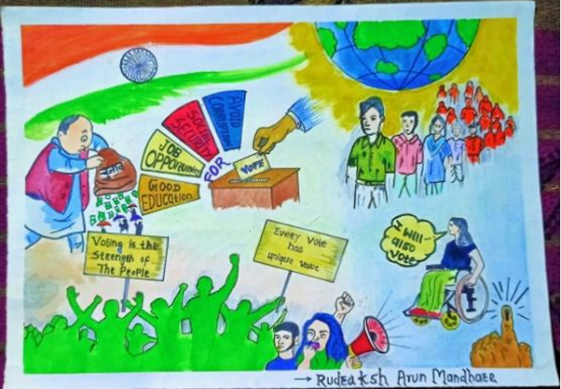
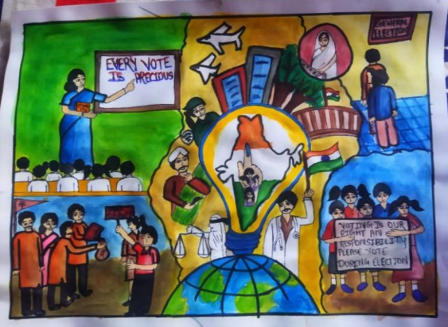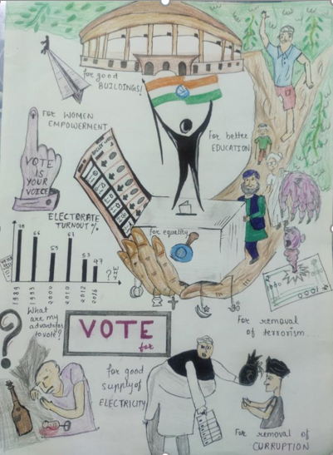

9) Short Film Competition (लघुपट स्पर्धा)
A short film competition on the occasion of National Voters Day is organized on 23rd Jan 2022. The objective of this short film competition is to highlight the importance of voting and every vote. This day also marks the foundation of the Election Commission of India. It not only encourages the youth to participate in the electoral process but also focuses that the Right to vote is a basic right. This competition is organized for college students. In this competition, the students were asked to form a group and write a small script on the topics assigned to them. There were some rules framed for the short film competition such as the film should be shot with full HD (1080p) resolution, and the short film should be a minimum of 3-5 minutes. After creating the short film, they have to submit their short film in Google form. The prize winners of this competition were also declared on 23rd Jan 2022. Around 4 entries have been received for the short film competition. The efforts of the students were highly praised by the college authorities. The topics for the short film competition given to participants were गोष्ट लोकशाहीची, मताधिकार हा माझा कायदेशीर, सार्वत्रिक प्रौढ मताधिकाराचे महत्त्व, अपंगांच्या मताधिकाराचे महत्त्व आणि आवाहन, तृतीय पंथीयांच्या मताधिकाराचे महत्त्व आणि आवाहन. The short film was assessed based on parameters such as originality, creativity, plot, pacing and structure, characters, cinematography, sound quality, and music. Participants and winners were awarded E-certificates and prizes. The faculty coordinator of this event is Prof. Praful Nandankar.

10) INVENTRIX 4.0
“INVENTRIX 4.0”
DARE 2 INVENT

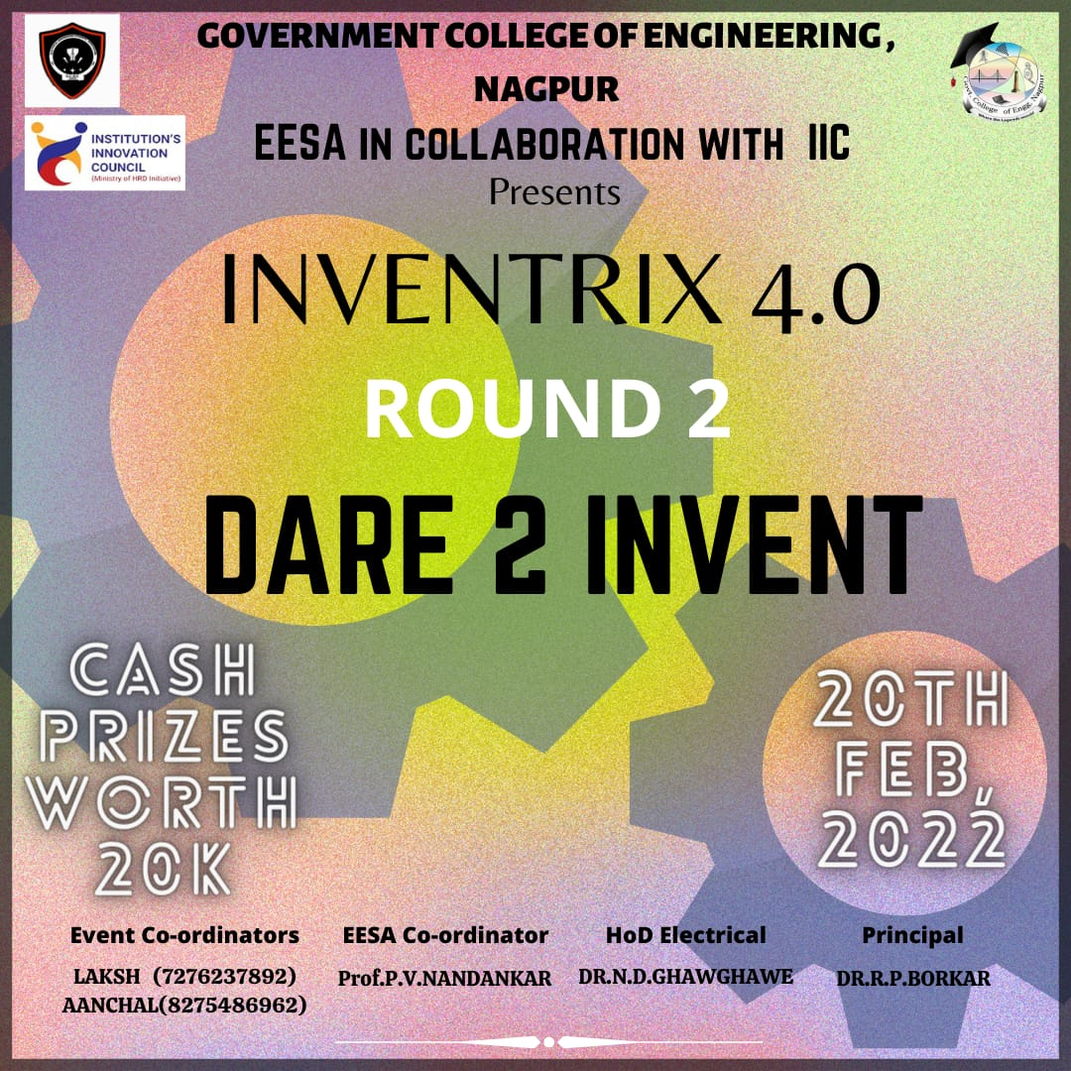

Report
Title: Dare 2 Invent
Conducted by: EESA in collaboration with IIC, GCOEN
Mode of Activity: Online on Google Meet in two parallel sessions
Google Meet Session-I Link: https://meet.google.com/kkv-odyc-tof
Google Meet Session-II Link: http://meet.google.com/exs-trph-zet
Date: 20th Feb 2022 (Sunday)
Timing: 11:30 AM to 3:30 PM
No. of Participants: 70
Dare 2 Invent Recording: https://drive.google.com/file/d/1CL2K4uW3cL_7ByE669GCkGv6FXEsQaQZ/view?usp=sharing

Introduction: Dare 2 Invent is organised by EESA in association with IIC, GCOEN. The idea behind this event is to select one particular problem statement from any one of the themes finalised for the Dare 2 Invent competition and then present reliable, efficient, optimal and viable solutions for the selected problem statement. Total 30 problem statements were obtained and six themes have been finalised for Dare 2 Invent competition. This event provides a solution-based approach to solving problems. It helps us in the process of questioning the problem, questioning the assumptions and questioning the implications. This will also help in re-framing the problem in human-centric ways. It is also referred to as ‘outside the box’ thinking as participants attempt to develop new ways of thinking that do not abide by the dominant or more common problem-solving methods.
Summary:
Evaluators for Session I: Dr. Nitin Ghawgahwe (HoD, Electrical), Dr. Latesh Bhagat (HoD, CSE), Dr. Jasmirkaur Randhawa (IIC Vice President)
Evaluators for Session II: Dr. Rajesh Surjuse (Training Placement Officer), Dr. Sachin Jolhe (Assistant Professor, Electrical), Prof. Shrikrishna Wagh (Assistant Professor, Mechanical)
Faculty Coordinator: Prof. Praful Nandankar (Assistant Professor, Electrical Engg. Dept., Govt. College of Engineering, Nagpur)
Student Coordinator: Laksh Bahl & Aanchal Darodkar
- Dare 2 Event started at 11:30 AM on 20th Feb 2022 with an inauguration video. This is followed by an inspirational speech by Dr. Nitin Ghawghae, HoD Electrical. He explained the importance of innovation in today’s scenario. He also pointed out various stages of Design thinking as Dare 2 Invent competition is analogous to Design thinking event.
- After a motivational speech, the rules and regulations of this competition have been explained to participants. The Session-2 link is forwarded in the chat-box and evaluators of Session-2 advanced to the second session.
- Participants have selected their problem statement and they have given their solutions. The solutions of the participants are evaluated based on parameters like concept novelty, practicability, presentation, potential social impact and scalability.
- The template of the presentation for this event have already been forwarded on their mail. The participants have to first highlight their problem statement and then they will have to explain their approach towards idea development. They have also been asked to discuss various tools, technologies used for prototype development. The participants have also discussed the expected cost of implantation and the feasibility of their proposed solutions.
- The participants received valuable feedback, suggestions from evaluators after their presentation. The two parallel sessions ended with a vote of thanks by respective session coordinators.
Outcome:
- The participants got various suggestions, feedback, critical reviews, ideas from the evaluators of both the sessions for enhancing their solution to the next level.
- Their suggestions will help them to apply, explore and practice creativity in a proper direction.
- This event has allowed them to view a problem from a different perspective. It will encourage their innovative thinking and creative problem-solving ability.
- Dare 2 Invent has provided a platform to participants to validate their solutions in front of evaluators and their suggestions and feedback will help them in creating a hardware prototype for their selected problem statement.
Photos:
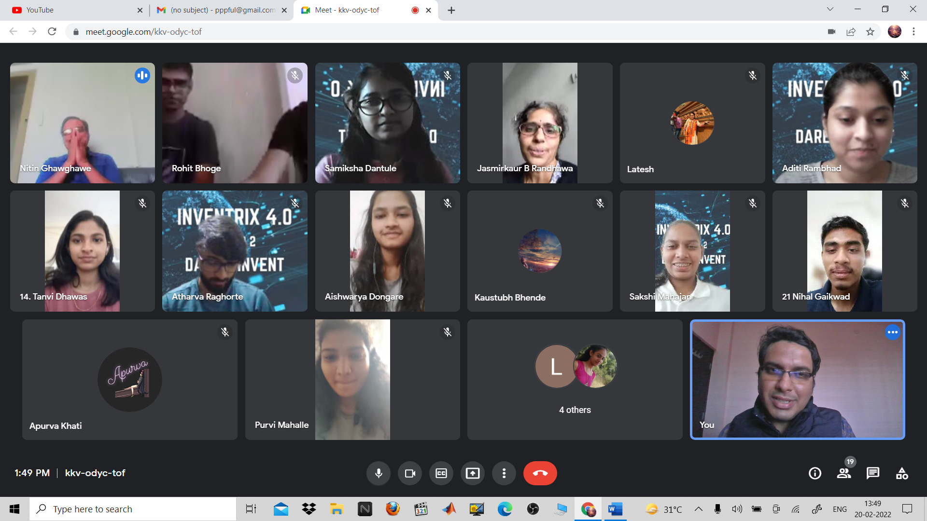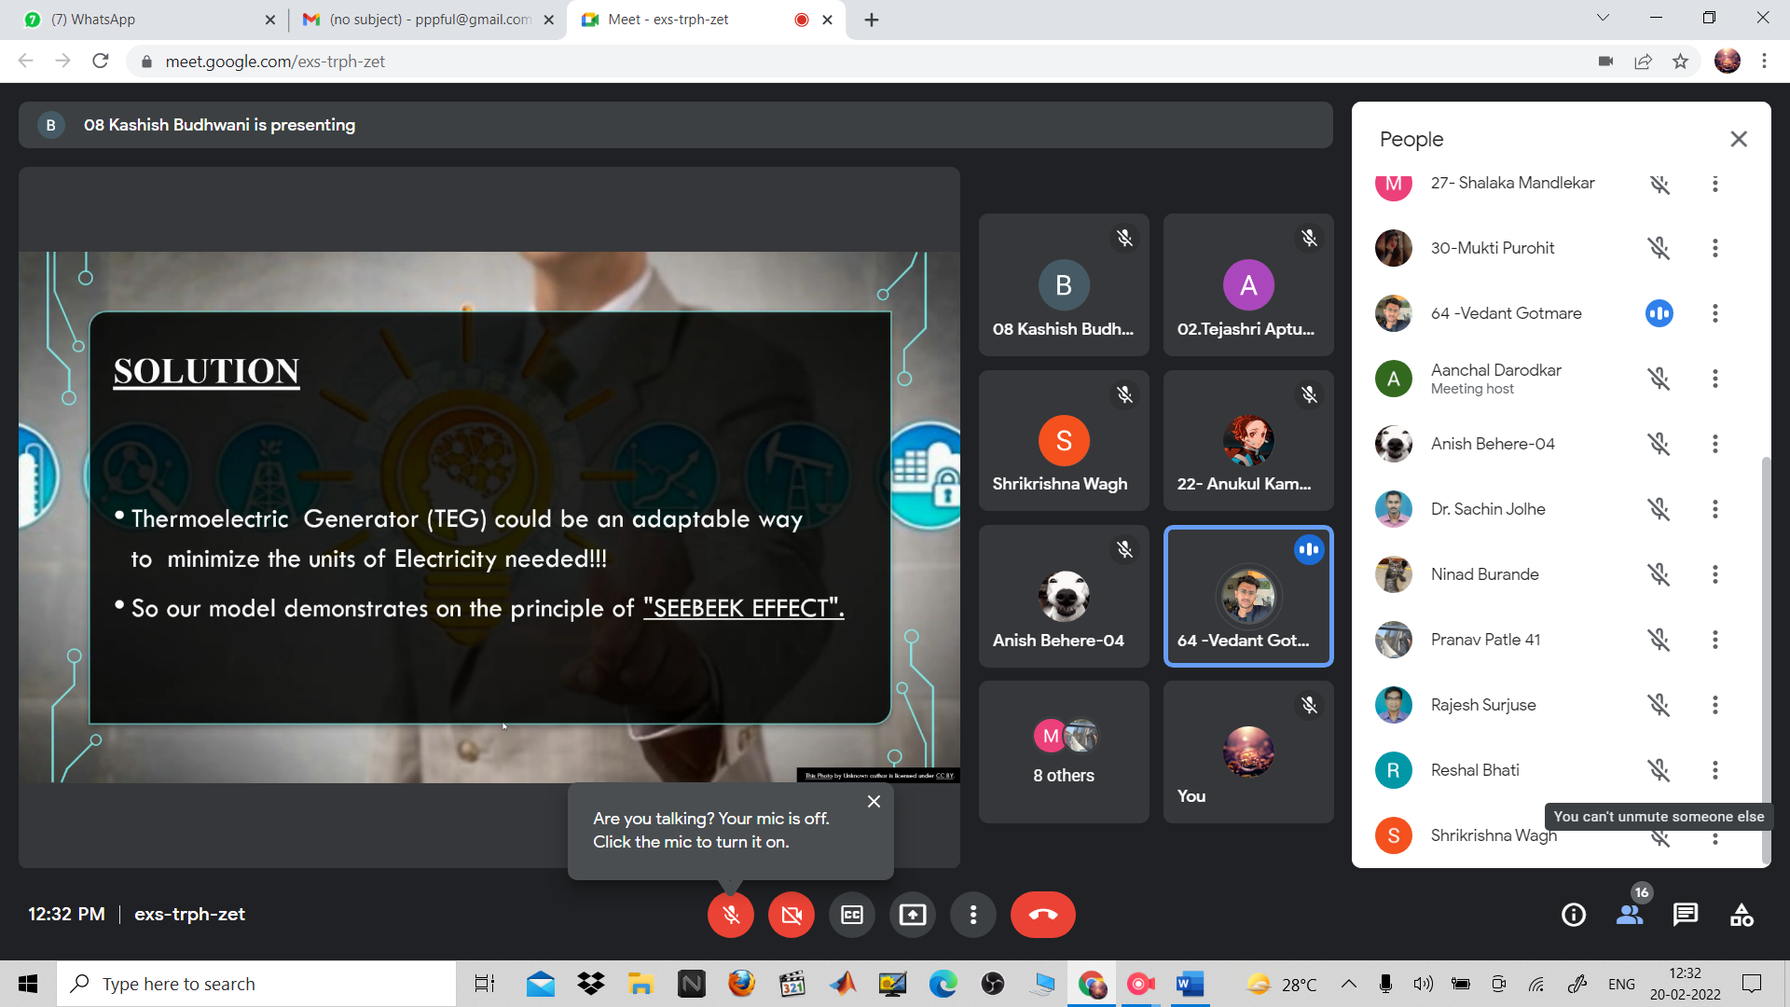
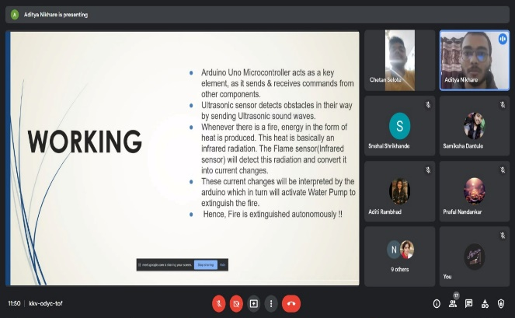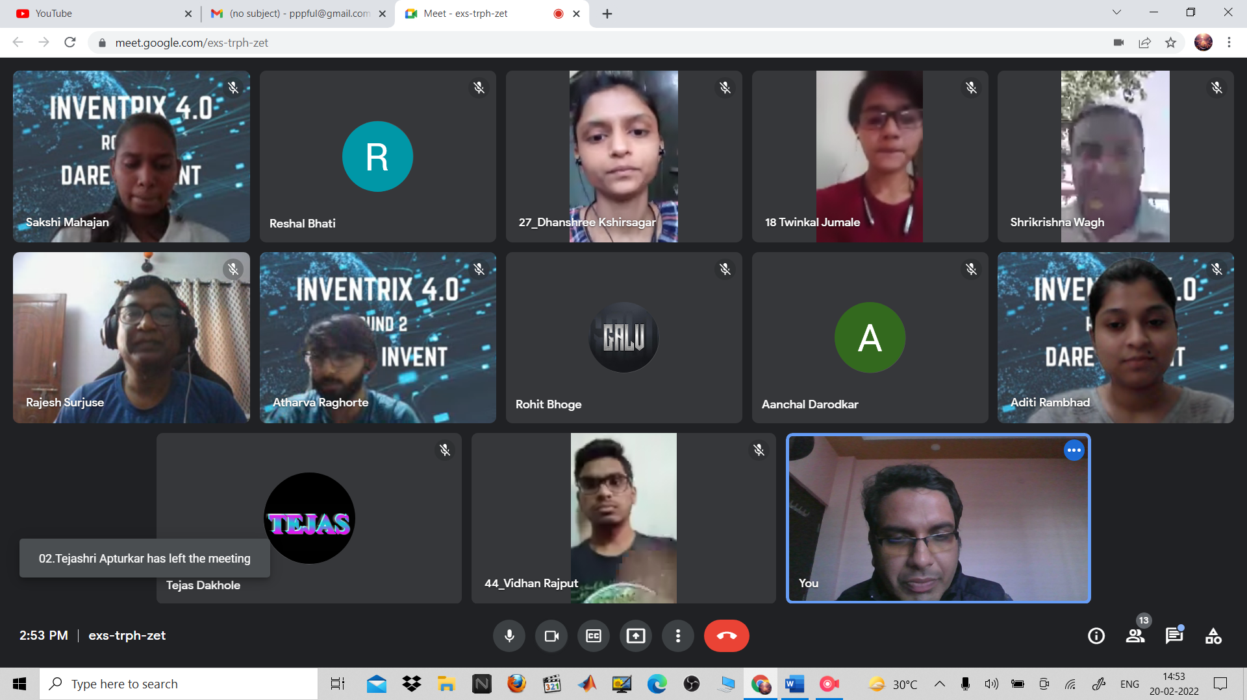
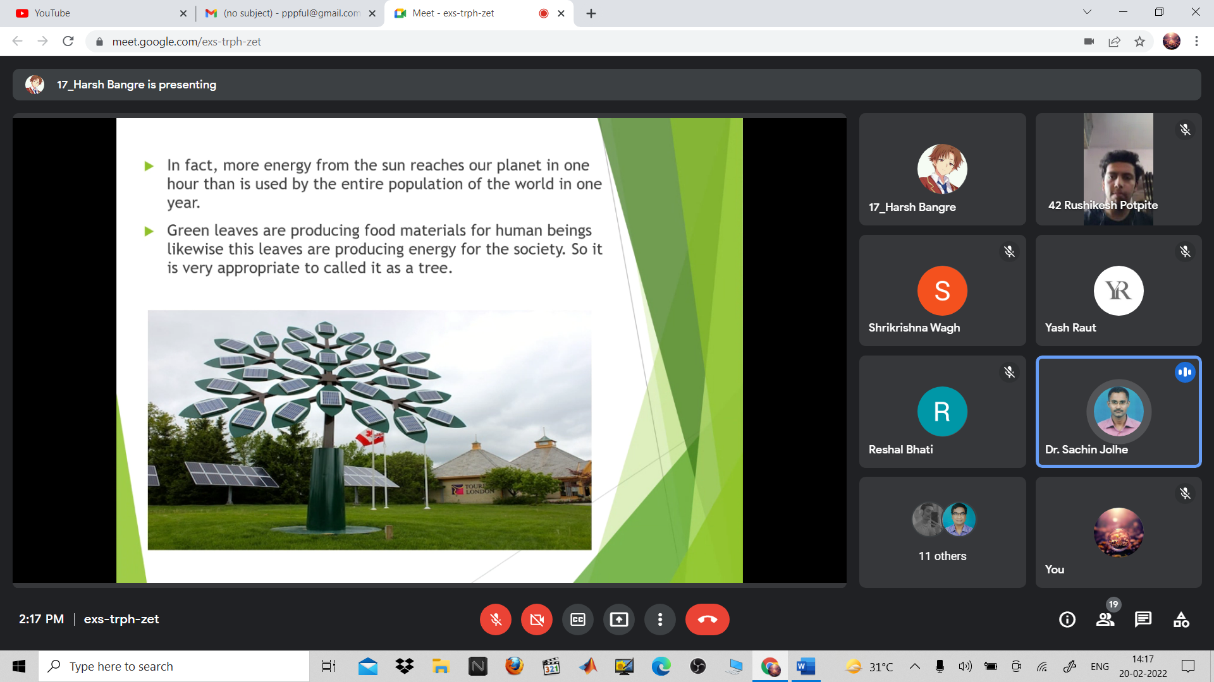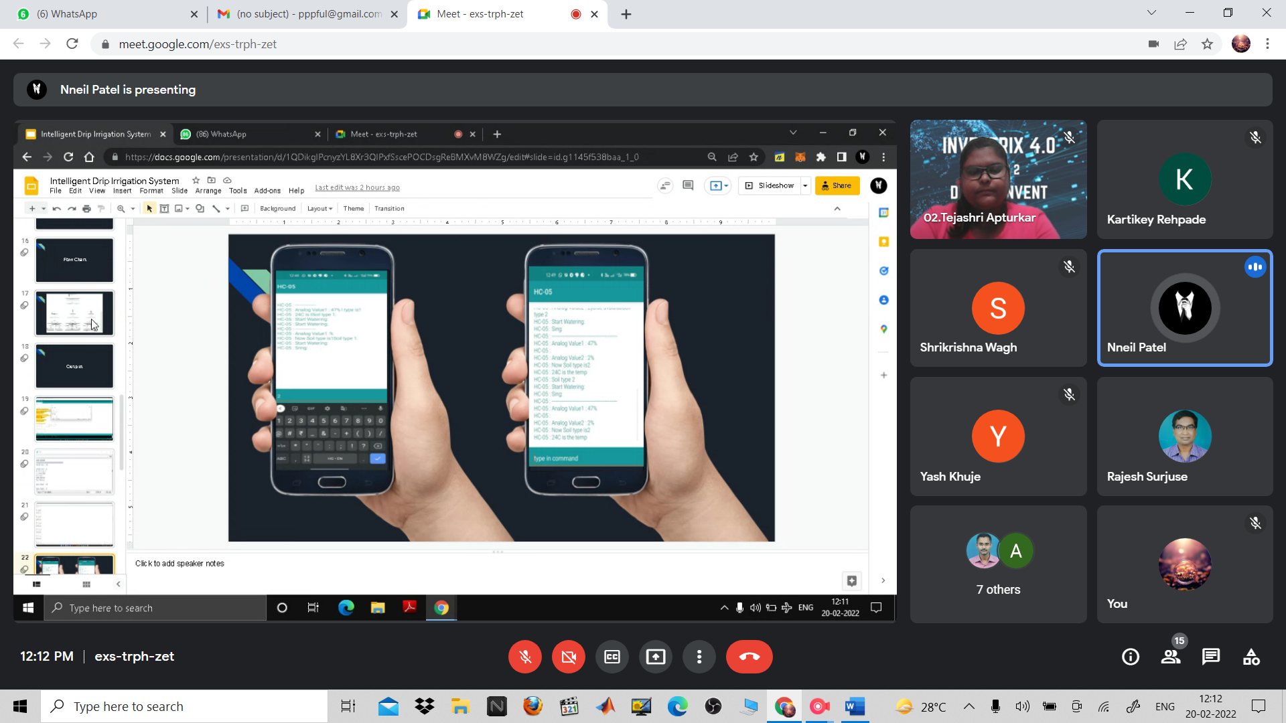
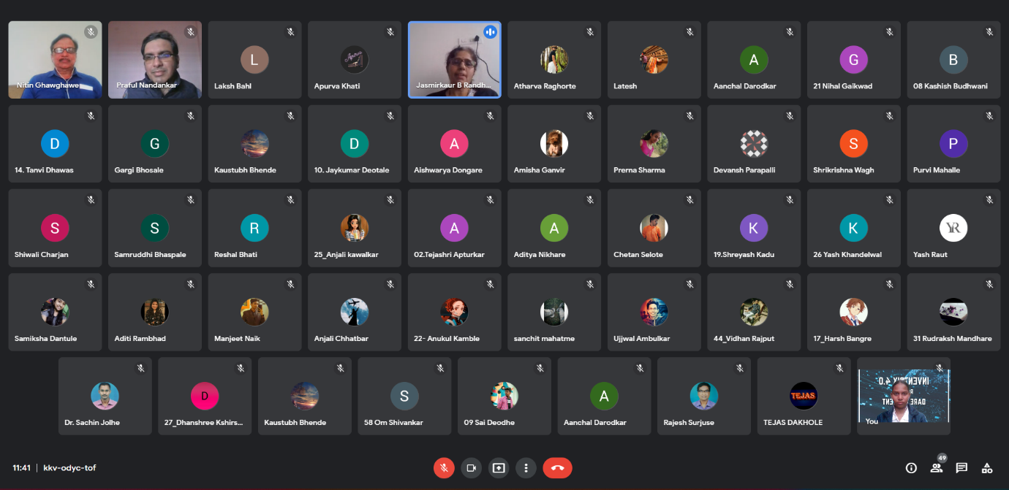
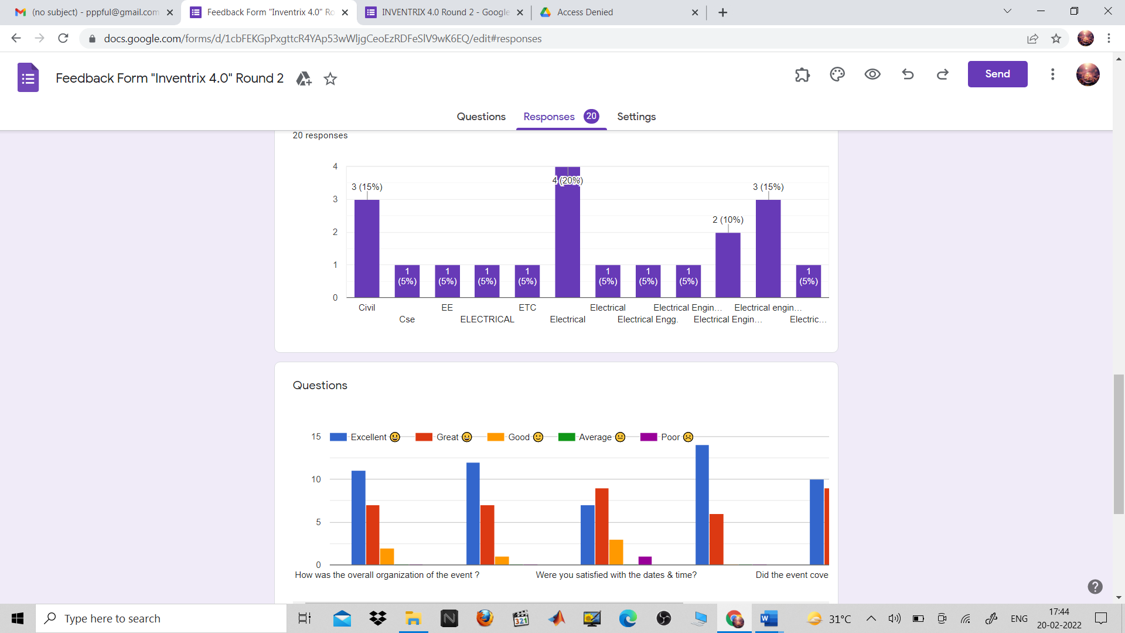
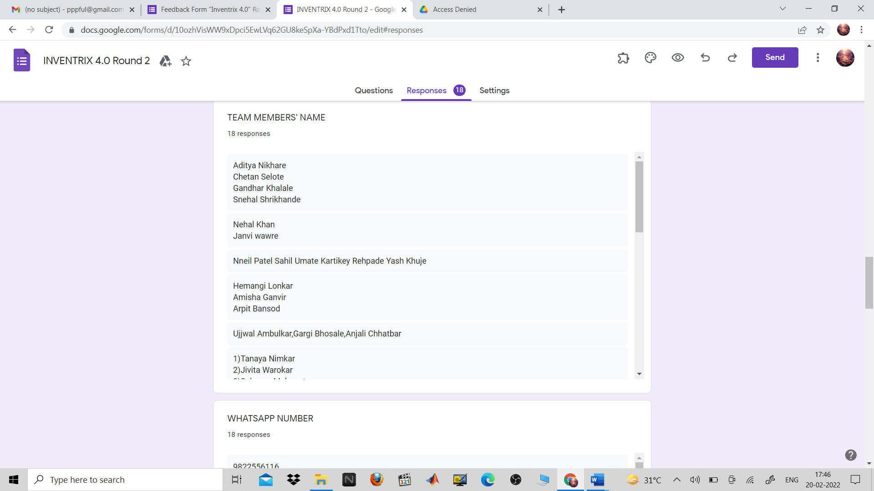
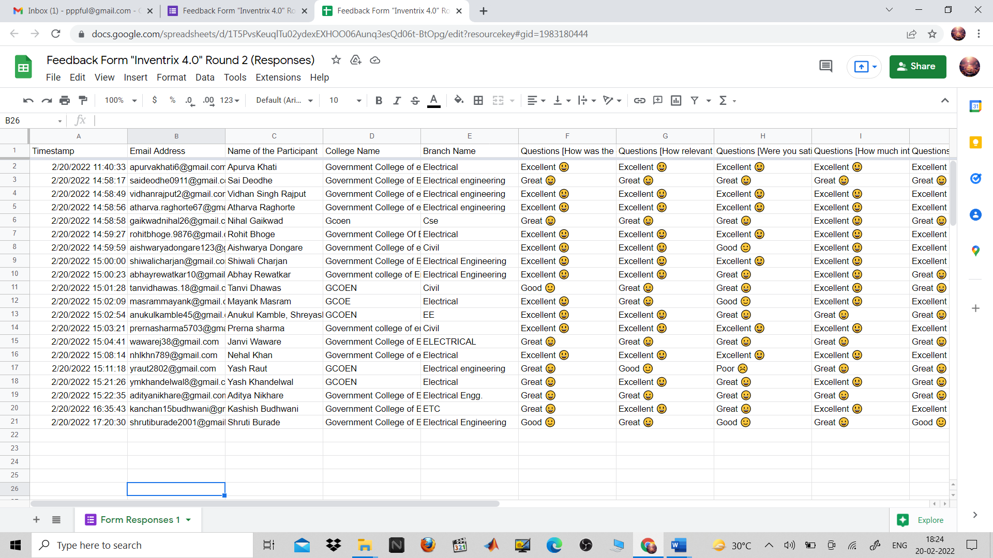
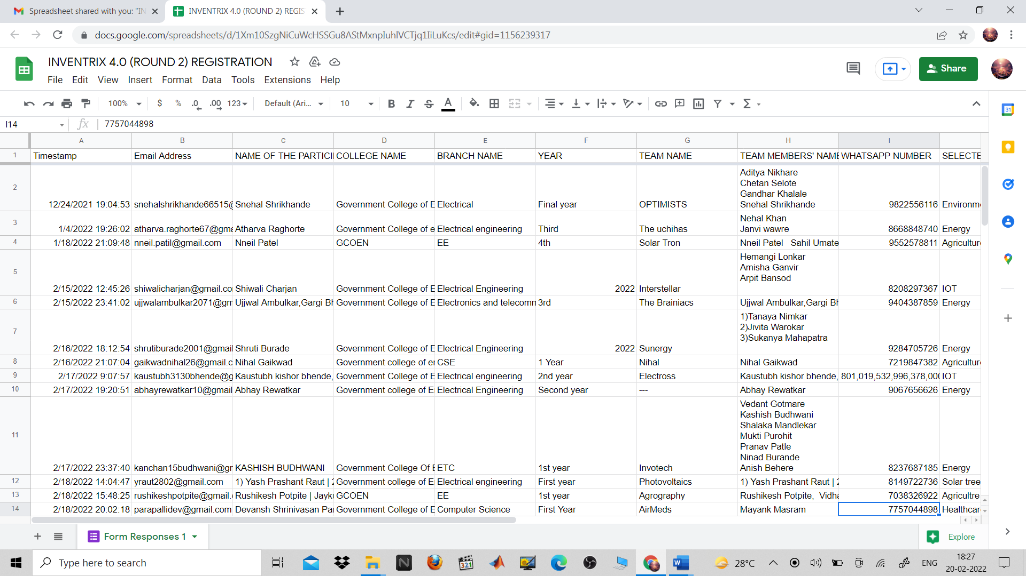

“INVENTRIX 4.0”
PLAN 2 PROTOTYPE

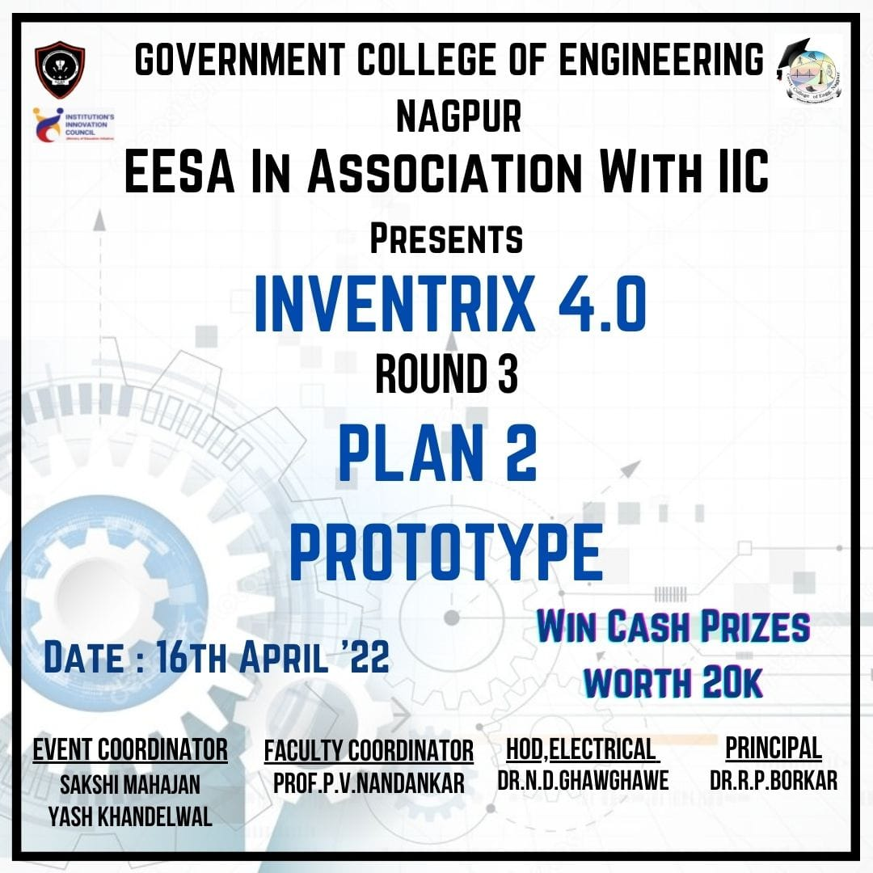

Report
Title: Plan 2 Prototype
Conducted by: EESA in collaboration with IIC, GCOEN
Mode of Activity: Online on Google Meet
Google Meet Session Link: https://meet.google.com/ugd-kosz-ujr
Date: 16th April, 2022 (Saturday)
Timing: 11 AM to 3 PM
No. of Participants: 70
Dare 2 Invent Recording: https://drive.google.com/file/d/1DPZX3F4Exj0qtxuGmoKvmgR5x1IXZcVQ/view?usp=sharing

Introduction: Plan 2 Prototype is organised by EESA in association with IIC, GCOEN. The idea behind this event is to invent the ideas/ problem statements from our surroundings and then present the reliable, efficient and optimal solutions for the ideas/ problem statements. Inventrix 4.0 was organised in the Government College of Engineering in three different rounds. The first round was to collect the ideas and problem statements from the surroundings and then in round-2, the team has to provide an optimal and viable solution for their selected problem statement. If the solution for the selected problem statement gets approved by judges, then they will be asked to prepare the hardware prototype for their claims made in Round-2.
Summary:
Evaluators for Final Round: Dr. Nitin Ghawgahwe (HoD, Electrical), Dr. Latesh Bhagat (HoD, CSE), Dr. Jasmirkaur Randhawa (IIC Vice President), Dr. Rajshree Raut (HoD, ETC), Dr. Sachin Jolhe (Assistant Professor, Electrical), Prof. Shrikrishna Wagh (Assistant Professor, Mechanical)
Faculty Coordinator: Prof. Praful Nandankar (Assistant Professor, Electrical Engg. Dept., Govt. College of Engineering, Nagpur)
Student Coordinator: Yash Khandelwal and Reshal Bhati
- Plan 2 Prototype event started at 11:00 AM on 16th April, 2022 with an inauguration video. This is followed by a motivational speech by Principal Dr. Rewatkumar Borkar. He explained the importance of innovation in today’s scenario. He also stressed the importance of prototype development as this is the first step in the direction toward Entrepreneurship.
- After a motivation from Principal Sir, the brain behind this event, Dr. Nitin Ghawghawe, HoD Electrical was asked to inspire the participants for Round-3. Sir has highlighted the importance of Design thinking for engineering students and how this helps in building a reliable prototype.
- After an inspirational speech, the rules and regulations of this Round-3 (Plan 2 Prototype) have been explained to participants.
- The Round-3 started with the live demonstration of work done by 8 teams. All teams have briefly explained their solution for their selected problem statement and they have also demonstrated their hardware prototype and software. The hardware prototype presented by participants is evaluated based on parameters like concept novelty, practicability, presentation, potential social impact and scalability.
- Revered judges highly appreciated the final product of all 8 teams. The respected judges have also asked teams to implement their products for the upliftment of college resources.
- The participants received valuable feedback, and suggestions from evaluators and finally Round-3 (Plan 2 Prototype) ended with a vote of thanks by the faculty coordinator.
- Two teams named “Solar Trons” and “Interstellar” have achieved 1st position in INVENTRIX 4.0 and team “The Uchihas” have bagged 2nd position. The winners have received a whopping amount of Rs.12000/- and runners-up have received an amount of Rs.8000/-
Outcome:
- The participants got various suggestions, feedback, critical reviews, and ideas from the evaluators for enhancing their solution to the next level.
- Their suggestions will help them to apply, explore and practice creativity in a proper direction.
- This event has allowed them to view a problem from a different perspective. It has encouraged their innovative thinking and creative problem-solving ability.
- Plan 2 Prototype has provided a platform for participants to validate their solutions in front of evaluators.
Photos:
