Engineers’ Day Celebration at Govt. College of Engineering Nagpur
OR
GCOEN Technocrats’ Contribution to Social Service
Electrical Engineering Students of Government College of Engineering Nagpur, have proved the real contribution of engineers towards society lies in technology transfer. On the occasion of “Engineers Day” function at Government College of Engineering Nagpur, final year Electrical Engineering Students designed and fabricated a user friendly, electrically operated e-tricycle. The same was donated to a differently-able student of Computer Science and Engineering of the same Institute thereby showing their sensitivity towards social problems. The final year students namely Abdur Rahman, Prakhar Gupta, Sai Sarath, Dipti Zade, Vaishnavi Ekonkar, Shivani Ingale, under the guidance of Prof. N. D. Ghawghawe worked over the project thereby successfully designing and fabricating the e-tricycle. The e-tricycle is equipped with state of the art “REGENERATIVE BRAKING” and is battery operated. The tricycle is fully controlled by the switches and very easy to operate by the persons having physical disability of legs. The tricycle was donated to Chandrahas Patale, a Third Year Student of Computer Science and Engg., at the hands of Er.D.S.Ghugal Chief Engineer MSEDCL. The programme was organized by Electrical Engineering Students Association (EESA) under the president ship of Principal Dr. M.B. Kumthekar. Initially Prof. N.D. Ghawghawe HOD Electrical Engineering presented the welcome note. The function was graced with technical address by Chief Guest Er. D.S. Ghugal and inspirational words by Guest of Honour Er. Sanjay Nichat, an eminent industrialist. Dr.M.B.Kumthekar delivered the presidential speech. The new office bearers of EESA committee were also announced. The students of Electrical Engineering showing their talents in various fields were also felicitated at the hands of Guests. Faculty members, staff and all the students of Electrical Engg were present of the function.

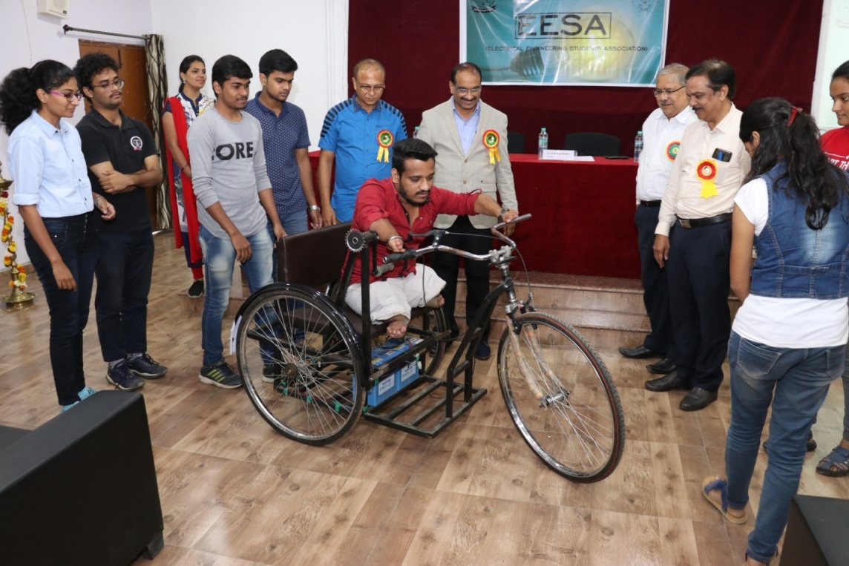

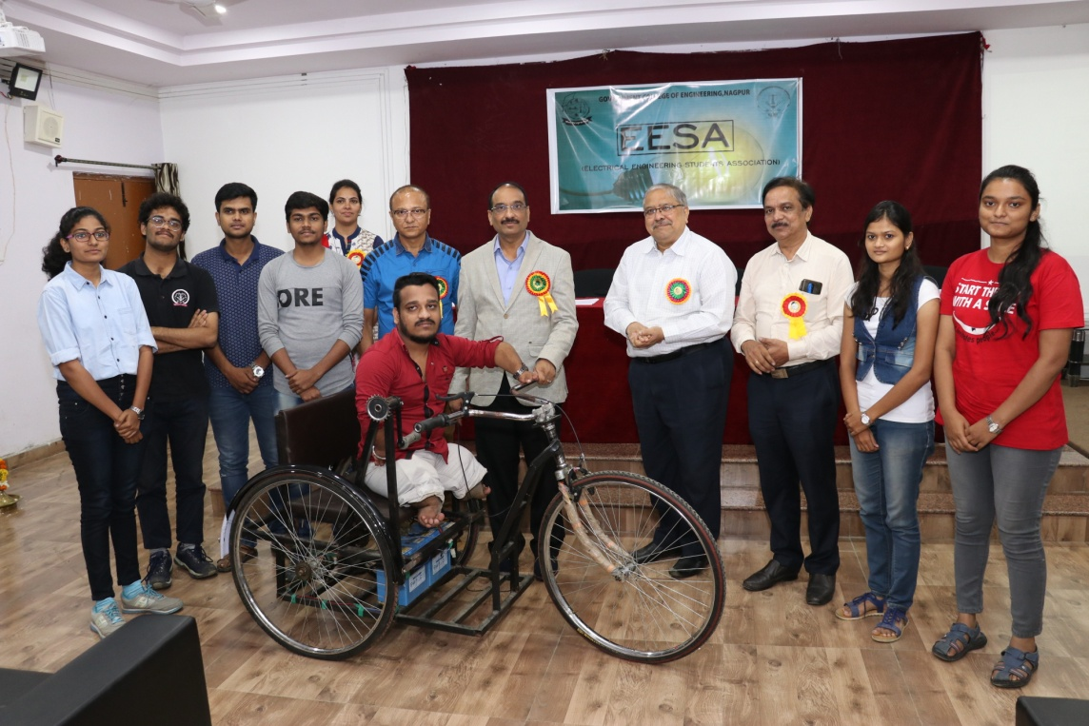
Mr. CHnadrahas Patale riding on the Tri-cycle

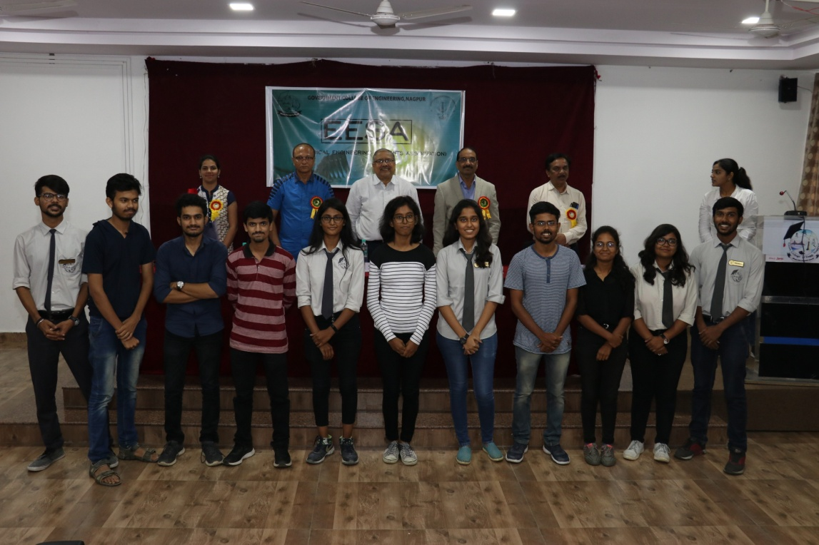
Electrical Engineering Students bringing laurels for the Institute

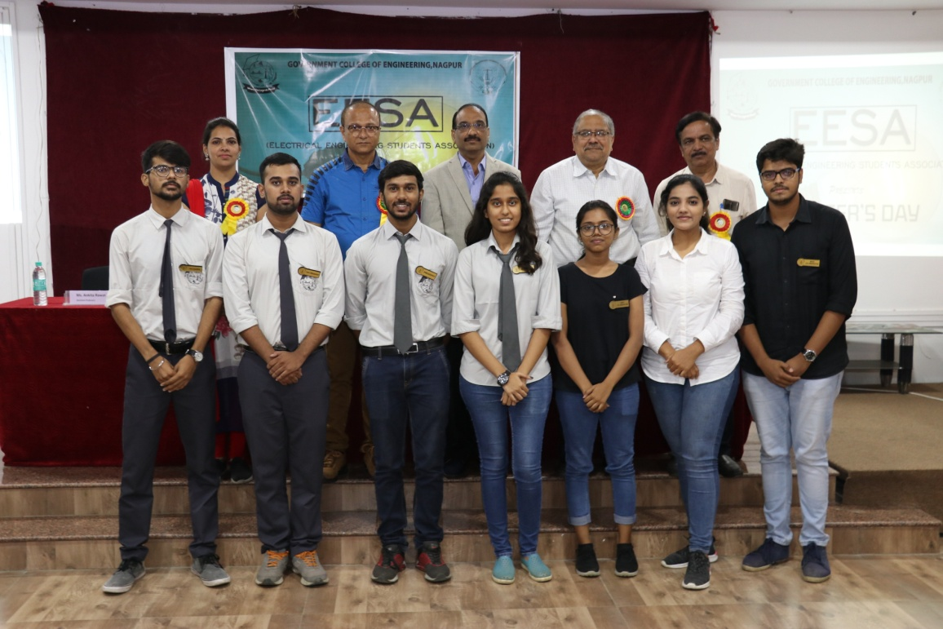
EESA Committee with the Guests

