NSS ACTIVITIES FOR SESSION 2022

Sr No | Name of  Activity | Level of Activity | Name of Coordinator | Duration in Days | Dates | No of  Participants | Supporting  Doc /Photos  Attached
01 | NSS  Orientation  Programme | Institute Level | Prof.S.R.Wagh | 01 |  | 60
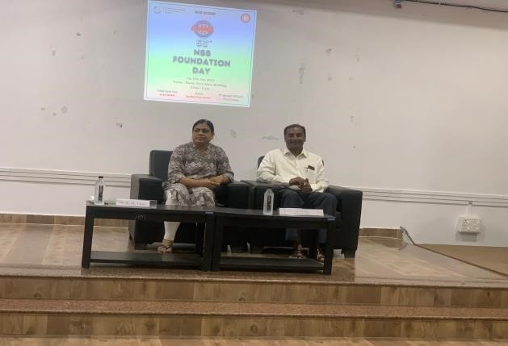
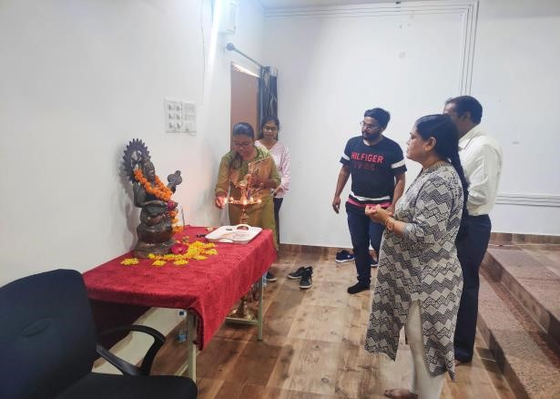
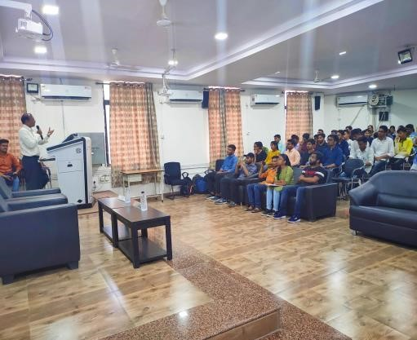

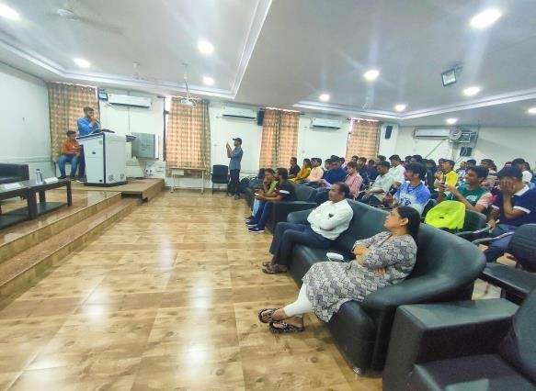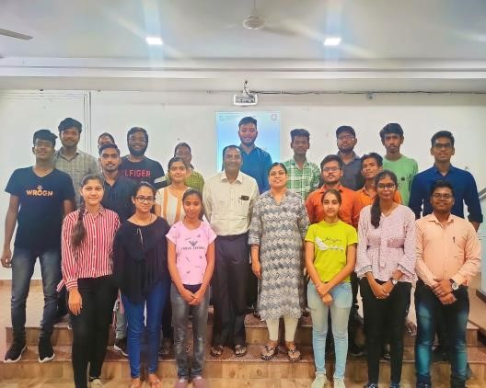

Sr No | Name of  Activity | Level of Activity | Name of Coordinator | Duration in Days | Dates | No of  Participants | Supporting  Doc /Photos  Attached
02 | Har Ghar  Tirangaa  Abiyaan | National Level | Dr R.P.Borkar,Dr K.M.Tajane  & Prof.S.R.Wagh | 15 |  | All  Faculties,Staff and Students of Institute

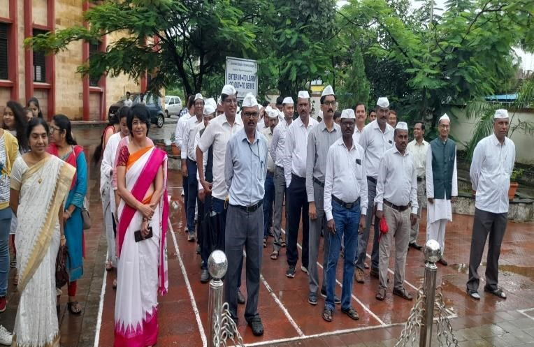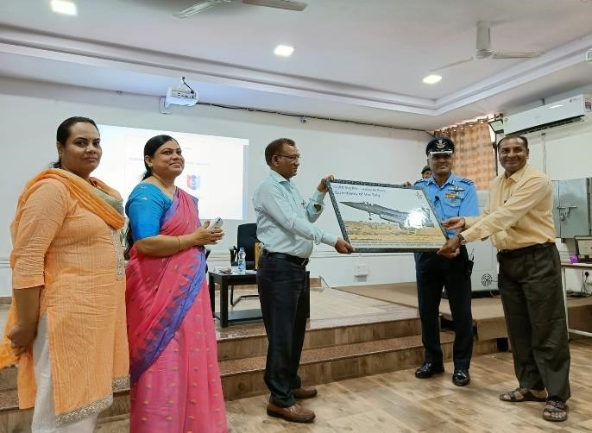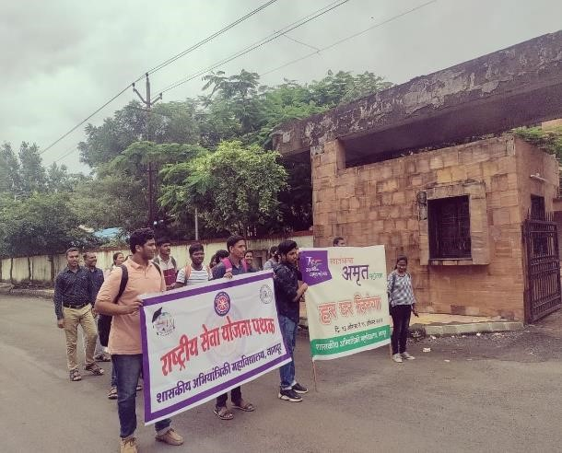

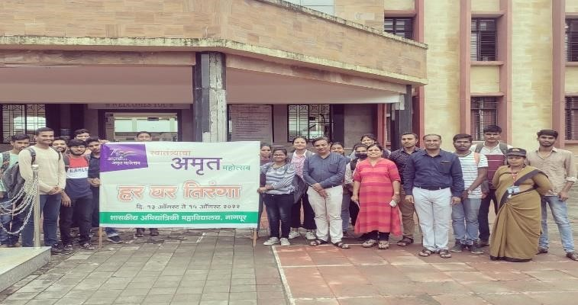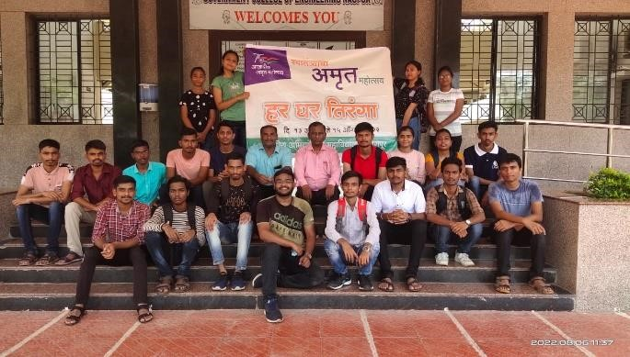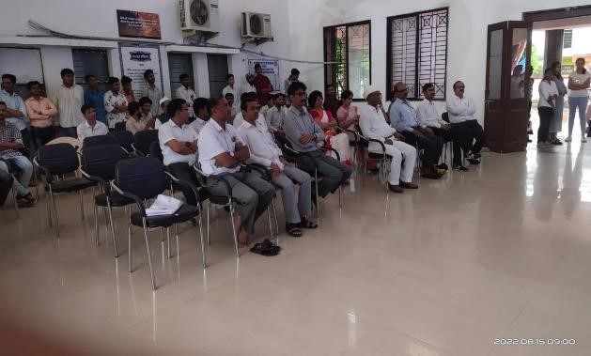

Sr No | Name of  Activity | Level of Activity | Name of Coordinator | Duration in Days | Dates | No of  Participants | Supporting  Doc /Photos  Attached
03 | Plantation | Institute Level | Dr R.P.Borkar,  Dr K.M.Tajane  & Prof.S.R.Wagh | 01 |  | All  Faculties,Staff and Students of Institute

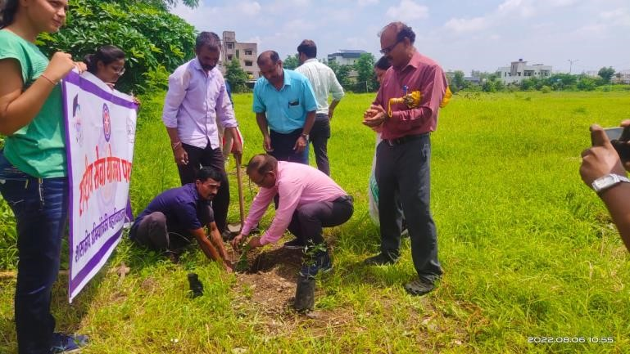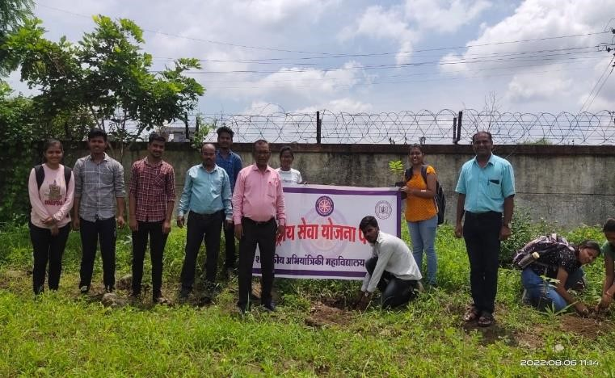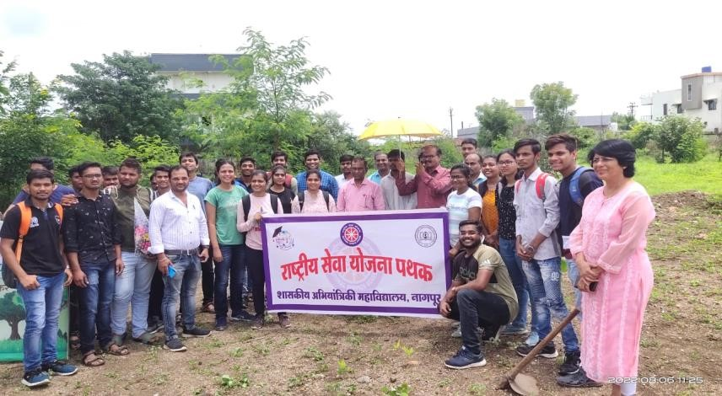

Sr No | Name of Activity | Level of Activity | Name of Coordinator | Duration in Days | Dates | No of Participants | Supporting  Doc /Photos  Attached
04 | Ekta Diwas Celebration | National Level | Dr R.P.Borkar,Dr K.M.Tajane  & Prof.S.R.Wagh | 01 |  | All Faculties,Staff and Students of Institute
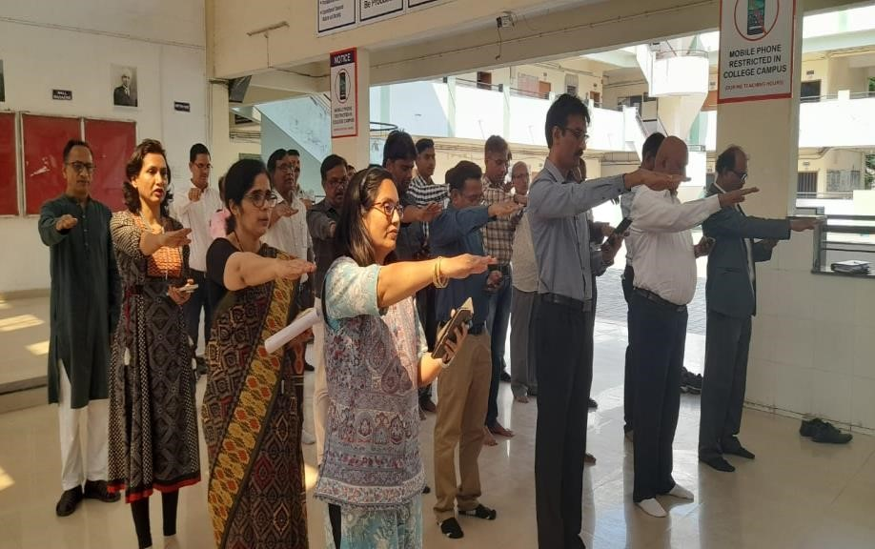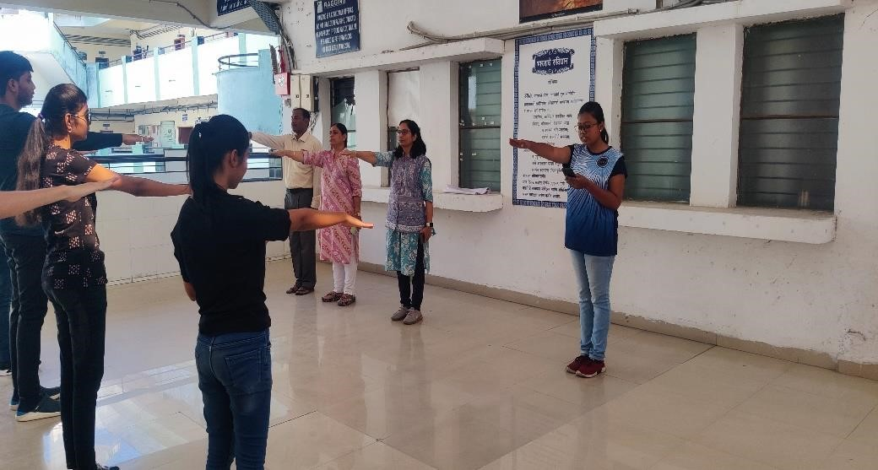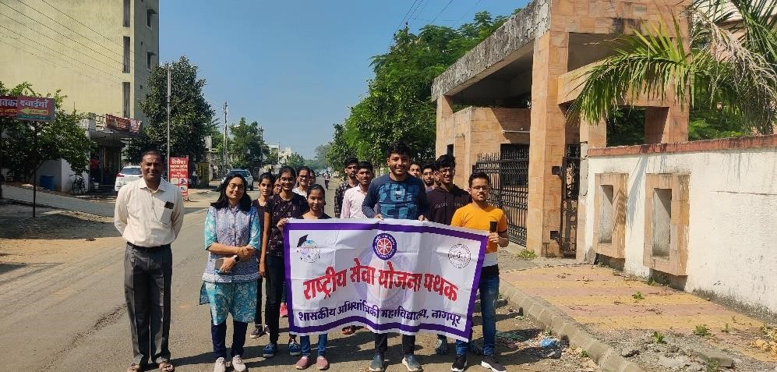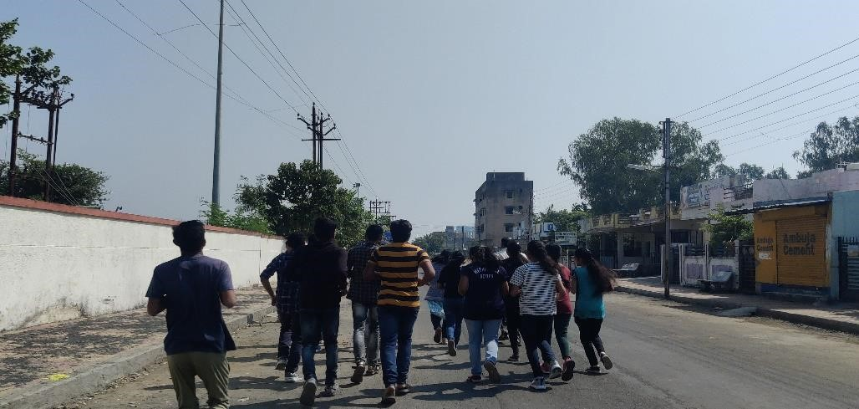

Sr No | Name of Activity | Level of Activity | Name of Coordinator | Duration in Days | Dates | No of Participants | Supporting  Doc /Photos  Attached
05 | White Cane Day | Institute Level | Dr K.M.Tajane, Prof S.R.Wagh and NSS Students | 1 |  | All NSS  Volunteers

WHITE CANE DAY
NSS GCOEN celebrated White Cane Day by highlighting the importance of the day and by sharing information and facts regarding white cane on the official Instagram handle of NSS GCOEN. A white cane in particular legally identifies someone as blind or visually impaired. This is most important as an indicator to motorists that a pedestrian may not be able to see them.
White canes are important mobility tools for their users. White canes allow people who are blind, DeafBlind, or visually impaired to navigate the world around them safely and independently.

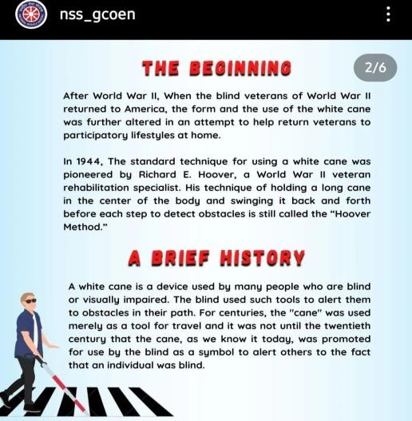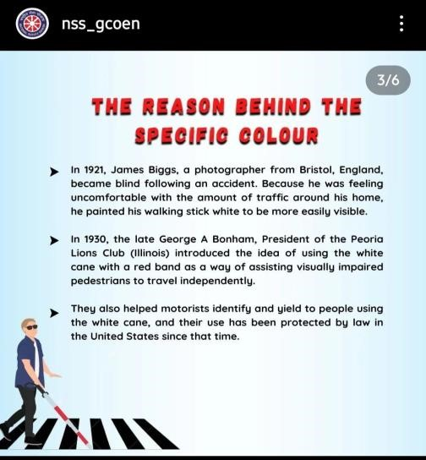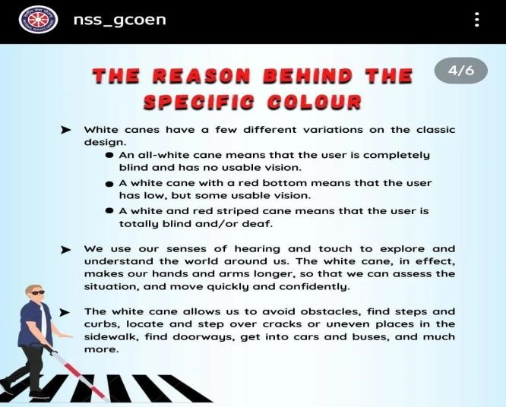

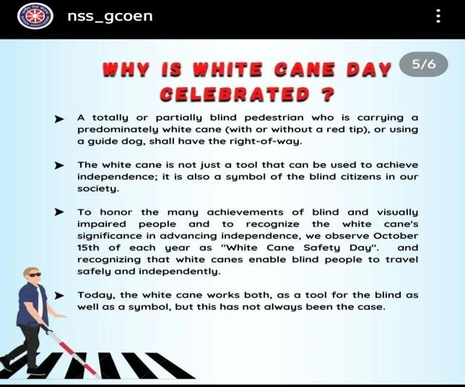

Sr No | Name of Activity | Level of Activity | Name of Coordinator | Duration in Days | Dates | No of Participants | Supporting  Doc /Photos  Attached
06 | Book Donation Drive | Institute Level | Dr  K.M.Tajane,Prof S.R.Wagh and  NSS Students | 1 | 7/11/2022 | All NSS  Volunteers

NSS GCOEN organized BOOK DONATION DRIVE for Needy on 7/11/2022 from 12:30 pm onwards. Students,Faculties and Office Staff participated by donating books .
Books Accepted for donation were
1.Dharmik (All Languages )
2.School/College text books (Any language, Any class)
3.Notebooks (Half filled)
4.Story Books (Any language)
5.Any other the donor wish to donate from their side
NSS GCOEN will donate received books to Orphanages, Old Age Homes and students who require them.

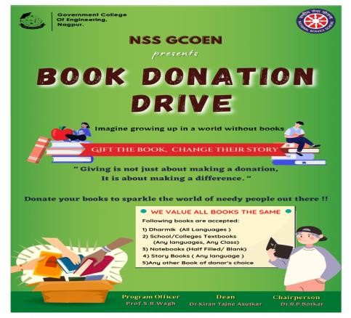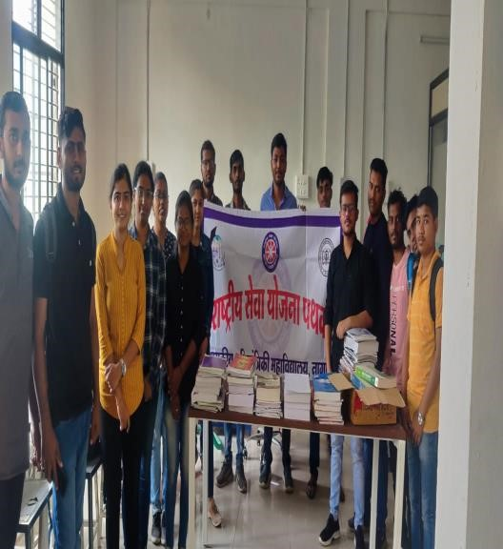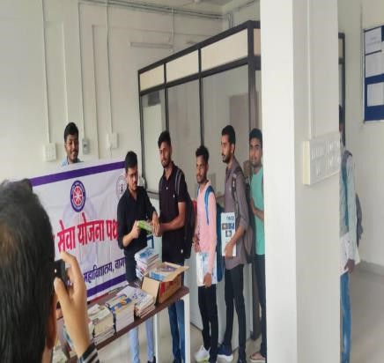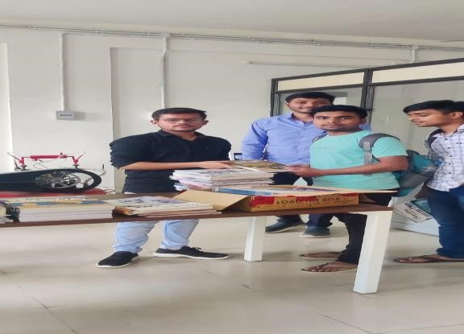

Sr No | Name of  Activity | Level of Activity | Name of Coordinator | Duration in Days | Dates | No of Participants | Supporting  Doc /Photos  Attached
07 | Republic Day Celebration | Institute Level | Dr R.P.Borkar  Dr K.M.Tajane,Prof  S.R.Wagh and NSS  Students | 1 | 26/01/22 | 50

On the occasion of Republic Day NSS team organised Programme in college premises that includes Preamble Reciting, by Students and Faculty Members.After that NSS volunteers and other students sang patriotic songs on the occasion.Also Poetry Writing competition and drawing competition was organised by NSS Unit.

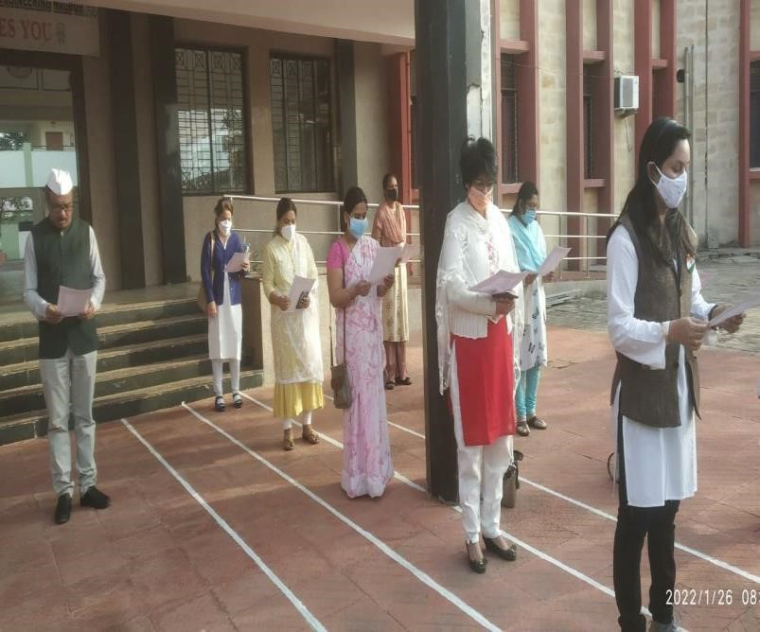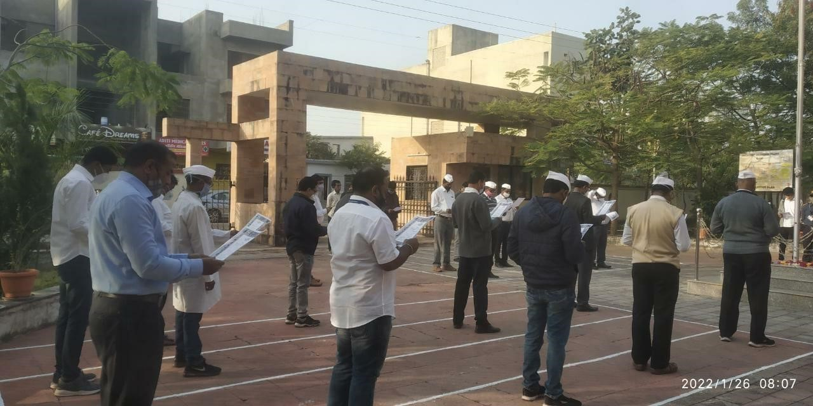

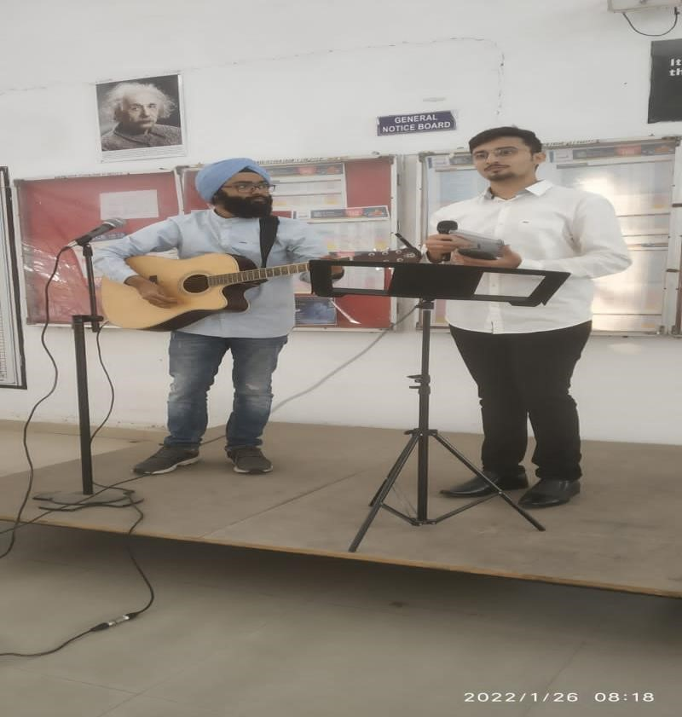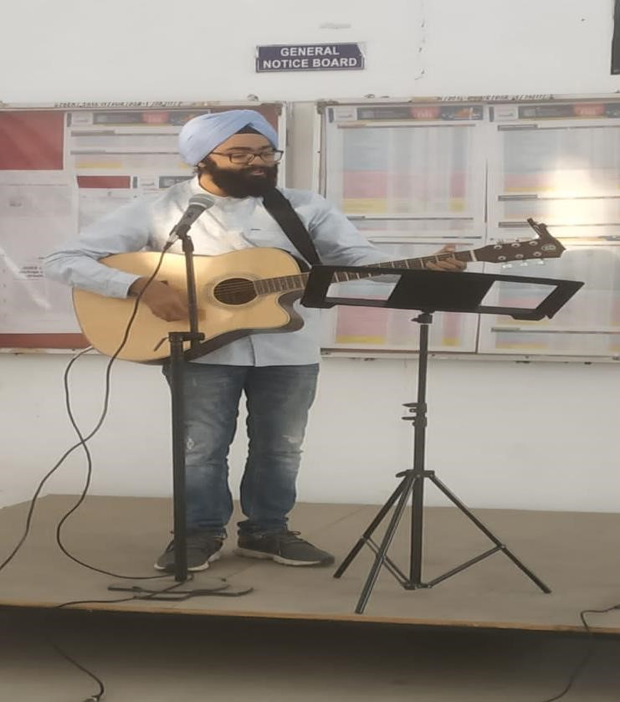

Sr No | Name of Activity | Level of  Activity | Name of Coordinator | Duration in Days | Dates | No of Participants | Supporting  Doc /Photos Attached
08 | World  Enviornment  Day | Institute Level | Dr K.M.Tajane,Prof  S.R.Wagh and NSS Students | 1 | 05/06/22 | 50

On June 05;2022 NSS Students celebrated World Enviornment Day.Students carried out plantation at their houses.Following are some photographs

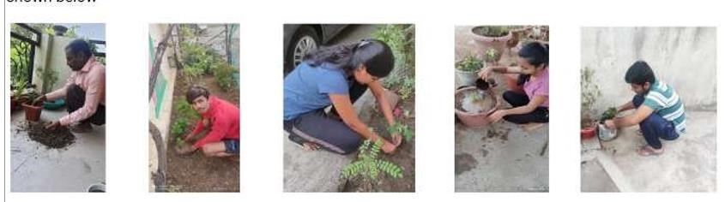
Sr No | Name of Activity | Level of Activity | Name of Coordinator | Duration in Days | Dates | No of Participants | Supporting  Doc /Photos  Attached
09 | International  Yoga Day | Institute Level | Dr K.M.Tajane,Prof  S.R.Wagh and NSS Students | 1 | 05/06/22 | 50
International Yoga day was celebrated by NSS Unit and other students. On this occasion Felicitation of one of NSS Volunteer who won Gold Medal in Triathlon event. After this Importance of Yoga Day was explained to students.Through out the week yoga was Celebrated. One of the faculty Member Prof M.S.Satpute imparted proper training of yoga to students.
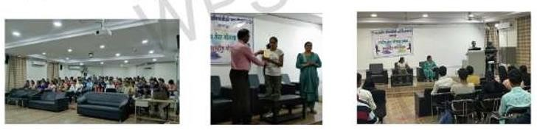
Sr No | Name of Activity | Level of Activity | Name of Coordinator | Duration in Days | Dates | No of Participants | Supporting  Doc /Photos  Attached
10 | Independence Day | Institute Level | Dr K.M.Tajane,Prof  S.R.Wagh and NSS Students | 01 | 15/08/22 | 70

This year 15 Th August was Celebrated 75Th Independence day as Azadi ka Amrut Mahotsav.Under this theme NSS Unit arranged different programmes in institute. The programme included Patriotic song sung by music club of college, poetry recital and speeches by NSS Volunteer giving an information on how Har Ghar Tiranga was executed and atmosphere was full of patriotism on the day.

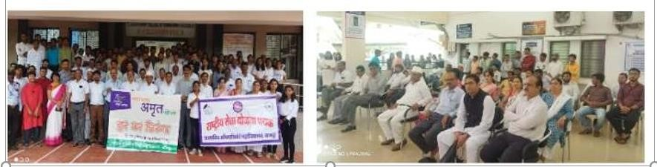
Sr No | Name of  Activity | Level of Activity | Name of Coordinator | Duration in Days | Dates | No of Participants | Supporting  Doc /Photos  Attached
11 | Teacher’s Day Celebration | Institute Level | Dr K.M.Tajane,Prof  S.R.Wagh and NSS Students | 01 | 05/09/22 | 40

On 5 Th September special programme was arranged by students for all teachers. Students Presented rose to teachers. Students were given chance to express their feelings towards teachers. Prof Vivek Nanoti well known teacher was invited as chief guest.

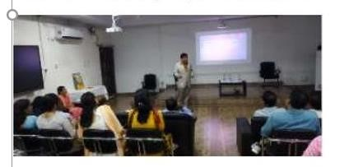

SPORTS ACTIVITIES FOR SESSION 2022

SUCCESFUL INNAUGRATION OFSPORTS WEEK ‘SFOORTI’ 2022 OF GCOEN
Sr No | Name of  Activity | Level of Activity | Name of Coordinator | Duration in Days | Dates | No of Participants | Supporting  Doc /Photos  Attached
01 | Sports Events | Institute Level Level | Dr K.M.Tajane & Prof.S.R.Wagh | One week | 16 Th – 21 St  March 2022 | Students of Institute

Once again it is felt that Government Engineering College, Nagpur is continuously striving for the overall development of the college students. On 15th March 2022 Ranji Trophy Player renowned former Indian Cricket Team Player Shri. Prashant Vaidya, the Principal of the Institute Dr. R.P.Borkar inaugurated "Sfoorti 2022" . This year, the Sfoorti was scheduled from 16 to 21 March. Sfoorti gets the multitude of participants in 11+ sports competitions. This year the sports included Cricket, Football, Kabaddi, Kho-Kho, Volleyball, Tug of War, Relay, Badminton, Chess, Carrom,Table-Tennis. The inauguration was conducted with great enthusiasm and spirits in the presence of teaching staff, non-teaching staff and students. The program started with the lighting of the torch by the chief guest. During the program the NCC team, student sports coordinators and also the students participating in various sports conducted a disciplined march. In the inauguration the principal of the institute emphasized the importance of versatile personality in modern as well as competitive era. Also the chief guest of the program Mr. Prashant Vaidya in his orientation speech gave detailed information about the mental and physical benefits of various sports to the students. The vote of thanks for the program was done by , student representative of the college. The program was moderated by Sunil Mane , Sport Secretary of Student Welfare Committee and Onkar Khumbhar, President to make the program successful. Dr. K.M.Tajne ,SWC Dean;S. Tekade, technical cordinator; Dr. C. P. Kalambe , Dr. R.R.Choudhary, Dr. D.B. Daigavane and also in-charge of sports department in the institution Prof. S. R Wagh, student sports coordinator and his team contributed to the success of the program. The program mainly benefited from the presence of department heads, teaching and non-teaching staff of the college.
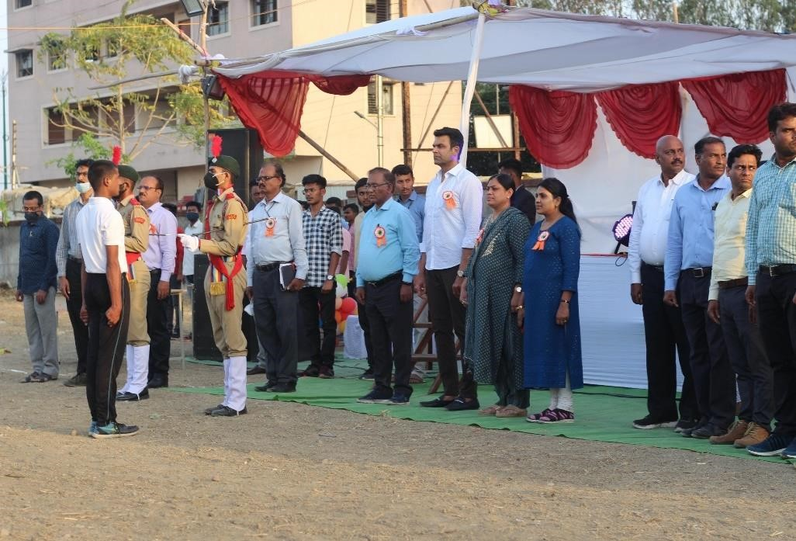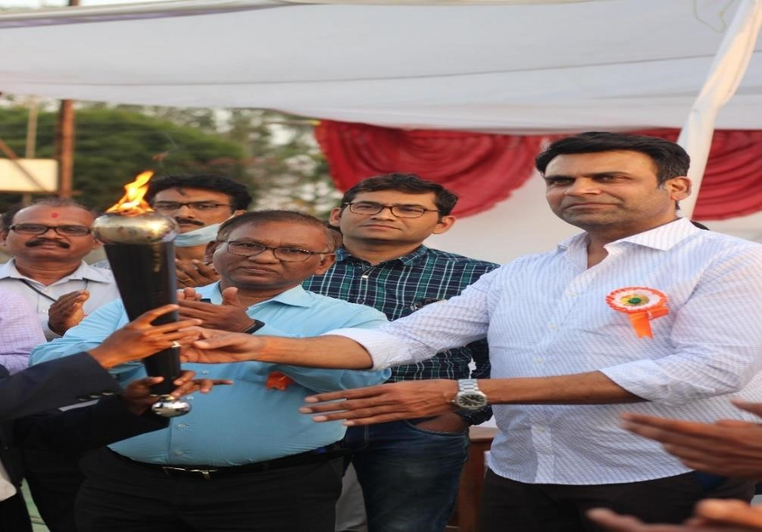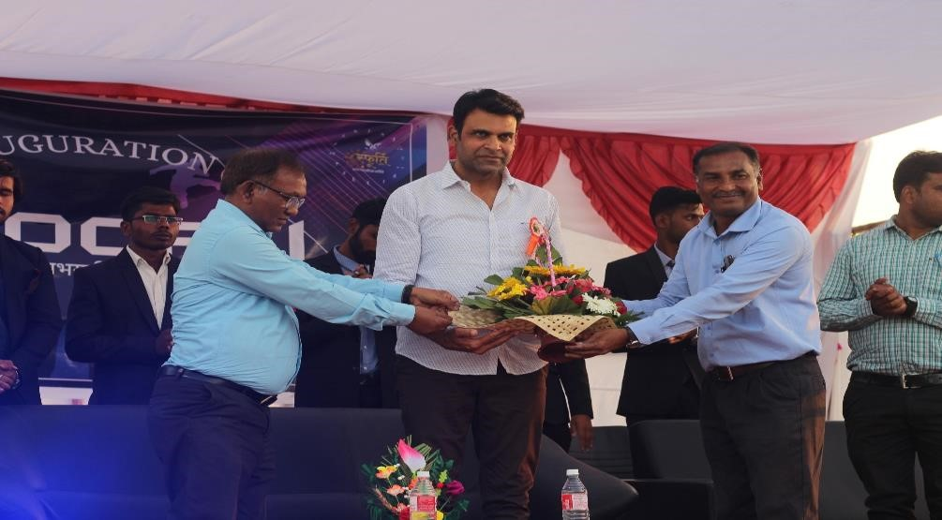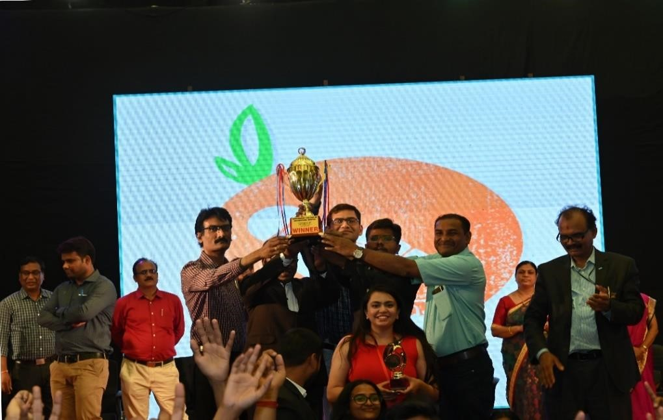

NCC ACTIVITIES FOR SESSION 2022

Sr No | Name of Activity | Level of Activity | Name of Coordinator | Duration in Days | Dates | No of Participants | Supporting  Doc /Photos  Attached
01 | Har Ghar Tiranga | National Level | Dr K.M.Tajane & Prof.S.R.Wagh | 2 weeks | 13 th – 15 th August 2022 | Faculties,Staff and Students of Institute

POSTER PREPRATION
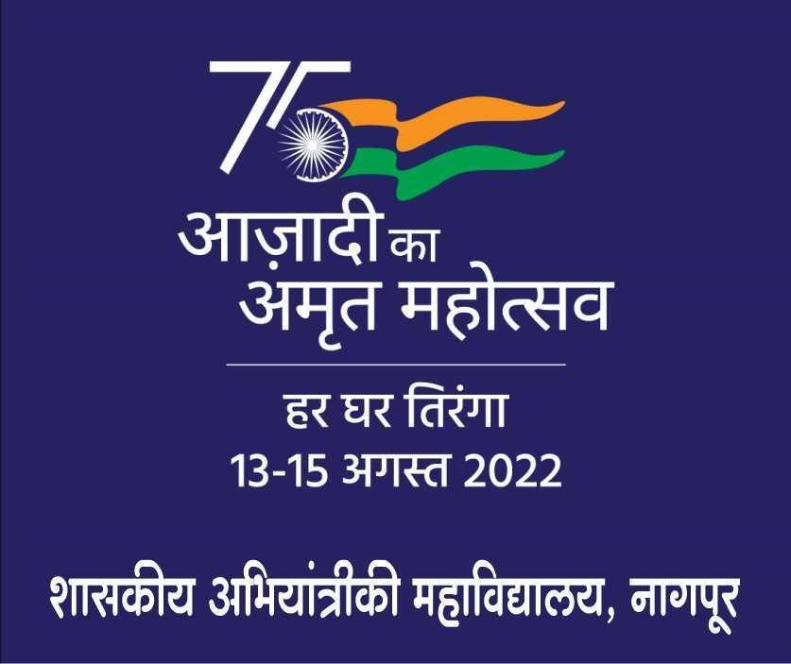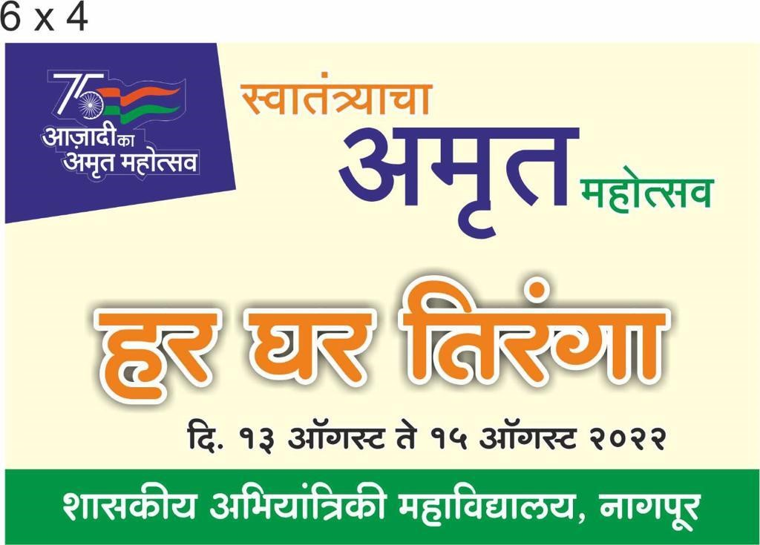
HAR GHAR TIRANGAA CAMPAIGN
BY NSS & NCC VOLUNTEERS
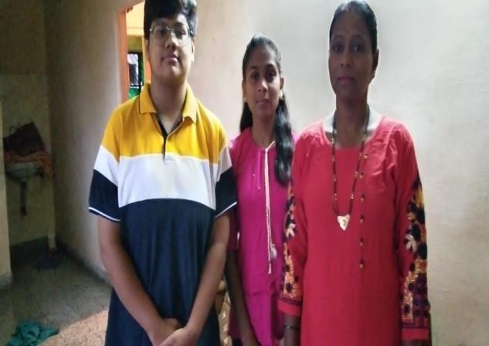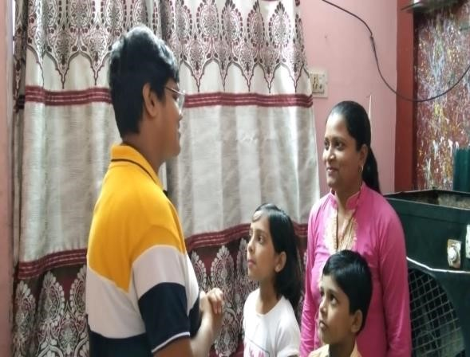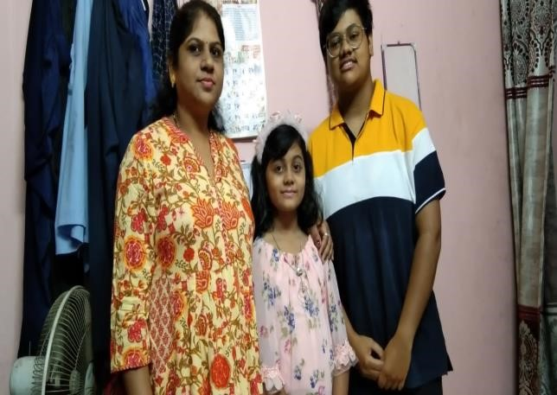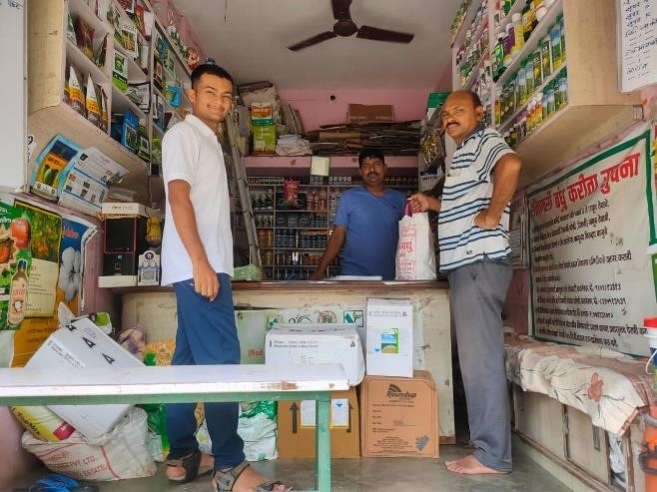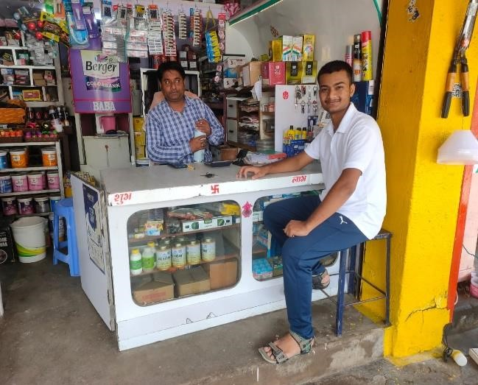

LECTURE BY AIR WING GROUP CAPTAIN
HON.D BHARATH
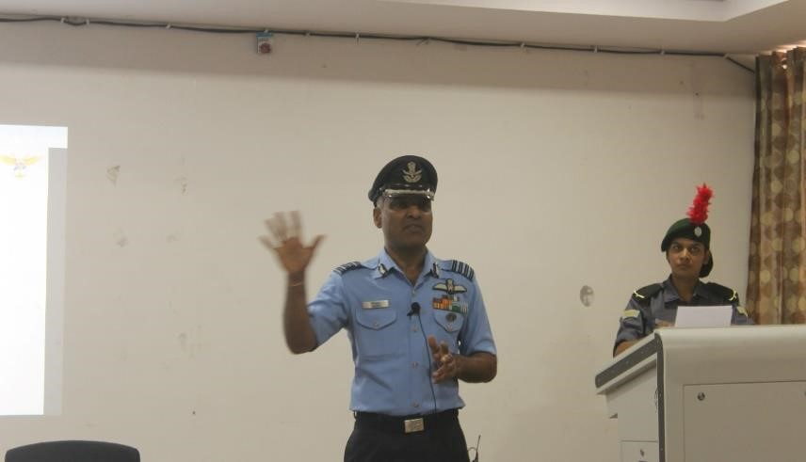
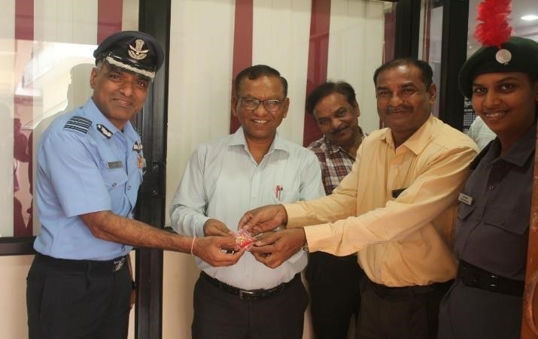
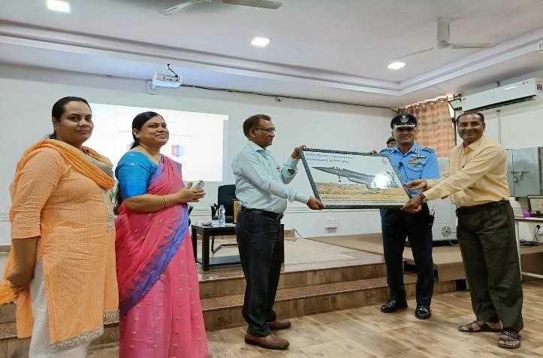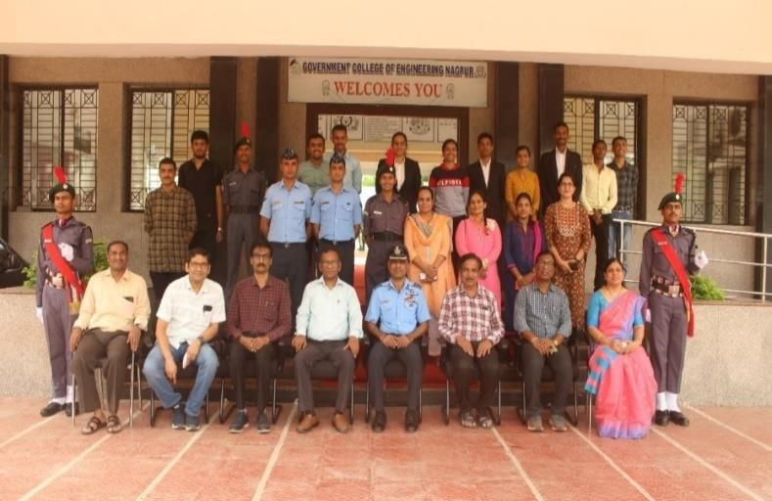

SPEECH BY HON.PRINCIPAL
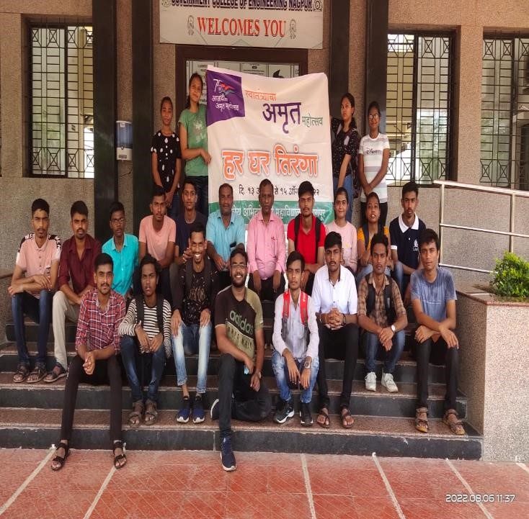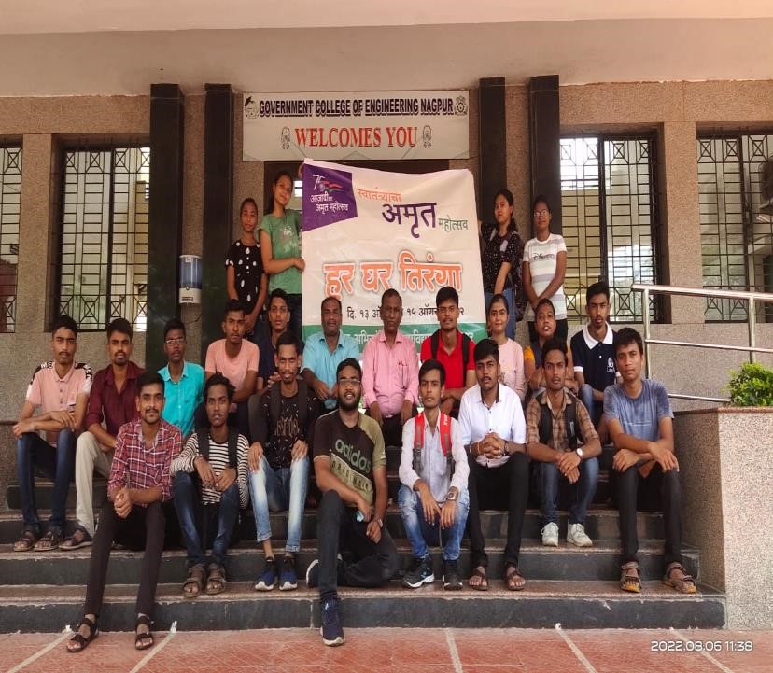

FLAG HOISTING_COLLEGE CAMPUS
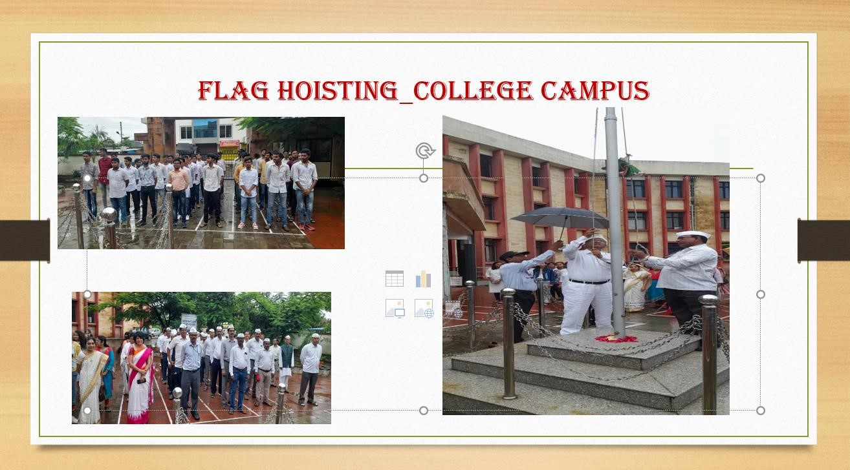

HAR GHAR TIRANGA WITH SELFIE

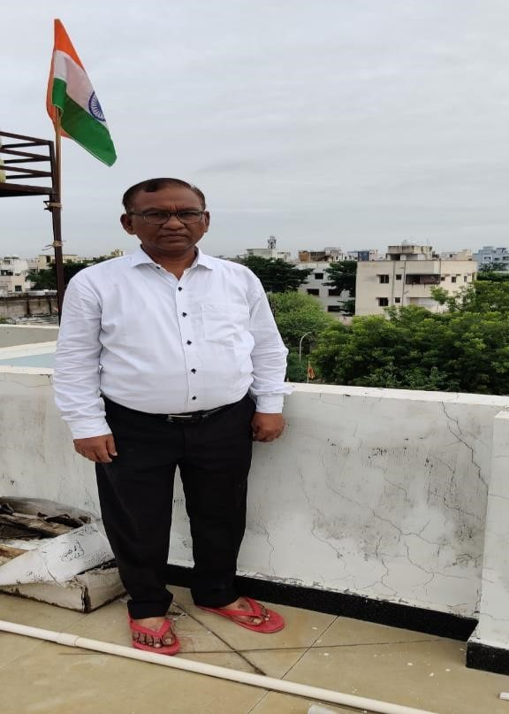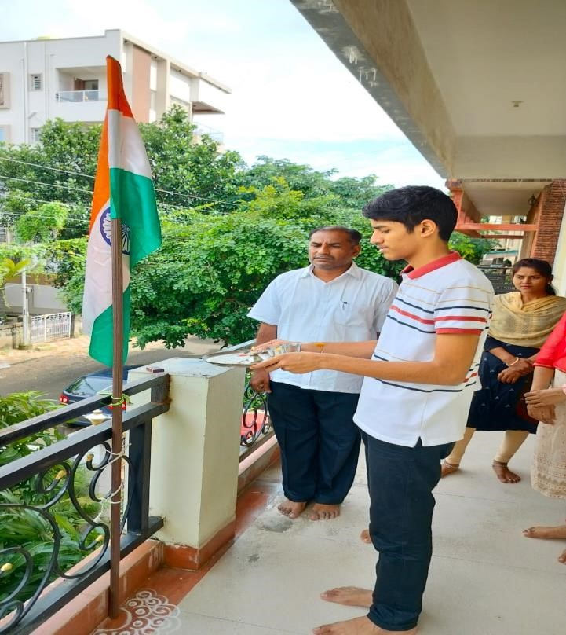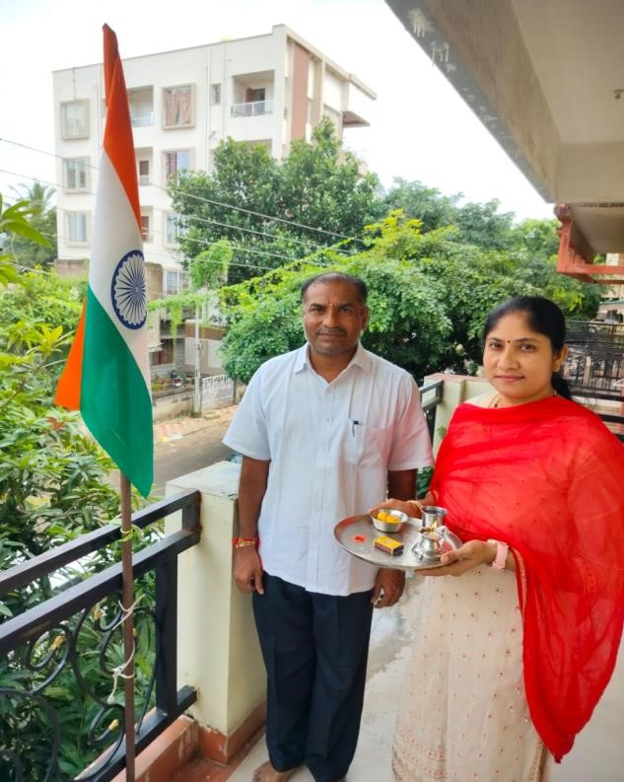

PATRIOTIC SPEECHES ON HAR GHAR TIRANGAA
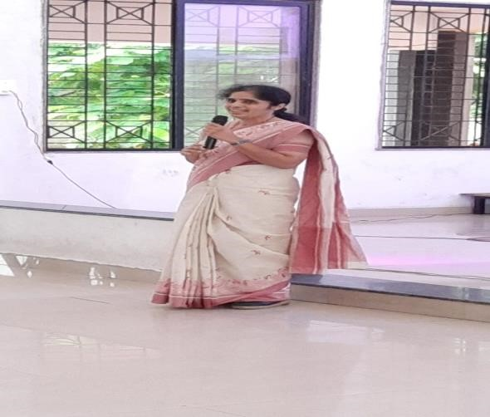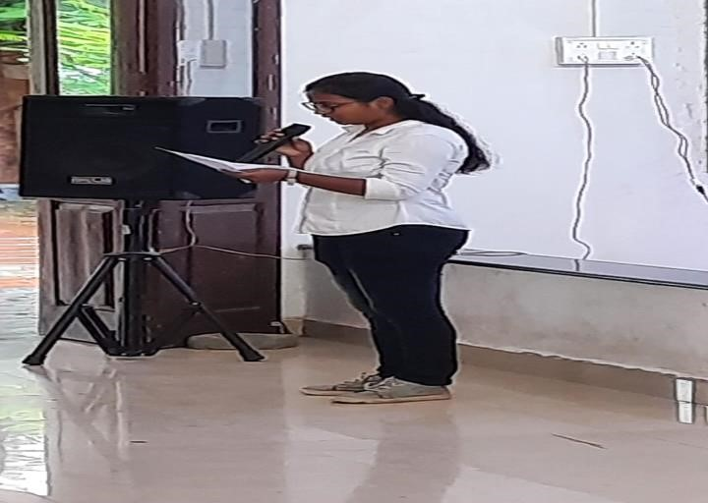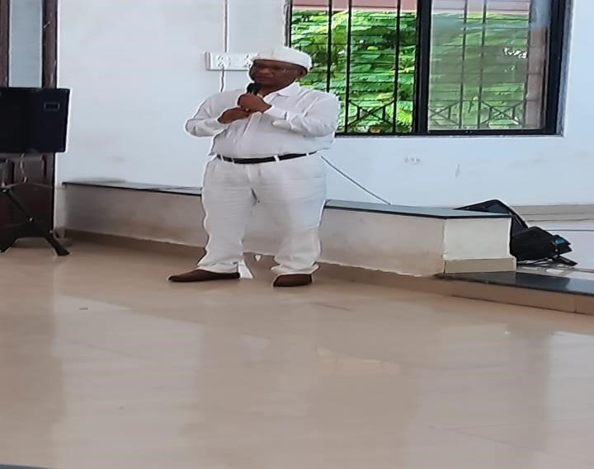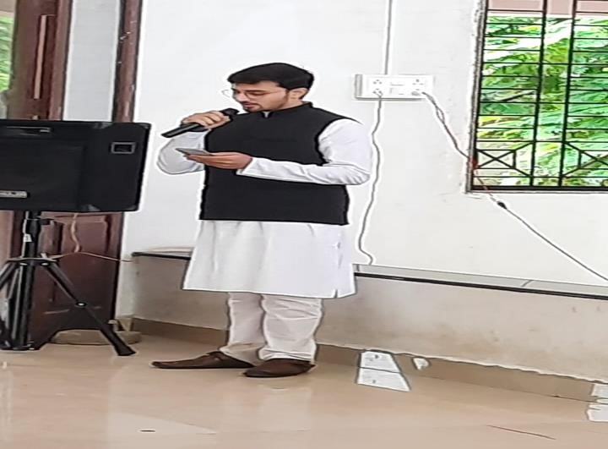

PATRITIC SONGS
