GOVERNMENT COLLEGE OF ENGINEERING NAGPUR
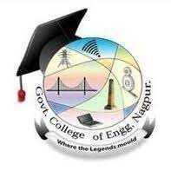
COMSA – YEARLY REPORT
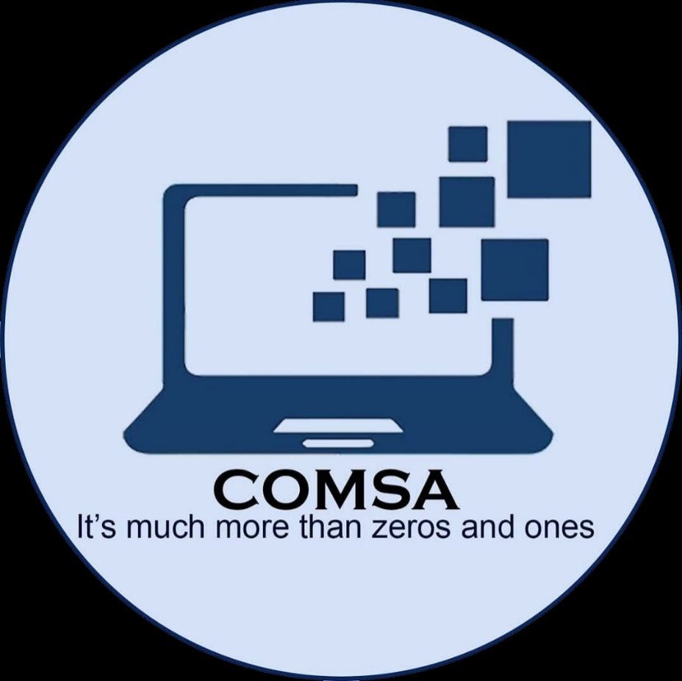
2024-2025

Head of Department – Dr. Latesh Malik
Faculty Coordinator – Dr. P. B. Jawade

About COMSA
COMSA (Computer Science and Engineering Students Association) is a student-run organization at Government College of Engineering Nagpur (GCOEN). It serves as a platform for students pursuing computer science and engineering to come together, collaborate, and enhance their academic and extracurricular experiences. COMSA plays a vital role in fostering a sense of community and promoting the overall growth and development of its members.

Objectives:
Academic Support: COMSA aims to provide academic support to its members by organizing workshops, seminars, and guest lectures on various topics related to computer science and engineering. These activities help students broaden their knowledge, stay updated with the latest advancements, and develop their technical skills.

Skill Development: The association focuses on enhancing the technical and soft skills of its members. COMSA organizes coding competitions, hackathons, and programming contests to sharpen problem-solving abilities and programming expertise. Additionally, workshops on communication skills, leadership, and teamwork are conducted to enhance overall personality development.

Industry Interaction: COMSA strives to bridge the gap between academia and the industry. The association facilitates industry visits, invites industry experts for talks and workshops, and organizes career guidance sessions. These initiatives enable students to gain exposure to real-world challenges and stay informed about industry trends and requirements.

Community Building: COMSA plays a pivotal role in building a sense of community and camaraderie among students and faculty members. It organizes social and cultural events, sports tournaments, and annual festivals to foster relationships, encourage teamwork, and promote a healthy work-life balance.

Leadership and Structure:
COMSA operates under the leadership of elected student representatives, including a president, vice-president, secretary, treasurer, and various coordinators responsible for specific domains such as academics, events, public relations, and technical affairs. The representatives work together to plan and execute activities, ensuring the smooth functioning of the association.
COMSA, the Computer Science and Engineering Students Association at Government College of Engineering Nagpur (GCOEN), plays a pivotal role in supporting, nurturing, and enhancing the educational journey of its members. Through its diverse range of activities and initiatives, COMSA fosters academic growth, skill development, industry interaction, community building, and social responsibility. The association continues to make a positive impact on the lives of its members, equipping them with the necessary skills and experiences to excel in the field of computer science and engineering.

Events conducted under COMSA in 2023-24:

Sr. No. | Date | Event
1 | 12/09/24  13/09/24 | 2-Days Workshop on Full-Stack Development
2 | 24/09/24 | High Performance Computing Awareness Workshop
3 | 30/10/24 | WebCraft
4 | 22/01/25 | Webinar on Generative AI by Prof. Virendra Singh
5 | 13/02/25 | Comsa installation and guest lecture by Amit Agarwal sir
6 | 13/02/25 | BIS-COMSA: Safeguarding information on digital age by Hemant Ade sir
7 | 15/02/25 | Industrial visit Persistent System
8 | 21/02/25 | Codeventure
9 | 21/02/25 | BIS-COMSA: Brain- Buster
10 | 03/03/25 | BIS-COMSA - Introduction to the concepts of AI by Sattu Savita mam

- High Performance Computing Awareness Workshop

Date: Tuesday, 24th September 2024
Location: Government College of Engineering Nagpur (GCOE Nagpur)
Mode: Offline

Introduction
The High Performance Computing Awareness Workshop, organized under the AICTE SANKALP initiative, aimed to enlighten students and faculty about the crucial role of high performance computing (HPC) in modern research and industry applications. This workshop provided insights into HPC's fundamentals, emerging trends, and practical applications across various fields.

Event Highlights
Dr. Pradnya Borkar, an esteemed AICTE CDAC Master Trainer, delivered an engaging lecture on high performance computing. She covered essential topics, including HPC architecture, its significance in data-intensive applications, and real-world case studies that showcased successful implementations of HPC in research and industry.
1. Keynote Presentation: Dr. Borkar's presentation provided a thorough overview of HPC, discussing its architecture and capabilities. She highlighted the growing demand for HPC in fields such as climate modeling, genomics, and artificial intelligence.
2. Real-World Applications: The speaker presented several case studies that illustrated how HPC is utilized in various sectors. These examples provided participants with a clear understanding of the practical implications and transformative power of HPC.
3. Hands-On Sessions: Attendees participated in hands-on sessions where they learned to navigate HPC tools and platforms. The practical exercises focused on parallel processing and resource management, enhancing participants’ technical skills.
4. Interactive Panel Discussion: An interactive panel discussion featured Dr. Borkar and other experts who addressed questions from the audience about the future of HPC and its challenges. This dynamic exchange fostered collaboration and knowledge sharing among participants.
5. Networking Opportunities: The workshop provided ample opportunities for students and faculty to connect with industry professionals, facilitating discussions about internships, research projects, and career paths in HPC.
Conclusion
The High Performance Computing Awareness Workshop successfully highlighted the significance of HPC in today’s technological landscape. Attendees left with valuable insights into HPC's capabilities and its critical role in solving complex problems across various domains.
The expertise of Dr. Pradnya Borkar greatly enriched the session, inspiring participants to further explore the field of high performance computing. GCOE Nagpur looks forward to hosting more such initiatives that bridge the gap between education and technological advancements, preparing students for future challenges in this dynamic field.

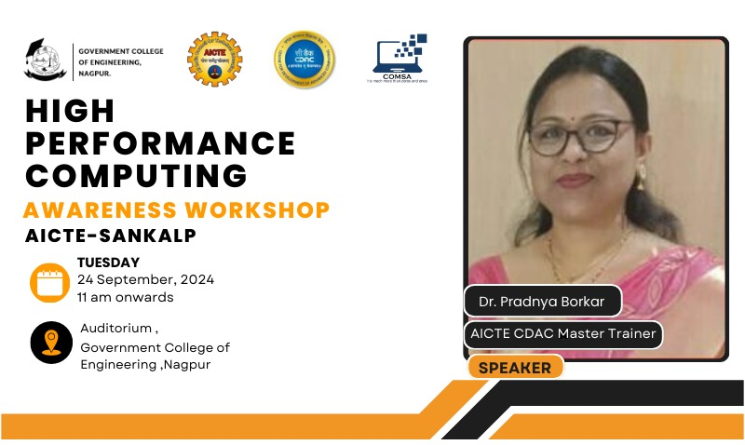
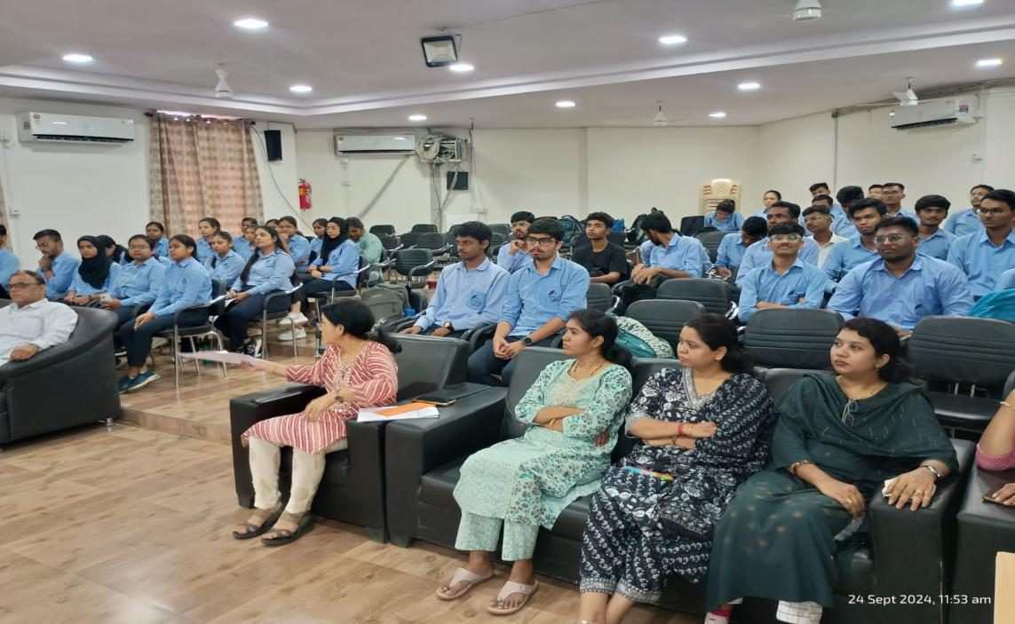

- 2-Days Workshop on Full-Stack Development

Date: Thursday-Friday, 12th - 13th September 2024
Location: CCC (Main Building), Government College of Engineering Nagpur
(GCOE Nagpur)
Mode: Offline

Introduction
The Department of Computer Science and Engineering (CSE) is excited to
announce the successful completion of a 2-day workshop on Full-Stack
Development, aimed at providing students with basics of hands-on experience in
building complete web applications. This workshop covered both front-end and
back-end technologies basics, empowering participants with the skills to create
dynamic, data-driven websites from start to finish.
Event Highlights
Day1: Keynote Session on Full-Stack Development:
The workshop kicked off with an introductory session on Full-Stack Development,
delivered by an industry expert in web technologies. The keynote addressed the
importance of Full-Stack skills in the current job market and provided a roadmap for
becoming a proficient full-stack developer.
• Key Topics Covered:
o Overview of Full-Stack Development: Front-end, Back-end, and
Database.
o Understanding the role of a Full-Stack Developer in modern software
teams.
o The importance of a versatile skill set for building scalable and efficient
web applications.
Day 2: Keynote Session on Full-Stack Development with C#:
The workshop began with an introductory session on the concept of full-stack
development, emphasizing the role of C# in the modern software development
stack. The keynote speaker discussed the architecture and workflow of full-stack
applications, with a focus on using ASP.NET Core to build scalable, highperformance
back-end systems.
• Key Topics Covered:
o Overview of full-stack development and the significance of C# in
modern web applications.
o Introduction to ASP.NET Core, an open-source framework for
building server-side applications with C#.
o Architecture of web applications: how front-end and back-end systems
interact, and the role of APIs in connecting them.
Conclusion
The 2-day Full-Stack Development workshop was a highly valuable learning
experience, providing students with the knowledge and practical skills needed to
build robust web applications using C# and ASP.NET Core. By the end of the
workshop, participants were equipped with the tools and techniques needed to
pursue further learning and professional growth in full-stack development. The
workshop not only enhanced their technical proficiency but also fostered a deeper
understanding of how web applications are designed, built, and deployed.

3) WebCraft
Date: 30th October 2024
Venue: Government College of Engineering Nagpur (GCOEN)
Mode: Online

Introduction:
WebCraft, a web development competition organized by the Computer Science and Engineering Student Association (COMSA) at the Government College of Engineering Nagpur, provided students with an exciting platform to showcase their web development skills through three engaging rounds.

Event Overview:
The event attracted enthusiastic participants eager to challenge themselves and improve their web development expertise. Each round of the competition tested different aspects of web development knowledge and creativity.

Rounds:
- WebMaster Quiz Battle: The first round tested participants' theoretical knowledge of web development concepts through a quiz. It set the tone for the competition by evaluating fundamental web-related topics.
- Design & Code Duel: In the second round, participants were given a mystery shape or design to code. This round assessed their coding abilities and creativity in transforming abstract ideas into functional web elements.
- The Secret Twist: The final round added an element of surprise, challenging participants to adapt quickly to unexpected tasks that pushed their problem-solving skills to the limit.

Outcome:
The event was a resounding success, with participants demonstrating remarkable technical acumen and creativity. It provided a dynamic learning experience, encouraging students to think on their feet and apply their knowledge in real-time scenarios.

Conclusion:
WebCraft not only celebrated the art of web development but also fostered a spirit of innovation and collaboration among students. The event concluded with recognition for top performers and appreciation for all participants who showcased their talents and passion for web development.

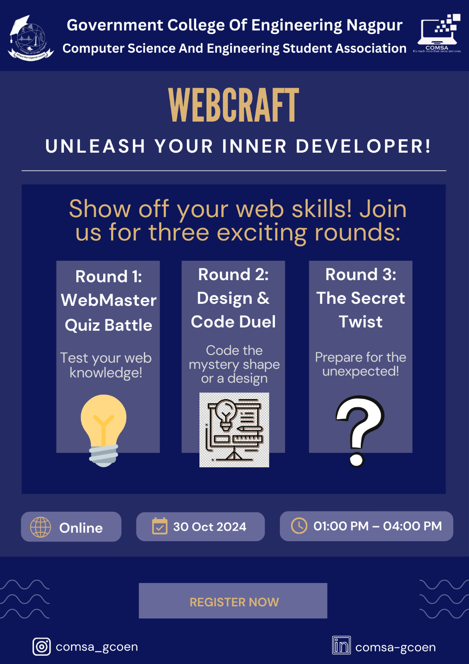

4)WEBINAR ON GENERATIVE AI

Date: 22nd January 2025
Venue: Government College of Engineering Nagpur (GCOEN)
Mode: Online

Event Overview:
The Computer Science Student Association (COMSA) of Government College of Engineering, Nagpur, successfully organized an online workshop on Generative AI on January 22, 2025. The workshop featured Prof. Virendra Singh, a renowned professor from IIT Bombay, as the guest speaker. The session aimed to provide participants with a deep understanding of the concepts, applications, and future potential of Generative AI.

Workshop Objectives:
The main objectives of the workshop were to:
- Introduce the fundamental concepts of Generative AI and its applications.
- Provide an overview of Generative AI models such as Generative Adversarial Networks (GANs), Variational Autoencoders (VAEs), and Transformers.
- Discuss the real-world use cases and ethical implications of Generative AI.
- Offer practical insights and resources to help students explore this field further.

Session Highlights:
The workshop covered a range of topics, which were explained in detail by Prof. Singh:
- Introduction to AI and Machine Learning:
  - Prof. Singh started by providing an overview of artificial intelligence and machine learning, explaining the foundational concepts that led to the development of Generative AI.
- Generative AI Models:
  - Prof. Singh explained the various Generative AI models, including:
    - Generative Adversarial Networks (GANs)
    - Variational Autoencoders (VAEs)
    - Transformers
  - He also demonstrated how these models are used to generate new content such as text, images, and music by learning patterns from existing data.
- Real-World Applications of Generative AI:
  - Prof. Singh highlighted several real-world applications of Generative AI, including:
    - Entertainment Industry: For generating realistic graphics in movies and video games.
    - Healthcare: In drug discovery by generating new molecular structures.
    - Art & Creativity: Creating original pieces of art, music, and writing.
- Ethical Implications:
  - Prof. Singh also addressed the ethical challenges associated with Generative AI, such as:
    - The potential for creating deepfakes and spreading misinformation.
    - Concerns regarding intellectual property and the authenticity of AI-generated content.
  - He emphasized the importance of responsible AI development and the need for policy and regulation to address these concerns.
- Tools and Frameworks:
  - Prof. Singh provided an introduction to several tools and frameworks used for building Generative AI models, including popular libraries such as TensorFlow and PyTorch.
  - He shared valuable resources for students to explore and experiment with Generative AI on their own.

Conclusion:
The workshop concluded with a Q&A session, allowing students to interact with Prof. Singh and gain further insights into the topics discussed. Overall, the event was a tremendous success, with participants gaining a thorough understanding of Generative AI and its wide range of applications.
This workshop was an excellent opportunity for students of Government College of Engineering, Nagpur to explore one of the most exciting fields in computer science. The COMSA team extends its sincere thanks to Prof. Virendra Singh for his valuable contribution and to all participants for their active participation.

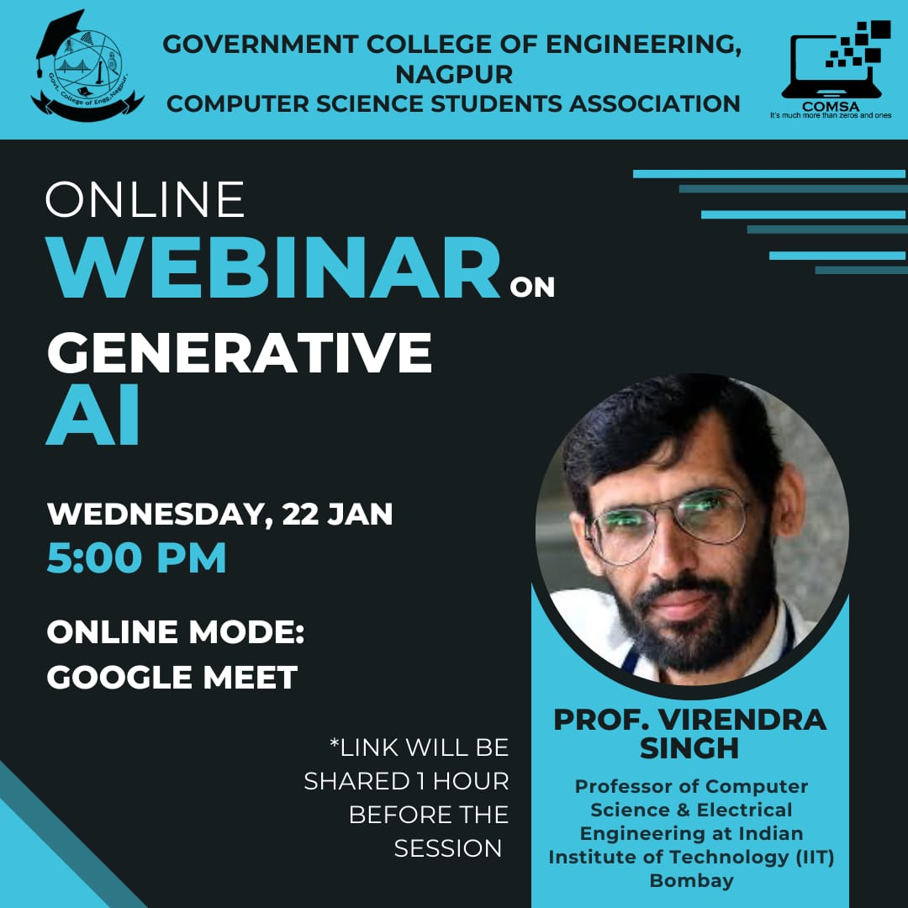

5) COMSA Installation and guest lecture

Date: 13th Feb 2025
Venue: Auditorium, Government college of engineering, Nagpur
Mode: Offline
Introduction
- The COMSA event installation was held to honour the outgoing committee and welcome the new team, celebrating the achievements of the Computer Science Student Association.
- The event was anchored by Shivani and Namrata, who set a warm and appreciative tone for the ceremony.
Event Flow and Highlights
- Opening Remarks:
Shivani welcomed guests, faculty, and students, emphasizing gratitude for the outgoing committee's contributions.
Namrata highlighted the importance of teamwork in achieving the association's goals.
- Calling the Guests:
Dignitaries Mr. Amit Agrawal, Dr. Latesh Malik, and Dr. Jawade were invited to the stage.
- Lamp Lighting Ceremony:
The ceremonial lamp lighting was conducted to symbolize the spread of knowledge and wisdom.
- Guest Introduction:
Shivani introduced Mr. Amit Agrawal, detailing his professional background and contributions to the community.
- Guest Facilitation:
Dr. Latesh Malik presented Mr. Agrawal with a token of appreciation.
4. Acknowledging the Previous Year’s Committee
The achievements of the outgoing committee members for the year 2023-24 were recognized.
Dr. Latesh Malik honoured the committee members, including:
  - President: Priya Nandanwar
  - Vice President: Devansh Parapalli
  - Secretary: Sahil Kuhikar
  - Treasurer: Rushikesh Ghawghawe
  - And others.
Speech by Dr. Latesh Malik
Dr. Malik shared inspiring words, reflecting on the committee's achievements and the importance of continued dedication.
Welcoming the New Committee
The new committee members were introduced and entrusted with the responsibility of leading the association.
Mr. Amit Agrawal presented badges and letters of appointment to the new committee members, including:
  - President: Sanika Jaolekar
  - Vice President: Ketan Baitule
  - Secretary: Aditya Shinde
  - And others.
Speech by the New President
Sanika Jaolekar presented the mission and vision of COMSA, outlining future goals and aspirations.
COMSA Website Launch
Dr. Latesh Malik officially launched the COMSA website, emphasizing
Its significance as a representation of student projects and achievements.
Achievements Section
Mr. Chandrajeet Borkar presented the achievements of COMSA members in various competitions and projects, celebrating their hard work and innovation.
Guest Lecture
Mr. Amit Agrawal delivered a guest lecture, sharing insights from his professional journey, which was well-received by the audience.
Q&A Session
An interactive session followed the guest lecture, allowing attendees to ask questions and engage with Mr. Agrawal.
Vote of Thanks
The Vice President, Mr. Ketan Baitule, presented the vote of thanks, expressing gratitude to all participants and guests.
Conclusion
The event concluded with a message of enthusiasm and determination for the future, encouraging all members to work together towards common goals. Special thanks were extended to all dignitaries, faculty members, committee members, and attendees for their contributions to the event's success.

- BIS-COMSA: Safeguarding information on digital age

Date: February 13, 2025
Venue: Room No. 211, Annex Building
Organized by: Bureau of Indian Standards (BIS)
On February 13, 2025, the Bureau of Indian Standards (BIS) conducted an insightful session on Cloud Computing, led by Mr. Heman B. Ade, the Director of BIS. The event took place in Room No. 211 of the Annex Building, with the presence of esteemed faculty members, including Mrs. Latesh Malik (HOD) and Professor P.B. Jawade.
Mr. Heman B. Ade delivered a comprehensive talk on the fundamental aspects,
advancements, and standardization of cloud computing technologies. He emphasized the role of BIS in ensuring quality and security standards for cloud-based solutions in India.
The session covered various aspects of cloud infrastructure, data security, scalability, and regulatory compliance, highlighting their growing importance in today’s digital
landscape.
The discussion was followed by an interactive QCA session where students and faculty members actively participated, seeking insights into the latest trends and challenges in cloud computing. The event proved to be a great learning opportunity for attendees,
fostering awareness about the significance of standardized cloud solutions in different sectors.
In conclusion, the session provided valuable knowledge, and the presence of distinguished faculty members enhanced the academic significance of the event. The event successfully achieved its objective of spreading awareness about cloud computing and its evolving standards.
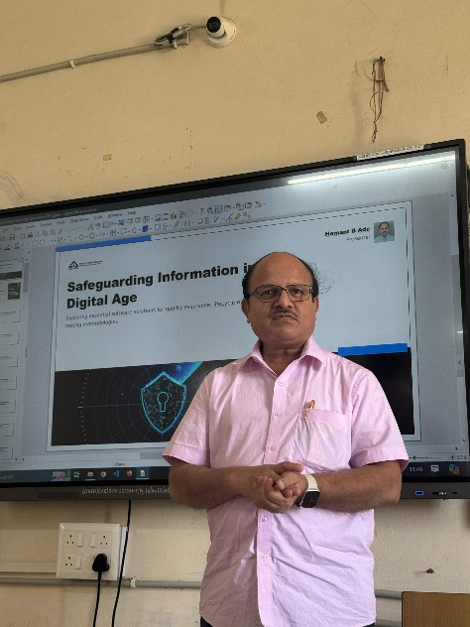
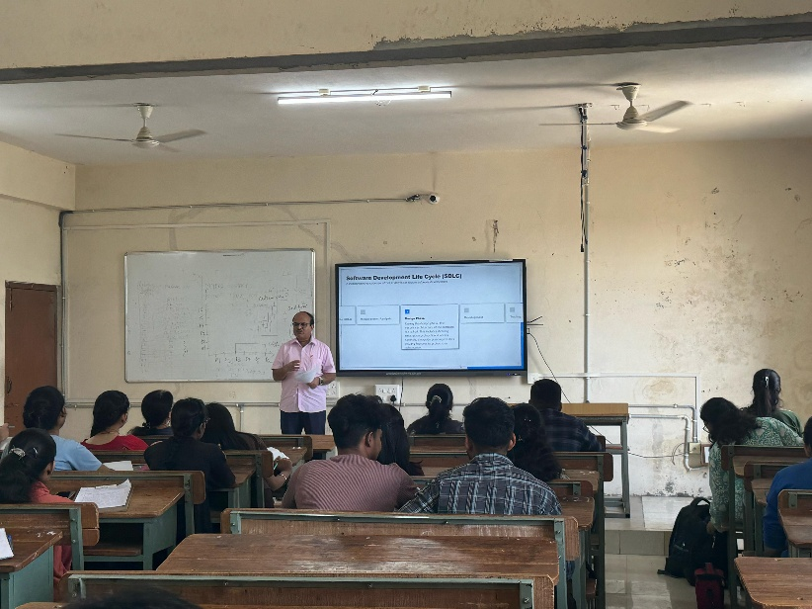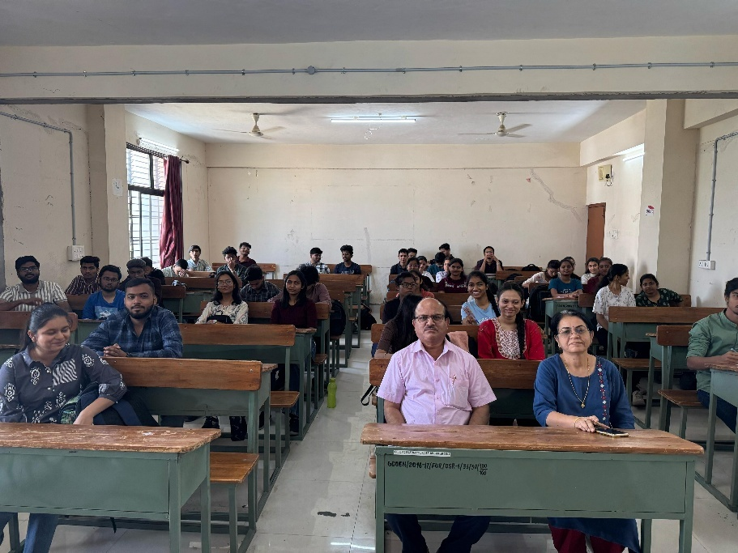

Industrial Visit: Persistent System Nagpur

Date: 15th February 2025
Venue: Persistent System, IT Park, Nagpur

Objective of the Visit:
The main purpose of the visit was to explore the use of Generative AI (Gen AI) in the field of coding. We wanted to understand how AI tools can assist in writing and optimizing code and how these tools can be applied in real-world programming tasks.

Activities During the Visit:
Workshop on Gen AI: The visit started with a workshop where we learned about the different tools used for writing AI-based code.

Problem-Solving Session: We worked on some coding challenges during a problem-solving session, using AI to find solutions.

Networking with Employees: There was a chance to interact with the employees at Persistent Systems, giving us insights into their work culture and how they apply AI in their projects.

Key Learnings:
Tools for Writing AI Code: We were introduced to the tools available for writing and optimizing AI code.

Technical Prompting: One key lesson was about how AI works best when given the right prompts. We learned how to be more specific and clear when working with AI.

Using Test Cases for Autocompletion: We saw how test cases help AI with code autocompletion and error checking.

Hands-On Exercise: We took part in a hands-on exercise where we explored practical applications of AI in coding.

Understanding Client Requirements: One of the exercises involved asking clients the right questions to understand their needs, which helped us understand how to guide AI in the right direction.

AI Assumptions: The session also covered the assumptions AI makes and how we can identify and manage them while working on coding projects.

Common Problems for Beginners: We learned about common issues beginner programmers face and how AI can assist in solving them.

Experience:
The visit was highly interactive and informative. A particularly interesting part was the hands-on demonstration using codecheck.io, where the speaker explained how AI makes assumptions about client requirements. We saw how to break down requirements into three categories: Clear, Unclear, and Repeat, which helped us understand how to manage different types of client needs and refine AI responses
Student Participation: 15
Faculty Participation: 1

Conclusion:
Overall, the visit to Persistent Systems was a great learning experience. We gained useful insights into how Generative AI can support coding tasks and help solve real-world problems in software development. It was a valuable experience that we hope to build on in future visits.
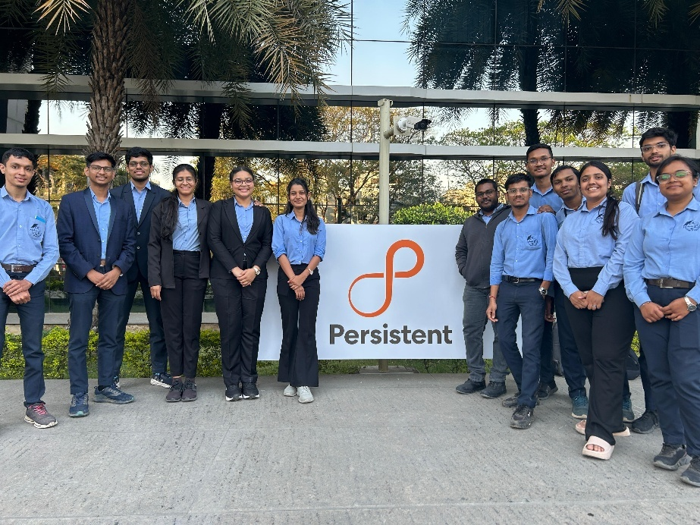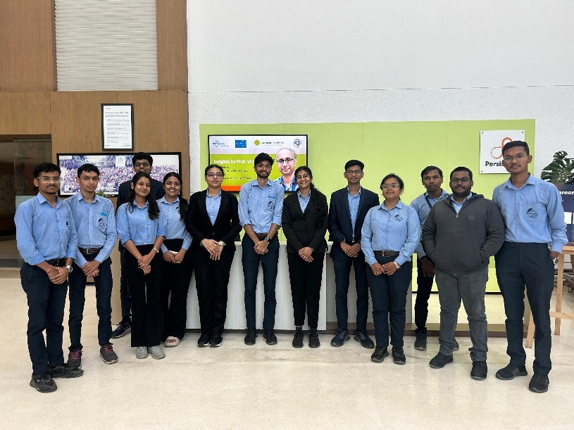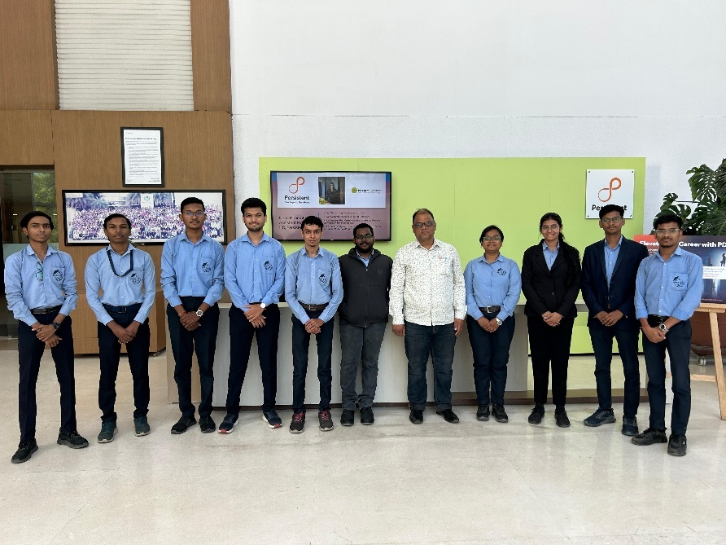
- Codeventure

Date: 21st February 2025
Venue: Government College of Engineering Nagpur (GCOEN)
Mode: Online

Introduction
Codventure Adhyaaya 2025, the flagship event organized by COMSA, aimed to assess participants' expertise in debugging and problem-solving through innovative programming solutions. The event comprised two challenging rounds: BugTrap and Recode, each designed to test coding proficiency under time constraints.
Event Structure
Round 1: BugTrap
- Objective: Participants were given a sample code containing errors, which they needed to identify and fix within a specified time limit.
- Challenge: Debugging and troubleshooting various issues in the given code.
- Duration: 2 hours

Round 2: Recode
- Objective: Participants were given intermediate-level problem statements that required logical reconstruction and efficient coding solutions.
- Challenge: Implementing problem-solving techniques and completing the assigned coding tasks within the stipulated time frame.
- Duration: 2 hours

Online Platform Used: HACKERANK
Winner Selection Criteria
The winner was determined based on the total scores from both rounds. In the event of a tie, the participant who submitted their solution first was declared the winner.
Participation and Results
- Total Entries: 27
- Total Participants Attended: 23
- Winner: Yash Balpande (Government College of Engineering, Nagpur)
- Runner-up: Aditya Thombre (Government College of Engineering, Nagpur )

Organizing Committee
- Adhyaaya Convenor : Prof. Tripti Kumbalpuri Mam
- Faculty Coordinator: Prof. R.V. Mahajan
- COMSA Leadership:
- President: Sanika Jaolekar
- Vice President: Ketan Baitule
- Event Coordinators:
- Devika Samudre
- Ameya Farkade

Conclusion
Codventure Adhyaaya 2025 was a resounding success, providing a platform for participants to showcase their debugging and coding skills. The event witnessed enthusiastic participation and intense competition, with the best
programmers emerging victorious. COMSA extends its gratitude to the faculty, coordinators, and participants for making this event a remarkable experience.

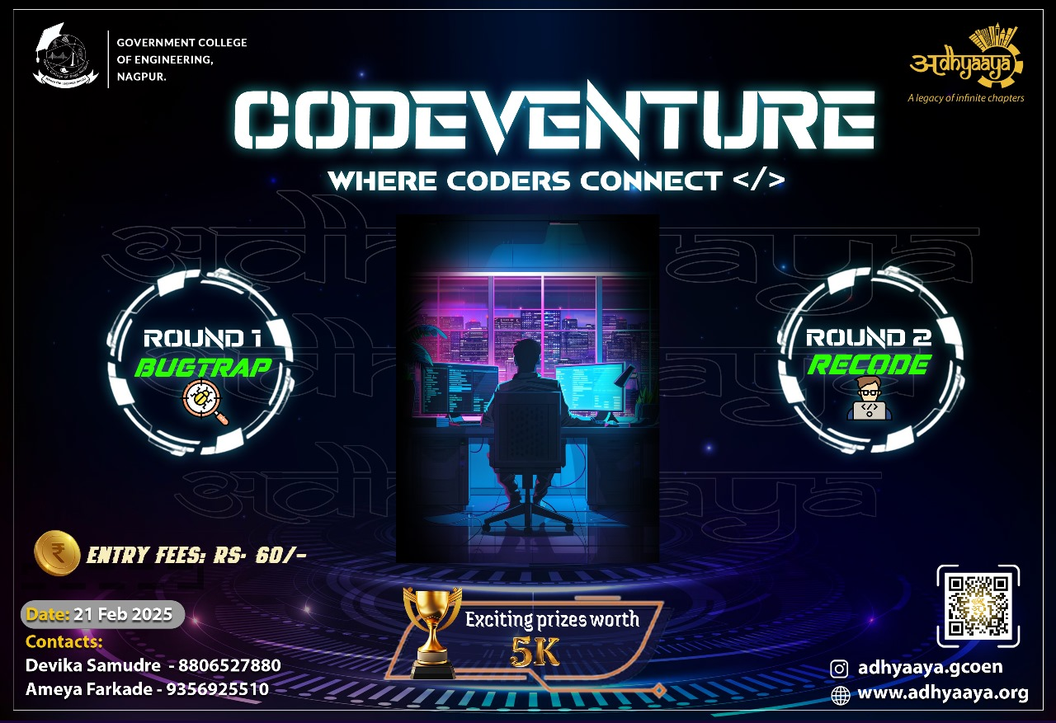

- BIS-COMSA: Brain- Buster

Date: 21st February 2025
⁠⁠Location: Room 211, Annex Building.

Introduction
The BIS Quiz aimed to raise awareness on standards, sustainability, IPR, and environmental regulations through an interactive format.
Event Details
•⁠⁠Faculty Coordinator: Prashant Jawade Sir
•⁠⁠Student Coordinator: Zoya Salahuddin & Yash Talmale
•⁠⁠Guests: Prashant Jawade Sir & DJ Chaudhari Sir
Participants & Winners:
•⁠⁠Total Participants: 15 teams [24 participants]
1. Winner: Roshan Padit (GCOEN)
2. Runner-Up: Apurv Hatmode (GCOEN)

Quiz Structure
•⁠⁠Round 1: "The Standard Pen" – MCQs & short answers on BIS guidelines, sustainability, IPR, and environmental standards.
•⁠⁠Round 2: "Fact or Fiction?" – True/False round debunking myths about BIS and sustainability.
•⁠⁠Round 3: "Menti Lightning Round" – Fast-paced live quiz on BIS regulations and consumer rights.
The quiz successfully engaged participants, raising awareness about BIS and standards in a fun and educational way. Future events can include case studies and interactive elements.

- BIS-COMSA: Introduction to the concepts of AI

Date: 3rd March 2025
Venue: Room No. 210, Annex Building
Organized by: Bureau of Indian Standards (BIS)

Background of the Speaker
• Name: Ms. Sattu Savitha
• Education:
o B.Tech in Electronics and Communication Engineering
o Master’s in Digital Systems and Computer Electronics (JNTU Hyderabad)
• Professional Expertise:
o Quality Management
o Information Security
o Laboratory Management Systems
• Career Highlights:
o 17 years at the Bureau of Indian Standards
o Key role in standard formulation and product certification
o Managed hallmarking operations across six southern states
Contributions and Achievements
• Supervised the Hallmarking department in six states.
• Conducted over 100 hallmarking audits.
• Trained 30 scientists in hallmarking processes.
• Pioneered quality control measures in certification processes.
Key Insights from the Session
• Importance of standardization in ensuring product quality and reliability.
• The role of quality management and information security in compliance and
regulation.
• Real-world applications of certification in various industries.
• Strategies for maintaining high standards in laboratory management.
Conclusion and Acknowledgment
• We extend our sincere gratitude to Ms. Sattu Savitha for sharing her expertise and
insights.
• Her contributions to the field of standardization are truly inspiring.
• We look forward to more such interactive and knowledge-enriching sessions in the
future.
Closing Remarks
The session provided valuable learning opportunities for all participant
Thank you to all attendees for their active participation and engagement.

