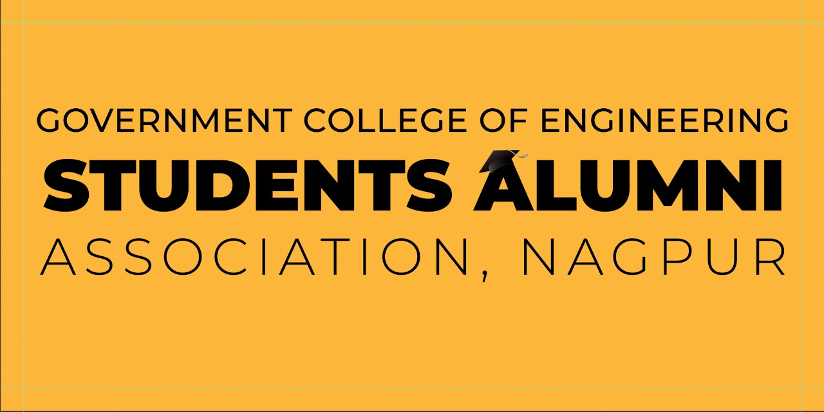

OFFICE BEARERS OF ALUMNI ASSOCIATION_GCOEN

Sr.No. | Full Name | Address | Designation | Age | Nationality | Occupation
1 | Prof. Rewatkumar Pithuji Borkar | Plot No:01, Gajanan Nagar, Near Yashoda Hospital, Manewada-Besa Road, Manewada, Nagpur.  440034 | President | 57 | Indian | Services/higher Equation
2 | Rashmi Arun Wagh | Flat No. 3/B/6, First Floor, Besara Apartment, Ahbab Colony, Near Kids Convent Polie Line, Takali Katol Road,Nagpur-440013 | Vice President | 23 | Indian | Services/higher Equation
3 | Angad Subhash Dewalkar | 46, Empress Mill Association, Shree Nagar, Nagpur | Secretary | 22 | Indian | Services/higher Equation
4 | Rajdeep Rashtrapal Wasekar | Word No. 29, Hanuman Nagar, Borgaon Road, Wardha.442001 | Joint Secretary | 25 | Indian | Services/higher Equation
5 | Bhakti Dilip Rathod | 5/6 Vishnu nagar, behind Central Excise, Navasari Road Amravati | Treasurer | 23 | Indian | Services/higher Equation
6 | Abhiroop Ashutosh Pathak | D110 Rachana Tarangan Hingna Road, Near Hingna T Point Adhyapak Layout, Nagpur-4400365 | Joint Treasurer | 24 | Indian | Services/higher Equation
7 | Prof. Neha Vijay Khadse | Shiv Elite Township  302,Helinium Building,  Shankarpur  Nagpur(Rural)  441108 | Member | 37 | Indian | Services/higher Equation
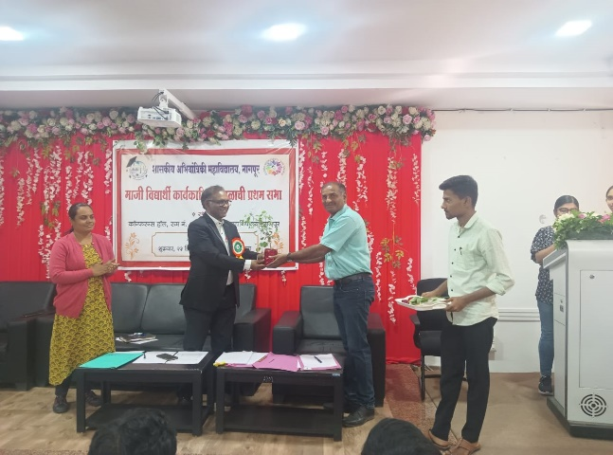 | 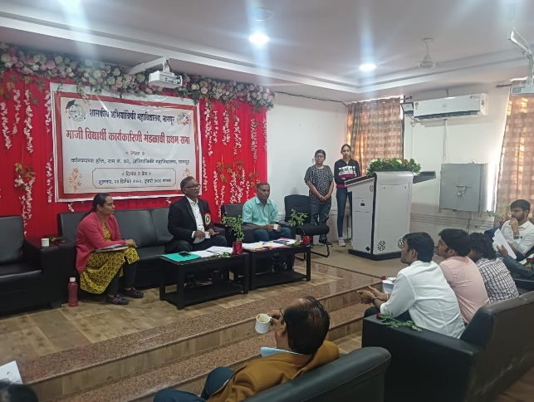
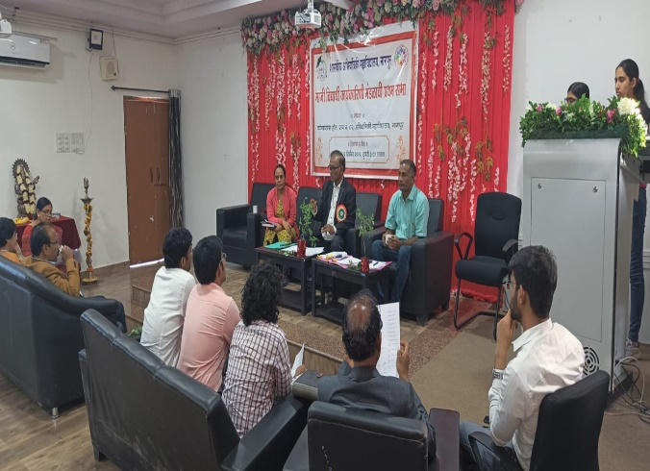 | 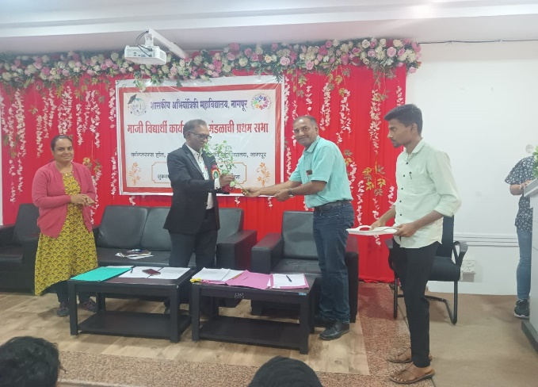
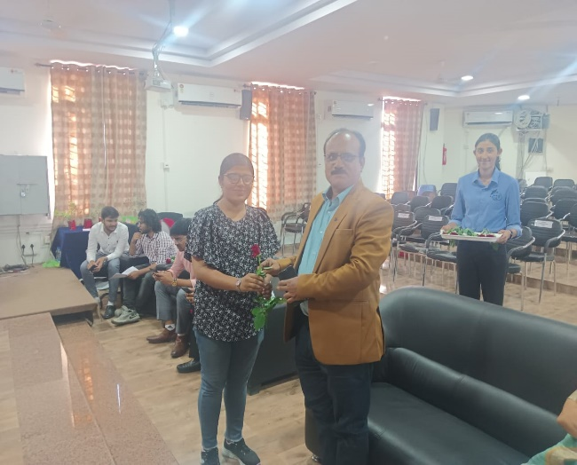 | 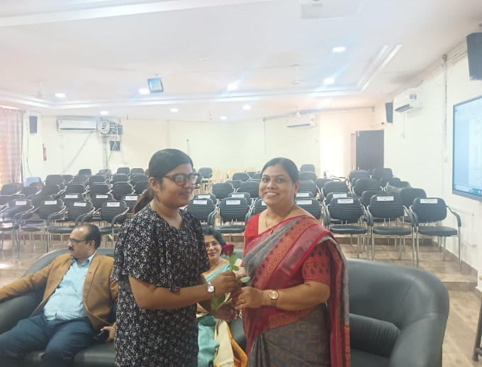
PHOTOS OF ALUMNI ASSOCIATIONGCOEN_OFFICE BEARERS MEETING HELD ON 23/12/2022

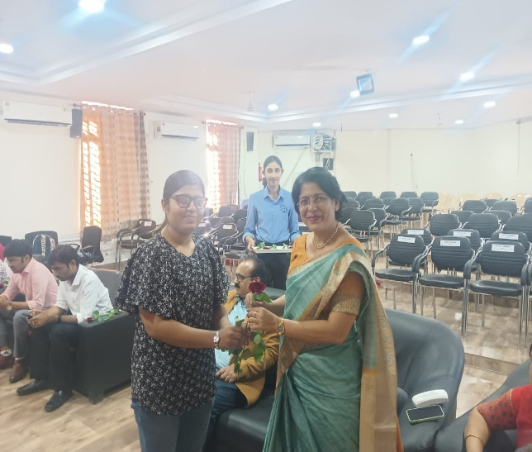 | 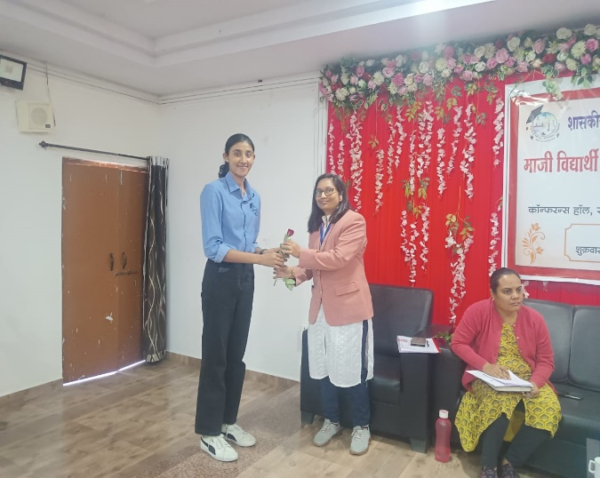
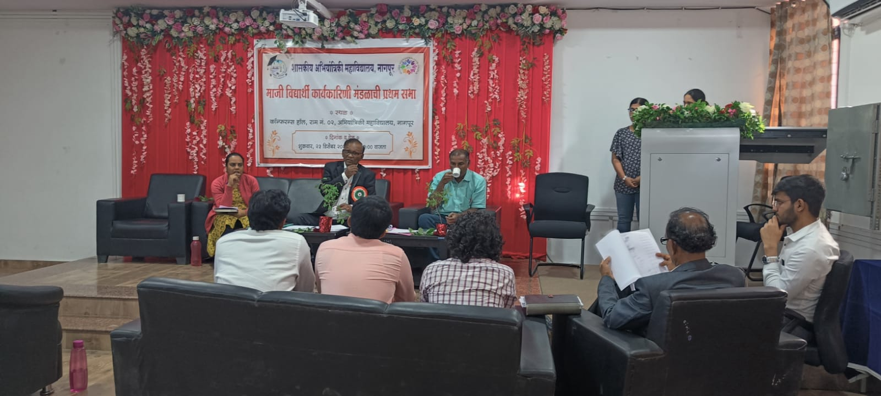 | 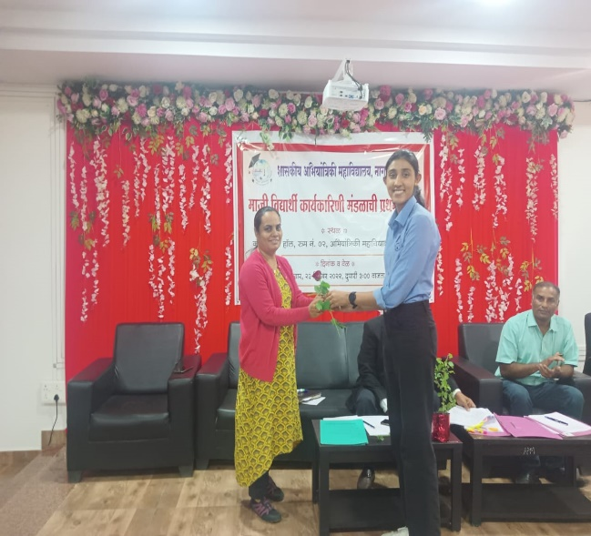
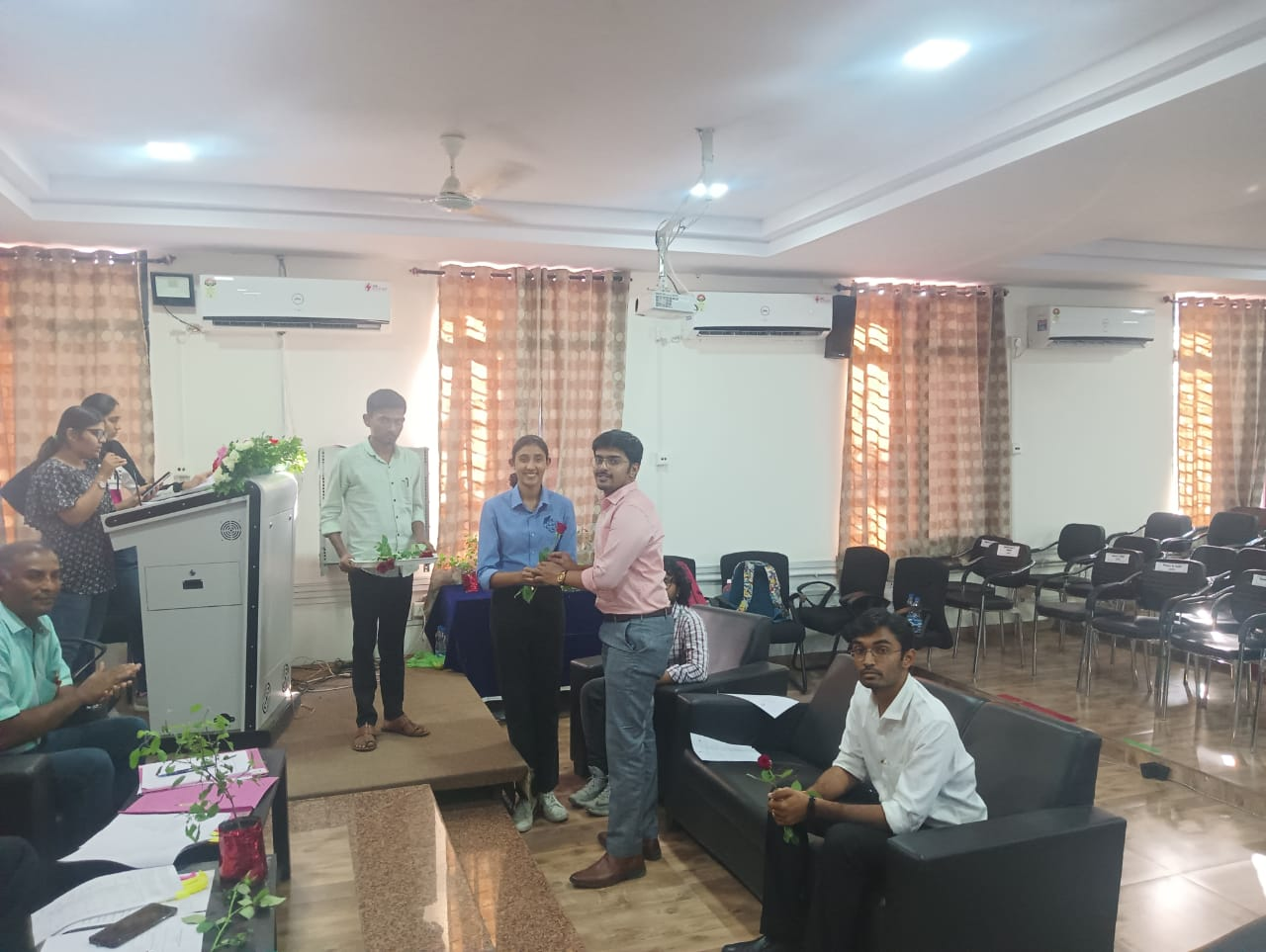 | 