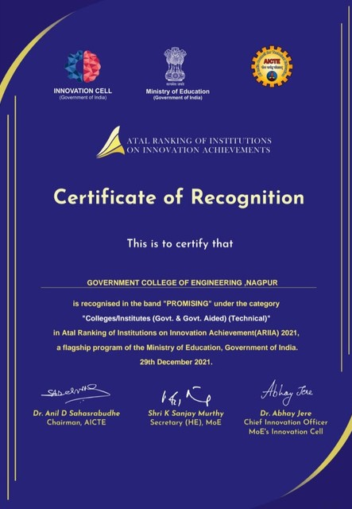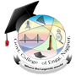
Project Gallery Blog About Contact

ARIIA
ATAL RANKING OF INSTITUTIONS OF INNOVATION ACHIEVMENTS

Atal Ranking of Institutions on Innovation Achievements (ARIIA) is an initiative of Ministry of Education (MoE), Govt. of India to systematically rank all major higher educational institutions and universities in India on indicators related to “Innovation and Entrepreneurship Development” amongst students and faculties.

Read More

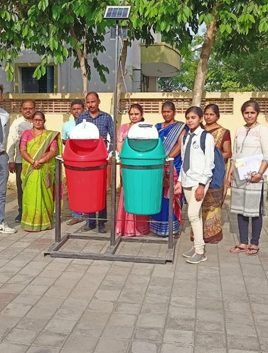
A Very Proud Moment
The rankings will certainly inspire Indian institutions to reorient their mind-set and build ecosystems to encourage high quality research, innovation and entrepreneurship in their campuses.

Read More

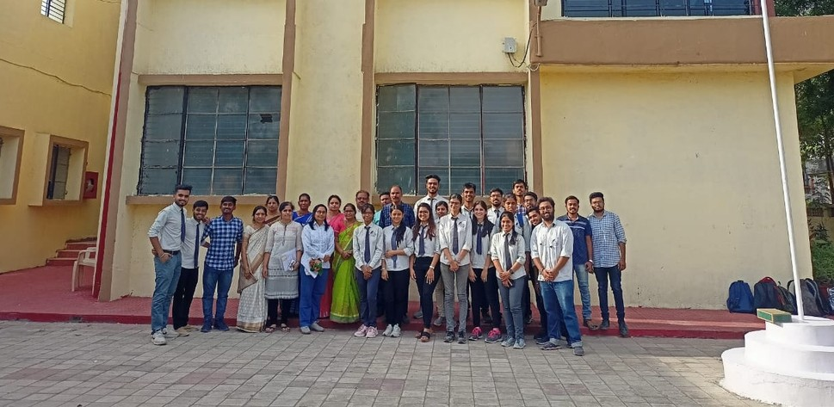
Project
Gallery
Blog
About
Contact

Innovation at Work

Further, the recently announced New Educational Policy 2020 will also make these efforts more effective and efficient, and impactful in the long run.

India is constantly improving on Global Innovation Index (GII) ranking and has now moved upward to 46th position in 2021 from 81st in 2015. It has also emerged as the world’s third- largest startup hub
Read More

