Mandatory Disclosures

The following information shall be given in the information Brochure besides being hosted on the Institution’s official Website.
The onus of the authenticity of the information lies with the Institution ONLY and not on AICTE.

Name of the Institution

Name | Government College of Engineering,  Nagpur
Address | Sector - 27, Mihan Rehabilitation Colony, Khapri,  Nagpur - 441108 (Maharashtra State)
State | Maharashtra
Phone No. | 07103-295226 (P), 295220 (O)
Fax No. | ----
Web site | www.gcoen.ac.in
E-mail | principal.gcoenagpur@dtemaharashtra.gov.in  office.gcoenagpur@dtemaharashtra.gov.in

Name and address of the Trust/Society/Company and the Trustees

The institute is funded by Government of Maharashtra.

Name and Address of the Vice Chancellor/Principal/Director

This institute is a state government institute and head of the institute is designated as Principal.

Name | Prof. R. P. Borkar, Principal
Address | Government College of Engineering,  Nagpur
Pin Code | 441108 | STD  Code | 07103
Phone No | 295226 | Fax No. | ------
Email | principal.gcoenagpur@dtemaharashtra.gov.in  principal@gcoen.ac.in | Web site | www.gcoen.ac.in

Name of the affiliating University
Rashtrasant Tukadoji Maharaj Nagpur University, Nagpur

Web site: www.nagpuruniversity.org

- Governance

  - Members of the Board and their brief background

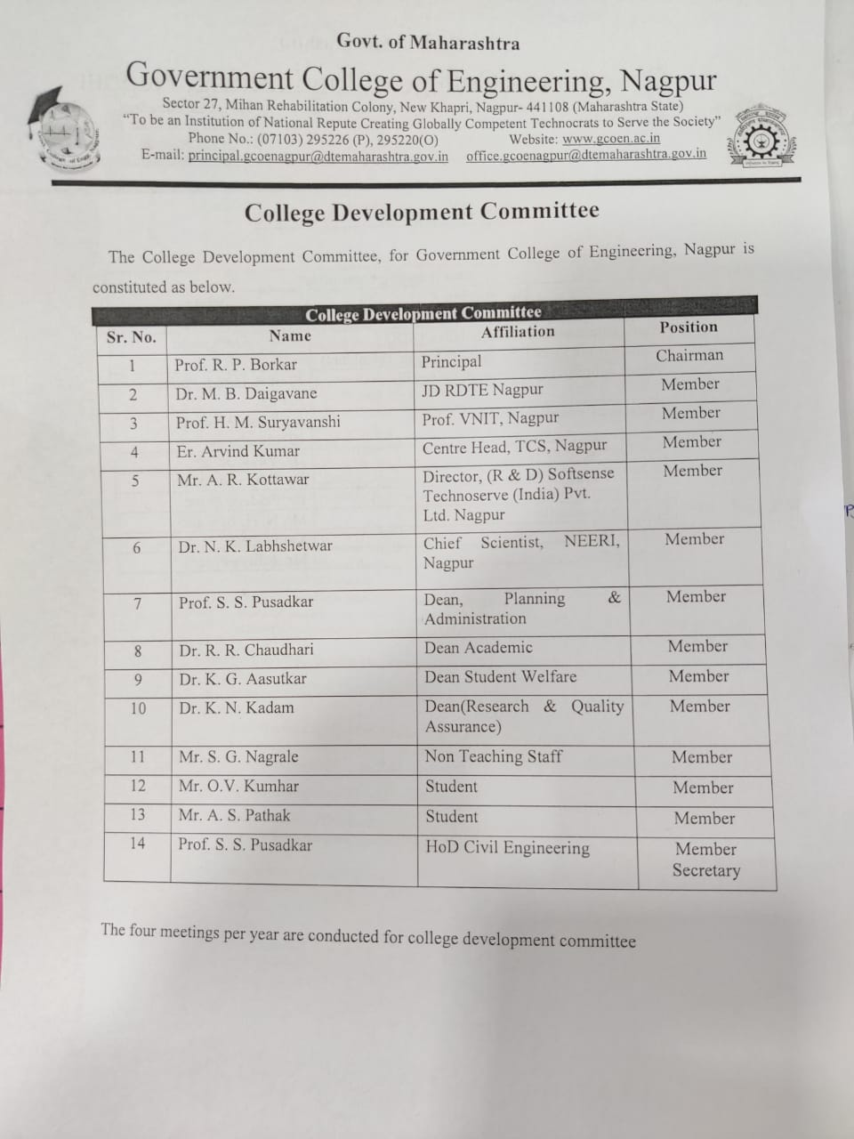

  - Members of Academic Advisory Body: As Above

  - Frequently of the Board Meeting and Academic Advisory Body: Normally four meetings per year.

  - Organizational chart and processes

  - Nature and Extent of involvement of Faculty and students in academic affairs/improvements

In a semester two times student feedback through their class representatives is taken. At the end of every semester all student feedback is taken. Student feedbacks are analyzed and discussed in the Heads of Department meeting. The performance of each faculty is discussed and in turn, head of department convey to respective faculty and corrective action is taken. Thus all faculty and students are involved in academic affairs/improvements.

  - Mechanism/Norms and Procedure for democratic/good Governance

Govt. College of Engineering, Nagpur is working under Higher and Technical Education ministry through Director, Directorate of Technical Education, Mumbai.

At institute level, Principal is the head of institutes and every department is headed by Head of department. In addition, various Deans are working for different institute level works such as Planning & Administration, Academic, Student Welfare, Corporate Affair, III & Placement, and Research & Quality Assurance. The library is headed by Librarian and a committee headed by Faculty in-charge.

The organization functioning and norms are as per Govt. of Maharashtra rules and regulations. All the government rules are followed for admission, academic and administration purpose. The institute also follows the guidelines issued by AICTE, UGC and affiliated university.

Every Head of Department is controlling the administration and academic quality of department through faculty and staff. The facility and equipments needed for the department is proposed by department depending upon need of curriculum and student development based upon the recommendation of concerned lab in charges.

The office is headed by Administrative Officer through Registrar & Office superintendent. All office staff is working under Administrative Officer and work for specified section work viz. Student Section, Class1 & Class 3 Staff Section, Account Section and Cashier Section. The office work is governed by rules and regulation instituted by Govt. of Maharashtra.

  - Student Feedback on Institutional Governance/Faculty performance

At the end of the last year, Feedback (Exit Survey) is taken from out going students.
Sample form is attached below:
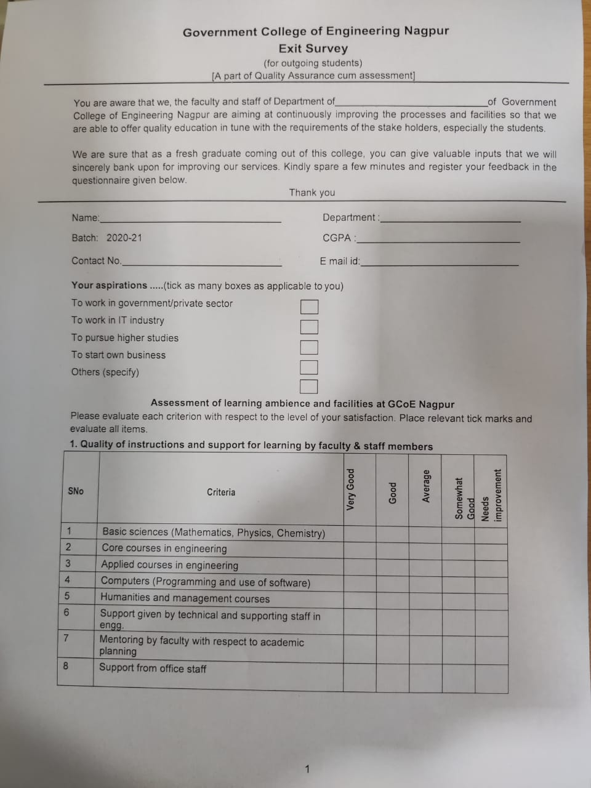
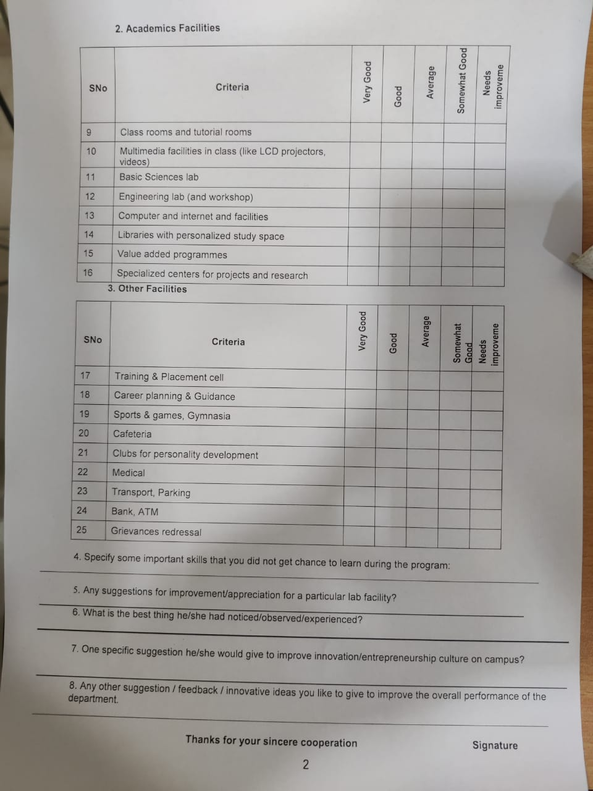
  - Grievance Redressal mechanism for Faculty, staff and students

A] Faculty & Staff: As per rules and regulations of Govt. of Maharashtra

Grievance Redressal Committee (For Faculty & Staff)
Position | Designation | Name
Chairman | Principal | Prof. R. P. Borkar
Member | Joint Director, RO, DTE Nagpur | Dr. M. B. Daigavane
Member | One Professor from affiliating university | -
Member | Senior faculty nominated by Principal (Not below Asso. Prof) | Prof. S. S. Pusadkar
Member | Lady Faculty/ Staff nominated by Principal | Dr. L. G. Malik
Member | Backward Class Faculty/ Staff nominated by Principal | Mr. A. A. Gawai
Member Secretary | Registrar | Mr. P. M. Mankar

B] Students:

Students Grievance Redressal Committee
S.N. | Position | Designation | Name
1 | Chairman | Principal | Prof. R. P. Borkar
2 | Member | Lady Faculty Member Nominated by Principal | Dr. K. G. Aasutkar
3 | Member | Backward class faculty representative nominated by Principal | Ms. R. M. Sahare
4 | Member | Sr Faculty | Dr. R. R. Choudhari
5 | Member | Student nominated by Principal based on merit / sport / community cork | --
6 | Member Secretary | Asst. Professor Civil Engineering | Dr. S. A. Tekade

  - Establishment of Anti Ragging Committee

Anti Ragging Committee
Designation | Name
Principal | Prof. R. P. Borkar
Civil Administrator representative (SDO / Tahsildar not below the rank of Nayab Tahsildar)) | Officiating
Police Administrator representative (PI) | PI of Beltarodi Police Station
Local media representative | Mr. Tushar Kohale  IBN Loakmat
NGO representative | Dr. Vijay Ghuge
Faculty representative | Dr. K. G. Aasutkar
Parent representative | Dr. Pradeep Salve
Staff representative | Registrar/Office Superintendent
Fresher student | Karn Gupta
Sr. student | Mr. Aditya Puram

  - Establishment of Online Grievance Redressal Mechanism

Student Grievance Redressal Committee

Sr. No. | Position | Designation | Name
1 | Chairman | Principal | Prof. Dr.R. P. Borkar
2 | Member | Lady Faculty Member Nominated by Principal | Dr. K. G. Aasutkar
3 | Member | Backward class faculty representative nominated by Principal | Ms. R. M. Sahare
4 | Member | Sr Faculty | Dr. R. R. Choudhari
5 | Member | Student nominated by Principal based on merit / sport / community cork | -----
6 | Member Secretary | Asst. Professor Civil Engineering | Dr. S. A. Tekade

Online Grievance form is available on College website. The students having any problem can fill it online. Message will be communicated to Dean, Student Welfare on email. On the basis of severity of problem, Student grievance redressal committee take the decision in meeting & resolve the problem.
  - Establishment of Grievance Redressal Committee in the Institution and Appointment of
OMBUDSMAN by the University

Grievance Redressal Committee (For Faculty & Staff)
Position | Designation | Name
Chairman | Principal | Prof. R. P. Borkar
Member | Joint Director, RO, DTE Nagpur | Dr. M. B. Daigavane
Member | One Professor from affiliating university | ----
Member | Senior faculty nominated by Principal (Not below Asso Prof) | Prof. S. S. Pusadkar
Member | Lady Faculty/ Staff nominated by Principal | Dr. L. G. Malik
Member | Backward Class Faculty/ Staff nominated by Principal | Mr. A. A. Gawai
Member Secretary | Registrar | Mr. P. M. Mankar

  - Establishment of Internal Complaint Committee (ICC)

Prevention of Sexual Harassment Committee (ICC)
Designation | Name
Woman Sr Level (not below Asso Prof) | Dr. K. G. Aasutkar
Faculty 1 | Dr. R. D. Raut
Faculty 2 | Mr. S. R. Wagh
Staff 1 | Smt. N. S. Dautpure
Staff 2 | Mr. S. M. Bajare
NGO / Association member with law background | Smt. A. A. Ghonge
Student 1 | Ms. Sakshi Kotekar
Student 2 | Ms. Radha Sajjanwar
Student 3 Girl Pre / Final year | Ms. Ayushi More

  - Establishment of Committee for SC/ST

SC/ST Grievance Committee
Position | Designation | Name
Chairman | Principal | Prof. R. P. Borkar
Member | Sr. Professor of University / DTE
Member | Sr. faculty 1 (not below Asso. Prof) | Dr. V. M. Aathawale
Member | Sr. faculty 2 (not below Asso Prof) | Dr. C. P. Kalambe
Member Secretary | Asst. Professor | Mr. A. A. Gawai

  - Internal Quality Assurance Cell

Sr. No. | Composition of IQAC | Name of person with affiliation | Designation in IQAC committee
1 | Chairperson:  Head of the Institution | Prof. R P Borkar, Principal | Chairman
2 | Teachers to represent all level (Three to eight ) | Prof. N D Ghawghawe, Dean C A | Member
 |  | Prof. S S Pusadkar, Dean P A | Member
 |  | Dr R R Chaudhari, Dean Acad | Member
 |  | Dr R R Surjuse, Dean III & P | Member
 |  | Prof. P B Daigawane, Dean Infrastructure | Member
 |  | Dr Kshitija Kadam, Dean R & QA | Member
 |  | Dr K M Tajne, Dean Student Affairs | Member
3 | One member from the Management | Dr M B Daigawane,  Joint Director, Nagpur Region, DTE | Member
4 | Few senior administrative officers | Mr N H Bhujade, Registrar | Member
 |  | Dr Latesh Bhagat, HoD Comp Engg | Member
 |  | Dr V M Athawale, HoD Mech Engg | Member
 |  | Dr Rajeshri Raut, HoD Extc Engg | Member  P.T.O.
5 | One nominee each from local society, Students and Alumni | Dr Vijay L Ghuge, President,  Nisarg Vidnyan Mandal, Nagpur | Member
 |  | Vinit Lohare, Student, IIIyr CSE | Member
 |  | Palak Kothari, Student, IIIyr ETC | Member
 |  | Er Dewashish Sontakke, Ex Engr, GAIL | Member
 |  | Er Abhijeet Roy, Application Development  Associate, Accenture | Member
6 | One nominee each from Employers  /Industrialists / stakeholders | Er. Arvind Kumar, Centre Head, TCS Nagpur | Member
 |  | Er Ajinkya M Kottawar Director, Siftsense  Technoserve (India) Pvt Ltd, Nagpur | Member
 |  | Dr. Pradeep Salve  Senior Principal Scientist, HRD Division  CSIR-NEERI, Nagpur | Member
7 | One of the senior teachers as the  co-ordinator / Director of the IQAC | Dr Kshitija Kadam, Dean R & QA | Member Secretary

Programmes

  - Name of Programmes approved by AICTE

Sr. No. | Name | Number of seats | Duration
1 | Civil Engineering | 60 each | Four years
2 | Mechanical Engineering
3 | Electrical Engineering
4 | Electronics & Telecommunication Engineering
5 | Computer Science & Engineering

  - Name of Programmes Accredited by NBA - Nil

  - Status of Accreditation of the Courses–Nil

For each Programme the following details are to be given (Preferably in Tabular form):
Sr. No. | Name | Number of Seats | Duration | Cut off marks/Rank of admission during the last three years |  |  |  |  |  | Fee (as approved by the state government) | Placement Facilities | Campus placement in last three years with minimum salary, maximum salary and average salary
 |  |  |  | 2019-20 |  | 2020-21 |  | 2021-22 |  |  |  | 2019-20 | 2020-21 | 2021-22
 |  |  |  | High | Low | High | Low | High | Low
1 | Civil Engg. | 60 | Four  year | 92.99 | 41.09 | 94 | 31 | 94.29 | 21.15 | Fee is as per the prevailing Govt of Maharashtra and affiliating University norms. It is on website. | The college has sufficient placement office for campus placement. Still college is working on betterment of facilities. | 11 | 5 | 8
2 | Mechanical Engg | 60 | Four  year | 95.25 | 40.32 | 97.27 | 23.12 | 98.56 | 27.21 |  |  | 20 | 35 | 33
3 | Electrical Engg | 60 | Four  year | 94.78 | 32.68 | 92.28 | 31.16 | 94.51 | 27.21 |  |  | 20 | 26 | 57
4 | Electronics & Tele. Engg | 60 | Four  year | 93.83 | 76.82 | 94.61 | 40.28 | 95.66 | 21.17 |  |  | 29 | 44 | 47
5 | Comp. Sci.& Engg | 60 | Four  year | 99.09 | 81 | 98.87 | 23.5 | 98.87 | 55.57 |  |  | 38 | 57 | 60
Minimum salary, Maximum salary and Average salary |  |  |  |  |  |  |  |  |  |  |  | Min. Sal. 2.26 LPA  Max Sal.  44 LPA  Avg. Sal. 5.397 LPA | Min. Sal. 2.46 LPA  Max Sal.  10 LPA  Avg. Sal. 4.17 LPA | Min. Sal.  3.1 LPA  Max Sal.  09 LPA  Avg. Sal. 4.94 LPA

  - Name and duration of Programme(s) having Twinning and Collaboration with Foreign University(s) and being run in the same Campus along with status of their AICTE approval. If there is Foreign Collaboration, give the following details: NIL

Faculty
Course/Branch wise list Faculty members: Civil Engineering

SN | Name of faculty | Designation
1 | Dr. R. P. Borkar | Professor and Principal
2 | Dr. S. S. Pusadkar | Professor and Head
3 | Dr. P. B. Daigavane | Professor
4 | Dr. S. N. Khante | Associate Professor
5 | Dr. K. M. Tajne | Associate Professor
6 | Dr. K. N. Kadam | Associate Professor
7 | Dr. R. L. Wankhede | Assistant Professor
8 | A. A. Gawai | Assistant Professor
9 | Dr. S. A. Tekade | Assistant Professor
Permanent Faculty

Designation | Number
Professor | 03
Associate Professor | 02
Assistant Professor | 03
    - Adjunct Faculty - Nil
    - Permanent Faculty :Student Ratio 9/180 = 1: 20
Number of Faculty employed and left during the last three years: 03+02

Course/Branch wise list Faculty members: Mechanical Engineering

SN | Name of faculty | Designation
1 | Dr. V. M. Athawale | Associate Professor and Head
2 | Dr. R. R. Chaudhari | Associate Professor
3 | Dr. U. S. Wankhede | Associate Professor
4 | Dr. R. B. Yarasu | Associate Professor
5 | V. P. Titarmare | Assistant Professor
6 | M. S. Satpute | Assistant Professor
7 | A. A. Uplap | Assistant Professor
8 | T. N. Kumbalpuri | Assistant Professor
9 | S. R. Wagh | Assistant Professor

Permanent Faculty

Designation | Number
Professor | 00
Associate Professor | 03
Assistant Professor | 06
    - Adjunct Faculty - Nil
    - Permanent Faculty :Student Ratio 9/180 = 1: 20
Number of Faculty employed and left during the last three years: 01+01

    - Course/Branch wise list Faculty members: Electrical Engineering

SN | Name of faculty | Designation
1 | Dr. N. D. Ghawghawe | Professor
2 | Dr. R. S. Surjuse | Associate Professor
3 | Dr. S. P. Jolhe | Assistant Professor
4 | Ms. R. M. Sahare | Assistant Professor
5 | Ms. N. V. Khadse | Assistant Professor
6 | Mr. P.V. Nandankar | Assistant Professor

    - Permanent Faculty

Designation | Number
Professor | 01
Associate Professor | 01
Assistant Professor | 04
    - Adjunct Faculty - Nil
    - Permanent Faculty :Student Ratio 6/180 = 1: 30
    - Number of Faculty employed and left during the last three years : NIL

    - Course/Branch wise list Faculty members: Electronics and Telecommunication Engineering

SN | Name of faculty | Designation
1 | Dr. R. D. Raut | Associate Professor
2 | S. G. Bhele | Assistant Professor
3 | S. K. Meshram | Assistant Professor

    - Permanent Faculty

Designation | Number
Professor | 00
Associate Professor | 01
Assistant Professor | 02
    - Adjunct Faculty - Nil
    - Permanent Faculty :Student Ratio 3/180 = 1: 60
    - Number of Faculty employed and left during the last three years : 00+01

    - Course/Branch wise list Faculty members: Computer Science and Engineering

SN | Name of faculty | Designation
1 | Dr. Latesh Gagan Malik | Associate Professor

    - Permanent Faculty

Designation | Number
Professor | 00
Associate Professor | 01
Assistant Professor | 00
    - Adjunct Faculty - Nil
    - Permanent Faculty :Student Ratio 1/180 = 1: 180
    - Number of Faculty employed and left during the last three years : 00+01

    - Course/Branch wise list Faculty members: Science and Humanities

SN | Name of faculty | Designation
1 | Dr. C. P. Kalambe | Associate Professor in Chemistry
2 | Dr. C. M. Khairnar | Associate Professor in Physics
3 | Dr. J. B. Randhawa | Assistant Professor in Physics
4 | Dr. V. J. Dagwal | Assistant Professor in Mathematics
    - Permanent Faculty

Designation | Number
Professor | 00
Associate Professor | 02
Assistant Professor | 02
    - Adjunct Faculty - Nil
    - Permanent Faculty :Student Ratio NA
    - Number of Faculty employed and left during the last three years : 0+1

Profile of Vice Chancellor/Director/Principal/Faculty

Personal Information:
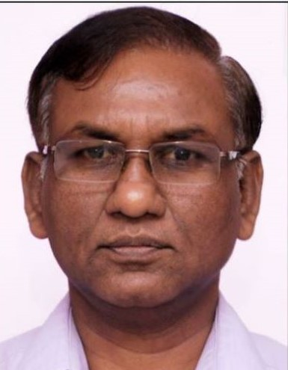

Full Name – Rewatkumar Pithuji Borkar

Date of Birth – 23/01/1964

Designation – Principal

Email Address – principal@gcoen.ac.in, rpborkar@rediffmail.com

Educational Information:

S.N. | Education | University/Institute | %age | Passing Year | Specialization | Special Honour
1 | B.E. | RSTM Nagpur University, Nagpur/VNIT Nagpur | 60% | 1987 | Civil Engg
2 | M.Tech. | RSTM Nagpur University, Nagpur/VNIT Nagpur | 66% | Oct.  1988 | Civil-Env.Engg.
3 | Additional B.A. | RSTM Nagpur University, Nagpur | --- | 1989 | Political Science
4 | Ph.D. | Indian Institute of Technology, Bombay | --- | 2008 | Environmental Engg.

Experience:

Sr.  No. | Organisation/Institute | Designation | Period |  | Subject
 |  |  | From | To
1 | K.D.K.College of Engineering, Nagpur | Lecturer in Civil Engineering | 24.07.1989 | 27.09.89 | Civil Engg.(UG)
2 | Govt. Polytechnic, Sakoli  Distt: Bhandara | Lecturer in Civil Engineering | 28.09.1989 | 04.09.1995 | Civil Engg.
3 | Govt. Polytechnic, Bramhapuri Distt.Chandrapur | Head of Civil Engineering | 05.09.1995 | 25.03.1996 | Civil Engg. & Administration
4 | Govt. College of Engineering, Amravati. | Asstt. Professor in Civil Engg. | 26.03.1996 | 30.01.2004 | Civil Engg.(UG /PG)
5 | Govt. College of Engineering, Amravati | Professor in Civil Engineering | 30.01.2004 | 01.07.2011 | Civil Engg (UG/PG) & administration
6 | Govt. College of Engineering, Jalgaon | Principal | 02.07.2011 | 29.07.2019 | Administration
7 | Govt. College of Engineering, Amaravati | Principal | 30.07.2019 | 05/10/2021 | Administration
8 | Govt. College of Engineering, Nagpur | Principal | 06/10/2021 | Till date | Administration

Other Related Experience, Research, Industries:
Sr.  No. | University/ College | Designation | Period |  | Subject
 |  |  | From | To
1 | Indian Institute of Technology, Bombay | QIP Research Scholar | 28/10/2001 | 28/10/2004 | Industrial wastewater Treatment

Subject Offered/ Taught:

S.No. | Course | Class | Branch | Subject
1 | Diploma | II and III yr Diploma | Civil Engg. | Surveying,  Fluid Mechanics,  Environmental Engg.  Transportation Engg.
2 | B.E. | II, III & IV yr. B.E./B.Tech. | Civil Engg. | Surveying I & II  Environmental Engg I &II,  Adv. Wastewater treatment
3 | M.Tech | I & II Yr M.Tech. (FT/PT) | Civil Engg.-Env.Engg. | Environmental Science & Engg.  Advanced Wastewater Treatment,  Industrial Wastewater Treatment,  Hazardous Waste management,  Solid Waste Management,  Adv.Water Treatment  Env.Impact & Analysis

Areas of Research / Interest:

Sr.No. | Research Area | Details | Grant Available
1 | Research promotion Scheme | RPS: Development of an Improved foundation system for BC soils of rural area using horizontal Geofoam layers- jointly undertaken & worked as Co-PI | 3.00 Lakhs (project completed)

No. of Ph.D. and M. Tech Guided:

(i) No. of Ph.D. students Guided - 03 (on-going)
(ii) No. of M.E./M. Tech Students Guided - 08

- National Conferences/Journals - 19

- International Conferences/Journals - 18

Books/Monograms/Review Articles/Patents if any

Patent: 01 Patent No. 260239

Title: “Innovative method of biodegradation of Chlorobenzenes using UASB reactor” Application No.392/MUM/2010A; Granted on 11/04/2014 and published on 18/04/2014.

Name: Dr. Sunil Shaligram Pusadkar
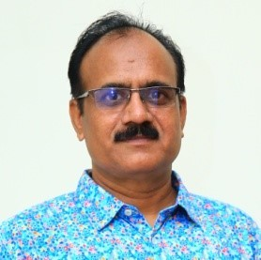

Faculty at Institute: Professor and HoD
Department of Civil Engineering, Govt. College of Engineering,
MIHAN Rehabilitation Colony, New Khapri,
Nagpur-441108

Date of Birth: 18thOctober1965

Unique ID: DTESSPM6501

Educational Qualification:
Sr.No. | Degree | University | Institution | Year of Passing
1 | B.E. | Nagpur University | VNIT(VRCE),  Nagpur | 1988
2 | M.E. | Pune University | CoE. Pune | 1991
3 | Ph.D. | IIT, Roorkee | IIT, Roorkee | 2005

Work Experience:
Teaching Experience: 27 years
Industrial Experience: 4 years

Area of Specialization: Geotechnical Engineering

Courses Taught:
- Geotechnical Engineering–I
- Geotechnical Engineering-II
- Advanced Soil Mechanics
- Geotechnical Investigation & Ground Improvement Technique
- Finite Element Analysis
- Pavement Analysis & Design
- Basic Civil Engineering
- Dock Yard, Tunnel and Airport Engineering
- Railway Engineering

Research Guidance:

Publications:
- Book Chapter-5 no
- National & International Journal – 34
- National & International Conferences-64
- Reviewer of Geotechnical and Geological Engineering, Springer Nature

Guided:
M.Tech. dissertation:25
Ph. D. students: One completed & Two undergoing

Project Carried Out
Sl.  No. | Title of Research  Project | Investigator(s) | Sponsoring  Agency | Year | Amount Rs.  In Lakhs
1. | Behavior of  Reinforced Coal Ash | Dr.S.S.Pusadkar | AICTE | 2007-2009 | 4.00
2 | Modernization of  Library | Dr.S.S.Pusadkar | AICTE | 2004-2007 | 6.24
PATENT:
2019 Patent filed on 15-04-2019 and published on 10-05-2019.
Title: ‘Load Application System for Different Configuration of Multiple Footings’

Application No.201921015107A

Name : Dr. Prashant B. Daigavane
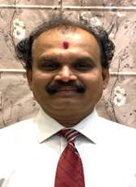
  - Date of Birth:
  - Unique ID : DTEPBDM6501
  - Education Qualifications : PhD, LLB

Work Experience
  - Teaching : 32 Years
  - Research : Nil
  - Industry : 01 Yr.
  - Others : Nil
- Area of Specialization : Geotech Engg

Courses taught at Diploma/ Post Diploma /Under Graduate/ Post Graduate /Post Graduate Diploma Level:

- Research guidance (Number of Students) : 02
  - No. of papers published in National/International Journals/Conferences :
  - Master (Completed/Ongoing) : Completed
  - Ph.D.(Completed/Ongoing) : Completed
- Projects Carried out: 02
- Patents(Filed & Granted): 01
- Technology Transfer: NIL
- Research Publications (No. of papers published in National/ International Journals/Conferences):
- No. of Books published with details : Nil
- Name of the book:
- Publisher with ISBN:
- Year of publication:

- Name: Dr Suraj Narendra Khante

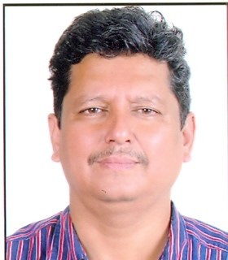
- Designation:
Associate Professor, Applied Mechanics Department
Govt. College of Engineering Nagpur
suraj.khante@gcoen.ac.in, 9860441250
- Date of Birth:13/07/1967

- Unique ID: DTESNKM6701

- Education Qualification:
Sr.  No. | Degree | Year of  Passing | University | Institute | Class/  Division | Field of  Specialization
1 | B. E.  (Civil) | 1988 | Nagpur  University | VRCE,  Nagpur | I | Civil  Engineering
2 | M.Tech. | 1993 | Nagpur University | VRCE,  Nagpur | I with Distinction | Structural Engineering
3 | Ph.D. | 2008 | RGPV  Bhopal | SGSITS,  Indore | - | Structural  Engineering

- Work Experience (Teaching, Research, Industry, Others)
Total experience:
Teaching: 32.0 years
Industry: 1.0 years
- Area of Specialization: Structural Engineering

- Courses taught at
 | Diploma | Post Diploma | Under Graduate | Post Graduate | Post Graduate Diploma Level
Names of Courses | - Applied Mechanics  - Environment Engineering  - TransportationEngg | - | - Engg, mechanics  - SOM  - TOS  - DSS  - Concrete Tech. | - Theory of elasticity plasticity  - Structural Dynamics | -

- Research guidance
  - Papers published
 | International Journals | National Journals | International conferences | National conferences | Total
No. of Papers | 15 | 06 | 22 | 08 | 51

  - ME/M.Tech Guided: 27

  - Ph.D. Guided: 02 in progress

- Projects Carried out:

Sr No. | Details
1 | Performance of Reinforced concrete exterior beam column joint subjected to cyclic loading  Cost-Rs.13.55 lakhs,Year-2012-14 AICTE, RPS

- Patents: Nil

Technology transfer: Nil

- Name: Dr Kiran M.Tajne (Dr.Mrs. Kiran G.Asutkar)
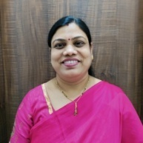

- Designation: Dean (Student Welfare) and
Associate Professor,
Civil Engineering Department

Govt. College of Engineering Nagpur
kiran.tajne@gcoen.ac.in, 9881747815
- Date of Birth: 13/03/1976

- Unique ID: DTEKMTF7601

- Education Qualification:
Sr. No. | Degree | Date of Passing | University | Class/  Division | Field of Specialization
1 | Ph.D. | Jan 2014 | Nagpur |  | Environmental Engineering
2 | M.E. | Jan 2000 | Nagpur | First | Urban Planning
3 | B.E. Civil | Jun 1997 | Amravati | First | Civil Engineering

Work Experience (Teaching, Research, Industry, Others)
Sr. No. | Post held | Organization  (Type- Teaching, Research, Industry, Others) | From | To
1 | Associate Professor | GCOE, Nagpur (Teaching) | 21/07/2017 | Till date
2 | Associate Professor | GCOE, Jalgaon (Teaching) | 24/11/2016 | 20/07/2017
3 | Assistant Professor | PCE, Nagpur (Teaching) | 05/05/2011 | 23/11/2016
4 | Lecturer | GHRP, Nagpur (Teaching) | 16/08/2001 | 04/05/2011
5 | Planner & Engineer | Maske & Associates | 05/02/2000 | 15/08/2001

Total experience: Teaching=20 years, Research= …, Industry=1.5 years, Others= …..

- Area of Specialization: Environmental Engineering

- Courses taught at
 | Diploma | Post Diploma | Under Graduate | Post Graduate | Post Graduate Diploma Level
Names of Courses | - Applied Mechanics  - Strength of Materials  - Geotechnical Engg  - Transportation Engg |  | - Engg, mechanics  - SOM  - PAD  - BDD  - EE-I  - APSWM  - E&C

- Research guidance
- Papers published
 | International Journals | National Journals | International conferences | National conferences | Total
No. of Papers | 22 |  | 12 | 08 | 42

- ME/ M Tech Guided: Nil
- Ph. D. Guided: Nil

- Projects Carried out: 09

- Patents : 01
Sr No. | Details
1 | Inventor ‘Smart Compost Bin’, patent filed on 31 August2019

- Technology transfer: Nil

- Research Publication:
- International Journals - 22

- International Conferences - 12

- National Conferences - 08

- Number of Books Published : 02
Sr No. | Details
1 | “Basics of Civil Engineering” in 2014 for S.Chand publication
2 | “Strength of Materials” in 2016 for Saijyoti publication

- Awards Received: 01
Sr No. | Details
1 | Best Paper Award for the paper on Smart Compost Bin in National conference on technology for “ Tribal and rural development-2020”, 29th and 30th January at GP Sakoli

Name: Dr. Kshitija N. Kadam
Designation: Dean (Research & Quality Assurance)
And Head & Associate Professor,
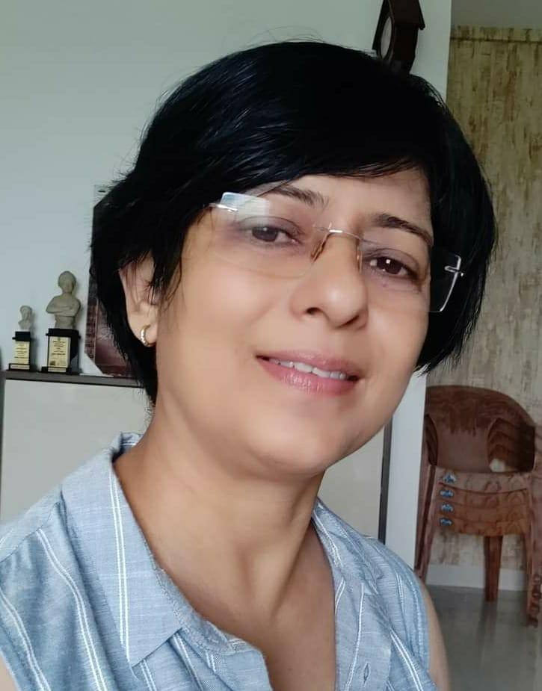
Applied Mechanics Department
Govt. College of Engineering
Nagpur
Date of Birth: 07/06/1970
Email Address: kadamkshitija7@gmail.com
Mobile No.: 9326235484

EDUCATIONAL QUALIFICATION

Sr. No. | Degree | Date of Passing | University | Class/  Division | Field of Specialization
1 | Ph.D. | 18-8-2010 | SGB Amravati University | Ph.D. awarded  August 2010 | Structural Engg
2 | M.E. Civil-Struct. Engg | 17-06-1995 | Amravati University | First division & stood Merit-I | Structural Engg
3 | B.E. Civil | 31-10-1991 | A.P.S. University | First division & stood Merit-II | Civil Engg

Thesis
- ME- Application of multi Objective Fuzzy Linera Programming to Upper Wardh Project

TEACHING & PROFESSIONAL EXPERIENCE -
Total experience: Teaching=24 Years , Research= Nil, Industry=02 Others= Nil

Area of Specialization: Structural Engineering

Courses taught at
 | Diploma | Post Diploma | Under Graduate | Post Graduate | Post Graduate Diploma Level
Names of Courses | Engineering Mechanics  Environmental Engineering  Fluid Mechanics, Programming Language |  | Engineering Mechanics,  Strength of Material,  Matrix method of Struct analysis, Finite Element Analysis | Matrix method of Struct analysis, Finite Element Analysis, Programming Language

RESEARCH GUIDANCE
Ph. D. Guided: 04 (Three awarded, One in progress)
M.E. Guided: 14

RESEARCH PAPERS PUBLISHED
 | International Journals | International conferences | National conferences | Total | Google search, Scopus
No. of Papers | 35 | 31 | 22 | 88 | Citation:122,  h-index:6  I index:3  Scopus =9

AWARDS
- Institution of Engineers (India) has awarded ‘The John C Gammon Prize’ for one of my research paper entitled ‘Geometric Non-linear Analysis of General Thin Plates’ in 25th Indian Engineering Congress held at Kochi on 16-18 Dec 2010
- Best Poster for a Paper in International Conference by ASCE India Chapter, VIT Vellore, 12-13 March 2015

BOOKS and BOOK CHAPTERS
- Abhijeet Roy, Rohit Motwani, Aditya Jaiswal, Aishwarya Raipurkar, and Kshitija Kadam, ‘Pre-Engineered Buildings—A Cost Saving Approach’, Lecture Notes in Civil Engineering, Advances in Construction Materials and Sustainable Environment, Select Proceedings of ICCME 2020, ISSN 2366-2557 ISSN 2366-2565 (electronic) Lecture Notes in Civil Engineering ISBN 978-981-16-6556-1 ISBN 978-981-16-6557-8 (eBook) https://doi.org/10.1007/978-981-16-6557-8 © Springer Nature Singapore Pte Ltd. 2022, Volume 196, pp-1019-1031
- Book Chapter ‘Fatigue Resistance of Recycled Steel Fibers (Discarded Vehicle Tyre Steel Fibers) Concrete Pavement’, M V Mohod and K N Kadam, Advances in Structural Technologies, Lecture Notes in Civil Engineering 81, ©Springer Nature Singapore Pte Ltd. 2021, https://doi.org/10.1007/978-981-15-5235-9_30, pp407-428, Oct 2010
- Book Chapter ‘Punching Shear Distribution of Flat Slab with Opening Adjacent to Column’, K. N. Kadam and Saurabh Ingole, Smart Technologies for Energy, Environment and Sustainable Development, Lecture Notes on Multidisciplinary Industrial Engineering, © Springer Nature Singapore Pte Ltd. 2019, https://doi.org/10.1007/978-981-13-6148-7_44 , pp447-454, July 2019
- ‘Finite Element Analysis of Annual Sector Plate’, Milind V. Mohod and Kshitija N. Kadam, Lambert Academic Publishing, Germany, Oct 2016, ISBN-13: 978-3659969270, ISBN-10: 3659969273
- ‘Finite Element Method in Structural Analysis’, A. S. Meghre and Ms K. N. Kadam, Khanna Publishers, Delhi, 2014, ISBN NO.:81-7409-283-0

PATENT:

Inventor ‘Interface layer concrete pavement slab and sub base (DLC) or subgrade’, patent published on 13 July 2018
- Inventor and applicant, ‘A high strength geopolymer concrete composition and a method to produce the high strength geopolymer concrete’, Patent number: 2021103690 granted on 11 August 2021

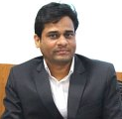
Name: RAJAN LAXMANRAO WANKHADE

Designation: Assistant Professor,
Applied Mechanics Department

Govt. College of Engineering Nagpur
Date of Birth: 04/01/1986
Email Address: rajanw04@gmail.com
Mobile No.: 7758883183

Education Qualification:

Sr. No | Degree | Date of Passing | University | Class/  Division | Field of Specialization
1 | Ph. D. | 2015 | IIT Bombay | First | Civil Engineering  (Structural Engg. Specialization)
2 | M.Tech. | 2009 | SGBAU Amravati  ( Government College of Engineering, Amravati) | First | Structural Engg.
3 | B. E. | 2007 | SGBAU Amravati  ( Government College of Engineering, Amravati) | First | Civil Engineering

Thesis
Degree | Thesis Title
Ph.D | Vibration Control and Stability of Smart Piezolaminated Beams and Plates Using Finite Element Method
M.Tech | Linear Bending, Geometric Nonlinear and Stability Analysis of Skew Plates Using Finite Element Method

Work Experience (Teaching, Research, Industry, Others)

Total experience: Teaching=11 Years, Research= Nil, Industry=Nil Others= Nil

- Area of Specialization: Water Resource

- Courses taught at
 | Diploma | Post Diploma | Under Graduate | Post Graduate | Post Graduate Diploma Level
Names of Courses |  |  | - Engineering Mechanics  - RCC Design  - Steel Structures | - Theory of Elasticity and Plasticity  - Earthquake Engineering

- Research guidance
- Papers published
 | International Journals | National Journals | International conferences | National conferences | Total
No. of Papers | 18 |  | 13 | 07 | 40

- BE project guided :- 10
- ME/ M Tech Guided: Nil

- Ph. D. Guided: Nil

- Projects Carried out: 05

- Patents : 04
Sr. No. | Title of Invention | Publisher | Year
1 | SENSING AND DETECTION OF CRACKS AND OBSTACLES ON THE RAILWAY LINE (Patent application no. 202141036443) | The Patent Office Journal No. 39/2021 Dated 24/09/2021 (https://ipindia.gov.in/journal-patents.htm) | 2021
2 | EXPERIMENTAL RESEARCH ON METAL MATRIX COMPOSITE TO BE USED IN HYDRAULIC TURBINE BUSH  (Patent application no. 202121035723) | The Patent Office Journal No. 35/2021 Dated 27/08/2021  (https://ipindia.gov.in/journal-patents.htm) | 2021
3 | THERMAL ANALYSIS ON GROOVED TUBES THROUGH A FRICTION ANALYSIS ON DIESEL ENGINE CYLINDER | The Patent Office Journal No. 44/2021 Dated 29/10/2021  (https://ipindia.gov.in/journal-patents.htm) | 2021
4 | A HIGH STRENGTH GEOPOLYMER CONCRETE COMPOSITION AND A METHOD TO PRODUCE THE HIGH STRENGTH GEOPOLYMER CONCRETE  (Patent number: 2021103690) | Australian patent (Granted Patent number: 2021103690) | 2021

- Technology transfer: Nil

- Research Publication:
- International Journals - 18

- National Journals - Nil

- International Conferences - 13

- National Conferences - 07
- Number of Books Published : 02
Sr. No. | Title of Book | Publisher | Year
1 | Design of Steel Structures  ISBN: 9351647749 | Nirali Prakashan,  2015 | 2015
2 | Nonlinear and Stability Analysis of Skew Plates using FEM  Author: Rajan L. Wankhade  ISBN: 978-3-659-46970-1 | LAP LAMBERT Academic Publishing GmbH and Company,  KG, DudweilerLandstr., 99, 66123 Saarbrucken, Germany.  Published in September 2013 | 2013

- Awards Received: Nil

Name: ASHWINKUMAR ABHIMAN GAWAI
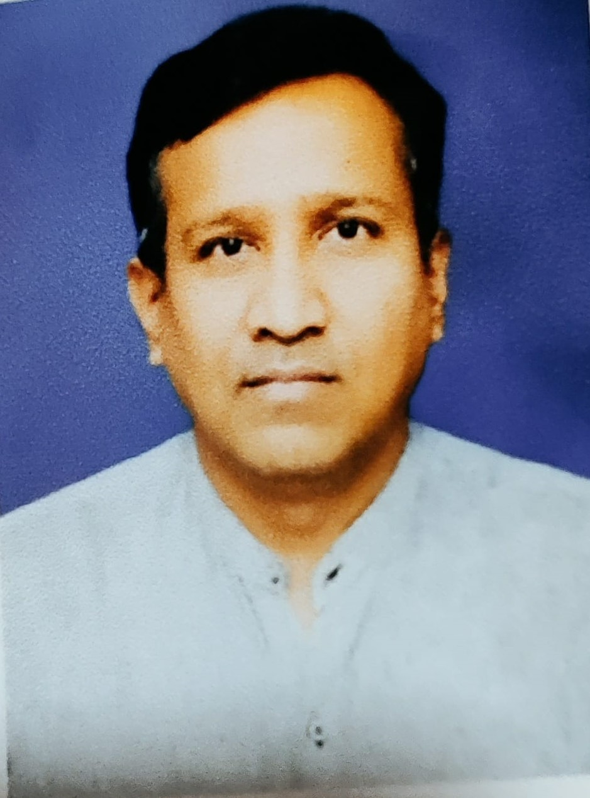

Designation: Assistant Professor,
Civil Engineering Department

Govt. College of Engineering Nagpur

Date of Birth: 01/07/1977
Email Address: ashwingawai@yahoo.com, ashwin9777@gmail.com
Mobile No.: 9881771900

Education Qualification:
Sr. No. | Degree | Date of Passing | University | Class/  Division | Field of Specialization
1 | M.E. | 18/08/2001 | SRTMU Nanded | First | Water Management
2 | B.E.Civil | 03/07/1998 | SGBU Amravati | First | Civil Engineering

Thesis
- ME- Application of multi Objective Fuzzy Linera Programming to Upper Wardh Project

Work Experience (Teaching, Research, Industry, Others)
Sr. No. | Post held | Organization  (Type- Teaching, Research, Industry, Others) | From | To
1 | Assistant Professor | Goverment College of Engineering, Nagpur | 30/06/2018 | Till date
2 | Assistant Professor | Goverment College of Engineering Chanrdpur | 11/01/2011 | 29/06/2018
3 | Lecturer | Jawaharlal Darda Institute of Engineering and Technology Yavatmal | 30/08/2007 | 10/01/2011
4 | Lecturer | Government Polytechnic, Khamgaon | 06/12/2005 | 29/08/2007
5 | Lecturer | Government Polytechnic, Washim | 30/10/2003 | 05/12/2007
6 | Visiting Faculty | Shri Guru Gobind Singhji College of Engineering & Technology Nanded | Jan 2001 | April 2003

Total experience: Teaching=20 Years, Research= Nil, Industry=Nil Others= Nil

- Area of Specialization: Water Resource

- Courses taught at
 | Diploma | Post Diploma | Under Graduate | Post Graduate | Post Graduate Diploma Level
Names of Courses | Engineering Mechanics  Environmental Engineering  Fluid Mechanics |  | Engineering Mechanics,  Strength of Material,  Fluid Mechanics  Surveying  Hydrology and Water Resources | C programming

- Research guidance
- Papers published
 | International Journals | National Journals | International conferences | National conferences | Total
No. of Papers | 05 |  |  | 04 | 09

- BE project guided :- 26
- ME/ M Tech Guided: Nil

- Ph. D. Guided: Nil

- Projects Carried out:Nil

- Patents : Nil

- Technology transfer: Nil

- Research Publication:

- International Journals - 06

- National Journals

- International Conferences - Nil

- National Conferences - 04

Name: Dr Shrikant A. Tekade
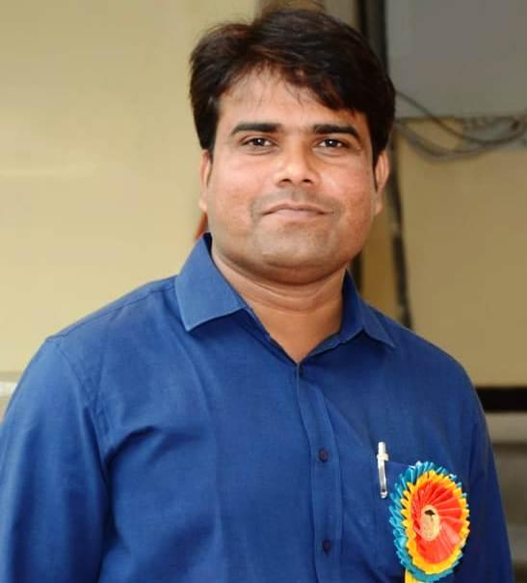
Designation: Assistant Professor, Department of Civil Engineering

Govt. College of Engineering Nagpur
Shrikant.tekade@gov.in, shrikant.tekade@yahoo.com,
M. No. 9975722854
Date of Birth: 05/10/1985
Unique ID: DTESATM8501

Education Qualification:
Sr. No. | Degree | Date of Passing | University | Class/  Division | Field of Specialization
1 | Ph.D. | 17/02/2017 | VNIT, Nagpur | 1st | Civil Engineering
2 | M.E. | 13/07/2011 | VNIT Nagpur | 1st | Water Resources Engineering
3 | B.E.Civil | 18/06/2009 | RTMNU, Nagpur | 1st | Civil Engineering

Work Experience (Teaching, Research, Industry, Others)

Sr. No. | Post held | Organization  (Type- Teaching, Research, Industry, Others) | From | To
1 | Assistant Professor | Shri Balaji Institute of Technology, Betul Teaching | 01/08/2011 | 30/06/2012
2 | Research Scholar | VNIT, Nagpur-Research | 01/07/2012 | 30/06/2016
3 | Assistant Professor | Shri Ramdeobaba College of Engieering- Teaching | 01/07/2016 | 21/01/2017
4 | Assistant Professor | Shri Balaji Institute of Technology, Betul- Teaching | 23/01/2017 | 17/01/2018
5 | Assistant Professor | Government College of Engineering, Nagpur-Teaching | 18/01/2018 | Till Date

Total experience: Teaching=6.6 , Research=04 , Industry=00 Others=00

Area of Specialization: Water Resources Engineering, Hydraulics

Courses taught at
 | Diploma | Post Diploma | Under Graduate | Post Graduate | Post Graduate Diploma Level
Names of Courses | ….. | …… | Fluid Mechanics, Irrigation Engg. Design of Hydraulic Structures, Concrete Technology, Geology, Water Resources Management, Water Power Engineering, Advanced Fluid Mechanics, Hydrology | …. | …..

Research guidance
- Papers published
 | International Journals | National Journals | International conferences | National conferences | Total
No. of Papers | 07 | 00 | 04 | .. | 11

- ME/ M Tech Guided: Nil

- Ph. D. Guided: Nil

Projects Carried out:NIL

Patents : 1. STAPLER AND ADHESIVE TAPE UNIT SET (Published)

2. EF- Brick -Roof Tiles: Making Method and Process
Environment- Friendly Brick and Roof Tiles. (Filed)

Technology transfer:

Research Publication:

- International Journals - 07

- National Journals - Nil

- International Conferences - 04

- National Conferences - Nil

Number of Books Published : 00

Awards Received: NIL
Number of Books Published : Nil
Awards Received: Nil

Name : Dr. Vijay Manikrao Athawale
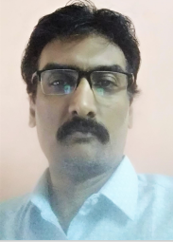
Date of Birth: 30/11/1971
Unique ID : DTEVMAM7101
Education Qualifications: B.E.(Mechanical Engg),
M.B.A. (Marketing)
M.Tech.(IE), Ph.D.

Work Experience-
Teaching : 21 Years
Research : 03 Years
Industry : 6 months
Others : Nil

Area of Specialization: Industrial Engineering

Courses taught at Diploma/Under Graduate/Post Graduate/ Post Graduate Diploma Level:
Machine Design, Operations Research, Industrial Engineering, Industrial
Management, Engineering Drawing, Mechanics of Materials, Theory of machine

Research Students Guided: 00

No. of papers published in National Journals: 08
No. of papers published in International Conference: 23
No. of papers published in International Journal: 11

Master (Completed/Ongoing): Completed

Ph.D.(Completed/Ongoing) : Completed

Projects carried out: NIL

Patents (Filed & Granted): 00

Technology Transfer: 01
Research Publications (No. of papers published in National/ International Journals/Conferences): 42
No of Books Published with details: Nil

Faculty Name- Dr. R. R. Chaudhari
Date of Birth- 25/01/1975
Unique ID- DTERRC75M
Education Qualifications- Ph.D, M.E.., B.E.
Work Experience
Teaching-19
Research-0
Industry-01
Others-Nil
Area of Specialization-Design, Combustion
Courses taught at Diploma/ Post Diploma/ Under Graduate/ Post Graduate/ Post Graduate Diploma
Level- DME, MP, MOM, TOM etc

Research guidance (Number of Students)- 00

No. of papers published in National/ International Journals/ Conferences-26

Master (Completed/Ongoing)-Completed

Ph.D. (Completed/Ongoing)- Completed

Projects Carried out- 10

Patents (Filed & Granted)- Nil

Technology Transfer-Nil

Research Publications (No. of papers published in National/International Journals/Conferences)-26

No. of Books published with details (Name of the book, Publisher with ISBN, year of publication, etc.) - 02

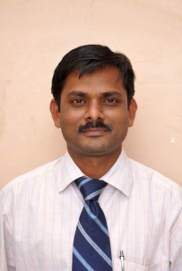
Name : Dr. Uday Suresh Wankhede
  - Date of Birth: 06/09/1976
  - Unique ID : DTEUSWM7401
  - Education Qualifications: PhD, M.E. B.E.

Work Experience
  - Teaching : 21 Years
  - Research : Nil
  - Industry : Nil
  - Others : Nil
- Area of Specialization : Thermal Engineering

Courses taught at Diploma/ Post Diploma/ Under Graduate/ Post Graduate/ Post Graduate Diploma
Level-Thermodynamics , Refrigeration and Air-Conditioning, Fluid Power

Research guidance (Number of Students)- 1 completed, 1 submitted, 3 on-going
  - No. of papers published in National/International Journals/Conferences: 75
  - Master (Completed/Ongoing) : Completed
  - Ph.D.(Completed/Ongoing) : Completed
- Projects Carried out: 02
- Patents(Filed & Granted): 1-granted,7-filed
- Technology Transfer: NIL
- Research Publications (No. of papers published in National/ International Journals/Conferences): 75
- No. of Books published with details (Name of the book, Publisher with ISBN, year of publication, etc.) – 04 book chapters

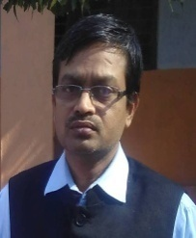
Name: Dr. Ravindra Babu Yarasu
Date of Birth 27/08/1970
Unique ID DTERBYM7001
Education Qualifications: B.E. (Mech), M. Tech.(Thermal), Ph.D.(Aerospace)
Work Experience:
Teaching: 28years
Research: Nil
Industry: Nil
Others: Nil
Area of Specialization: Thermal Engineering, CFD Simulation
Courses taught at Diploma/ Post Diploma/ Under Graduate/ Post Graduate/ Post Graduate Diploma: Heat Transfer, Refrigeration & Air-conditioning
Research guidance (Number of Students): 3 PhD completed, 4 PhD scholars registered
No. of papers published in National/ International Journals/ Conferences: 55
Master (Completed/Ongoing): Completed
Ph.D. (Completed/Ongoing): Completed
Projects carried out: No
Patents (Filed & Granted): 01filed
Technology Transfer: 01
Research Publications (No. of papers published in National/International Journals/Conferences) 32
No. of Books published with details (Name of the book, Publisher with ISBN, year of publication, etc.): Book chapter 01

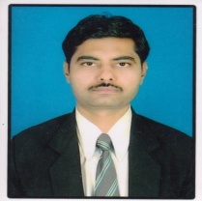
1 Name Alokkumar Ashokkumar Uplap
2 Date of Birth 25/09/1976
3 Unique ID DTEAAUM7601
4 Education Qualifications: B.E.(Mech), M.E.
5 Work Experience:
6 Teaching 21 years
7 Research Nil
8 Industry Nil
9 others Nil
10 Area of Specialization Production Technology
11 Courses taught at Diploma/ Post Diploma/ Under Graduate/ Post Graduate/ Post Graduate Diploma: Manufacturing Processes, Material Science & Engineering, Engg.Graphics, Mechanical Measurement, Fluid Power, Engg, Thermodynamics, Machine Drawing, Engg. Metallurgy, Basic Mechanical Engg.
13Research guidance (Number of Students) 0
14 No. of papers published in National/ International Journals/ Conferences 15
15 Master (Completed/Ongoing): Completed
16 Ph.D. (Completed/Ongoing): No
17 Projects Carried out: No
18 Patents (Filed & Granted): No
19 Technology Transfer: No
20 Research Publications (No.of papers published in National/International Journals/Conference): 15
21 No. of Books published with details (Name of the book, Publisher with ISBN, year of publication, etc.) No

1 Name: Monika Shankarrao Satpute
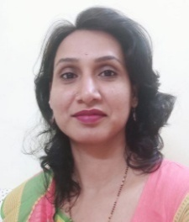
2 Date of Birth 14/12/1984
3 Unique ID DTEMSSM8401
4 Education Qualifications: B.E.(Mech), M.Tech.(Thermal)
5 Work Experience:
6 Teaching 15 years
7 Research Nil
8 Industry Nil
9 others Nil
10 Area of Specialization: Thermal Engineering
11 Courses taught at Diploma/ Post Diploma/ Under Graduate/ Post Graduate/ Post Graduate Diploma:
Engineering Graphics, machine drawing, Modern Energy sources, Advance Refrigeration System
13 Research guidance (Number of Students) 00
14 No. of papers published in National/ International Journals/ Conferences 12
15 Master (Completed/Ongoing): Completed
16 Ph.D. (Completed/Ongoing): No
17 Projects Carried out: No
18 Patents (Filed & Granted): 01 published
19 Technology Transfer: No
20 Research Publications (No. of papers published in National/International Journals/Conference): 15
21 No. of Books published with details (Name of the book, Publisher with ISBN, year of publication, etc.) No

1 Name: Shrikrishna Rajaram Wagh
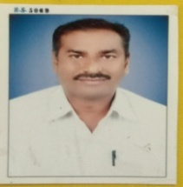
2 Date of Birth 25/06/1976
3 Unique ID DTESRWM7601
4 Education Qualifications: B.E.(Mech), M.Tech.(Thermal)
5 Work Experience:
6 Teaching 20 years
7 Research Nil
8 Industry 01
9 others Nil
10 Area of Specialization: Thermal Engineering and I C Engine
11 Courses taught at Diploma/ Post Diploma/ Under Graduate/ Post Graduate/ Post Graduate Diploma:
I.C. Engines, Thermodynamics, Energy Conversion, Kinematics of Machines, Dynamics of Machines, Power Plant Engineering, Renewable Energy Sources
13Research guidance (Number of Students) 00
14 No. of papers published in National/ International Journals/ Conferences 02
15 Master (Completed/Ongoing): Completed
16 Ph.D. (Completed/Ongoing): No
17 Projects Carried out: No
18 Patents (Filed & Granted): Nil
19 Technology Transfer: No
20 Research Publications (No. of papers published in National/International Journals/Conference): 02
21 No. of Books published with details (Name of the book, Publisher with ISBN, year of publication, etc.) No

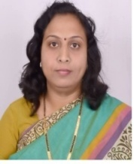
1 Name: Tripti Namdeo Kumbalpuri
2 Date of Birth 03/06/1976
3 Unique ID DTETNKF7601
4 Education Qualifications: B.E.(Mech), M.Tech
5 Work Experience:
6 Teaching 20 years
7 Research Nil
8 Industry 01
9 others Nil
10 Area of Specialization: Micro-fluidics
11 Courses taught at Diploma/ Post Diploma/ Under Graduate/ Post Graduate/ Post Graduate Diploma:
I.C. Engines, Thermodynamics, Energy Conversion, Kinematics of Machines, Dynamics of Machines, Power Plant Engineering, Renewable Energy Sources
13Research guidance (Number of Students) 00
14 No. of papers published in National/ International Journals/ Conferences 07
15 Master (Completed/Ongoing): Completed
16 Ph.D. (Completed/Ongoing): No
17 Projects Carried out: No
18 Patents (Filed & Granted): Nil
19 Technology Transfer: No
20 Research Publications (No. of papers published in National / International Journals/Conference): 07
21 No. of Books published with details (Name of the book, Publisher with ISBN, year of publication, etc.) No

1 Name: Vikram Prabhakar Titarmare
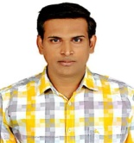
2 Date of Birth 23/11/1978
3 Unique ID DTEVPTM7801
4 Education Qualifications: B.E.(Mech), M.Tech
5 Work Experience:
6 Teaching 11 years
7 Research Nil
8 Industry 07 years
9 others Nil
10 Area of Specialization: Mechanical engineering
11 Courses taught at Diploma/ Post Diploma/ Under Graduate/ Post Graduate/ Post Graduate Diploma:
Design of mechanical drives, Hydraulic machines, Mechanical measurement, Industrial management, Metallurgy
13 Research guidance (Number of Students) 00
14 No. of papers published in National/ International Journals/ Conferences 02
15 Master (Completed/Ongoing): Completed
16 Ph.D. (Completed/Ongoing): No
17 Projects Carried out: 05
18 Patents (Filed & Granted): 01
19 Technology Transfer: No
20 Research Publications (No. of papers published in National/International Journals/Conference): 02
21 No. of Books published with details (Name of the book, Publisher with ISBN, year of publication, etc.) No

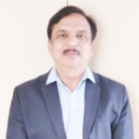
Name : Dr. Nitin Deorao Ghawghawe
Date of Birth: 01/09/1964
Unique ID : DTENDGM6401
Education Qualifications: B.E.(Electrical),M.E.(EPS), Ph.D. M.B.A.

Work Experience-
Teaching : 33 Years
Research : 03
Industry : Nil
Others : Nil

Area of Specialization: Electrical Power Systems

Courses taught at Diploma/Under Graduate/Post Graduate/ Post Graduate Diploma Level:
- Electrical Engineering
- Network Analysis
- Digital Electronic Circuits
- Switchgear and Protection
- Power Systems
- Control Systems
- Microprocessors and Applications
- Optimization Techniques

Research Students Guided: 04

No. of papers published in National/International Journals/Conferences : 11

Master (Completed/Ongoing) : Completed

Ph.D.(Completed/Ongoing) : Completed

Projects Carried out: NIL

Patents(Filed & Granted): 01

Technology Transfer: 01
Research Publications (No. of papers published in National/ International Journals/Conferences): 32
No of Books Published with details: 01 (Book Chapter in Springer)
Title: Available Transfer Capability Enhancement using Generator Participation Factors (,
Publisher: Springer Nature Switzerland CRC Press Hard, ISBN: 9781774910009
E-Book ISBN: https://doi.org/10.1007/978-3-030-16848-3_1
Year of Publication: 2020

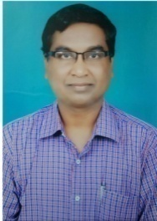
1) Faculty Name- Rajesh Shankarrao Surjuse

2) Date of Birth- 30/08/1971

3) Unique ID- DTERSSM7102

4) Education Qualifications- Ph.D, M.Tech., B.E.

5) Work Experience
a) Teaching-26
b) Research-3
c) Industry-Nil
d) Others-Nil

6) Area of Specialization-The main area of research is Power Electronics, Drives and Control, Power Quality, dSpace hardware & software technique, Power System Stability and Control using static VAR Controller, PWM Inverter and other Converters, Steady-State, Transient, Stability and Harmonics analysis of the Drives using Conventional Control, Direct Torque Control, Vector Control, Sensor less and other control scheme, Artificial Intelligence based estimators and observers, Application of soft computational methods to power system, Solar PV Systems Grid connected / Standalone, Electric Vehicles, smart grid.

7) Courses taught at Diploma/ Post Diploma/ Under Graduate/ Post Graduate/ Post Graduate Diploma Level- Electrical Machine, Microprocessors and Microcontrollers, Measurement and Instrumentation, Installation System, Power Electronics, Power System, FACTS, Switchgear and Protection.

8) Research guidance (Number of Students)-04

9) No. of papers published in National/ International Journals/ Conferences-16

10) Master (Completed/Ongoing)-Completed

11) Ph.D. (Completed/Ongoing)- Completed

12) Projects Carried out- MODROB-01

13) Patents (Filed & Granted)- Filed-01

14) Technology Transfer-Nil

15) Research Publications (No. of papers published in National/International Journals/Conferences)-16

16) No. of Books published with details (Name of the book, Publisher with ISBN, year of publication, etc.) - Nil

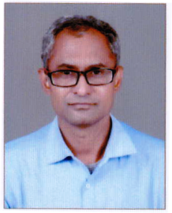
Name : Dr. Sachin Purushottam Jolhe
  - Date of Birth: 05/07/1977
  - Unique ID : DTESPJM7701
  - Education Qualifications : PhD, M.E. (EPS)

Work Experience
  - Teaching : 17 Years
  - Research : Nil
  - Industry : Nil
  - Others : Nil
- Area of Specialization : Electrical Power system

Courses taught at Diploma/ Post Diploma /Under Graduate/ Post Graduate /Post Graduate Diploma Level:Basic Electrical Engineering, Renewable Energy studies, Electrical Measurement & Instrumentation, Electrical machines-I and II , Poiwer System I and II, High voltage Engineering, Switch gear and protection, Electrical Drives and control, Flexible AC Transmission System , Electrical Installation & Design.

Research guidance (Number of Students)
  - No. of papers published in National/International Journals/Conferences : 11
  - Master (Completed/Ongoing) : Completed
  - Ph.D.(Completed/Ongoing) : Completed
- Projects Carried out: NIL
- Patents(Filed & Granted): NIL
- Technology Transfer: NIL
- Research Publications (No. of papers published in National/ International Journals/Conferences): 11
- No. of Books published with details : 01 ( Book Chapter )
- Name of the book: Sustainable Engineering, Energy, and the Environment Challenges and Opportunities
- Publisher with ISBN: CRC Press Hard, ISBN: 9781774910009
E-Book ISBN: 9781003277484
- Year of publication: July 2022

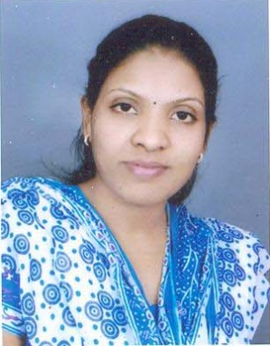
Profile of Faculty
- Name: Rajani Maniramji Sahare
- Date of Birth: 29/11/1982
- Unique ID: DTERMSF8202
- Education Qualifications M. Tech. in Electrical Power System (EPS)
- Work Experience 12 years
- Teaching 12 years
- Research Nil
- Industry Nil
- others Nil
- Area of Specialization Electrical Power System (EPS)
- Courses taught at Diploma/ Post Diploma/ Under Graduate/ Post Graduate/ Post Graduate Diploma Basic Electrical Engineering, Energy Resources& Generation, Switch Grear & Protection, Signals & Systems, Electrical Mesurement & Instrumentation, Industrial Organizaton & Management, Electrical Power System
- Level 10(57700-182400)
- Research guidance (Number of Students) 4 M. Tech. Students
- No. of papers published in National/ International Journals/ Conferences 7
- Master (Completed/Ongoing) Completed
- Ph.D. (Completed/Ongoing) No
- Projects Carried out No
- Patents (Filed & Granted) No
- Technology Transfer No
- Research Publications (No.of papers published in National/International Journals/Conferences) No
- No. of Books published with details (Name of the book, Publisher with ISBN, year of publication, etc.) No

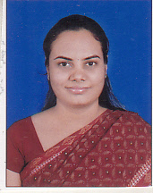
Profile of Faculty
- Name NEHA VIJAY KHADSE
- Date of Birth 07-06-1984
- Unique ID DTENVKF8402
- Education Qualifications M. Tech. in Electrical Power System (IPS)
- Work Experience 11 years
- Teaching 11 years
- Research Nil
- Industry Nil
- others Nil
- Area of Specialization Intergrated Power System (IPS)
- Courses taught at Diploma/ Post Diploma/ Under Graduate/ Post Graduate/ Post Graduate Diploma Basic Electrical Engineering, Energy Resources& Generation, Electrical Mesurement & Instrumentation, Electrical Power System,Utilization Electrical Energy,Electrical distribution system,Electrical Power System,Power Station Practice
- Level 10(57700-182400)
- Research guidance (Number of Students) 0
- No. of papers published in National/ International Journals/ Conferences 2
- Master (Completed/Ongoing) Completed
- Ph.D. (Completed/Ongoing) No
- Projects Carried out No
- Patents (Filed & Granted) No
- Technology Transfer No
- Research Publications (No.of papers published in National/International Journals/Conferences) No
- No. of Books published with details (Name of the book, Publisher with ISBN, year of publication, etc.) No

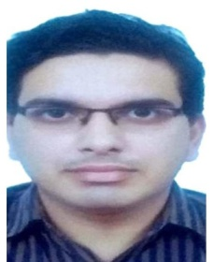
- Faculty Name- Praful V. Nandankar
- Date of Birth- 30/12/1988
- Unique ID-DTEPVNM8801
- Education Qualifications- MTech
- Work Experience
- Teaching-9
- Research-2
- Industry-Nil
- Others-Nil
- Area of Specialization-Power Electronics and Drives
- Courses taught at Diploma/ Post Diploma/ Under Graduate/ Post Graduate/ Post Graduate DiplomaLevel- FACTS, Analog Electronics, Digital Electronics, Electrical Machine Design, Microprocessors and Microcontrollers, Non-conventional Energy sources, Computer Programming, Power Devices and Machines, Control Systems-I, Power Electronics.
- Research guidance (Number of Students)-Nil
- No. of papers published in National/ International Journals/ Conferences-15
- Master (Completed/Ongoing)-Completed
- Ph.D. (Completed/Ongoing)-Ongoing
- Projects Carried out- One UBA Project
- Patents (Filed & Granted)- a) Granted-5, b) Filed-10
- Technology Transfer-Nil
- Research Publications (No.of papers published in National/International Journals/Conferences)-20
- No. of Books published with details (Name of the book, Publisher with ISBN, year of publication, etc.)
Authors | Title of Book | Publisher | ISBN number | Year of Publication
Praful Vijay Nandankar, Vishwanath Shridhar Gaikwad, Molleshree Prabhakar Saware, Dr Sanjiv Kumar Jain | Electrical Vehicle Future of Mobility | InSc International Publishers (IIP) | 978-1-956102-35-2 | August 2021
Praful V. Nandankar, Dr Shaik Mohammad Rafi, Dr Gaurav Kumar Ameta, Mr Mahesh Manohar Bhanushali | R Programming for Beginners | Notionpress | 9798885032872 | November 2021

Name : Dr Rajeshree Raut
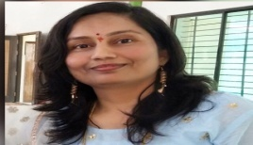
  - Date of Birth: 2nd August 1976
  - Unique ID : DTERDRF7601
  - Education Qualifications : PhD in Wireless Communications

WorkExperience
  - Teaching : 23 yrs
  - Research : 11 yrs
  - Industry : 1.5 years
- Others :
- Area of Specialization : Wireless Communication, Cognitive Radio
Courses taught at Diploma/ Post Diploma /Under Graduate/ Post Graduate /Post Graduate Diploma Level: EDC, Digital Communication, Communication Engineering, WCOM

Researchguidance (NumberofStudents)
  - No.ofpaperspublishedinNational/InternationalJournals/Conferences : 80
  - Master(Completed/Ongoing) : Completed
  - Ph.D.(Completed/Ongoing) : Completed
- Projects Carriedout: 5- Industry sponsored
- Patents(Filed&Granted): 6
- Technology Transfer: Nil
- Research Publications (No. of papers published in National/ International Journals/Conferences): 80
- No. of Books published with details : 2
- Book on “Cognitive Radio: Basic Concepts, Mathematical Modeling and Applications”, CRC press, April 7, 2020.
- Book on ‘Error Control Coding; For Performance Improvement in Cognitive Radio’, has been published by LAP Verlag Academic Publishing, on August 17, 2012.

- Book chapter written: Microelectronics, Electromagnetics and Telecommunications (ICMEET) 2015, Lecture Notes in Electrical Engineering (LNEE), Chapter No12, pp., 121-134, December 2015, Published by: Springer, ISBN: 978-81-322-2726-7

Name : Sujata G. Bhele
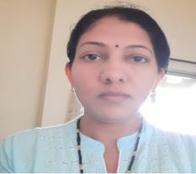
  - Date of Birth: 9th May 1979
  - Unique ID : DTESGBF7901
  - Education Qualifications : M.Tech(Electronics Engg.)

Work Experience
  - Teaching : 13 yrs
  - Research : Nil
  - Industry : Nil
- Others :
- Area of Specialization: Digital Signal and Image Processing, Embedded systems.
Courses taught at Diploma/ Post Diploma /Under Graduate/ Post Graduate /Post Graduate Diploma Level: Digital circuit, Control system, Analog circuit design,DSP Processors & Architecture, Microwave & Radar Engineering,EMI.

Research guidance (Number of Students)
  - No. of papers published in National/International Journals/Conferences : 06
  - Master(Completed/Ongoing) : Completed
  - Ph.D.(Completed/Ongoing) : Ongoing
- Projects Carried out: 4
- Patents(Filed & Granted): Nil
- Technology Transfer: Nil
- Research Publications (No. of papers published in National/ International Journals/Conferences): 06
- No. of Books published with details : Nil

Name :Shilpa Meshram(Mrs.Shilpa Ukey)
  - Date of Birth: 14 August 1981
  - Unique ID :
  - Education Qualifications : M.Tech VLSI

Work Experience
  - Teaching : 11
  - Research : nil
  - Industry : nil
- Others :
- Area of Specialization : VLSI
Courses taught at Diploma/ Post Diploma /Under Graduate/ Post Graduate /Post Graduate Diploma Level: EMI,OC,CCN,DE

Research guidance (Number of Students)
  - No. of papers published in National/International Journals/Conferences : 3
  - Master(Completed/Ongoing) : Completed
  - Ph.D.(Completed/Ongoing) :
- Projects Carried out:
- Patents(Filed & Granted):
- Technology Transfer:
- Research Publications (No. of papers published in National/ International Journals/Conferences):
- No. of Books published with details :
- Name of the book:
- Publisher with ISBN:
- Year of publication:

Name: Dr Chandrashekhar Pundlik Kalambe
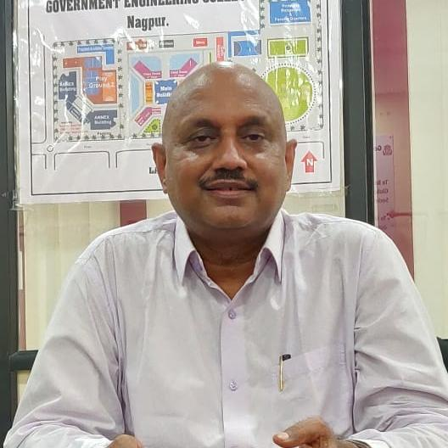

Designation: Head & Associate Professor (CAS),
Applied Chemistry Department

Govt. College of Engineering Nagpur
cpkalambe@rediffmail.com , 9423124435
Date of Birth: 15/06/1965

Unique ID:

Education Qualification:
Sr. No. | Degree | Date of Passing | University | Class/  Division | Field of Specialization
1 | Ph.D. | 1992 | Nagpur Univ.  Nagpur | ---- | Coordination Polymers:Strual & Synthetic Studies
2 | M.Sc | 1987 | Nagpur Univ.  Nagpur | I Class | Inorganic Chemistry
3 | B.Sc. | 1985 | Nagpur Univ.  Nagpur | I Class

Work Experience (Teaching, Research, Industry, Others)
Sr. No. | Post held | Organization  (Type- Teaching, Research, Industry, Others) | From | To
1 | Lecturer | B D College of Engg. Sewagram, Wardha. | 10/09/1990 | 30/04/2091
2 | Lecturer | Institute of Science Nagpur | 02/12/2091 | 03/09/1998
3 | Lecturer | Govt. Engg College, Chandrapur | 04/09/1998 | 08/06/2005
 | Lecturer | Govt. Engg College, Amrawati | 12/06/2005 | 31/07/2008
 | Asso. Prof | Govt. Engg College, Chandrapur | 01/08/2008 | 01/06/2018
 | Asso. Prof | Govt. Engg College, Nagpur | 02/06/2018 | Till Date
Total experience: Teaching= 30 Years , Research= …. , Industry=…. , Others= …..

Area of Specialization: Inorganic Chemistry, Coordination Chemistry

Courses taught at
 | Diploma | Post Diploma | Under Graduate | Post Graduate | Post Graduate Diploma Level
Names of Courses |  |  | 1.Inorg Chem/phy Chem/org Chem (B. Sc.)  2. Engg. Chem ( B.E. First Year)  3.Pollution Controll & Instrumentation  (B. E. VI SEM INST.)  4. Analytical & chemical Instrumentation (B. E. VII SEM INST.) | 1.Inorganic Chemistry  2. Coordination Polymer
Research Publication:

- International Journals - 05

- National Journals

- International Conferences
- National Conferences

Number of Books Published : 02

Awards Received: 02

Name : Dr C M khairnar
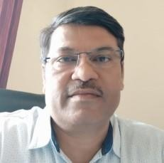
  - Date of Birth: 26 December 1981
  - Unique ID :
  - Education Qualifications : M.Sc, M phil, Ph D

Work Experience
  - Teaching : 28 years
  - Research : 05
  - Industry : nil
- Others :
- Area of Specialization : Thin films, AI
Courses taught at Diploma/ Post Diploma /Under Graduate/ Post Graduate /Post Graduate Diploma Level: Engineering physics

Research guidance (Number of Students)
  - No. of papers published in National / International Journals / Conferences : 10
  - Master(Completed/Ongoing) : Completed
  - Ph.D.(Completed/Ongoing) : completed
- Projects Carried out: nil
- Patents(Filed & Granted): nil
- Technology Transfer: nil
- Research Publications (No. of papers published in National/ International Journals/Conferences): 10
- No. of Books published with details : nil
- Name of the book:
- Publisher with ISBN:
- Year of publication:

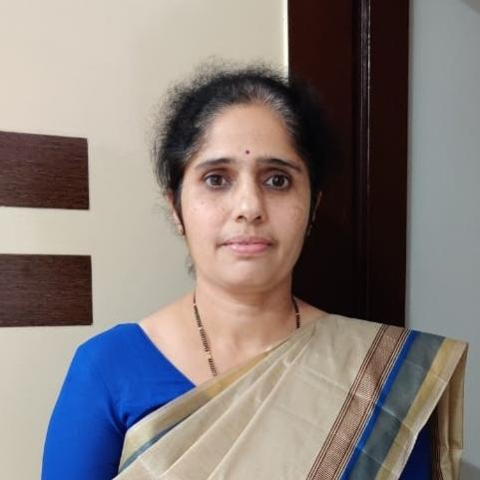
Name :Jasmirkaur B Randhawa
  - Date of Birth: 13 November 1972
  - Unique ID :DTEJBRF7201
  - Education Qualifications :M Sc Physics, Ph D

Work Experience
  - Teaching :21
  - Research :16
  - Industry :Nil
- Others :
- Area of Specialization: Materials Science, Electrochemical Devices

Courses taught at Diploma/ Post Diploma /Under Graduate/ Post Graduate /Post Graduate Diploma Level: Applied Physics, Solid State Physics, Quantum Mechanics, Condensed Matter Physics, Physics of Electrical Engineering Materials

Research guidance

Number of Students: Nil
  - Master(Completed/Ongoing) : Completed
  - Ph.D.(Completed/Ongoing) : Completed
- Projects Carried out: 01 (MODROBS)
- Patents(Filed & Granted): Granted 01
- Technology Transfer: Nil
- Research Publications (No. of papers published in National/ International Journals/Conferences): 22
- No. of Books published with details: 02

  - Name of the book: Applied Physics
  - Publisher with ISBN: Alliance & Co. Nagpur ISBN: 9788195177240
  - Year of publication: 2020

  - Name of the book: Advanced Engineering Materials
  - Publisher with ISBN: Alliance & Co. Nagpur ISBN: 9788195177271

Year of publication: 2021

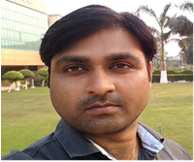
Dr. Vinod Jagatrao Dagwal
Head & Assistant professor,
Dept of Mathematics,
Govt.College of Engineering, Nagpur
Mobile No- 9890345496
Email-ID-vdagwal@gmail.com

Date of Birth: 01-11-1985

Unique ID -: DTEVJDM8501

Qualification: M.Sc.,Ph.D. (Mathematics)

Employment Record

Total Teaching experience -: 11 years
(Under Graduate -: 11,Post Graduate-: 5 years, 5 months)

Administrative Experience -: 5 years (Head, Department of Mathematics)

Total Research Experience-: 12 years

Invited Lectures/ Expert Member:- 5
Area of Specialization -:Cosmology, General Relativity, Modified Theories of Gravity
Research Activities

- Paper published in Journal [Total: 30](Scopus, SCI, SCIE and GoodImpact Factor-16; UGC care– 02;UGC Approved Journal -03 ; Peer-Reviewed- 9)
- Single Author Paper published in Journal [Total: 4] (Scopus, SCI, SCIE and GoodImpact Factor- 03 ; UGC Approved Journal - 01)
- Google Citations - : 316 (h-index=12 ,i10-index = 13)
- Scopus Citations - :88 (h-index=06)
- Conferences:- 29(International = 15,National=14)
- REVIEWER ( Scopus, SCI, SCIE index Journal )-: (02)

- Seminar [2], Workshop [5], FDP[1] and STTP [6]-:13
- ONLINE-: FDP AND STTP [14],WEBINAR [03], WORKSHOP [01]QUIZ [01] =19
- Co-Curricular Activities (09)
- Awards/Medals/Merit (3)
Book Authored -: 02
The details of the books are:
Sr.  No. | ISBN | Tile Name | Year of Publication | Published
1 | 9789355011930 | Mathematics - I | 2022 | S Chand And  Company Ltd.

Fee
Details of Fee, as approved by State Fee Committee, for the Institution: - As per GR No. TEM-2003 /249/03/TE-1, Date, 11 September’2003 and available on college website.https://www.gcoen.ac.in/wp-content/uploads/2021/12/Fees_First_year_2021.pdf

  - Time schedule for payment of Fee for the entire Programme : after declaration of Result by semester wise(June-July) and during admission
No. of Fee waivers granted with amount and name of students
- 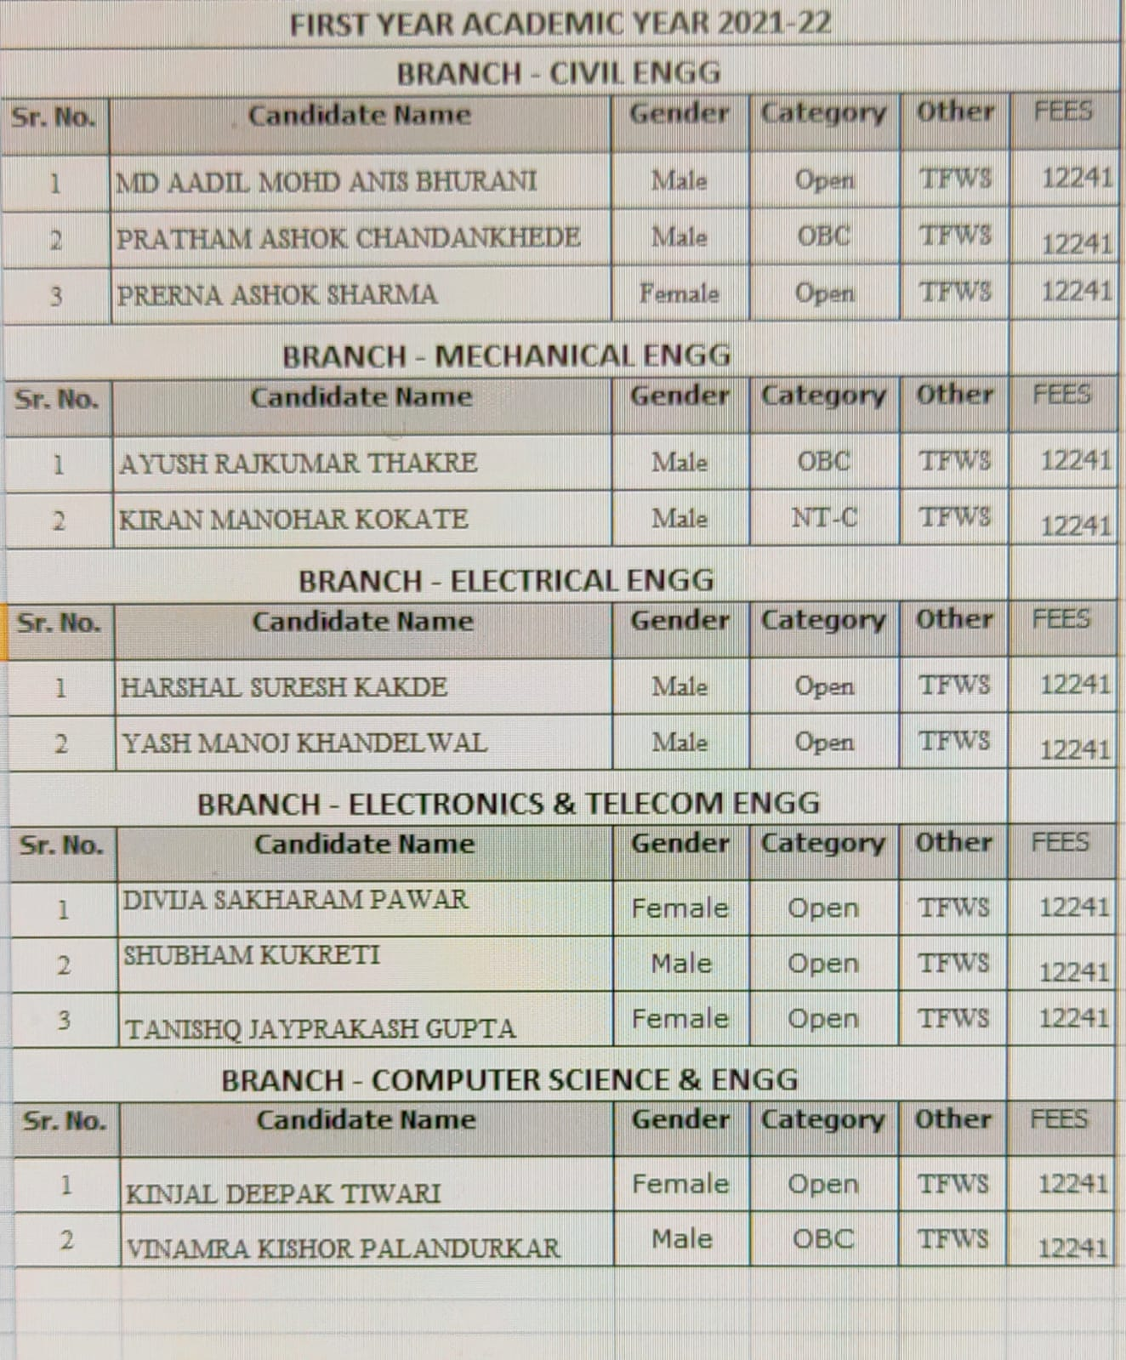
Number of scholarship offered by the Institution, duration and amount: GOI, Minority, EBC (CSMS).
  - Criteria for Fee waivers/scholarship: Annual Income Less than Eight Lakh as per Merit for open category students and As per GOI & Govt. of Maharashtra for all backwards classes including EWS.
  - Estimated cost of Boarding and Lodging in Hostels: Rs. 20000+2,750 = 22750 /- per year/student.
  - Any other fee please specify

Admission
  - Number of seats sanctioned with the year of approval – 60 for Each Branch( Total:300) year of approval: 2016-17
  - Number of Students admitted under various categories each year in the last three years
SC-121, ST-146, OBC-514, General-191, PWD-19, Minority-08
  - Number of applications received during last two years for admission under Management Quota
and number admitted – Not Applicable

Admission Procedure

Admission on the basis of test conducted by
“State Common Entrance Test (CET) Cell, Government of Maharashtra”

HEAD OFFICE Address:

8th Floor, New Excelsior Building, A. K. Nayak Marg, Fort, Mumbai- 400 001. Phone (Board line): 022 – 22016153 / 57/59
E-Mail: maharashtra.cetcell@gmail.com Website: www.mahacet.org
- 100% Seat allotted by merit on the basis of CET (Test conducted by Maharashtra state).

Admission through Centralized Admission Process (CAP), carried out by CET Cell, Government of Maharashtra.

Calendar for admission against Management/vacant seats:

No management quota in college. Vacant seats arising from CAP rounds are filled on Institute level.

If any seat remains vacant in CAP, this vacant seat will be filled by conducting counseling round on the basis of Maharashtra Merit Number (assigned on the basis of CET)

If any CAP seat remains or becomes vacant after the CAP Rounds, then the same shall be filled in by the Candidate from the same Category for which it was earmarked during the CAP. Further if the seats remain vacant then the seats shall be filled on the basis of Inter-Se-Merit of the applicants.

Cancellation of Admission and Refund of fees, return of documents by Institutions. - (a) The Candidate shall apply online for cancellation and submit duly signed copy of system generated application for cancellation of admission to the institution. Once the candidate submits online request for cancellation, his/her admission shall be treated as cancelled. Institute shall refund the entire fees to the candidate after deduction of Rs.1000/- towards processing charges and return all his/her original documents submitted to the Institute within two days from submission of duly signed copy of system generated application to the Institute;

Candidate shall not be entitled to any refund of his/her fee except the Security Deposit and Caution Money Deposit Rs. 500/- if the online cancellation is effected by the candidate after 5.00 p.m. of the cut-off date prescribed by the Competent Authority.

Criteria and Weightage for Admission

Syllabus, Weightage and Pattern of Examination: Syllabi of Physics, Chemistry, Mathematics and Biology for the MHT - CET 2021, is declared by Director, Technical Education, and Mumbai vide Letter 2A/ADM/MHT CET Syllabus/2020/347, Dated 01/12/2020 is as follows: The questions will be based on Syllabus of Maharashtra State Board of Secondary and Higher Secondary Education. Approximately 20% Weightage will be given to Std. XI curriculum and 80% Weightage will be given to Std. XII curriculum while setting the question paper There will be no Negative Marking, however difficulty level will be at par with the JEE (Main) for Mathematics, Physics, Chemistry and difficulty level for Biology will be at par with NEET. The questions will be mainly application based.

Eligibility Criteria

(1) Maharashtra State Candidature Candidates. - (i) The Candidate should be an Indian National; (ii) Passed HSC or its equivalent examination with Physics and Mathematics as compulsory subjects along with one of the Chemistry or Biotechnology or Biology or Technical Vocational subject or Computer Science or Information Technology or Informatics Practices or Agriculture or Engineering Graphics or Business Studies and obtained at least 45 % marks (at least 40 % marks, in case of Backward Class categories, Economically Weaker Section and Persons with Disability category candidates belonging to Maharashtra State), in the above subjects taken together; and the Candidate should have appeared in all the subjects in CET and should obtain non zero score in CET conducted by the Competent Authority; or (ii) Passed Diploma in Engineering and Technology and obtained at least 45 % marks (at least 40 % marks, in case of Backward Class categories, Economically Weaker Section and Persons with Disability category candidates belonging to Maharashtra State);

(2) All India Candidature Candidates, Union Territory of Jammu and Kashmir and Union Territory of Ladakh Migrant Candidature Candidates. - (i) The Candidate should be an Indian National; (ii) Passed HSC or its equivalent examination with Physics and Mathematics as compulsory subjects along with one of the Chemistry or Biotechnology or Biology or Technical Vocational subject or Computer Science or Information Technology or Informatics Practices or Agriculture or Engineering Graphics or Business Studies and obtained at least 45 % marks (at least 40 % marks, in case of Backward Class categories, Economically Weaker Section and Persons with Disability category candidates belonging to Maharashtra State) in the above subjects taken together; and should obtain non zero positive score in JEE (Main) B.E./B.Tech or the candidate should have appeared in all the subjects in CET and should obtain non zero score in CET conducted by the Competent Authority. However preference shall be given to the candidate obtaining non zero positive score in JEE (Main) B.E./B.Tech over the candidates who obtained non zero score in CET; or (ii) Passed Diploma in Engineering and Technology and obtained at least 45 % marks (at least 40 % marks, in case of Backward Class categories, Economically Weaker Section and Persons with Disability category candidates belonging to Maharashtra State )

List of Applicants

•List of candidate whose applications have been received along with percentile/percentage score for each of the qualifying examination in separate categories for open seats. List of candidate who have applied along with percentage and percentile score for Management quota seats —No Management quota seats.

Results of Admission Under Management seats/Vacant seats

No Management quota. Only vacant seats are filled as per admission procedure given in brochure published by CET cell, Mumbai.
- Composition of selection team for admission under Management Quota with the brief profile of members (This information be made available in the public domain after the admission process is over) — NIL
• Score of the individual candidate admitted arranged in order or merit — NA
• List of candidate who have been offered admission — NIL
• Waiting list of the candidate in order of merit to be operative from the last date of joining of the first list candidate — NIL
• List of the candidate who joined within the date, vacancy position in each category before operation of waiting list. NA

Information of Infrastructure and Other Resources Available
  - Number of Class Rooms and size in (m) & area (m²)

Class Room Details
SN | Name | L | B | Area | Room No | Dept
1 | Class room | 8.6 | 7.0 | 60.2 | 11 | ETC
2 | Smart Class Room | 8.6 | 7.0 | 60.2 | 12 | ETC
3 | Class room | 9.8 | 11.4 | 111.4 | 23 | FY
4 | Class room | 10.3 | 7.0 | 71.8 | 110 | EE
5 | Class room | 11.4 | 8.8 | 99.5 | 111 | FY
6 | Class room | 10.3 | 7.0 | 71.8 | 111 | ETC
7 | Smart Class Room | 7.8 | 8.6 | 66.7 | 118 | EE
8 | Class room | 8.8 | 11.4 | 99.5 | 123 | FY
9 | Smart Class Room | 9.0 | 10.9 | 98.5 | 203 | Mech
10 | Class room | 9.0 | 10.7 | 95.9 | 209 | Mech
11 | Smart Class Room | 8.8 | 11.4 | 99.5 | 210 | civil
12 | Smart Class Room | 10.3 | 7.0 | 71.8 | 210 | CS
13 | Class room | 9.0 | 10.7 | 96.2 | 211 | civil
14 | Class room | 10.3 | 7.0 | 71.8 | 211 | CS
15 | Class room | 8.8 | 11.4 | 99.5 | 218 | civil
16 | Class room | 9.0 | 10.7 | 95.9 | 219 | Mech
 |  |  |  | 1369.838

  - Number of Tutorial rooms and size of each

Tutorial Room Details
SN | Name | L | B | Area | Room No | Dept
1 | Tutorial Room | 7 | 8.6 | 60.2 | 121 | EE
3 | Tutorial Room | 9 | 5.25 | 47.25 | 117 | Civil
4 | Tutorial Room | 8.6 | 7.75 | 66.65 | 218 | CS
5 | Tutorial Room | 9 | 5.25 | 47.25 | 221 | Mech
 |  |  |  | 221.35

  - Number of Laboratories and size of each

Sr. No | NAME | Length | Width | AREA | ROOM NO | DEPT | Type
1 | EM lab | 14.15 | 11.37 | 160.89 | 7 | First year | I
2 | SOM | 9.00 | 8.95 | 80.55 | 8 | Civil | I
3 | TRE | 9.00 | 8.95 | 80.55 | 9 | Civil | I
4 | GT | 9.00 | 8.95 | 80.55 | 10 | Civil | I
5 | FM lab | 9.80 | 9.07 | 88.86 | 21 | Civil | I
6 | chemistry lab | 11.37 | 14.00 | 159.18 | 27 |  | I
7 | Cad lab | 9.00 | 10.52 | 94.64 | 103 | Civil | I
8 | EE | 8.75 | 11.37 | 99.49 | 105 | Civil | I
9 | LAB | 9.00 | 10.65 | 95.85 | 106 | Mech | I
10 | LAB | 9.00 | 5.33 | 47.93 | 108 | mech | I
11 | LAB | 9.00 | 5.33 | 47.93 | 109 | mech | I
12 | HT Lab | 9.00 | 10.70 | 96.26 | 112 | mech | I
13 | Langauge Laboratory | 9.00 | 5.33 | 95.85 | 122+121 | First year | I
14 | Dark Room |  |  | 47.25 | 127 | First year | I
15 | physics lab | 9.00 | 15.98 | 95.85 | 127 | First year | I
16 | CAD | 9.00 | 10.52 | 94.64 | 204 | Mech | I
17 | Engineering Metelergy Lab | 8.75 | 11.37 | 99.49 | 205 | Mech | I
18 | Geology Lab | 9.00 | 10.65 | 95.85 | 206 | civil | I
19 | Mecatronics Lab | 9.00 | 10.73 | 96.53 | 222 | Mech | I
20 | Hydraulic Machine Lab | 9.00 | 10.69 | 96.21 | 225 | Mech | I
21 | Microprocessor Lab | 8.60 | 7.00 | 60.20 | 3 | EE | I
22 | Electrical Machine Lab | 8.60 | 12.50 | 107.50 | 4 | EE | I
23 | EMAI ACL | 7.00 | 8.60 | 60.20 | 13 | EE | I
24 | Basic Electrical | 7.00 | 8.60 | 60.20 | 14 | EE | I
25 | RE Lab | 8.60 | 5.50 | 47.30 | 21 | EE | I
26 | Laboratory | 7.00 | 8.60 | 60.20 | 22 | EE | I
27 | SOFTWAREROOM | 7.00 | 8.60 | 60.20 | 101 | ETC | I
28 | EDCL | 7.00 | 8.60 | 60.20 | 102 | ETC | I
29 | AADCL | 7.00 | 8.60 | 60.20 | 103 | ETC | I
30 | EMAIL | 7.00 | 8.60 | 60.20 | 109 | ETC | I
31 | NETWORKANALYSIS | 7.00 | 8.60 | 60.20 | 112 | EE | I
32 | COMPUTER LAB | 7.75 | 8.60 | 66.65 | 119 | EE | I
33 | DALECL | 7.75 | 8.60 | 66.65 | 120 | EE | I
34 | COMPUTER WORKSHOP | 7.75 | 8.60 | 66.65 | 201 | CS | I
35 | SYSTEM PROGRAM LAB | 7.75 | 8.60 | 66.65 | 202 | CS | I
36 | COMMUNICATION LAB | 7.75 | 8.60 | 66.65 | 203 | ETC | I
37 | Laboratory | 7.00 | 8.60 | 60.20 | 208 | ETC | I
38 | Microprocessor Lab | 7.00 | 8.60 | 60.20 | 209 | ETC | I
39 | computer networking lab | 8.60 | 7.00 | 60.20 | 212 | CS | I
40 | programming lab | 8.60 | 5.50 | 47.30 | 219 | CS | I
41 | project lab | 8.60 | 7.75 | 66.65 | 220 | etc | I
42 | server room | 8.00 | 3.41 | 27.28 | 223 | CS | I
43 | e-yantra lab | 8.00 | 3.41 | 27.28 | 224 | CS | I
44 | DBMS | 7.75 | 8.00 | 62.00 | 225 | CS | I
45 | Material Testing &Project Lab |  |  | 150.00
 |  |  |  | 3445.283

- Number of Drawing Halls with capacity of each

Drawing Hall
SN | Name | L | B | Area | Room No | Capacity
1 | Machine Drawing Hall | 8.75 | 11.37 | 99.49 | 224 | 30
2 | Drawing Hall |  |  | 137.71 | 102 | 60

  - Number of Computer Centers with capacity of each

Five computer centers with 20 capacity each.

  - Central Examination Facility, Number of rooms and capacity of each
Exam control Room with area 47.25 sqm. Its big room with 20 faculty/staff can be accommodated.

  - Online examination facility (Number of Nodes, Internet band width, etc.)

Sr. No. | Particular | Nos.
1. | Internet Bandwidth | 200 MBPS & 2 MBPS Wi-Fi
2. | Number and Configuration of System | Intel i7, 8 GB RAM, 1 TB HDD = 150  Intel i5, 4 GB RAM, 1 TB HDD = 029  Intel Core2 Duo 2 GB RAM, 500 GB HDD = 042  Total 221+ 9 laptops
3. | Total No. of System Connected by LAN | 180
4. | Total No. of System Connected by WAN | 50

  - Barrier Free Built Environment for disabled and elderly persons

Ramp is provided in all buildings. Lift facility is provided. Separate toilet for disabled person in each building floor is available.

  - Occupancy Certificate

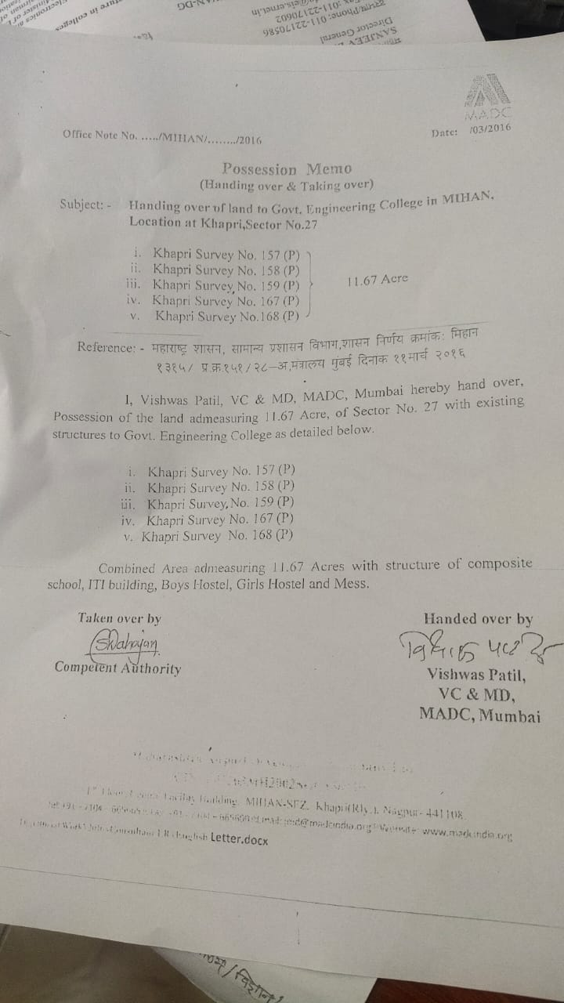

  - Fire and Safety Certificate

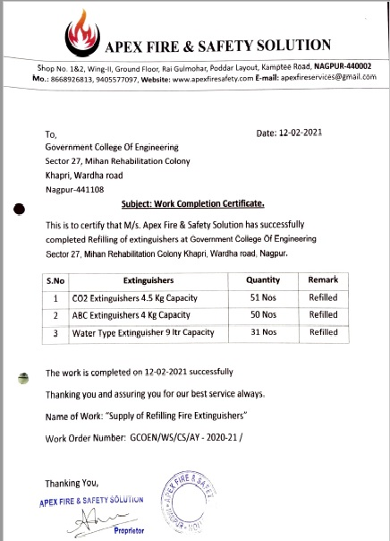

  - Hostel Facilities
Girls Hostel 1079.072 sqm Capacity 90 Nos
Boys Hostel 1993.562 sqm Capacity 180 Nos

Library
  - Number of Library books -/Titles/Journals available (Programme-wise)

Sr. No. | Name of Programme | No. Volumes | No. of Titles
1 | Mechanical Engineering | 1051 | 133
2 | Electrical Engineering and ETC | 1777 | 166
3 | Civil Engineering | 1108 | 139
4 | Computer Sci. & Engineering | 1174 | 245
5 | Other | 1352 | 172

LIST OF INTERNATIONAL JOURNALS
Sr No | TITLE OF JOURNALS | TYPE OF JOURNALS
Computer Science & Engg. Dept.
1 | Indian journal of comp. sci. & prog. language | International
Mechanical Engg. Dept.
2 | International journal of Advanced Mechatronic & Robotics | International
3 | International journal of metallurgical engg. | International
4 | International journal of Advanced Mechanical Engg. | International
Electrical Engg. Dept.
5 | IEEE transaction on smart grid | International
6 | International journal of Advance electrical engg. | International
7 | International journal of Advances in circuit system | International
8 | International journal of engg. mathematics | International
Electronics & Tele. Engg. Dept.
9 | IASET: international journal of electronics & communication engg. | International
10 | International journal of computer & electronics engg. | International
11 | International journal of electronics, communication & soft computing science & engg. | International
12 | International journal of computational intelligence & telecommunication systems. | international
Civil Engg. Dept.
13 | international journal of Geological & geotechnical engg. | International

  - List of online National/International Journals subscribed - Nil
  - E- Library facilities -Available
  - National Digital Library(NDL) subscription details–Subscribed and subscription details awaited

Laboratory and Workshop
Department of Mechanical Engg
List of Equipment
 | Name of Equipment |  | Quantity | Name of Lab |  | Cost (Rs.)
 | Equipment to find losses in pipes. |  | 01 NO. | Hydraulic Machines |  | 35,800
 | Reynold's apparatus to find Reynold's No.& Its significance |  | 01 NO. |  |  | 24,000
 | Verification of Bernouli's equation Equipment |  | 01 NO. |  |  | 34,320
 | Reynold's apparatus to find Reynold's No.& Its significance |  | 01 NO. |  |  | 24,000
 | Performance characteristic of Reciprocating Pump |  | 01 NO. |  |  | 56,000
 | Performance characteristic of Variable speed Pump(Centifugal Pump) |  | 01 NO. |  |  | 48,275
 | Equipment for stability of floating Bodies & submerged Bodies. |  | 1 NO. |  |  | 15,714
 | Cut Section of Jet Pump |  | 1 NO. |  |  | 14,160
 | Metalurgical Microscope |  | 19 NO | Engineering Metallurgy |  | 2,56,500
 | Metalurgical Microscope |  | 01 NO. |  |  | 13,500
 | Jominy End -Quench Hardenability Set up |  | 02 NO. |  |  | 54,600
 | HARDENABILITY TEST EQUIPMENT. |  | 02 NO. |  |  | 54,600
 | Hardness Test by Brinell equipment. |  | 02 NO. |  |  | 1,24,000
 | Hardness Test by Rockwell Test. |  | 02 NO. |  |  | 99,200
 | Magnetic Partical & Dye penetration Test |  | 2 NO. |  |  | 78,000
 | Abrasive Cut-Off Machine |  | 2 NO. |  |  | 30,000
 | Mounting Machine |  | 2 NO. |  |  | 84,000
 | Specimen Polishing Machine (Single Disc) |  | 2 NO. |  |  | 30,645
 | Belt Polisher (Grinder) |  | 2 NO. |  |  | 42,630
 | Poldi Hardness Tester |  | 04 No |  |  | 22,000
 | Metallurgical materials specimen set box for microstructure(M&S) |  | 24 nos. |  |  | 29725
 | Level measurement trainer |  | 1 No. | Mechanics of Material & Mechanical Measurement and Metrology |  | 21700
 | Temperature sensor module |  | 1 No. |  |  | 8614
 | LVDT module micrometer displacement |  | 1 No. |  |  | 9400
 | pressure measurement using pizeo resistive |  | 1 No. |  |  | 11000
 | Screw thread micrometer |  | 2 Nos. |  |  | 12000
 | Dial calipers |  | 1 Nos. |  |  | 5400
 | lever type dial indicator |  | 1 Nos. |  |  | 5153
 | Micrometer stand |  | 1 Nos. |  |  | 1700
 | set Angle gauge Gauge |  | 1 Nos. |  |  | 15553
 | outside micrometer |  | 2 Nos. |  |  | 12200
 | sine bar |  | 1 No. |  |  | 8024
 | limit plug Gauge |  | 2 Nos. |  |  | 6394
 | Digital Vernier Calliper |  | 02 No. |  |  | 17,000
 | Radius Gauge, Range: 7.5 – 15mm |  | 1 No. |  |  | 1000
 | Radius Gauge, Range: 1 – 7mm |  | 1 No. |  |  | 1100
 | Plunger Dial Gauge, L.C: 0.01mm, Range: 0 – 10mm |  | 1 No. |  |  | 2300
 | Depth Micrometer, L.C: 0.01mm, Range: 0 – 150mm |  | 1 No. |  |  | 12500
 | Digital Inside Groove Caliper, L.C: 0.01mm 25-200 MM |  | 1 No. |  |  | 19500
 | Lever Dial Gauge, L.C: 0.01mm, Range: 0 – 10mm |  | 1 No. |  |  | 4300
 | Magnetic V Block – in pairs ,Size: 40 x50x 40mm = 2” |  | 1 No. |  |  | 7600
 | Flexibale Magnetic Dial Stand |  | 1 No. |  |  | 3800
 | Mercury thermometer, Range: -10C to 110C |  | 1 No. |  |  | 800
 | Plain Plug Gauge, Size: 20mm |  | 1 No. |  |  | 2100
 | Allen key set (10 piece) |  | 1 No. |  |  | 700
 | Double ended flat spanner set |  | 1 No. |  |  | 800
 | Screw driver set |  | 1 No. |  |  | 2200
 | Universal set |  | 1 No. |  |  | 3100
 | Electric tester ( heavy duty) |  | 1 No. |  |  | 800
 | Drop & Film condensation appratus |  | 1 No. | Heat Transfer |  | 44840
 | Heat Transfer Through Composite Wall |  | 1 No. |  |  | 36750
 | Thermal conductivity of Insulating Powder |  | 1 No. |  |  | 27000
 | Heat Transfer From pin fin |  | 1 No. |  |  | 27140
 | Emissivity Measurement Appratus |  | 1 No. |  |  | 28910
 | Laser Printer Sp-210 |  | 01 NO. | CAD |  | 4985
 | Laptop Hp Core I5 Generation 6 |  | 01 NO. |  |  | 47250
 | Lcd Projector Screen Wall Mount Size-4'×6' |  | 01 NO. |  |  | 2688
 | Lcd Projector 3200 Lumen,2240 Lumen Svga 800 ×600 4:3 Epson Eb-531 Lcd Multi M/S Dwarka Enterprises ,Na Gpur Sr.No.Week 7300662 |  | 01 NO. |  |  | 30,280
 | Scanner Canon Lide 110 Scan Jet Photo Scanner Paper Size A4 Sr.No.:-Kkge85472 M/S. Copypro Technologies Pvt Ltd Nagpur |  | 01 NO. |  |  | 3050
 | Laser Printer Icmf3010B,Laser A4, Multijunctional Printer Sr.No Wxm33498 M/S. Copypro Tech.Nologies Pvy Ltd Nagpur |  | 01 NO. |  |  | 8500
 | Tablet 7'screen ,1GB ram 8GB internal memorty 1.3 GHZ quad core processor.android v5 lollipop 3450 mah battery sr.no. :-fanpfx080 517 m/s. aryaman sales corporation,nagpur |  | 01 NO. |  |  | 6500
 | H.p. Desktop computers 280 G3 Desktop Intel CORE–I7-8700 (3.2 GHZ, 12 MB cache, 6 cores) 8th generation ,intel H370 chipset, Graphics integrated ,windows 10 professional 8 GB ram,1 TBHDDD 19.5 " Monitor (5 years warrenty) |  | 17 NOS. |  |  | 1130075
 | Samsung Printer 1676 Laser Printer |  | 01 NO. | CAD |  | 5500
 | Canon Laser Mono Printer Lbp2900 |  | 01 NO. |  |  | 11445
 | Evota 75" Interactive Touch Display With Wall Mount Kit |  | 01 NO. |  |  | 132000
 | Pc Module-15(Ops) |  | 01 NO. |  |  | 47500
 | Online Ups |  | 02 NO. |  |  | 38300
 | Digital Teaching Device |  | 02 NO. |  |  | 47800
 | Video Conferencing Camera |  | 01 NO. |  |  | 94501
 | Speaker Phone Uvc15 |  | 01 NO. |  |  | 14725
 | PLC Educational Trainer kit |  | 1 No. | Mechatronics |  | 37,000
 | Cam Analysis Machine |  | 01 No. | Dynamics of Machine |  | 28,535
 | Static and Dynamic Balancing Equipment |  | 01 No. |  |  | 23,600
 | Universal Governor |  | 01 No. |  |  | 28,535
 | Performance characteristics of Gyroscope |  | 01 No. |  |  | 28,535
 | critical speed of shaft |  | 1 NO. |  |  | 31,624
 | Petrol Engine Four Stroke In Cut Section |  | 01 No. | Energy Conversion |  | 14,868
 | Two Stage Reciprocating Air Compressor Test Rig (2 H.P.) |  | 01 No. |  |  | 64,900
 | Single Stage Reciprocating Air Compressor Test Rig (2 H.P.). |  | 01 No. |  |  | 53,100
 | Centrifugal Blower Test Rig. (Backward Curved Vanes) |  | 01 No. |  |  | 64,900
List of Experimental Set up
Sr. No. |  | Name of Experimental Setup |  |  | Name of Lab
3rd Sem.
1 |  | Study of Cupola Furnace |  |  | Manufacturing Processes
2 |  | Study of Moulding Techniques
3 |  | Study of Casting Process
4 |  | Study of Pattern Making
5 |  | Study of Joining Processes
6 |  | Study of Forming Processes
7 |  | Study of Drawing Processes
8 |  | One Job – Pattern Making
9 |  | One Job – Casting
10 |  | One Job – Welding
11 |  | Demonstration on Plastic, Glass and Ceramic Processing (Industrial visit)
 |  | Minimum Eight out of the above shall be performed:
01 |  | 2-D Orthographic pencil drawings of standard components with dimensions and detailing: Minimum One sheet |  |  | Machine Drawing and Solid Modeling
02 |  | 2-D Orthographic pencil drawings showing sectional views of part with dimensions and detailing: Minimum One sheet
03 |  | 2-D Orthographic pencil drawings of Assembly showing at least two views with assembly dimensioning, part list and ballooning: Minimum One sheet
04 |  | 2-D Orthographic pencil drawings of Assembly detailing (disassembly) showing dimensional details of assembly components : Minimum One sheet
05 |  | Creating 3-D solid model of simple part with basic features like extrude, revolve, holes, round, chamfer from given 2-D detailing using any CAD software package. Perform 2-D drafting and detailing of solid model: Print out showing 2-D detailing and pictorial view (isometric view) of part to be submitted.
06 |  | Creating 2-D Orthographic drawings of Assembly with one sectional view with assembly dimensioning, part list and ballooning using any CAD software package: Print out to be submitted.
07 |  | Production drawing and process sheet: Prepare production drawing and process sheet of any standard machine component using CAD software package: Submit print out.
08 |  | Compulsory Reverse engineering group activity (maximum 4 members in a group): Each group to be given unique assembly comprising of minimum four components (preferably standard assembly e.g. bearing housing, tool post, clutch housing, automobile parts, parts in workshop facilities etc.). Students to disassemble all parts, study each part, identify standard components, perform complete reverse engineering process: create  rough sketch of each part, measure its various dimensions using basic measuring instruments (ruler scale, vernier etc.), prepare final drawing using any CAD software package , apply GD&T: Print out showing complete detailing of each assembly component to be submitted
 |  | Minimum Eight out of the above shall be performed:
1 |  | Development of programs in C To find area/surface area, volume for Planes, Solids. (Applications for cost involved for painting surface of any plane(square, rectangular, hexagonal etc), costing based on metal sheet material required for manufacturing cylinder(ends open/closed/one end open), cone, cube etc. with varying quantity |  |  | Computer Application/Progra mming
2 |  | Development of programs in C To find Stress with given force and cross sectional area(square, rectangle, circular etc)
3 |  | Development of programs in C To find angular velocities and acceleration of the output and coupler link for four bar chain mechanism.
4 |  | Development of programs in C for given inner, outer radii for single plate clutch and axial force calculate minimum, maximum, and average pressure acting on clutch plate.(or calculating inner outer radii, width of friction lining, axial force etc. for single/multi plate clutch or similar type of simple calculation programme for block brake.
5 |  | Development of programs in C for Addition, Multiplication Matrices.
6 |  | Development of programs in C for any Numerical methods like Newton Raphson, GaussElimination, Gauss-Jordan, Crout’s method and Gauss-Seidel Method. Development of programs in C / C+ + for any Numerical methods like Taylor’s series method, Runge Kutta method, Euler’s modified method, Milne’s predictor corrector method, Iterative methods for eigen value & eigen vector determination.
7 |  | Development of programs in C To determine type of flow of fluid(laminar/turbulent/transient) on the basis of Reynolds’s Number
8 |  | Development of programs in C To calculate specific density, specific weight, weight if specific gravity is given for liquid
4th Sem.
1 |  | Study of Metallurgical Microscope. |  |  | Material Science & Engineering
2 |  | Preparation of Specimen for metallographic examinations.
3 |  | Study and drawing of microstructures of Steels.
4 |  | Study and drawing of microstructures of Cast Iron.
5 |  | Study and drawing of microstructures of Non Ferrous Metals.
6 |  | Study of the effect of annealing and normalizing on properties of steels
7 |  | Determination of hardenability of steels by Jominy End Quench test.
8 |  | Measurement of hardness of ferrous or non-ferrous materials with the help of Brinell hardness tester & Rockwell hardness tester.
9 |  | Study of effect of alloying elements on properties of steels.
10 |  | Study of Pack carburizing of steel samples
11 |  | Study of Flame & Induction hardening.
 |  | Minimum Eight out of the above shall be performed:
01 |  | To determine the metacentric height of given floating vessel. |  |  | Fluid Mechanics &  Hydraulic Machines
02 |  | To verify Bernoulli’s theorem.
03 |  | To find friction losses in pipe.
04 |  | To find the value of co-efficient of given venture meter fitted in a pipe.
05 |  | To find the value of co-efficient of Discharge for a given orifice meter.
06 |  | Performance characteristics of Pelton wheel.
07 |  | Performance characteristic of Francis Turbine.
08 |  | Performance characteristic of Kaplan Turbine.
09 |  | Performance characteristic of Variable Centrifugal speed pump
10 |  | Performance characteristic of Reciprocating pump.
11 |  | To find Reynold’s Number
 |  | Minimum Eight out of the above shall be performed:
1 |  | Study of Single Point Cutting Tool. |  |  | Machining Processes
2 |  | Study of Various forces on single point cutting tools.
3 |  | Study of multiple point cutting tools (milling, drilling)
4 |  | Study of Lathe Machine.
5 |  | Study of Shaper mechanisms.
6 |  | Study of Broaching machines.
7 |  | One Job on Milling.
8 |  | One Job on Drilling, Boring
9 |  | One Job on Thread Cutting, Taper Turning.
10 |  | One Job on Surface Grinding.
 |  | Minimum Eight out of the above shall be performed:
5th Sem.
1 |  | To determine the thermal conductivity of composite wall. |  |  | Heat Transfer
2 |  | Determination of thermal conductivity of an insulating powder.
3 |  | Determination of thermal conductivity of metal bar.
4 |  | Determination of Stefan Boltzmann constant.
5 |  | Determination of temperature distribution & heat transfer rate from fin under forced convection.
6 |  | Determination of heat transfer coefficient in natural convection for vertical tube.
7 |  | Determination of condensation heat transfer coefficient in film wise & drop wise condensation.
8 |  | Determination of emmissivity of non black body.
9 |  | Study of various types of heat exchangers.
10 |  | Computerized analysis of various parameters of heat exchanger using shell and tube heat exchanger.
11 |  | Study of heat pipe.
 |  | Minimum Eight out of the above shall be performed:
1 |  | Static characteristic of at least one Instrument. |  |  | MMM
2 |  | Static calibration of at least one Instrument.
3 |  | Measurement of parameters by minimum three different types of Instruments.
4 |  | Measurement of Linear, Angular dimensions (Using Vernier, Sine bar, Clinometers)
5 |  | Measurement of Flatness & Straightness.
6 |  | Study and Measurement of Parameters using Toolmaker’s microscope.
7 |  | Study and Measurement of Parameters using Optical profile projector.
8 |  | Use of Optical flat.
9 |  | Design of Limit gauge.
 |  | Minimum Eight out of the above shall be performed:
1 |  | Development of application programs in C / C++ exploring use of functions, vectors, arrays etc. |  |  | Computer Application-I
2 |  | Development of programs in C / C++ for any Numerical methods like Newton Raphson, Gauss-Elimination, Gauss-Jordan, Crout’s method and Gauss-Seidel Method.
3 |  | Development of programs in C / C+ + for any Numerical methods like Taylor’s series method, Runge Kutta method, Euler’s modified method, Milne’s predictor corrector method, Iterative methods for eigen value & eigen vector determination.
4 |  | Development of programs in C / C++ to solve the problem in the following areas of Mechanical Engineering like, Mechanics, Kinematics of Machines, Engineering Thermodynamics, Hydraulic Machines, Mechanics of Material, Design of Machine elements, Heat Transfer etc.
5 |  | Application of Mathematical Software/s for solution of problems in the areas of Mechanical Engineering.
 |  | Minimum Eight out of the above shall be performed:
6th Sem.
1 |  | Identification & study of solid state electronic devices. |  |  | Mechatronics
2 |  | Identification, study & demonstration of different sensors.
3 |  | Identification, study & demonstration of different actuators.
4 |  | Demonstration of working of various digital to analog and analog to digital Converters.
5 |  | Development of ladder diagram, programming using PLC
6 |  | Trace, interpret and demonstrate working of electro pneumatic systems.
7 |  | Trace, interpret and demonstrate working of electro hydraulic systems
1 |  | Determination of jump-of speed of a typical cam- follower system. |  |  | Dynamics of Machine
2 |  | Dynamic balancing of rotating masses(study of wheel balancing machine along with performance by visiting any automobile workshop).
3 |  | Balancing of reciprocating mechanism.
4 |  | Critical speed of shafts.
5 |  | Performance characteristics of Gyroscope.
6 |  | Free vibration of single DOF and two DOF spring mass system.
7 |  | Natural frequency determination of cantilever beam.
8 |  | Damping determination through free vibration logarithmic decay of a simple damped system.
9 |  | Natural frequency determination of two and three rotor system.
10 |  | Torsional vibration of bifilar or trifilar pendulum.
11 |  | Transmissibility of single degree of freedom system
12 |  | Dynamic vibration absorber.
13 |  | Dynamic force analysis of four bar mechanisms.
14 |  | Dynamic force analysis of slider crank mechanism.
15 |  | Flywheel selection and parameter design for a typical multi-cylinder engines.
16 |  | Performance characteristics of governors.
17 |  | Study of any mechanism in workshop/industry..
18 |  | Use of FFT analyzer for determination of natural frequencies of machine components.
 |  | Minimum Eight out of the above shall be performed:
1 |  | At least eight Practicals in applications like Material Management, Inventory Management, Office automation etc. based on above syllabus shall be conducted using suitable DBMS packages like ORACLE, MS ACCESS etc. or relevant freeware/s. |  |  | Computer Application-II
7th Sem.
1 |  | 2-D Geometric modeling of an Engineering object, demonstrating Boolean operations like add,subtract and PAN, ZOOM, ROTATE commands |  |  | CAD
2 |  | 3-D Geometric Modeling of an Engineering object, demonstrating extrude, revolve and loft commands.
3 |  | Generation of at least two simple solid models showing geometric properties using any CAD software.
4 |  | Generation of any Assembly model along with animation.
5 |  | Static structural analysis using 1-D bar element by standard FE package.
6 |  | Static structural analysis using 1-D truss element by standard FE package.
7 |  | Static structural analysis using 2-D CST element by standard FE package.
8 |  | Program for any one of optimization method.
9 |  | Programs for generation of entities like Line, Circle, Ellipse using Bressenham’s algorithms.
10 |  | Programs for 2-D & 3-D transformations.
11 |  | Program for Bezier Curve generation
 |  | Minimum Six Practicals out of above on the standard CAD/CAE packages like ANSYS /NASTRAN/ UNIGRAPHICS/ CATIA / PRO-E / any other suitable software:
1 |  | Performance analysis of reciprocating Compressor |  |  | Energy Conversion -II
2 |  | Study of performance characteristics of rotary compressor.
3 |  | Study and demonstration of internal combustion engine and its components.
4 |  | Study and demonstration of fuel injection systems and ignition systems of I. C. Engines.
5 |  | Performance testing of a single cylinder I.C. Engine.
6 |  | Study and demonstration of engine cooling and lubrication systems.
7 |  | Performance analysis of multicylinder engine with energy balance sheet.
8 |  | Exhaust gas analysis of I. C. Engine.
9 |  | Conduction of Morse test on multicylinder I.C. engine.
10 |  | Performance on vapour compression refrigeration system.
11 |  | Study & demonstration on household refrigerator.
12 |  | Study of vapour absorption refrigeration system.
13 |  | Study of Psychometric Processes on mini-air conditioning tutor.
 |  | Minimum Eight out of the following shall be performed (out of which six must be experimental):
7th Sem.
A |  | A) Design problems (at least 8 problems should be included in the Journal) |  |  | Design of Mechanical Drives
1 |  | Design of fly wheel.
2 |  | Design of coupling.
3 |  | Design of Journal Bearing.
4 |  | Design & Selection of Antifriction bearing.
5 |  | Design of Belt drive.
6 |  | Design of chain drive.
7 |  | Design of Wire rope.
8 |  | Design of I C engine Components.
9 |  | Design of Spur Gear drive.
10 |  | Design of Helical Gear drive.
11 |  | Design of Bevel Gear drive.
12 |  | Design of Worm Gear drive.
 |  | Design problems (at least 8 problems should be included in the journal.
B |  | Student shall submit one assembly design report along with the drawing for assembly/sub assembly for any mechanical system consisting of not less than four members included in the syllabus. Submission mentioned in (A) & (B) are compulsory.
8th Sem.
1 |  | Introduction to CIM. (Product Development Cycle, CIM Wheel) |  |  | Elective – II : Computer Integrated Manufacturing
2 |  | Introduction to NC. (Basic components, classification)
3 |  | Manual Part Programming – Lathe.
4 |  | Manual Part Programming – Milling.
5 |  | Manual Part Programming by using Sub routine & Canned Cycles.
6 |  | Part classification and Coding using G.T.
7 |  | Study of F. M. S.
8 |  | Study of CAPP Systems. (Retrieval & Generative)
9 |  | Study of different quality measurement tools.
10 |  | Assignment on implementation of CIM in Industry.
 |  | Minimum Eight out of the following shall be performed (out of which six must be experimental):
1 |  | To perform experiments on vapour compression test rig to determine COP of the system. |  |  | Elective – II: Refrigeration And Air conditioning
2 |  | Study of various types of compressor.
3 |  | Study of various types of condenser, expansion devices and evaporators used in RAC.
4 |  | Study of various types of air conditioning systems
5 |  | To perform experiments on Air-conditioning test rig.
6 |  | Study & performance of window air conditioner.
7 |  | To perform experiments on desert cooler to evaluate its performance.
8 |  | Demonstration of use of various tools and equipments used for installation, maintenance & repair of refrigeration systems.
9 |  | Testing and charging of vapour compression refrigeration system.
10 |  | Report on visit to refrigeration plant/AC plant/cold storage plant.
 |  | Minimum Eight out of the above shall be performed (out of which six must be experimental):
8th Sem.
1 |  | Performance, Simulation on CNC lathe (at least two complex geometries). |  |  | Automation in Production
2 |  | Performance, Simulation on CNC milling (at least two complex geometries).
3 |  | Practice Programming on Manual Part Program.
4 |  | Practice Programming on APT.
5 |  | Case Study on Automated System of any Industry.
6 |  | Study/Performance on Robot.
7 |  | Part Coding and Group Technology.
8 |  | Study of Automation & Case Study of Automated System of any Industry.
9 |  | Study of NC System.
 |  | Minimum Eight out of the above shall be performed:
1 |  | Study of gas turbine and jet propulsion system. |  |  | Energy Conversion - III
2 |  | Study of current energy scenario and various techniques of saving energy.
3 |  | Study & demonstration of solar lightning system.
4 |  | Case study on energy conservation opportunities in industry.
5 |  | Study of various hydraulic pumps.
6 |  | Study of various valves, actuators used in hydraulic system.
7 |  | Study of various industrial hydraulic circuits.
8 |  | Study of various compressors used in pneumatic system.
9 |  | Study of air preparatory unit.
10 |  | Study of various industrial pneumatic circuits.
 |  | Minimum Eight out of the above shall be performed

Department of Computer Science & Engineering

- Lab Equipment/ facilities in each laboratory/ workshop

Sr. No. | Name of Item | Name of Lab | Qty. | Total Amt
1 | LCD Projector Screen Wall Mountes Size of 4' x 6' | Prog. Lab | 1 | 2668.00
2 | LCD Projector XGA with Wi-Fi | Prog. Lab | 1 | 45163.00
3 | Scanner (Canon Lide 100) | Prog. Lab | 1 | 3050.00
4 | Laser Printer A 4  ICMF 3010 B | Prog. Lab | 1 | 8500.00
5 | Laptop HP | Prog. Lab | 1 | 47250.00
6 | Laser Printer  Make - Richoh | Prog. Lab | 1 | 11727.00
7 | Rating of UPS | Prog. Lab | 1 | 44578.00
8 | LCD Projector | Prog. Lab | 1 | 38000.00
9 | Vaccum Clener | Prog. Lab | 1
10 | LASER PRINTER- HP Leserjet pro M202/203 dw | Prog. Lab | 3 | 40446.00
11 | UPS 2 KVA | Networking Lab | 2 | 47900.00
12 | Multifunction Machine | Networking Lab | 1 | 26500.00
13 | Air Conditionar  Split Air conditioner 2 ton, | Networking Lab | 1 | 47725.00
14 | 42 U Rack  (Dlink NFR) | Networking Lab | 1 | 42495.00
15 | IOT Lab:  Connecting Sensors- Analog type- | Networking Lab | 1 | 49930.00
16 | IOT Components | Networking Lab | 1 | 49930.00
17 | IOT LAB:Software | Networking Lab | 1 | 49930.00
18 | IOT LAB: Connecting Sensors- Digital Type | Networking Lab | 1 | 49930.00
19 | IOT LAB: Connecting Sensors- 12C type- RGB LCD | Networking Lab | 1 | 49930.00
20 | IOT LAB: Programming Environment | Networking Lab | 1 | 49930.00
21 | IOT LAB: IOT Gateway solution based Hardware with power supply | Networking Lab | 1 | 49930.00
22 | IOT LAB: Acessories | Networking Lab | 1 | 49930.00
23 | IOT LAB: Integrated Sensor/ Actuator Library in software Integrated Sensor/ Actuator Library in Software | Networking Lab | 1 | 49930.00
24 | System Bus and Protocol Analyzer Trainer | Networking Lab | 1 | 48990.00
25 | Ethernet protocol Trainer | Networking Lab | 1 | 48950.00
26 | Digital Photocopier Machine | Networking Lab | 1 | 47000.00
27 | ERP Software | Software | 1 | 49621.00
28 | Adobe Acrobat Prof DC | Software | 1 | 21363.00
29 | Adobe Photoshop | Software | 1 | 34000.00
30 | Redhat Enterprise Linux Desktop 5. x 5 MB Subscription (1 yr) | Software | 13 | 47630.00
31 | MS Windows 10 Pro | Software | 4 | 44400.00
32 | TURBO C++ Software Academic purpose 15 users (Embracadero C++ | Software | 15 | 49500.00
33 | Visual Studio. NET Professional (2015) | Software | 5 | 30500.00
34 | Microsoft Office 2007 | Software | 7 | 41300.00
35 | Network Simulation & Learning Resource Software | Software | 1 | 48960.00
36 | Flat Bed Cum Sheet Fed Scanner | Computer Workshop | 1 | 25500.00
37 | Visual Presenter, Desktop Type | Computer Workshop | 1 | 39163.00
38 | Tablet | Computer Workshop | 1 | 6500.00
39 | Computer - make Acer All in One | computer Lab | 22 | 977680.00
40 | Hp 280 G3 desktop | computer Lab | 80 | 4508240

- List of experimental setup in each lab/ workshop

List of Practical of all subjects of Third and Fourth Semester 2021-2022

Subject –Object Oriented Programming in JAVA IIIrd Semester

1) Write a programs to find sum of digits of four digit number.
2) Create a student result database in Java. Calculate the grades of students. Decide criteria for best student and short-list students who satisfy the criteria.
a) A student has a roll No, name, marks in five courses and a grade. A student list has many students. If a student has grade equal or beyond 8, he is considered as a top band student.
b) Create at least ten students. From these, find all such students which satisfy the criteria of top band student. Create a list of such students and display the students in the list.
3) A company has many employees. An employee has employee Id, basic salary, house rent allowance, dearness allowance, profession tax and total salary. An employee has an address. The address has apartment number, apartment name, road and PIN code.
The total salary of an employee is the summation of basic salary, house rent allowance which is 20 percent of basic salary, dearness allowance which is 45 percent of basic salary. The take home salary is calculated after deducting profession tax from which is 7 percent of basic salary from the total salary.
When an employee is appointed, he is assigned with an employee Id and basic salary. One can ask for total salary of the employee and take-home salary of the employee.
Identify a class/classes from the above statement, identify the attributes, the data types, the behaviour. Test your program for ten employees
Display all the details of the employees as per id and as per pin code.
Display takes home salary for all the employees; display the tax to be deducted across all employees.
4) A circle has a radius. Its area can be calculated. The area is a double number. Its perimeter can be calculated as . The perimeter is a double number. Given two circles one can find out which is large and which is small.
Create two circles c1 and c2 with radius as 10 and 7 respectively. Calculate the area and perimeter of each. Compare two circles with each other and display which is large and which is small.
5) Write a JAVA program to perform String operations using String/StringBuffer class
a) Write a program that reads a word and then prints the first character, the last character, and the characters in the middle. For example, if the input is GCOEN ,the program prints G N COE.
b) Write a program that reads a name (such as Ranbeer Rishi Kapoor ) and then prints amonogram consisting of the initial letters of the first, middle, and lastname (such as RRK).
6) Reading material has title and price. A book is a reading material. It has ISBN number. A magazine is a reading material, it has month of issue. A CD is a reading material, it has duration in minutes. Represent the above description as a generalization, specialization tree. Identify the parent class, its attributes, child class and their attributes. Write all of them clearly.
7) A vehicle has engine no and chassis number. It can be locked, unlocked. Every vehicle is movable (interface). It can be started, stopped, turned, accelerated, turned, and decelerated. A car is a vehicle. It has steering. An airplane is a vehicle. It has wings. A boat is a vehicle. It has propeller.
8) Consider student data consist of fields such as roll number, name, and marks of various subjects.
Write a program using inbuilt and user defined exceptions to avoid invalid entry.
9) Design a user defined abstract data type ‘Complex&#39; in Java. Write a program to perform arithmetic operations of two complex numbers.
A complex number has a real part and an imaginary part.
a) Given the values of real part and imaginary part of a complex number, the magnitude of the complex number can be calculated as square root of the sum of squares of real part and the imaginary part.
b) The argument of the complex number can be calculated as tan inverse of ratio of imaginary part(numerator) and real part(denominator )
c) The complex number can be added to another complex number and the answer of the addition is a complex number. When one adds two complex numbers, the real parts of each of the complex numbers is added which becomes a real part of the answer and imaginary part of each complex number is added together which becomes imaginary part of the answer. Both these results are real and imaginary parts for a complex number which is the answer of the addition complex conjugate of the complex number can be calculated by negating the imaginary part of the complex number
d) The complex number can be subtracted from another complex number and the answer of the subtraction is a complex number.
e) When one subtracts a complex number from the other, the real part one complex number is subtracted from the other and the result becomes a real part of the answer and imaginary part of one complex number is number is subtracted from the other and the result of subtraction becomes imaginary part of the answer. Both these results are real and imaginary parts for a complex number which is the answer of the subtraction.

Subject: Operating System Lab IIIrd Semester
1. To Study Operating System and its different types
2. To write C program to implement System Call link() in UNIX
3. To write C program to create a Process using System call fork()
4. To write C program to implement system calls getpid() and getppid() to returns Process Id
5. To write C program to implement FIFO Page Replacement Algorithm
6. Write C program to simulate the Paging technique of memory management
7. Write C program to simulate the Segmentation technique of memory management
8. Write C program to demonstrate the working of Semaphore
9. Write C programs to simulate the Contiguous File allocation methods
10. Write a C program to simulate Deadlock in operating system

Computer Workshop Lab -I {BECSE308P} IIIrd Semester

- Develop an HTML document for a web page using Character and Page formatting elements
- Develop an HTML document for a web page using Ordered, Unorderedand Definition list. Design web page using attractive background color, text color and background image.
- Create static web page using complex table like mark sheet,telephone bill,time –table etc.
- Create a static web page which defines all types of links in single webpage.
- Develop a complete web page using Frames and Frameset which gives the information about college.
- Create registration form using HTML form objects.
- Create any website layout using CSS.
- Apply style sheet in Web page. [inline, embedded and linked]
- Create a HTML web page using Java script.
- Introduction to Applets.

Sub: - Database Management System IVth Semester
1) To study and execute the DDL commands execute queries on create , Alter drop, truncate and rename statement
2) To study and execute the DML commands execute queries on Select , insert, Update and Delete statement.
3) To study and execute various types of integrity constraints.
4) To study and execute for retrieving data using SELECT clause.
5) To study and execute for retrieving data using SELECT clause.
6) To study and execute for retrieving data using SELECT clause.
7) To study and execute group by and having clause.
8) To study and execute queries based on Cartesian product
9) To Study and execute various join types and join conditions.
10) To study and execute COMMIT and ROLLBACK

Sub-Data Structure and Program Design IVth Semester
1) Write a program to search a list of N elements for the Occurrence of the element,
using Liner Search Method &amp; Binary search method.
2) Write a program to sort a list of N elements in ascending Order by Bubble Sort &amp; Selection Sort methods.
3) Write a program to sort a list of N elements in ascending Order by Insertion Sort.
4) Write a program to carry out push and Pop operation on The stack.
1. Push the elements onto the stack.
2. Pop the elements from stack.
3. Display elements of stack.
5) Write a program To evaluate the Postfix expression. Given a postfix expression and
evaluate that expression Using stack.
6) Write a program to carry out Insert and Delete Operations on the queue.
1.Insert elements in the queue.
2. Display elements of queue.
2.Remove elements from the queue.
7) Write a program to implement Singly Linked List
(1) Creation of link list.
(2) Adding a node at first, middle &amp;last position of an Linked list.
(3) Deleting a node from first, middle, last position in A linked list.
8) Write a Program to implement the INORDER, PREORDER and POSTORDER
traversal performed on the binary tree.
9) Write a program to implement Breadth first search in graphs.
10) Write a program to implement Depth first search in graphs.

Subject – Computer Workshop – II Lab IVth Semester
1. Print only the words that start with letter ‘s’ in the following statement –St- ‘print only the word that starts with s in this sentence’.
2. Print every word from the below sentence which has even number of letters –St- ‘print only the word that starts with s in this sentence’.
3. Write a program that prints the integers from 1 to 100, but for multiples of 3 print ‘FIZZ’ instead of number and for multiples of five print ‘BUZZ’. For numbers which are multiples of both 3 and 5 print ‘FIZZBUZZ’.
4. Write a program using function to check who is employee of the month.
5. Write a program to mimic the carnival game ‘Three Cup Montee’.
6. Write a program that returns the lesser of two given numbers if both numbers are even, but returns the greater if one or both numbers are odd.
7. Write a python function that accepts a string and calculate the number of upper case
letters and lower case letters.
8. Write a python function that takes a list and return a new list with unique elements of the first list. For example, Sample List =[1,1,1,2,2,3,3,4]Unique List = [1,2,3,4]
9. Write a python function to multiply all the numbers in the list
10. Write a program for validating the user input
11. Using Object oriented Programming, write a program for opening a Bank account,
deposit of money and withdrawal of money. Also generate a 4 digit unique code for each
transaction.
12. Write a program to print next 5 days starting from today
13. Write a function that asks for an integer and prints square of it. Use a while loop with a try, except, else block to account for incorrect inputs.

List of Practical of all subjects of Fifth and Sixth Semester 2021-2022

Sr. No. | List of practical | Name of subject
1. | - write C++ program that takes the information of 5 students from the user and displays it on the screen.(Store  information in Structure and Display it).  - Write a C++ Program to implement a sphere class with appropriate members and member function to find the surface area and the volume. (Surface = 4 π r2 and Volume = 4/ 3 π r3 )  - Write a C++ program having class Account with data membersaccount_number and balance_amount. Accept data for 2 accounts and display the data of accounts having balance less than 5000/-.  - Implement a C++ program to find the area of a rectangle using an inline function defined outside the class. (Area=length*breadth)  - Write a function power()to raise a number m to a power n. Thefunction takes a double value for m and int value for n, and returns the result correctly. use a default value of 2 for n to make the function to calculate squares when this argument is omitted. write a main function that gets the values of m and n from the user to test the function.  - An electricity board charges the following rates to users –  For first 100 units :- 60p per unit.  For next 200 units : - 80p per unit.  Beyond 300 units :- 90p per unit.  All users are charged a minimum of Rs.50. If the total cost is more than Rs.300.00 then an additional charges of 15% are added. Write a C++ program using class to read the name of users & number of units consumed & print out the charges with names.(Use Array of Objects).  - Write a program to accept five different numbers by creating a class called friendfunc1 and friendfunc2 taking 2 and 3 arg respectively and calculate the average of these numbers by passing object of the class to friend function.  - Write a C++ program to find the area of circle and rectangle by using default and parameterized constructor.  Create a class student containing data members: – Rollno – name -marks1, marks2, marks3 Write necessary member functions: 1. to accept details of all students 2. to display details of one student 3. to display details of all students(Use Function overloading).  - Write a C++ program to overload “= =” to compare two strings and overload “+” operator for concatenation of two strings.  - Write a C++ program to count the number of persons inside a bank, by increasing countwhenever a person enters a bank, using an increment(++) operator overloading function, and decrease the count whenever a person leaves the bank using a decrement(--) operator overloading function inside a class  - Write a C++ program to implement flight class with data member as flight no.,source, destination and fare. Write a member function to display the flight information using this pointer.  - Consider a publishing company that markets both book and audio cassette version to its works. Create a class Publication that stores the title (a string) and price (type float) of a publication. Derive the following two classes from the above Publication class: Book which adds a page count (int) and Tape which adds a playing time in minutes(float).Each class should have get_data() function to get its data from the user at the keyboard.Write the main() function to test the Book and Tape classes by creating instances of them asking the user to fill in data with get_data() and then displaying it using put_data().  - Write a program to calculate bonus of the employees. The class master derives the information from both admin and account classes which derives information from class person. Create base and all derived classes having same member functions called getdata, display data and bonus. Create a base class pointer that capable of accessing data of any class and calculates bonus of the specified employee. Use virtual functions.  - Write a class template to represent a generic vector. Include member functions to perform the following tasks:  1) To create the vector .  2) To modify the value of a given element.  3) To multiply the vector by a scalar value.  4) To display the vector in the form (10, 20, 30,…..) | Object Oriented Programming
2. | 1. To study and execute the DDL commands execute queries on create , Alter drop, truncate and rename statement  2. To study and execute the DML commands execute queries on Select , insert, Update and Delete statement.  3. To study and execute various types of integrity constraints.  4.To study and execute for retrieving data using SELECT clause.  5.To study and execute for retrieving data using SELECT clause.  6. To study and execute for retrieving data using SELECT clause.  7. To study and execute group by and having clause.  8.To study and execute queries based on Cartesian product  9.To Study and execute various join types and join conditions.  10.To study and execute COMMIT and ROLLBACK statement | Database Management System
3. | 1. Sort a given set of elements using the Quick sort , Merge sortand Heap sort method and determine the time required to sort the elements. Repeat the experiment for different values of n. Hence realate how the time complexity of quick can be reduced to make worst case as best case.  2. Write a program to implement knapsack problem in order to determine maximum profit by weight by using greedy approach on the basis of profit, weight, and capacityof bag.  3. Apply Greedy approach to find Minimum Cost Spanning Tree of a given undirected graph using prims’s algorithm regarding to lease telephone network line to different offices which are to be considerd in dense area.  4. Apply Greedy approach to find Minimum Cost Spanning Tree of a given undirected graph using Kruskal’s algorithm to realate itwith how to plan lay cables for a cable TV service between the limited area .  5. From a given vertex in a weighted connected graph, find shortest paths to other vertices using Dijkstra's algorithm and also check wheather is works for negative values or not?  6. How you can relate the heap sort program in forecasting of future demand for data transfer between nodes in a large network that spanned the country. The program could be configured in terms of the how to choose routes for the data transfer, with the objective of minimizing cost of the required equipment overall.  7. Implement N Queen problem program of placing N chess queens on an N×N chessboard so that no two queens attack each other. For example, following is a solution for 4 Queen problem. The expected output is a binary matrix which has 1s for the blocks where queens are placed.  8. Print all the nodes reachable from a given starting node in a digraph of GPS NavigationSystem to find all nebouring locations using BFS method hence, relate it with Social Networking Websites where we can find people within a given distance ‘k’ from a person using Breadth First Search till ‘k’ levels.  9. Implement Binary search, Linear search, Bubble sort, Selection sort algorithm to sort a given set of elements and determine the time required to searching and sorting the elements.  10. Implement DFS to relate it with all the nodes reachable from a given starting node in a Crawlers build index to start from source page and follow all links from source and keep doing same. | Design and Analysis of Algorithms
4. | 1. Write a Program to implement Factory pattern in which We're going to create a Shape interface and concrete classes implementing the Shape interface. A factory class ShapeFactory is defined as a next step.FactoryPatternDemo, our demo class will use ShapeFactory to get a Shapeobject. It will pass information (CIRCLE / RECTANGLE / SQUARE) to ShapeFactory to get the type of object it needs.  2. Write a Program to implement Singleton pattern in which we're going to create a SingleObject class. SingleObject class have its constructor as private and have a static instance of itself.  3.Write a Program to implement Builder pattern in which we will consider a business case of fast-food restaurant where a typical meal could be a burger and a cold drink. Burger could be either a Veg Burger or Chicken Burger and will be packed by a wrapper.  4.Write a Program to implement Mediator pattern in which we are demonstrating mediator pattern by example of a chat room where multiple users can send message to chat room and it is the responsibility of chat room to show the messages to all users.  5.Write a Program to implement Composite pattern to demostrate tree structuce in which we are going to create a ComputerPart interface defining showPrice() operation .Keyboard, Mouse, Monitor are concrete classes/Leaf classes implementing ComputerPart interface .  6. Write a Program to implement Template pattern to create a Game abstract class defining operations with a template method set to be final so that it cannot be overridden. Cricket and Football are concrete classes that extend Game and override its methods.  7.Write a Program to implement Observer pattern uses three actor classes. Subject, Observer and Client. Subject is an object having methods to attach and detach observers to a client object. We have created an abstract class Observer and a concrete class Subject that is extending class Observer.  8. Write a Program to implement Command pattern creating an interface Order which is acting as a command. We have created a Stock class which acts as a request. We have concrete command classes BuyStock and SellStock implementing Order interface which will do actual command processing. A class Broker is created which acts as an invoker object. It can take and place orders.  9. Write a Program to implement Bridge pattern have a DrawAPI interface which is acting as a bridge implementer and concrete classes RedCircle, GreenCircle implementing the DrawAPI interface. Shape is an abstract class and will use object of DrawAPI. BridgePatternDemo, our demo class will use Shape class to draw different colored circle.  10.Write a Program to implement Chain Of Responsibility pattern which will create an abstract class AbstractLogger with a level of logging. Then we have created three types of loggers extending the AbstractLogger. Each logger checks the level of message to its level and print accordingly otherwise does not print and pass the message to its next logger.  11. Case study. | Design Patterns
5. | 1. To study various networking devices  2.To study and implement network configuration commands on windows and Linux.  3. Execute program to implement bit stuffing method.  4. Execute program to implement distance vector routing algorithm.  5. Execute a program to implement Dijkstra’s shortest path algorithm.  6.Execute a program to determine if the IP address is in class A, B, C, D or E.  7. To Study OMnet++ Open source simulator  8. Execute a program to implement cyclic redundancy check error detection method.  9.Execute a program to implement checksum error detection method.  10.To study NAS, SAN and DAS. | Computer Networks

List of Practical of all subjects of Seventh and Eighth Semester 2021-2022
Sr. No. | List of practical | Name of subject
1. | 1. To study translator, compliers, lexical analyzer, cross complier and Regular language.  2. Design a lexical analyzer for given language and the lexical analyzer should ignore redundant spaces, tabs and new lines. It should also ignore comments. Although the syntax specification states that identifiers can be arbitrarily long, you may restrict the length to some reasonable value. Simulate the same in C language.  3. Write a C program to identify whether a given line is a comment or not.  4. Write a C program to recognize strings under 'a', 'a*b+', 'abb'.  5. Write a C program to test whether a given identifier is valid or not.  6. Write a C program to simulate lexical analyzer for validating operators.  7. Implement the lexical analyzer using JLex, flex or other lexical analyzer generating tools.  8. Write a C program for implementing the functionalities of predictive parser for the mini language specified in Note 1.  9. a) Write a C program for constructing of LL (1) parsing.  b) Write a C program for constructing recursive descent parsing.  10. Write a C program to implement LALR parsing. | Language Processor
2. | - To study data mining & KDD architecture  - To study and install Weka for Data Mining and Warehousing.  - To create Operational System, a data warehouse for given case study Medical Store.  - To create star, snowflake and fact constellation schemas for selected case study.  - To create a Weather table with the help of data mining tool WEKA and apply preprocessing techniques to the training dataset of weather table.  - To perform Association Rule process on dataset.  - To perform classification rule on dataset.  - To perform clustering rule on dataset.  - To perform Regression rule on dataset.  - To perform time series analysis on dataset. | Data Warehouse & Mining
3. | 1. To Study basic theory of MPI and MPI Commands.  2. Construct a program to demonstrate the concept of logical clock synchronization in distributed environment using Lamport logical clock.  3. Build a program to implement concept of distributed mutual exclusion using token based algorithm.  4. Construct a javaprogram to demonstrate the Distributed Deadlock Detection using Chandy Haas Misra.  5. To implement CORBA mechanism by using C++ program at one end and Java Program on the other.  6. Use the RMI concept to perform string operations like concatenation, copy, etc.  7. Construct a program to implement two phase commit protocol.  8. Construct chat application to demonstrate the concept of echo client server application.  9. Program to implement termination detection. | Distributed Operating System
4. | - To study the OSI Security Architecture.  - Write a C / Java program to implement DES Algorithm.  - Write a C/ Java program to implement Hill Cipher for encryption and decryption  - Write C/Java program to implement Diffie-Hellman Key Exchange technic for Asymmetric Cryptography  - Write C/ Java program to implement RSA Public-Key Cryptographic algorithm foe encryption and decryption  - To write a C/ Java program to implement the MD5 hashing technique.  - To write a C/Java program to implementation of Rail Fence transposition technique.  - To develop a C/ Java program to implement Advanced Encryption Standard for encryption and decryption.  - To implement the SHA-I hashing technique using C/ Java program.  - To write a C/ Java program to implement the Signature scheme named Digital Signature Standard | Information and cyber security

Electrical Engineering Dept

Laboratory Name:- BEE LAB
Sr. No. | Name of Equipment | Qty. | Amount
1 | Moving coil DC voltmeter 0/50/125/250/500v,120mm,mirro scale dial | 02 | 2840
2 | Single phase Auto Transformer | 03 | 9174
3 | Moving coil DC Ammeter triple range 05/10/20A,120mm mirror scale dial | 02 | 2730
4 | Moving coil DC Voltmeter for range 75/150/300/600A,120 mm mirror scale dial | 02 | 2840
5 | DC Voltmeter (0.75/50/300V) 120mm Mirror Scale Dial | 02 | 2730
6 | Single phase Transformer Air Cooled 1KVA 1phase 230v 115v | 02 | 10868
7 | 4Y₂ Digital Multi meter True RMS 40mm | 01 | 1950
8 | 3 ¹/₂ Portable Digital Millimeter | 03 | 3558
9 | Induction Load 1 Phase | 02 | 26105
10 | Capacitive Load 1 Phase | 02 | 17706
11 | Rheostat Range 400 Ohms 1 A | 02 | 2587
12 | Rheostat Range 150 Ohms 2 A | 02 | 3466
13 | Rheostat 1 Phase Range 40 Ohms 10 A | 02 | 6129
14 | Loading Rheostat one phase 230 V/10A | 02 | 18400

 |  | Computer Lab.
Sr. No. | Name Of Items | Desktop No. | Quantity | Rate per Unit | Total Cost
1 | LCD Projector | DSR NO. - 2  page No. - 4  item No. - 1 | 1 | 2668 | 2668
2 | Scanner | DSR NO. - 2  page No. - 5  item No. - 2 | 1 | 3050 | 3050
3 | Laser Printer | DSR NO. - 2  page No. - 6  item No. - 3 | 1 | 8500 | 8500
4 | Tablet | DSR NO. - 2  page No. - 7  item No. - 4 | 1 | 6500 | 6500
5 | Laser jet printer Colour Pro-M LBP 252 dw | DSR NO. - 2  page No. - 8  item No. - 5 | 1 | 35775 | 35775
6 | HP 280 G-3DESKTOP  COMPUTER | DSR NO. - 2  page No. - 9  item No. - 6 | 17 | 66,475 | 1130075
7 | Computer Make ACCER | DSR NO. - 2  page No. - 10  item No. - 7 | 1 | 44440 | 44440

Laboratory Name:- DLE LAB
Sr. No. | Name of Equipment | Qty. | Amount
01 | AC Voltage Stabilizer 1ɸ | 01 | 3140
02 | Dual DC Regulator Power Supply | 02 | 9962
03 | 4Y₂ Digital Multi meter True RMS 40mm | 10 | 29250
04 | Regulated DC Power Supply (4Am) | 03 | 16174
05 | 3 ¹/₂ Portable Digital Millimeter | 03 | 3558

Laboratory Name:- PDM LAB
Sr. No. | Name of Equipment | Qty. | Amount
01 | Set of Study of V-I SCR | 01 No. | 5500
02 | Set of Study of V-I Characteris Set of TRIAC | 01 No. | 5500
03 | 4Y₂ Digital Multi meter True RMS 40mm | 10 | 29250
04 | Experimental KIT to study Characteristic of Mosfet,FET& UJT | 04 | 10896
05 | 3 ¹/₂ Portable Digital Multimeter | 03 | 3558

Laboratory Name:- EMI LAB
Sr. No. | Name of Equipment | Qty. | Amount
1 | Moving Iron AC Ammeter 5/10/30A/120mm Mirror Scale | 02 Nos. | 2730
2 | Rheostat 100Ω, 5A | 05 No. | 28375
3 | Rheostat 250Ω, 2.5A | 02 | 7500
4 | 4Y₂ Digital Multi meter True RMS 40mm | 10 | 29250
5 | Kelvin’s Bridge Trainer | 01 | 3182
6 | Hay’s Bridge Trainer | 01 | 3182
7 | Maxwell’s Bridge Trainer | 01 | 3182
8 | Density’s and Schering Bridge Trainer | 01 | 3182
9 | Owen’s Bridge Trainer | 01 | 3182
10 | Anderson Bridge Trainer | 01 | 3182
11 | Experimental KIT to study Temperature Tran sure | 02 | 9874
12 | Experimental KIT for High Resistant’s Measurement | 01 | 3995
13 | Exp. Kit To Study Linear Variable Differential Transformer (LVDT) | 02 | 17933
14 | Power Factor Meter | 01 | 2656
15 | 3 ¹/₂ Portable Digital Multimeter | 03 | 3558
16 | Portable LCR Meter | 01 | 12293

Laboratory Name:- EDC LAB
Sr. No. | Name of Equipment | Qty. | Amount
1 | Digital Multi meter True RMS/AC/DC voltage | 01 | 1897
2 | 4Y₂ Digital Multi meter True RMS 40mm | 10 | 29250
3 | Regulated DC Power Supply (2Am) | 02 | 7800
4 | Regulated DC Power Supply (4Am) | 03 | 16174
5 | Astable&MonostableMultivibrator Experimental KIT | 04 | 8172
6 | Diode Characteristic Trainer Experimental KIT | 04 | 10896
7 | Rectifier Trainer Experimental KIT | 04 | 10896
8 | Transitor Characteristic Trainer Exp.Kit | 04 | 10896
9 | Hartley and Colpitts Oscillator Kit | 04 | 8172
10 | Digital Storage Oscilloscope 40 MHz | 02 | 44460
11 | Whide Frequency range Function Generator | 04 | 34496
12 | Variable Single DC power Supply 0-15v | 03 | 10500
13 | Phase Shift Oscillator with power supply | 04 | 12031
14 | When Bridge Oscillator with power supply/ | 04 | 12031

EQUIPMENT LIST - Machine Laboratory
Sr. No. | Name Of Items | Desktop No. | Quantity | Rate per Unit | Total Cost
1 | Motor generator set 1HP  M/s Shahid & co.  Roshan Ali itwari Nagpur | DSR NO. - 1  page No. 3  item No. 3 | 1 | 41500 | 41,500.00
2 | Capacitor bank insulated load  M/s Shahid & co. Nagpur  Capacitor bank insulated 3 phase | DSR NO. - 1  page No. 4  item No. 4 | 1 | 21450 | 21,450.00
3 | Variable DC Rectifier  0-230 V-20A  M/s Elite tools corp. itwari Nagpur | DSR NO. - 1  page No. 4  item No. 5 | 1 | 42415 | 42,415.00
4 | 3 Phase Inductive Load Bank 3kw/12A with Ammeter & Voltmeter  M/s Elite touls corp. itwari Nagpur | DSR NO. - 1  page No. 5  item No. 6 | 1 | 33605 | 33,605.00
5 | MI type Ammeter (0-20A) Portable 120mm Dial  M/s Elite touls corp. itwari Nagpur | DSR NO. - 1  page No. 5  item No. 7 | 4 | 1256 | 5,024.00
6 | DC Series Motor with Lading arrangement 1HP 1500rpm 230 V with 2 point started  M/s Shahid & co.  Roshan Ali itwari Nagpur | DSR NO. - 1  page No. 6  item No. 8 | 1 | 32500 | 32,500.00
7 | DC Shunt Motor with arrangement 1HP with 3 point Starter  M/s Shahid & co.  Roshan Ali itwari Nagpur | DSR NO. - 1  page No. 6  item No. 9 | 1 | 32500 | 32,500.00
8 | Rheostat 100Ω, 5A  M/s Elite touls corp. itwari Nagpur | DSR NO. - 1  page No. 7  item No. 10 | 5 | 5675 | 28,375.00
9 | Squired cage induction motor with mechanical loading arrangement 30 ɸ  440 v -1440 rpm,2kw induction motor  M/s Elite touls corp. itwari Nagpur | DSR NO. - 1  page No. 7  item No. 11 | 1 | 31450 | 31,450.00
10 | Techo meter hunt hand digital non contact type 0-10000rpm  M/s Elite touls corp. itwari Nagpur | DSR NO. - 1  page No. 8  item No. 12 | 1 | 2425 | 2,425.00
11 | Resistive load bank 2kw 3ɸ  M/s Elite touls corp. itwari Nagpur | DSR NO. - 1  page No. 8  item No. 13 | 2 | 25350 | 50,700.00
12 | Rubber mats tested for 1100 v  M/s Elite touls corp. itwari Nagpur | DSR NO. - 1  page No. - 8  Item No. - 14 | 6 | 1700 | 10,200.00
13 | 3phase auto transformer 0-470/20A  M/s Izzy supplying corp. Oanchpaoli road Nagpur | DSR NO. - 1  page No. - 9  Item No. - 15 | 1 | 21220 | 21,220.00
14 | Single phase 0-3000 w,watermeter 120 mm dial 5/10 Amp  M/s Izzy supplying corp. Oanchpaoli road Nagpur | DSR NO. - 1  page No. - 9  Item No. - 16 | 4 | 2185 | 8,740.00
15 | Mi Type Voltmeter (0-500v)portable 120 mm dial  M/s Izzy supplying corp. Oanchpaoli road Nagpur | DSR NO. - 1  page No. - 9  Item No. - 17 | 4 | 1256 | 5,024.00
16 | Star delta starter for 3p 2kw induction motor  M/s Izzy supplying corp. Oanchpaoli road Nagpur | DSR NO. - 1  page No. - 10  Item No. - 18 | 2 | 2800 | 5,600.00
17 | 4 point starter DC motor starter for 5 Hp – DC motor  M/s Izzy supplying corp. Oanchpaoli road Nagpur | DSR NO. - 1  page No. - 10  Item No. - 19 | 1 | 2665 | 2,665.00
18 | Rheostat 250Ω, 2.5A  M/s Izzy supplying corp. Oanchpaoli road Nagpur | DSR NO. - 1  page No. - 10  Item No. - 20 | 2 | 3750 | 7,500.00
19 | Moving Coil rectifier type AC Voltmeter for range 75/150/300/600v, 120 mm mirror scale dial  M/s Elite touls corp. itwari Nagpur | DSR NO. - 1  page No. - 11  Item No. - 21 | 2 | 1640 | 3,280.00
20 | DC voltmeter (0-150-300-600v)120 mm, mirror scale dial  M/s Elite touls corp. itwari Nagpur | DSR NO. - 1  page No. - 11  Item No. - 22 | 2 | 1365 | 2,730.00
21 | Moving iron AC voltmeter 125/250/500v 120 mm mirror scale dial.  M/s Elite touls corp. itwari Nagpur | DSR NO. - 1  page No. - 11  item No. - 23 | 2 | 1365 | 2,730.00
22 | Moving coil DC voltmeter 0/50/125/250/500v,120mm,mirro scale dial  M/s Elite touls corp. itwari Nagpur | DSR NO. - 1  page No. - 12  item No. - 24 | 2 | 1420 | 2,840.00
23 | Single phase Auto Transformer  M/s Elite touls corp. itwari Nagpur | DSR NO. - 1  page No. - 12  item No. - 25 | 3 | 3058 | 9,174.00
24 | Moving coil DC Ammeter triple range 05/10/20A,120mm mirror scale dial  M/s Shahid & co.  Roshan Ali itwari Nagpur | DSR NO. - 1  page No. - 13  item No. - 26 | 2 | 1365 | 2,730.00
25 | Moving coil DC Voltmeter for range 75/150/300/600A,120 mm mirror scale dial  M/s Shahid & co.  Roshan Ali itwari Nagpur | DSR NO. - 1  page No. - 13  item No. - 27 | 1 | 1420 | 1,420.00
26 | DC Voltmeter (0.75/50/300V) 120mm Mirror Scale Dial  M/s Shahid & co.  Roshan Ali itwari Nagpur | DSR NO. - 1  page No. - 13  item No. - 28 | 2 | 1365 | 2,730.00
27 | 4Y₂ Digital Multi meter True RMS 40mm  M/s Scientific Corp. Dhantoli Nagpur | DSR NO. - 1  page No. - 24  item No. - 43 | 2 | 2925 | 5,850.00
28 | Single phase Transformer Trainer  M/s AR corp. Scetor 3,  Kharghar,  Navi Mumbai | DSR NO. - 1  page No. - 27  item No. - 46 | 1 | 32348 | 32,348.00
29 | Experimental Setup for Load Test 3 Phase Induction Motor Trainer  M/s NVIS Technologies,  PVT. LTD. Indore (M.P.) | DSR NO. - 1  page No. - 29  item No. - 48 | 1 | 53676 | 53,676.00
30 | Experimental Set up to Perform no Load & Block Rotor Test on 3 Phase Induction Motor  M/s NVIS Technologies,  PVT. LTD. Indore (M.P.) | DSR NO. - 1  page No. - 30  item No. - 49 | 1 | 53783 | 53,783.00
31 | Loading Rheostat 3 phase 415 v/10 Amp  M/s Global Marketing Nagpur | DSR NO. - 1  page No. - 38  item No. - 57 | 2 | 22417 | 44,833.00
32 | Exp. Setup for speed Torque Characteristic of 3 phase slip-Ring Induction Motor  M/s AR corp. Scetor 3,  Kharghar,  Navi Mumbai | DSR NO. - 1  page No. - 46  item No. - 65 | 1 | 61290 | 61290
33 | Power Factor Meter  M/s Monarch Enterprises  Amravati Road Nagpur | DSR NO. - 1  page No. - 56  item No. - 74 | 1 | 2656 | 2656
34 | Lamp Bank 1 Phase  M/s Monarch Enterprises  Amravati Road Nagpur | DSR NO. - 1  page No. - 60  item No. - 78 | 4 | 8853 | 35412
35 | Transformer Rectifier Unit Input  M/s Bhumika Enterprises Thane | DSR NO. - 1  page No. - 61  item No. - 78A | 1 | 74700 | 74700
36 | Capacitive Load 3 Phase Range 415 V/10A  M/s Monarch Enterprises  Amravati Road Nagpur | DSR NO. - 1  page No. - 66  item No. - 83 | 2 | 19635.5 | 39271
37 | 3 Phase Induction Motor Trainer  M/s NVIS Technologis Pvt. Ltd. Indore (M.P.) | DSR NO. - 1  page No. - 68  item No. - 85 | 1 | 33867 | 33867
38 | Single Phase Induction Motor Trainer  M/s NVIS Technologis Pvt. Ltd. Indore (M.P.) | DSR NO. - 1  page No. - 69  item No. - 86 | 1 | 38340 | 38340
39 | 3Phase auto transformer 10A  M/s Yogi Gajanan Enterprises Nagpur | DSR NO. - 1  page No. - 83  item No. - 98 | 2 | 20475 | 40,950.00

Department of Electronics and Telecommunication Engineering
List of Equipment’s
Sr. No. |  | Name of Equipment | Name of Lab | Total Amt
1 |  | OPERATIONAL AMPLIFIRE TRAINER | ACD LAB | 23832 =00
2 |  | ASTABLE & MONOSTABLE MULTIVIBRATOR EXPERIMENTAL KIT |  | 8172=00
3 |  | OP - AMG. 741 CHARA. & APPLICA. TRAINER |  | 8496=00
4 |  | PLL 565 TRAINER KIT |  | 6254=00
5 |  | ADC / DAC TRAINER KIT |  | 7050=00
6 |  | MICROPROCESSOR KIT 8085 | MICROPROCESSOR LAB | 10620=00
7 |  | DSP DEVELOPMENT BOARD |  | 23500=00
8 |  | 8086 TRAINER KIT |  | 16000=00
9 |  | 8051 EVALUATION BOARD |  | 11200=00
10 |  | ADD ON CARD FOR 8086 TRAINER KIT |  | 9600=00
11 |  | 8086 MICROPROCESSOR TRAINER KIT |  | 19500=00
12 |  | 8051 EVALUATION BOARD KIT |  | 10856=00
13 |  | MICROPROCESSOR KIT 8085 |  | 10620=00
14 |  | DSP DEVELOPMENT BOARD |  | 23500=00
15 |  | 8086 TRAINER KIT |  | 16000=00
16 |  | 8051 EVALUATION BOARD |  | 11200=00
17 |  | ADD ON CARD FOR 8086 TRAINER KIT |  | 9600=00
18 |  | Experimental Kit To Studdy Water Level Measurment | EMI LAB | 9372=00
19 |  | KELVINS BRIDGE TRAINER |  | 3182=00
20 |  | HAY'S BRIDGE TRAINER |  | 3182=00
21 |  | MAXWELL'S BRIDGE TRAINER |  | 3182=00
22 |  | DESAUTY'S AND SCHERING BRIDGE TRAINER |  | 3182=00
23 |  | OWEN'S BRIDGE TRAINER |  | 3182=00
24 |  | ANDERSON BRIDGE TRAINR |  | 3182=00
25 |  | Experiment Kit To Studdy Temperature Transducre |  | 9824=00
26 |  | EXPERIMENTAL KIT FOR HIGH RESISTANT MEASUERMENT |  | 3995=00
27 |  | EXP. KIT STUDY LINEAR VARIABLE DIFFERENTIAL TRANSFORMER ( LVDT ) |  | 17933=00
28 |  | WIDE FREAUELY RANGE FUNCTION GENRATORE |  | 33496=00
29 |  | VARIABLE SINGLE DC POWER SUPPLY 0-15V/1-A |  | 10500=00
30 |  | PORTABLE LCR METER ( LCR ) |  | 11293=50
31 |  | WHEATSTONE BRIDGE |  | 2900=00
32 |  | TRANSDUCER TRAINER |  | 18750 = 00
33 |  | 3- 1/2 PORTABLE DIGITAC MULTIMETER |  | 2372=40
34 |  | Dual D. C. Regulated Power Supply | EDC LAB | 9962=00
35 |  | Regulated DC Power Supply ( 2 Amp ) |  | 7800=00
36 |  | Regulated DC Power Supply ( 4 Amp ) |  | 10782=00
37 |  | DIODE CHARACTERISTICS TRAINER EXPERIMENTAL KIT |  | 10896=00
38 |  | RECTIFIR TRAINER EXPERIMENTAL KIT |  | 7264=00
39 |  | TRANSISTOR CHARACTERISTICS TRAINER EXPERIMENTAL KIT |  | 10896=00
40 |  | HARTLEY & COLPITTS OSCILATOR EXPERIMENTAL KIT |  | 8172=00
41 |  | DIGITAL STORAGE OSCILLOSCOPE , 40 MH2 |  | 44460=00
42 |  | EXPERIMENTAL KIT To Study BATERY CHARGER |  | 13393=00
43 |  | KIT TO STUDY FULL WAVE RECTIFIER |  | 9421=00
44 |  | PHASE SHIFT OSCILLAOR WITH POWER SUPPLY |  | 12031=00
45 |  | WIEN BRIDGE OSCILLATOR WITH POWER SUPPLY |  | 12031=00
46 |  | 1 MHZ MULTI.- WAVEFORM SINGLE ( FUNCTION ) GENTATOR |  | 21800=00
47 |  | RC COUPLED AMPLIFIER |  | 11600=00
48 |  | DUAL POWER SUPPLY |  | 21200=00
49 |  | EXP. KIT To STUDY BRIDGE RECTIFIER USING |  | 6240=00
50 |  | Digital Multimeter True Rms AC/ DC Voltage |  | 1897=00
51 |  | 4- 1/2 Digital Multimeter True Rms 40 mm |  | 29250=00
52 |  | HP 280 G3 DESKTOP COMPUTER | COMPUTER LAB | 1130075=00
53 |  | LAPTOP HP Core I 5 Generation - 6 Ram 1.7 GH2 DOR 31- 4 GB ,HDP ITB,Screen 15.06 inches, Preloaded 05 Window 7 or obve m/s Digitech Control System Pune |  | 47250=00
54 |  | LCD Porjector Screen Wall Mornted -Size- 4* 6* M/S Yesh Engineering Sales Nagpur |  | 2668=00
55 |  | Scanner Canon Lide 110 Scanjet Photo scanner Paper size A-4 |  | 3050=00
56 |  | SAMSUNG LASER PRINTER -1676 |  | 11000=00
57 |  | LCD Porjector 3600 Liners XGA- M/S Dwarka Enterprises RamkrushnaTawerLxmi Nagar Nagpur |  | 44811=00
58 |  | ASK / FSK / PSK MODULATION & DEMODULATION TRAINER | CE LAB | 42000=00
59 |  | PAM/ PWM / PPM MODULATION & DEMODULATION TRAINER |  | 39000=600
60 |  | AM SUPERHETRODYNE RADIO RECIVER |  | 10400=00
61 |  | DIFFERNTIAL PULSE COD MODULATION |  | 34800=00
62 |  | SSB - SC MODULATION DEMODULATION |  | 44880=00
63 |  | DSB - SC MODULATION DEMODULATION |  | 28800=00
64 |  | DELTA ADPTIVE MODULATION & DEMODULATION |  | 19000=00
65 |  | FM TRANSMITTER RECEIVER KIT |  | 36800=00
66 |  | AMPLITUDE MODULATION DEMODULATION |  | 11280=00
67 |  | DPSK MODULATION DEMODULATION TRAINER KIT |  | 38400=00
68 |  | FREQ. MODULATION DEMODULATION USING PLL. |  | 13440=00
69 |  | DSB TRANSMITER RECCIVER KIT |  | 10030=00
70 |  | AM/FM/PM MODULATION & DMODULATION TRAINER |  | 13570=00
71 |  | PRE. EMPHASIS & DE-EMPHASIS EXP. KIT |  | 4763=00
72 |  | PULSE AMPLITUDE MODULATION & DEMODULATION KIT |  | 6543=01
73 |  | SSB TRANSMITER / RECCIVER KIT |  | 14396=00
74 |  | FM MODULATION & DEMODULATION KIT USING PLL |  | 5074=00
75 |  | AUTOMATIC GAIN CONTROL CKT |  | 5127=00
76 |  | FM TRANSMITTER / RECEIVER TRAINER KIT |  | 23954=00
77 |  | AM TRANSMITTER / RECEIVER TRAINER KIT |  | 23482=00
78 |  | FDM (FREQ. DIVISION ) MULTIPLEXING & DEMULTIPLEXING KIT M/S SincomSindhu Electronic &comm.Pvt. Ltd.Nagpur |  | 13216=00
79 |  | ADAPATIVE/ DELTA MODULATOR TRAINER |  | 21680 = 00
80 |  | ERROR DETECTOR TRAINER |  | 22300 = 00
81 |  | QPSK MODULATION TRAINER |  | 19900=00
82 |  | MULTIPLEXER & DEMULTIPLEXER TRAINER | DCFM LAB | 10218=00
83 |  | ARITHMETEC & LOGIC UNIT TRAINER |  | 12258= 00
84 |  | LOGIC GATES TRAINER |  | 10218=00
85 |  | ENCODER DECODER TRAINER ( DECODER & MULTIMETER ) |  | 10218=00
86 |  | BREAD BOARD TRAINER |  | 12392=00
87 |  | LOGIC ANALYZAR 45 CHANNEL |  | 29170=00
88 |  | DTMF ENCODER & DECODER TRAINER KIT |  | 35200=00
89 |  | UNDERSTANDING CHARACTERISTCS OF DIAC & TRIAC | PDM LAB | 6584=00
90 |  | Experimental Kit To Study Characterstic of Mosfet&Fet& UJT |  | 10896=00
91 |  | EXPERIMENTAL KIT TO STUDY OF V-I CHARACTERISTICS ( GATE DRIVE ) TRIGGEREING CIRCUITS FOR MOSFIT & IGBT |  | 11804=00
92 |  | POWER FACTOR METER |  | 2656=00
93 |  | SINGALE ELEMENT WATTMETER |  | 1969=50
94 |  | SINGALE ELEMENT DYNAMOMETER TYPE WATTMETER |  | 1969=50
95 |  | EXP. KIT FOR STUDING IGBT CHARACTERISTICS |  | 6000=00
96 |  | EXP. KIT To STUDING SERIES INVERTOR USING ( SCR ) |  | 10011=00
97 |  | EXP. KIT To SINGLE PHASE CONVERTOR |  | 38078=00
98 |  | EXP. KIT For STUDY TRIGGERING CKT. |  | 6240=00
99 |  | EXP. KIT To STUDY PARALLEL INVERTER |  | 8320=00
100 |  | EXP. KIT FOR STUDYING STEP-UP CHOPPER |  | 10400=00
101 |  | EXP. KIT FOR STUDYING STEP DOWN CHOPPER |  | 10400=00
List of Experiments
Sr. no. | Name of experimental setup |  | Name of Subject / Lab
1 | 1. To study architecture of TMS320C54XX & Motorola DSP563XX |  | DSP Processor And Architecture
 | 2. To generate basic signals using TMS320C54XX .
 | 3. Write an ALP using instruction of TMS processors to add two numbers.
 | 4. Write ALP to subtract two numbers.
 | 5. Write an ALP to multiply two numbers of unsigned 32 bit data.
 | 6. Write an ALP to divide 16 –bit data by an eight bit data.
 | 7. Implementation of FFT using code Composer studio.
 | 8. To implement Interpolation filter by Matlab.
 | 9. To implement Decimation filter by Matlab.
 | 10.To design FIR filter using MATLAB and find finite word length effect & cross verify using DSP processor.
 | 11.To design IIR filter using MATLAB and find finite word length effect & cross verify using DSP Processor.
2 | 1. To study & understand TV Receiver block diagram & analyze and synthesize TV Pictures. |  | Television And Video Engineering
 | 2. To study & understand the color composite video signal.
 | 3. To study & understand the RF tuner section & measure the voltage at different test points.
 | 4. To study & understand the VIF & SIF section & measure the voltage at different test points.
 | 5. To study & understand the chroma section & measure the voltage at different test points.
 | 6. To study & understand the vertical & horizontal section & measure the voltage at different test points.
 | 7. To study & understand the EHT section.
 | 8. To study & understand power supply section of colour TV system.
 | 9. To study & understand the different patterns with the help of pattern generator.
 | 10. Case study of live broadcasting (e.g. Cricket match/football match).
 | 11. To study & understand HDTV standards.
 | 12. To study & understand various faults and trouble shooting of colour T.V.
 | 13. To study & understand different TV receiver picture tube.
 | 14. To study & understand Digital TV satellite System.
3 | 1. Design of basic logic gates using VHDL. |  | Advanced Digital System Design
 | 2. Design of full adder/substractor using VHDL.
 | 3. Design of Multiplexer/ Demultipelxer using VHDL.
 | 4. Design of Priority encoder using VHDL.
 | 5. Design of BCD-to-Seven segment encoder.
 | 6. Design of n-bit up-down counter.
 | 7. Design of n-bit shift register using VHDL.
 | 8. Design of sequence detector using Mealy FSM.
 | 9. Design of sequence detector using Moore FSM.
 | 10.Design of 4-bit ALU using VHDL.
 | 11.Design & Implementation of 4-bit barrel shifter using FPGA / CPLD.
 | 12.Design & Implementation of 4-bit multiplier using FPGA / CPLD.
 | 13.Design & Implementation of 4 X 4 keyboard scanner using FPGA / CPLD.
 | 14.Design of Asynchronous sequential circuit using VHDL.
 | 15.Design & implement Mini project on FPGA/CPLD.
4 | 1. Study of 8086 microprocessor. |  | Microprocessor And Microcontrollers
 | 2. Write and execute 8086 assembly Language Programs to multiply two 16 bit numbers.
 | 3. Write and execute 8086 assembly Language Programs to divide 16 bit number by 8 bit number.
 | 4. Write and execute 8086 assembly Language Programs to search a look-up table for a byte (make use of XLAT)
 | 5. Write and execute 8086 assembly Language Programs to compare two strings (use String instructions)
 | 6. Write and execute 8086 assembly Language Programs to arrange the data bytes in ascending/descending order.
 | 7. Write and execute 8086 assembly Language Programs to generate Fibonacci series and store it from memory location 0050H.
 | 8. Write and execute 8051 assembly language program to find smallest byte in a string of bytes.
 | 9. Write and execute 8051 assembly language program to exchange two data strings.
 | 10.Write and execute 8051 assembly language program to generate square wave of 1 KHz (and any other frequency) on one of the pin of output port.
 | 11.Interface 8255 with 8086 microprocessor and write a program to glow the alternate LED’s.
 | 12.Interface 8255 with 8086 microprocessor and write a program to rotate the stepper motor.
 | 13.Interface 8253 with 8086 microprocessor and write a program to generate square waveform.
 | 14.Interface 8279 with 8086 microprocessor and write a 8086 instructions to initialize 8279 (for a task as per the user’s requirement).
 | 15.Interface of ADC using 8255 with 8086 and write a program to convert analog signal input into its equivalent digital value and store it in memory locations.
5 | 1. (A)Design Non-Inverting OP-AMP and measure the gain and plot the input/output waveforms. |  | Analog Circuit And Design
 | (B)Design Inverting OP-AMP and measure the gain and plot the input/output waveforms.
 | 2. Plot the Frequency response of Inverting and Non-inverting amplifiers.
 | 3. Implementation of Op-Amp as adder &subtractor.
 | 4. To design OP-AMP as Integrator and Differentiator and plot its input/output waveforms.
 | 5. To design OP-AMP as Schmitt trigger for generating a waveform of specific pulse width.
 | 6. To design OP-AMP as peak detector.
 | 7. To design OP-AMP as Precision rectifier and plot the waveforms.
 | 8. To Verify Op-amp parameters (1) CMRR (2) Slew Rate.
 | 9. To Verify and simulate Clipper circuit using IC 741.
 | 10.Design and verify Multivibrator circuits using IC 555.
 | 11.To study Phase Lock Loop using IC 565.
 | 12.To study OP-AMP as Clippers & Clampers.
 | 13.Design RC oscillator using OP-AMP and calculate its frequency.
 | 14.Design transistorized LC oscillator and calculate its frequency.
 | 15.Design first & second order low pass Butterworth filer.
 | 16.Design first & second order high pass Butterworth filer.
 | 17.Design of series voltage regulators.
 | 18.Design of Driver Circuit for DC servomotor/Relays.
 | 19.Design of control circuit for stepper motor.
6 | 1. To generate Amplitude Modulated wave using different techniques and plot its waveform. |  | Communication Electronics
 | 2. To study different AM detection techniques.
 | 3. To measure Noise Figure.
 | 4. To generate Frequency Modulated wave using different techniques and plot its waveform.
 | 5. To study different FM Detection Techniques.
 | in MATLAB.
 | 6. To generate Pulse Amplitude Modulation (PAM) and plot the waveforms. Observe the demodulated output.
 | 7. To generate Pulse Width modulated signal and study PWM demodulation.
 | 8. To generate Pulse Position modulated signal and study Pulse Position Demodulation.
 | 9. To study Single side band (SSB) Transmission & Reception.
 | 10.To study Double Side Band (DSB) Transmission & Reception.
 | 11.To study generation of SSB-SC using balanced modulator.
 | 12.To study generation of DSB-SC signal.
 | 13.To study DTMF Encoder Decoder
 | 14.To perform Spectrum Analysis of AM & FM signals
 | 15.To perform Time Division Multiplexing (TDM).
 | 16.To study Pre-Emphasis and De-Emphasis
 | 17.To study Super heterodyne Receiver
 | 18.To study FM radio receiver circuit.
 | 19.Simulation of Analog modulation techniques using MATLAB.
 | 20.Simulation of Frequency modulation techniques using MATLAB.
 | 21.To perform Pulse Code Modulation (PCM) using Simulation
7 | 1. To Plot V-I Characteristics of Si/Ge Diode. |  | Electronic Devices And Circuits
 | 2. To study Half Wave and Full Wave rectifier with and without Capacitor filter.
 | 3. To study Input-output characteristics of Common Emitter Configuration.
 | 4. To determine the h-parameter of CE amplifiers.
 | 5. To find Bandwidth of RC coupled Amplifier.
 | 6. To Study RC Oscillator (RC-Phase Shift and Wien Bridge Oscillator).
 | 7. To Study LC Oscillators (Colpitt‟s and Hartley Oscillator).
 | 8. To study transistorized AstableMultivibrator.
 | 9. To study Cross-over distortion in Class-B power amplifier.
 | 10.To find the operating point of transistor.
 | 11.To study transistor as an amplifier.
 | 12.To study FET characteristics.
8 | 1. Measurement of Medium Resistance by using voltmeter ammeter method and Wheatstone bridge method. |  | Electronics Measurement And Instrumentation
 | 2. Measurement of Low Resistance by using Kelvin Bridge Method.
 | 3. Measurement of Unknown inductance by using Hay’s Bridge / Maxwell Bridge Method.
 | 4. Measurement of Unknown Capacitance by using Schering Bridge Method.
 | 5. To Determine DC Voltage, AC voltage and phase by using CRO.
 | 6. Temp. Measurement & control using RTD / Thermocouple / Thermistor.
 | 7. Displacement measurement using LVDT.
 | 8. Level measurement using capacitive / resistive transducer
 | 9. Flow measurement using optical transducer
 | 10.Measurement of signal parameters using Digital Storage Oscilloscope.
 | 11.Study of Data Acquisition system.
 | 12.Feature extraction of some standard signal using Spectrum Analyzer.
9 | 1. Write a C++ program to implement the concept of class and object. |  | Object Oriented Programming & Data Structure
 | Given Data: - class student:-roll number, name and address
 | 2. Write a C++ program to find the area of circle and rectangle by using default and
 | Parameterized constructer.
 | 3. Write a C++ program using following inheritance path: Student -> Marks-> Result & to produce result of each student.
 | 4. Write a C++ program, to implement operator overloading. Overload “+” operator so that two string can be concatenated.
 | 5. Write a C++ program to implement a following sorting tech. to arrange elements in ascending order.
 | 1) Bubble sort 2) Insertion sort
 | 6. Write a C++ program to implement a stack in which push, pop and display can be performed.
 | 7. Write a C++ program to implement a queue in which insertions, deletions and display can be performed.
 | 8. Write an interactive C++ program to create a singly linked list and perform following operation.
 | 1) Create 2) Insert 3) Delete
 | 9. Write a C++ program to construct a binary tree and perform following traversing techniques.
 | 1) Preorder 2) Inorder 3) Postorder
 | 10.Write a C++ program to construct a binary search Tree and perform following Operation.
 | 1) Insert 2) Delete 3) Print leaf node
 | 11.Write a C++ Program to implement quick sort.
 | 12.Write a C++ Program to implement “this” keyword.

Department of Civil Engineering

Sr. No. | Name of Equipment/Experimental Setup | Name of Lab | Cost (Rs)
1 | Verification of Bernoulli’s Equation | Fluid Mechanics | 34320
2 | Reciprocating Pump Test Rig |  | 56000
3 | Notch Apparatus |  | 42480
4 | Orifice & Mouthpiece Apparatus |  | 42480
5 | Reynolds Apparatus |  | 24000
6 | Experiment set to find losses in pipes |  | 35800
7 | Global Positioning System | Surveying | 96188
8 | Dumpy Level with Tripod Stand |  | 54000
9 | Dumpy level |  | 23835
10 | Aluminium levelling staff |  | 13800
11 | Auto level |  | 41700
12 | Plane table board |  | 16000
13 | Electronic Digital Meter |  | 45563
14 | Prismatic compass |  | 6750
15 | Planimeter Traditional |  | 159600
16 | Planimeter Kp-90N |  | 39900
17 | Digital Planimeter |  | 58500
18 | Steel metric chain |  | 3500
19 | Theodolite |  | 65750
20 | Laser Level |  | 58500
21 | Levelling Staff |  | 6469
22 | Electronic distance meter |  | 10000
23 | Conductivity Equipment | Environmental Engg. | 4895
24 | Determination of chlorides equipment |  | 2421
25 | Determination of solid particles |  | 9215
26 | Determination of Turbidity |  | 8253
27 | PH meter |  | 5902
28 | Determination of Acidity |  | 4325
29 | Determination of Dissolved oxygen |  | 8900
30 | Micro weighing balance |  | 37455
31 | Bitumen Penetration value test | Transportation Engg. | 40377
32 | Abrasion test apparatus |  | 120000
33 | Flakiness index apparatus |  | 20000
34 | Bitumen softening point test |  | 22065
35 | Bitumen specific gravity |  | 21852
36 | Bitumen Adhesion test |  | 146637
37 | Crushing value test |  | 8960
38 | Impact value test |  | 32238
39 | Standard compaction test | Geotech Engg. | 18400
40 | Grain size analysis |  | 27900
41 | California bearing ratio test |  | 246500
42 | Liquid limit apparatus |  | 40250
43 | Plastic limit apparatus |  | 7500
44 | Shrinkage limit apparatus |  | 11750
45 | Permeability apparatus |  | 97500
46 | Oven |  | 36547
47 | Sand replacement apparatus |  | 6275
48 | Core cutter apparatus |  | 15000
49 | Unconfined compression testing machine |  | 49600
50 | Modified proctor test |  | 23250
51 | Electronic weighing balance |  | 32500
52 | Direct shear test |  | 95500
53 | Triaxial shear test |  | 92200
54 | Field CBR |  | 75000
Total Cost |  |  | 23,04,302

SUBJECT: - Fluid Mechanics
SEMESTER:- IIIrd
LIST OF PRACTICAL

1. Determination of Metacentric height and its importance
2. Calibration of Venturimeter and its practical utility
3. Calibration of Orificemeter and its practical utility
4. Calibration of Rectangular Notches/V-Noteches
5. Hydraulic coefficient of an orifice
6. Hydraulic coefficient of an Mouthpiece
7. Verification of Bernoulli’s equation
8. Impact of jet apparatus

SUBJECT: - Solid Mechanics
SEMESTER:- IIIrd
LIST OF PRACTICAL

1. To study various types of Strain Gauge apparatus.
2. To determine the Tensile Strength of Steel specimen.
3. To perform Hardness test on various metals. (Brinell’s hardness test & Dynamic hardness test)
4. To perform standard Torsion test on metals.
5. To perform the Impact test on metal (Izod/ Charpy).
6. To determine the spring constant of Closely Coiled Spring.
7. To perform shear test on different metals.
8. To perform fatigue test on mild steel bar.
9. To perform the bending test on wooden beam and find its Flexural Rigidity.

SUBJECT: - GEOTECHNICAL ENGINEERING
SEMESTER:- IIIrd
LIST OF PRACTICAL
A. Any Ten Practical
1. Moisture content and Specific gravity of soil.
2. Grain size Analysis – (Sieve Analysis).
3. Consistency limit, plastic limit and liquid limit of soil.
4. Hydrometer Analysis.
5. Constant Head Permeability test of or Falling Head Permeability test.
6. Consistency limit of soil ( shrinkage limit).
7. Field Density by sand replacement method.
8. Field Density by core cutter method.
9. Unconfined compression test.
10. Direct shear Test.
11. Tri axial shear test (Demonstration).
12. Proctors compaction Test and Proctor needle test.
13. Study of Plate Load Test
B. One field visit or one case study included in journal
C. Use of Plasticity chart or Newmarks chart

SUBJECT: - BUILDING CONSTRUCTION & ELEMENTARY BUILDING DRAWING
SEMESTER:- IIIrd
LIST OF PRACTICAL
- Development of a given line plan of a Residential building
Draw to a scale 1:50
- Detailed Plan
- Elevation
- Section
- Following Sketches pertaining to the above plan (with standard dimensions)
- Door-panelled door
- Window
- Stair
- Masonry
- Lintel
- Student should prepare working drawing of Foundation plan (on tracing paper) for the above Residential Building Plan. It should contain detailed foundation plan with foundation details (use suitable scale 1:50 or 1:100)
- Draw sketches using computer software of the following:
- Foundations- two plates
- Line sketches of shallow and deep footing.
- Details of any one of the shallow footing.
- Arches -Two plates
- Different types of Arches
- Details of arch showing different components
- Trusses- one plate (Showing different components)
- One seminar report and presentation based on various aspects of Modern materials and construction methods.
- Site visit and technical report (Minimum Two)
- Collection of advertisements of modern construction materials and tools used in construction
- Indoor dimensions: Height of Kitchen Platform, Bathroom fittings positioning details, furniture details etc.

SUBJECT: - STRUCTURAL ANALYSIS
SEMESTER:- IVth
LIST OF PRACTICAL (Any Six)

1. Verification of Maxwell’s reciprocal theorem using simply supported beam.
2. Verification of Maxwell’s reciprocal theorem using simply supported truss.
3. Horizontal thrust in two hinged arch
4. ILD for horizontal thrust in two hinged arch
5. Horizontal thrust in three hinged arch
6. ILD for Horizontal thrust in three hinged arch
7. Verification of flexural rigidity using simply supported beam
8. Analysis of a continuous beam using computer software
9. Analysis of a plane frame using computer software
10. Analysis of a plane truss using computer software

SUBJECT: - ENVIRONMENTAL ENGINEERING
SEMESTER:- IVth
LIST OF PRACTICAL
A. Any Ten
1. Determination of pH
2. Determination of Conductivity
3. Determination Chlorides
4. Determination of Solid’s (Suspended & dissolved)
5. Determination of Turbidity
6. Determination of Acidity & Alkalinity
7. Determination of Dissolved Oxygen
8. Determination of Available Chlorine
9. Determination of Residual Chlorine
10. Jar Test (optimum dose of coagulant)
11. Only demonstration of COD, BOD.
12. Bacteriological Plate count and MPN tests.
B. Design of Water Treatment unit or waste water treatment unit (Any Two units as per CPHEEO Manual)
III. Brief Report on Visit to water and waste water treatment plant.

SUBJECT: - TRANSPORTATION ENGINEERING
SEMESTER:- IVth
LIST OF PRACTICAL
- Test on Soil
CBR test
AASHO Classification
Test on stabilized soil
- Test on Aggregate
Specific Gravity and Water absorption test
crushing value test
Los Angeles abrasion value test.
impact test.
- Test on Bitumen
Penetration Test
Softening point test
Ductility Test
Specific gravity of bitumen
- Study experiments
Bituminous mix design
Road construction machineries
Road safety Audit

SUBJECT: - SURVEYING & GEOMATICS
SEMESTER:- IVth
LIST OF PRACTICAL (Any 15 Practicals)
1. Determination of area of given polygon by tape and cross staff survey.
2. Measurement of area of plot by Plane Table Surveying.
3. Determination of elevation of various points with Auto level.
4. Levelling-Longitudinal and cross section and plotting
5. Measurement of horizontal angles by using Theodolite
6. Measurement of vertical angle and Trignometric levelling using theodolite.
7.Determination of Tacheometric constants.
8. Determination of elevation of points, horizontal distance and gradient by Tacheomatric survey.
9. Setting out of simple circular curve by offsets from chord produced method
10. Setting out of simple circular curve by Rankine method of tangential angle
11.Determination of height, remote elevation, distance between 2-3 points using total station
12. Determination of Area using total station
13. Determination of Area using DGPS
14. Contour Map: Contouring using DGPS
15. Toposheet: Understanding and identification of different features of drawing
16. Lay-out marking of building plan
17. Study of EDM, GPS, Digital Planimeter

SUBJECT: - Structural Analysis II
SEMESTER:- Vth
LIST OF PRACTICAL
Student shall undertake Practicals on: Minimum Eight Problems, on complete syllabus with hand calculations using scientific calculators and also solution to same problems by using available application software. (Solution is restricted to four degree of freedom problems and assembly restricted to eight degree of freedom problems)

SUBJECT: - REINFORCED CEMENT CONCRETE (RCC) STRUCTURES
SEMESTER:- Vth
LIST OF PRACTICAL
Student shall undertake Practicals on:
1. Design of beams, columns, slab and foundation as per relevant IS Code
2. Understanding the professional RCC drawing.
3. Minimum One Site visit pertaining to above design

SUBJECT: - FLUID MECHANICS I
SEMESTER:- Vth
LIST OF PRACTICAL (Any 8 Practicals)
1. To verify Bernoulli’s theorem
2. To determine the coefficient of discharge of Venturimeter
3. To determine the coefficient of discharge of Orifice meter
4. To determine the coefficient of discharge of Rectangular Notch
5. To determine the coefficient of discharge of Triangular Notch
6. To determine the coefficient of discharge of an orifice of a given shape. Also to determine the
coefficient of velocity and the coefficient of contraction of the orifice and mouth piece.
7. To verify the momentum equation using the experimental set-up on diffusion of submerged air
jet.
8. To determine the variation of friction factor ‘f’ for turbulent flow in commercial pipes.
9. To study the transition from laminar to turbulent flow and to determine the lower critical
Reynolds number

SUBJECT: - COMMUNICATIVE ENGLISH & TECHNICAL WRITING
SEMESTER:- Vth
LIST OF PRACTICAL
Practical 1- Language and style
Grammar, Mechanics, Punctuations, Spellings, Vocabulary & Word Watch (List of Technical and Business terms with usage
Assignments: 4 Nos. (3 worksheets on Grammar, 1 on Mechanics and Punctuation)
Grammar- Subject and verb agreement, prepositional phrases, pronouns, pronoun references, avoiding shifts, avoiding sexism (avoiding gender bias), modifiers, the clause and simple sentence, compound sentences, transition words, parallelisms.
Mechanics- Fragments, run-ons, and comma splices abbreviations & acronyms.
Punctuations - colons and semicolons, end punctuations, parentheses, dashes, brackets, ellipses, slashes, and hyphens, apostrophes.
Method / plan – Concept clearance using Worksheets with MCQ / activities
Practical 2- Writing at Work & Other Business Writing
Assignments: 4 Nos. (2 topics from A & B each)
- Writing at Work
Types of Letters (inquiry, order, sales, complaint etc), Memos, E- mail, The Job Search (Resume & Cover letter), Fliers & Brochures.
Method / plan: analyzing errors in mails, resumes, letters and brochures with respect to practical- 1, practice writing with samples given
- Other Business writing
Itinerary Writing, Inter –office Memorandum (memo), Circulars (Informative, Public, Official), Notice, Agenda and Minutes
Method / plan: analyzing errors in circulars, memos with respect to practical 1, practice writing with samples given as assignment
Practical 3- Report Strategies
Assignment: 2 Nos. (Any two reports from the given topics)
Reports (Trip / study tour / site visit ), reports, Incident reports, Investigative Maintenance manual for buildings
Lab reports, Feasibility reports / Recommendation reports, Technical Proposals, The Summary,
Method / plan: Analyze reports and proposals in the area of your study. Attempt following all the rules in Practical -1 & Practical-5 and give a presentation to your class.
After attending a lecture / meeting / conference, summarize its contents. Provide the speakers name, location of the presentation, date of presentation for the source citation.
Sample for summary
Many textbooks begin or end chapters with summaries. Find such a summary in one of your textbooks. Then read the accompanying chapter. Is the summary effective? If so, why? If not, Why not? If the summary is ineffective, how would you rewrite it?
Practical 4- Orientation to Research
Planning and process, Structure, documentation, composing a bibliography for a research paper /report
Assignments: 3 Nos. (Preparation of a technical paper, Review of 10 technical papers on a particular subject, Study of Detailed Project Report & Preparing a summary)
Method / Plan: Assignments 1. Planning and process,
Structure- Title, authors details, abstract, introduction, discussion, conclusion, footnotes / list of references, Bibliography
Documentation- relevance and purpose, methods and systems available
composing a Bibliography for a research paper /report- placement and arrangement, author, inclusive page numbers, citing an introduction, preface, foreword, or afterword, articles, online journals or website, Check list for a research paper
2. Choosing a Detailed Project Report / Carrying out feasibility study (prepare a summary based on the research )
Practical 5- Dynamics of Professional Presentations
1. Introduction, planning, occasion, audience, purpose, thesis statement
2. Outlining and structuring, introduction, main body, conclusion
3. Nuances of delivery, modes of delivery, guidelines to effective delivery
4. Visual aids in presentation
5. Organizational GD

Practical 6: Report Writing on Summer Training-1 (ST-1)

SUBJECT: - STEEL STRUCTURES
SEMESTER:- VIth
LIST OF PRACTICAL

1. Minimum three design assignment based on above topics along with the detailed structural drawings on A2 size sheets.

SUBJECT: - SURVEYING II
SEMESTER:- VIth
LIST OF PRACTICAL (Any 8 Practicals)

1. Determination of constants of Tacheometer
2. Determination of elevation of points by Tacheometric surveying
3. Determination of elevation of points and horizontal distance between them by
Tacheometric survey.
4. Determination of gradient of given length of road by Tacheometric survey
5. Setting out of simple circular curve by offsets from chord produced method
6. Setting out of simple circular curve by Rankine method of tangential angle
7. Setting out of simple transition curve by tangential angle method
8. Use of Advanced techniques of surveying.
9. Toposheet: Understanding and identification of different features of drawing
B) SURVEY PROJECT: Survey project should be carried out for minimum 2 days in the following areas (Any One)
1. Road Project,
2. Irrigation Project (canal alignment, watershed demarking, contouring)
3. Water Supply Project

SUBJECT: - FLUID MECHANICS II
SEMESTER:- VIth
LIST OF PRACTICAL (Any 10 Practicals)
1. Study of flow around immersed bodies.
2. Determination of Darcy-Weisbach friction factor for given pipes.
3. Determination of Manning’s or Chezy’s constant for an open channel.
4. Developing specific energy diagram for a rectangular channel.
5. Study of GVF profiles.
6. Study of hydraulic jump in a horizontal rectangular channel.
7. Study and performance of Francis turbine.
8. Study and performance of Pelton Wheel turbine.
9. Study and performance of Centrifugal pump.
10. Study and performance of Reciprocating pump.
11. Problem on pipe network analysis manually and using application software.

SUBJECT: - BUILDING DESIGN & DRAWING
SEMESTER:- VIth
LIST OF PRACTICAL
1. Working drawing of residential single storied building of terrace and pitched roofs with foundation plan of load bearing structure. (Two assignment one manual and one with Computer Aided Drafting)
2. Submission drawing of single storied residential building (framed structure) with access to terrace including all details and statements as per the local bye-laws. (One manual and one with Computer Aided Drafting)
3. Working drawing of multistoried Public/Educational/Health/Community/Industrial building including structural details and layout of services. (One assignment)
4. Two point perspective of the single storied Residential building neglecting small building elements. (one assignment - pitched or terraced roof)
5. Minimum 10 CAD based self explanatory dimensioned sketches of various building elements. 6. Line plans of various types of buildings e.g. public/educational/industrial/hospital/ community on graph sheets (04 assignments = 2 manual+2 CAD)
7. Submission drawing of two storied residential building framed structure including all details and statements as per the local byelaws.
8. One compulsory field exercise on layout of building etc.
9. Understanding professional architectural drawing.

SUBJECT: - ADVANCED CONCRETE STRUCTURE
SEMESTER:- VIIth
LIST OF PRACTICAL
1) Minimum 5 Design of Structure based on above Syllabus.
2) One problem of design of structure based on analysis and design software.
3) Minimum One Site visit pertaining to above design.

SUBJECT: - ESTIMATING AND COSTING
SEMESTER:- VIIth
LIST OF PRACTICAL
1. Preliminary estimate using Plinth area method.
2. Detailed estimate of Load bearing structure
3. Detailed estimate of Frame structure.
4. Calculation of steel with Bar bending Schedule.
5. Detailed estimate of earthwork of road for Approximate 1km length.
6. Draft Detailed specification for 8 major items.
7. Analysis the unit rate of 8 major items of work contained.
8. Draft a short tender notice for proposed work.
9. Calculation of annual and total Depreciation and book value of the end of each year.
10. Fixation of standard rent of property.
11. Market survey for material and labour rates for various items.
12. Detailed planning and estimate of plumbing work.
13. Detailed estimate of building using estimate software.

SUBJECT: - WATER AND WASTE WATER TREATMENT (ELECTIVE III)
SEMESTER:- VIIIth
LIST OF PRACTICAL
A) Minimum 6 experiments
1. Determination of Sulphates
2. Determination of Chlorides.
3. Residual, Available Chlorine and Chlorine demand.
4. Determination of BOD
5. Determination of COD.
6. Jar test.
7. Determination of filter sand from available stack sand.
8. Balferiology test on water.
B) Design of individual unit of water and waste water treatment.

Workshop
Sr. No. | Name of Equipment | Name of Lab | Cost (Rs)
1 | Circular Saw Machine | Carpentry | 33200.00
2 | Hand Grinder 4" | Carpentry | 8553.00
3 | Hand Drilling machine 6mm | Carpentry | 7553.00
4 | Bench Grinder With 6'' Wheel | Carpentry | 8400.00
5 | Carpentry Vice 8" | Carpentry | 89060.00
6 | Cut of Saw Machine Dia 355mm | Carpentry | 19153.00
7 | Carpentry Vice 9" | Carpentry | 65530.00
8 | Carpentry Vice 6" | Carpentry | 27720.00
9 | Sabre Saw 220mm /230 mmPower Input 1100w, Stroke Length 28mm | Carpentry | 25953.00
10 | Planners 82mm GHO 10-82 professional, 710w Input chip thikness 0-1.0mm, Rebating depth 0-9mm | Carpentry | 13750.00
11 | Carpentry Ratchet Brace | Carpentry | 3250.00
12 | Saw Set Plier | Carpentry | 800.00
13 | Pincher | Carpentry | 800.00
14 | Spoke Shave | Carpentry | 2200.00
15 | Wood Ras File 250mm | Carpentry | 3845.00
16 | Wood Ras File 300mm  Workshop Wall Chart | Carpentry | 5025.00  6600.00
17 | Marking Gauge Aluminium | Carpentry | 1800.00
18 | Try Square For Carpentry 8" | Carpentry | 5060.00
19 | Pincher 8" | Carpentry | 1125.00
20 | Jack Planner 18" | Carpentry | 31320.00
21 | Wooden Planner 9"  With Blade 9" | Carpentry | 1950.00
22 | Wooden Planner 14"  With Blade 14" | Carpentry | 3100.00
23 | Sprit Level 12" | Carpentry | 900.00
24 | Steel Rull 12" | Carpentry | 1560.00
25 | 1) Tenon Saw 10"  2) Tenon Saw 12" | Carpentry | 960.00  1200.00
26 | Hammer Claw Pin | Carpentry | 300.00
27 | TATA Ball Pain Hammer (200gm) | Carpentry | 4000.00
28 | Hand Saw 12" | Carpentry | 600.00
29 | Hand Saw 14" | Carpentry | 600.00

Sr. No. | Name of Equipment | Name of Lab | Cost (Rs)
1 | Cold & Hot set Roded | Smithy | 4460.00
2 | CHISEL FLAT 0.5" | Smithy | 1800.00
3 | Flatters 55mm | Smithy | 11600.00
4 | Fuller Top & Bottom | Smithy | 11600.00
5 | Swage Top & Bottom 6mm | Smithy | 7800.00
6 | Swage Top & Bottom 9mm | Smithy | 7800.00
7 | Flatter Roded 55mm | Smithy | 4800.00
8 | Hollowing Hammer | Smithy | 6720.00
9 | Stake Hatcht | Smithy | 24000.00
10 | Stake Grooving | Smithy | 24000.00
11 | Hammer Scalng | Smithy | 2800.00
12 | Cast Iron Anvil | Smithy | 43600.00
13 | Cast IRON Swadge Block | Smithy | 20960.00
14 | Bench Grinder 8” | Smithy | 14990.00

Sr. No. | Name of Equipment | Name of Lab | Cost (Rs)
1 | WORKSHOP WALL CHART | Fitter | 8925.00
2 | FILLER GAUGE 0.5mm | Fitter | 420.00
3 | RADIUS GAUGE | Fitter | 3853.00
4 | VERNIER CALLIPER 12mm | Fitter | 48265.00
5 | VERNIER BEVEL PROTECTOR | Fitter | 7500.00
6 | TRHREAD GAUGE GO, NOGO BSW (1" 3/4" 1/2") | Fitter | 14400.00
7 | SNAP GAUGE 10mm DOUBLE ENDED  SNAP GAUGE 20mm DOUBLE ENDED | Fitter | 3360.00  3960.00
9 | CRIBER | Fitter | 550.00
10 | NUMBER PUNCH | Fitter | 1625.00
11 | LETTER PUNCH | Fitter | 4266.00
12 | try Square 8" | Fitter | 4620.00
13 | STEEL RULL 12" | Fitter | 1560.00
14 | File Triangular 15cm | Fitter | 4990.00
15 | File Square 25cm | Fitter | 6440.00
16 | File Round 25cm IInd cut | Fitter | 5940.00
17 | File Half Round 25cm | Fitter | 10950.00
18 | File Flat 25cm Basterd | Fitter | 2650.00
19 | File Round 30cm | Fitter | 7050.00
20 | File Flat 30cm | Fitter | 4000.00
21 | Hand File 15cm | Fitter | 3640.00
22 | Triangular File 15cm | Fitter | 4990.00
23 | Square File | Fitter | 6440.00
24 | File Flat 25cm Bustard | Fitter | 2650.00
25 | Hacksaw Frame Heavy Duty | Fitter | 2800.00
26 | Portable Hand Drill Machine | Fitter | 1980.00
27 | Inside Caliper 6" | Fitter | 1600.00
28 | Outside Caliper 6" | Fitter | 1600.00
29 | Ring Spanner 6 to 32mm | Fitter | 1790.00
30 | Spirit level 12" | Fitter | 900.00
31 | Ring Spanner 6 to 32mm | Fitter | 8950.00
32 | Hacksaw Frame | Fitter | 2800.00
33 | Snap Gauge Go No-go 50mm | Fitter | 5166.00
34 | Hammer Drill Machine (22mm) | Fitter | 43306.00
35 | Spaner set | Fitter | 900.00
36 | Dot Punch | Fitter | 450.00
38 | Bench Drilling Machine | Fitter | 44553.00
39 | Impact Drill Machine 13mm capacity | Fitter | 13400.00
40 | Bench Vice 4" | Fitter | 85648.00
41 | Bench Grinder 8" dia 200mm with 25mm Bore 32mm with 1/2 HP/ 1HP Motor | Fitter | 14990.00
42 | veniresHeightGauge (18" Mitutoya) | Fitter | 45953.00
43 | Mini Angle Grinder (100mm) | Fitter | 10906.00
44 | Power Saw Machine 14" | Fitter | 49521.00
45 | Surface Plate 2' X 3' | Fitter | 79906.00
46 | Bench Drilling Vice 3" | Fitter | 2453.00
47 | Tata Ball Pin Hummer | Fitter | 800.00
48 | Center Punch | Fitter | 450.00

Sr. No. | Name of Equipment | Name of Lab | Cost (Rs)
01 | Heavy Duty Grinder with Stand | Machine Shop | 80000/-
02 | Hydraolic Power Saw Machine | Machine Shop | 80000/-
03 | Heavy Duty Lathe Machine | Machine Shop | 220210/-
04 | Heavy Duty Belt Driven Radial Drill Machine | Machine Shop | 94400/-

Sr. No. | Name of Equipment | Name of Lab | Cost (Rs)
1 | Steel Cupboard (Major) | Welding | 7800
2 | Steel Cupboard (Minor) | Welding | 4356
3 | Workshop Table | Welding | 15250
4 | Molded Chair Plastic | Welding | 500
5 | Double ended Grinder pedstal | Welding | 46753
6 | Electric Hand Drill Machine 1/2'' | Welding | 32259
7 | Bench Drilling Machine up to 12MM | Welding | 21953
8 | Welding Machine 20KVA/ 400A | Welding | 52953
9 | Electric Angle Cutter | Welding | 8553
10 | Machine Bench Vice | Welding | 17906
11 | Welding Transformer 100AMP | Welding | 27980
12 | Welding Helmate | Welding | 3500
13 | Angle Grinder | Welding | 19553
14 | Bench Vice 4'' | Welding | 21412
15 | Dissorve Acitiline Cylender | Welding | 18292
16 | Oxigne Cylender | Welding | 15930
17 | Heavy Duty Hand Oprated Round Bar Cutting Machine | Welding | 20453
18 | Welding Machine | Welding | 88133
19 | Portable Gas Cutter Set | Welding | 49560

Chemistry department

Sr No | Name of Equipment | Name of Lab | Cost (Rs)
01 | Digital Top Pan Balance  With Acrylic Wind Shield Cap 100 Gm Accuracy 1 Mg. | CHEMISTRY LABORATORY | 54000=00
02 | Digital Muffle Furnace  With Digital Temp |  | 26500=00
03 | Digital Top Pan Balance  With Acrylic Wind Shield Cap 300 Gm. Accuracy 10 Mg. |  | 20700=00
04 | Glass Distillation Assembly.  Cap. 2 Lit/Hr. |  | 29400=00
05 | Digital Conductivity Meter |  | 57000=00
06 | Penetrometer  For Determination Of Consistency & Penetration Test Of Grease |  | 68077=00
07 | Conrad son Carbon Residue Apparatus |  | 72345=00
08 | Pensky-Marten Flash Point Apparatus |  | 50235=00
09 | Redwood Viscometer |  | 50222=00
10 | Cleveland Open Cup Flash Point Apparatus |  | 48919=00
11 | Able`s Flash Point Apparatus |  | 53549=00
12 | Havel Induction, S.T. Model |  | 4050=00
13 | Printer |  | 5500=00
 |  | TOTAL AMOUNT | 5,40,497=00

List experimental setup in each lab/ workshop,

First Semester

Sr No | Name of experimental setup | Name of Lab
1 | Determination of Flash Point of lubricating oil by Cleveland`s open cup Apparatus. | Chemistry Laboratory
2 | Determination of Flash Point of Lubricating oil by abel`s close Apparatus.
3 | Determination of Flash point of lubricating oil by pensky martin`s close Apparatus.
4 | Determination of Viscosity of lubricating oil at different temperature by redwood viscometer no.1 or No 2.
5 | Determination of Neutralisation number (Acid value) of oil
6 | Proximate Analysis of coal-Determination of % of Moisture in coal sample
7 | Demonstration of determination of % carbon by Carbon residue conradson apparatus.
8 | 13) Demonstration of determination of Consistency of grease byPenetrometer.
9 | Demonstration (Virtual) of determination of Calorific value of solid/liquid fuels.
10 | Determination of amount of Chloride (in Cl⁻ form) by Mohr’s method.

Second semester

Sr No | Name of experimental setup | Name of Lab
1 | Preparation of different solutions molar solution, Normal solution. | Chemistry Laboratory
2 | Determination of surface tension of a given liquid solution,
3 | Determination Hardness of water sample by complexometric method
4 | Determination of types and extent of alkalinity of water sample
5 | Determination of free chlorine in water sample by lodometry
6 | Determination of cell constant and conductance of a given solution.
7 | Synthesis of a polymer/drug
8 | Determination of Dissolve Oxygen.
9 | Demonstration of study of Adsorption of Acetic acid by Charcoal.
10 | Virtual Demonstration of Lambert-Beer’s Law

Physics Department
Sr. No. | Name of Equipment | Name of Lab | Qty. | Cost
01 | P.N. Junction Diode Characteristics with 2 DPM | Engg. Physics Lab | 02 | 16200=00
02 | Zener Diode Characteristics |  | 02 | 16200=00
03 | Study of Characters LED |  | 02 | 15750=00
04 | Band Gap P.N. Junction Diode with 2 DPM |  | 02 | 17775=00
05 | Half & Full wave Rectifier |  | 02 | 30375=00
06 | Transistor characteristic study kit in CB and CE mode |  | 06 | 51600=00
07 | Power Supply 30v/2 amp single variable with 2 digital meter |  | 02 | 14625=00
08 | Power Supply 30v/2 amp Dual variable with 2 digital meter |  | 02 | 33750=00
09 | Hand held Digital multi-meter of standard make |  | 02 | 3360=00
10 | Hall effect study set up with bulky/ non bulky electromagnet |  | 04 | 200875=00
11 | 4 probe surface resistivity Study kits |  | 04 | 63793=00
12 | Cathode Ray oscilloscope |  | 02 | 76500=00
13 | Audio function generator 2MHz with digital display | Optics and Advance Physics Lab | 06 | 52470=00
14 | Determination of e/m of an electron |  | 04 | 53449=00
15 | Cathode Ray oscilloscope |  | 03 | 61374=00
16 | Auto clove 0.1 litter capacity |  | 01 | 27240=00
17 | High temperature Furnace |  | 01 | 34731=00
18 | Newton’s rings apparatus with Sodium source and power supply |  | 04 | 69300=00
19 | Optical spectrometer with LC 1min |  | 04 | 80388=00
20 | Optical fiber trainer kit |  | 02 | 44310=00
21 | Lorentz Half shed polarimeter |  | 04 | 61320=00
22 | Astronomical Telescope |  | 01 | 49775=00
23 | LASER trainer kit with source, optical bench and diffraction grating |  | 04 | 141020=00

Sr. No. | Name of experimental setup | Name of Lab
1 | Study the given PN junction diode in forward and reverse biased mode. Plot V-I characteristics and determine the values of cut-in voltage, forward dynamic resistance and reverse static resistance. | Engineering Physics Lab
2 | Study V-I characteristics of given zener diode and determine values of cut-in voltage, zener breakdown voltage and zener resistance.
3 | Study V-I characteristics of given LED and determine the value of cut-in voltage.
4 | Study the working of Half wave, Full wave and Bridge rectifier circuits and determine the ripple factor and rectification efficiency.
5 | Determine the energy band gap of the given semiconductor by using reverse biased PN junction diode.
6 | Study the temperature variation (Room temperature to 110° C) of surface resistivity of the given sample and determine the energy band gap. (4 Probe Method)
7 | Study the variation of hall voltage with magnetic field and determine the hall coefficient and charge carrier concentration.
8 | Study the Input and Output characteristics of given PNP transistor in CE configuration and determine the input resistance and output resistance.

Sr. No. | Name of experimental setup | Name of Lab
1 | To determine the radius of curvature of given  Plano convex lens by using interference of  light in thin film (Newton’s rings). | Optics and Advance Physics Lab
2 | Determination of number of lines per cm on the given diffraction grating using He-Ne LASER beam.
3 | Determination of the wavelengths of spectral  lines using diffraction grating.
4 | To study CRO for measurement of ac voltage  and frequency.
5 | To determine specific charge e/m of an electron by Thomson’s method.
6 | To find the specific rotation of sugar solution by using a polarimeter.
7 | To determine numerical aperture and  attenuation loss of optical fibre.

Computing Facilities

Sr. No. | Particular | Nos.
1. | Internet Bandwidth | 200 MBPS & 2MBPS Wi-Fi
2. | Number and Configuration of System | Intel i7, 8 GB RAM, 1 TB HDD = 150  Intel i5, 4 GB RAM, 1 TB HDD = 029  Intel Core2 Duo 2 GB RAM, 500 GB HDD =042  Total 221+ 9 laptops
3. | Total No. of System Connected by LAN | 180
4. | Total No. of System Connected by WAN | 50
5. | Major Software Packages available | 09
6. | Special Purpose Facility available | Internet for Campus and Hostel
7 | Facilities for conduct of classes/courses in online mode(Theory &Practical) | Interactive Panels -10  Digital Teaching Devices-10

  - Innovation Cell

Sr. No. | Faculty Representation | Faculty
1 | President | Dr Kshitija Kadam (IA)
2 | Convener,  Coordinator for Smart India Hackathon (SIH) | Dr Latesh Bhagat (IA)
3 | Innovation activity coordinator,  Coordinator for National Innovation Contest (NIC) | Prof P V Nandankar (IA)
4 | Start up activity coordinator (NISP coordinator) | Dr Jasmeer Randhawa (IA)
5 | Internship coordinator | Dr V M Athawale (IA)
6 | IPR activity Coordinator | Dr S A Tekade (IA)
7 | Social Media Coordinator | Dr Rajeshree Raut (IA)
8 | ARIIA Coordinator | Dr S R Wagh
9 | NIRF coordinator | Prof M Satpute
10 | Members | Dr P B Daigavane (IA)  Dr C M Khairnar  Prof R M Sahare

  - Social Media Cell :- Nil

  - Compliance of the National Academic Depository (NAD),applicable to PGCM/PGDM Institutions
and University Departments– Not Applicable

List of facilities available
  - Games and Sports Facilities

Gymnasium facility is provided.
Ground Area: - 4.84 Acres
Indoor Game:- Chess, Table Tennis, Carom, Power Lifting
Outdoor Game:- Kho-Kho, Kabaddi, Vollyball, Football, Cricket, Running, Handball, Hockey, Tug of War, Boxing, Judo Karate

  - Extra-Curricular Activities
Annual gathering function is conducted every year which includes dancing, singing, drama etc. Extra Curricular Activities are conducted by department Students Association & various Clubs operated by students only

Student Association
Professional associations such as Institutional of Engineers (India) and Indian Society for Technical Education are newly formed. Apart from this, following Student associations are working in every department named as:
MESA – Mechanical Engineering Student Association
CESA – Civil Engineering Student Association
COMSA – Computer Student Association
EESA – Electrical Engineering Student Association
ETSA – Electronics Telecommunication Engineering Student Association
Various technical and non technical activities are organized throughout the year in each department by student association.
Various Clubs available in the Institute
Drone Club  Coding& Language club  Robotics club  Hobby club & Music club | Astronomy club  Automobile club  Virina club  Trishakti club

  - Soft Skill Development Facilities
Language lab is available with necessary software.

Teaching Learning Process
  - Curricula and syllabus for each of the Programmes as approved by the University

As per RTM Nagpur University. Curriculum and Syllabus is available on https://nagpuruniversity.ac.in

  - Academic Calendar of the University

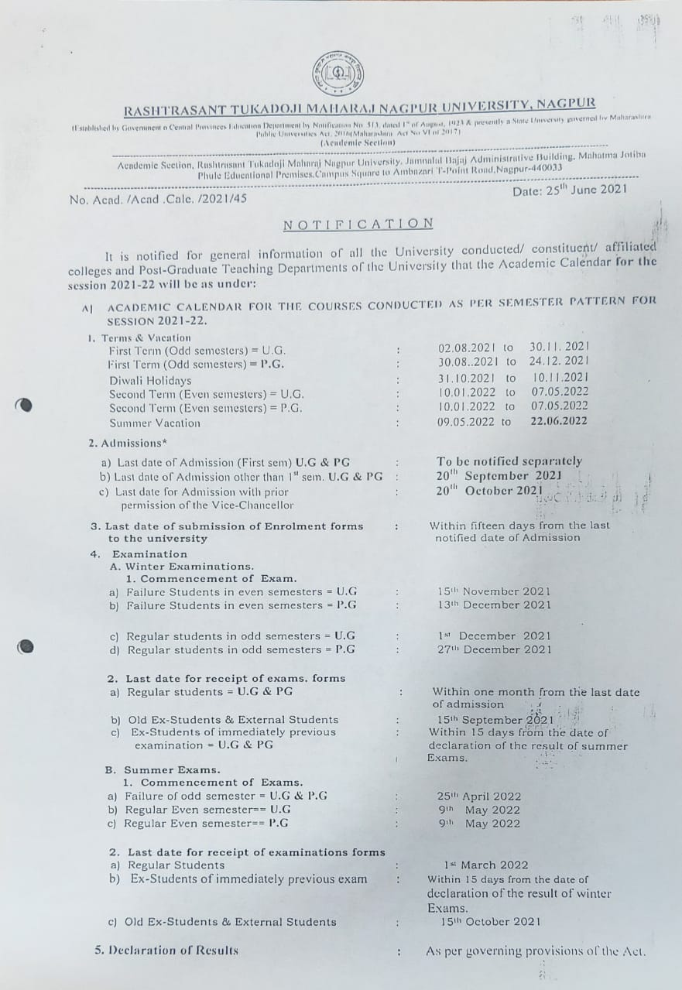
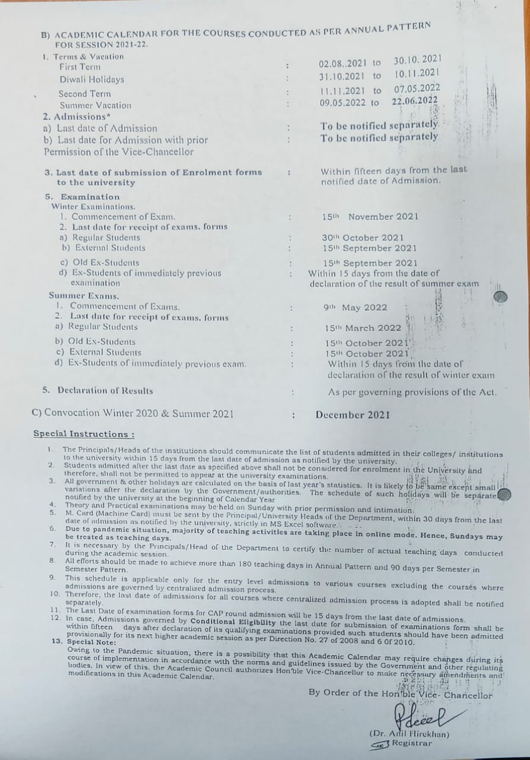

  - Academic Time Table with the name of the Faculty members handling the Course

DEPTT OF ELECTRICAL ENGINEERING

TIME TABLE (2021-22)

III SEMESTER ELECTRICAL ENGG WEF- Dt. 20.09.2021

PERIOD  DAY | 10:30-11:30 | 11:30-12:30 | 12:30-01:00 | 1:00-2:00 | 2:00-3:00 | 03:00-03:15 | 3.15-4.15 | 4.15-5.15
MON | EEM  (VM) | NCES  (SPJ) | R  E  C  E  S  S | NT/EMI/ADC/Python  (PR)  S1/S2/S3/S4  (VE-1/VE-8/VE-10/VCSE) |  | R  E  C  E  S  S | NT  (VE-1) | NT/EMI/ADC  (TU)  S2/S3/S4  (VE-1/RMS/PVN)
TUE | ADC  (PVN) | EEM  (VM) |  | NT/EMI/ADC/Python  (PR)  S2/S3/S4/S1  (VE-1/VE-8/VE-10/VCSE) |  |  | EMI  (RMS) | NT/EMI/ADC  (TU)  S3/S4/S1  (VE-1/RMS/SPJ)
WED | EEM  (VM) | NCES  (SPJ) |  | NT/EMI/ADC/Python  (PR)  S3/S4/S1/S2  (VE-1/VE-8/VE-10/VCSE) |  |  | NT  (VE-1) | ES  (PBD)
THU | ADC  (PVN) | NCES  (SPJ) |  | NT/EMI/ADC/Python  (PR)  S4/S1/S2/S3  (VE-1/VE-8/VE-10/VCSE) |  |  | IPP  (VCSE) | NT/EMI/ADC  (TU)  S4/S1/S2  (VE-2/RMS/SPJ)
FRI | ADC  (PVN) | NT/EMI/ADC  (TU)  S1/S2/S3  (VE-2/RMS/PVN) |  | NT  (VE-1) | EMI  (RMS) |  | EMI  (RMS) | EEM  (TU)  (VM-1/VM-2/VM-3/VD)
SAT

- Abbreviations (Subjects):
Subject Code | Name of Subject | Subject Code | Name of Subject
EEM | Electrical Engineering Mathematics | EMI | Electrical Measurement & Instrumentation
ADC | Analog Devices & Circuits | IPP | Introduction to Python Programming
NT | Network Theory | ES | Environmental Studies
NCES | Non conventional Energy Studies
- Abbreviations (Faculty):
Faculty Code | Name of Faculty | Faculty Code | Name of Faculty
NDG | Dr. N.D.Ghawghawe | VD | Dr. Vinod Dagwal
RSS | Dr. R.S.Surjuse | PBD | Dr. Prashant Diagavane
SPJ | Prof. S.P.Jolhe | VE-1, VE-2, VE-8, VE-10 | Visiting Electrical
RMS | Prof. Rajni Sahare | VM | Visiting Maths
NVK | Prof.NehaKhadse | VCSE | Visiting Computer Science
PVN | Prof. Praful Nandankar

V SEMESTER ELECTRICAL ENGG WEF- Dt.20.09.2021

PERIOD  DAY | 10:30-11:30 | 11:30-12:30 | 12:30-01:00 | 1:00-2:00 | 2:00-3:00 | 03:00-03:15 | 3.15-4.15 | 4.15-5.15
MON | EMC-II  (RSS) | EMD  (PVN) | R  E  C  E  S  S | EPS-I  (RMS) | EPS-I/EMD/EMC-II/UEE  (TU)  (T1/T2/T3/T4)  (VE-7/PVN/RSS/NVK) | R  E  C  E  S  S | µP/EMC-II/EEW/EDS  (PR)  (T1/T2/T3/T4)  (NDG/VE-2/VE-8/VE-4)
TUE | µP  (NDG) | EMC-II  (RSS) |  | EMD  (PVN) | µP/EPS-I/EMD/EMC-II  (TU)  (T1/T2/T3/T4)  (NDG/VE-7/PVN/RSS) |  | µP/EMC-II/EEW/EDS  (PR)  (T2/T3/T4/T1)  (VE-2/RSS/VE-8/VE-4)
WED | EMC-II  (RSS) | EMD  (PVN) |  | EPS-I  (RMS) | EPS-I  (RMS) |  | µP/EMC-II/EEW/EDS  (PR)  (T3/T4/T1/T2)  (VE-2/RSS/VE-8/VE-9)
THU | µP  (NDG) | UEE  (NVK) |  | UEE  (NVK) | EPS-I  (RMS) |  | EMD/EMC-II/UEE/ µP  (TU)  (T1/T2/T3/T4)  (PVN/SPJ/NVK/VE-2)
FRI | EMC-II  (RSS) | UEE  (NVK) |  | EMD  (PVN) | µP  (VE-2) |  | µP/EMC-II/EEW/EDS  (PR)  (T4/T1/T2/T3)  (VE-2/VE-1/VE-8/VE-9)
SAT | EMC-II/UEE/ µP/EPS-I  (TU)  (T1/T2/T3/T4)  (RSS/VE-9/VE-2/RMS) | EMC-II/UEE/ µP/EPS-I  (TU)  (T1/T2/T3/T4)  (RSS/VE-9/VE-2/RMS) |  | UEE/ µP/EPS-I/EMD  (TU)  (T1/T2/T3/T4)  (VE-9/VE2/RMS/PVN) | UEE/ µP/EPS-I/EMD  (TU)  (T1/T2/T3/T4)  (VE-9/VE-2/RMS/PVN)

Abbreviations (Subjects):
Subject Code | Name of Subject | Subject Code | Name of Subject
EMD | Electrical Drawing and Simulation | EPS-I | Electrical Power System-i
µP | Microprocessor and Interfacing | EMC-II | Electrical Machine -II
UEE | Utilization of Electrical Energy
Abbreviations (Faculty):
Faculty Code | Name of Faculty | Faculty Code | Name of Faculty
NDG | Dr. N.D.Ghawghawe | NVK | Prof.NehaKhadse
RSS | Dr. R.S.Surjuse | PVN | Prof. Praful Nandankar
SPJ | Prof. S.P.Jolhe | VE-1, VE-2, VE-4, VE-7, VE-8, VE-9 | Visiting Electrical
RMS | Prof. Rajni Sahare

VII SEMESTER ELECTRICAL ENGG WEF- Dt.23.08.2021

PERIOD  DAY | 9:30-10:30 | 10:30-11:30 | 11:30-12:30 | 12:30- 01:00 | 1:00-2:00 | 2:00-3:00 | 03:00-03:15 | 3.15-4.15 | 4.15-5.15
MON | HVE(VE-9) | EPS-II  (VE-4) | CS-II  (VE-6) | R  E  C  E  S  S | EID  (NVK) | ELE-I/ CS-II/EPS-II/HVE  TU  (F1/F2/F3/F4)  (SPJ/VE-6/VE-4/VE-9) | R  E  C  E  S  S | HVE/EID  (PR)  (F1/F2)  (VE-9/VE-7)
TUE | CS-II  (VE-6) | EPS-II  (VE-4) | ELE-I  (SPJ) |  | EID  (NVK) | CS-II/EPS-II/HVE/EID  TU  (F1/F2/F3/F4)  (VE-6/VE-4/VE-9/NVK) |  | HVE/EID  (PR)  (F2/F3)  (VE-9/VE-7)
WED |  | HVE  (VE-9) | EID  (NVK) |  | EID  (NVK) | ELE-I/EPS-II/HVE/EID  TU  (F4/F1/F2/F3)  (SPJ/VE-4/VE-7/NVK) |  | HVE/EID  (PR)  (F3/F4)  (VE-7/VE-6)
THU |  | CS-II  (VE-6) | HVE  (VE-7) |  | EPS-II  (VE-4) | ELE-I/ CS-II/HVE/EID  TU  (F3/F4/F1/F2)  (SPJ/VE-6/VE-7/NVK) |  | HVE/EID  (PR)  (F4/F1)  (VE-7/VE-6)
FRI |  | ELE-I  (SPJ) | CS-II  (VE-6) |  | ELE-I  (SPJ) | ELE-I/ CS-II/EPS-II/EID  TU  (F2/F3/F4/F1)  (SPJ/VE-6/VE-4/NVK) |  | HVE  (VE-7) | EPS-II  (VE-4)
SAT |  | P & S (NDG/RSS/SPJ/  RMS/NVK/PVN) | P & S (NDG/RSS/SPJ/  RMS/NVK/PVN) |  | P & S (NDG/RSS/SPJ/  RMS/NVK/PVN) | P & S  (NDG/RSS/SPJ/  RMS/NVK/PVN) |  | P & S (NDG/RSS/SPJ/  RMS/NVK/PVN) | P & S (NDG/RSS/SPJ/  RMS/NVK/PVN)
Abbreviations (Subjects):
Subject Code | Name of Subject | Subject Code | Name of Subject
ELE-I | Energy Management and Audit | EPS-II | Electrical Power System-II
HVE | High Voltage Engineering | CS-II | Control Systems-II
EID | Electrical Installation Design
Abbreviations (Faculty):
Faculty Code | Name of Faculty | Faculty Code | Name of Faculty
NDG | Dr. N.D.Ghawghawe | NVK | Prof.NehaKhadse
RSS | Dr. R.S.Surjuse | PVN | Prof. Praful Nandankar
SPJ | Prof. S.P.Jolhe | VE-4, VE-6, VE-7, VE-9 | Visiting Electrical
RMS | Prof. Rajni Sahare

IV SEMESTERELECTRICALENGG WEF- Dt.10.01.2022
PERIOD  DAY | 10:30- 11:30 | 11:30-12.30 | 12.30-01.00 | 01:00-2:00 | 2:00-3:00 | 03:00-03:15 | 03:15-04:15 | 04:15-05:15
MON | DE(TH)  (PVN) | EM-I (TH)  (SPJ) | R  E  C  E  S  S | PT&S (TH)  ECSE | EMF (TH)  (EV2) | R  E  C  E  S  S | DE/EM-I/PT&S (PR)  (PVN/SPJ/ECSE)  (S1/S2/S3)
TUE | EMF (TH)  (EV2) | EM-I (TH)  (SPJ) |  | PT&S (TH)  ECSE | PS (TH)  (EV8) |  | DE/EM-I/PT&S (PR)  (PVN/SPJ/ECSE)  (S2/S3/S4)
WED | DE(TH)  (PVN) | EM-I (TH)  (SPJ) |  | S & S (TH)  (RMS) | S & S (TH)  (RMS) |  | DE/EM-I/PT&S (PR)  (EV3/EV5/ECSE)  (S3/S4/S1)
THU | DE(TH)  (PVN) | PS (TH)  (EV8) |  | PT&S (TH)  ECSE | S&S/EMF (TU)  (RMS/EV2)  (S1/S2) |  | DE/EM-I/PT&S (PR)  (EV3/EV5/ECSE)  (S4/S1/S2)
FRI | EMF (TH)  (EV2) | PS (TH)  (EV8) |  | S & S (TH)  (RMS) | S&S/EMF (TU)  (RMS/EV2)  (S2/S3)
SAT | S&S/EMF (TU)  (RMS/EV2)  (S3/S4) | S&S/EMF (TU)  (RMS/EV2)  (S3/S4) |  | S&S/EMF (TU)  (RMS/EV2)  (S4/S1) | S&S/EMF (TU)  (RMS/EV2)  (S4/S1)

Abbreviations (Subjects):

Subject  Code | Name of Subject | Subject  Code | Name of Subject
S&S | Signals &Systems | PS | Power System
DE | Digital Electronics | PT&S | Programming Techniques & Simulation
EM-I | Electrical Machines-I

Abbreviations (Faculty):

Faculty Code | Name of Faculty | Faculty Code | Name of Faculty
SPJ | Dr. S.P.Jolhe | ECSE | Visiting Faculty Computer Science
RMS | Prof. R.M.Sahare | EV | Visiting Faculty EE
PVN | Prof. P. V. Nandankar

VI SEMESTER ELECTRICAL ENGG WEF- Dt.24.01.2022

PERIOD  DAY | 10:30-11:30 | 11:30-12:30 | 12:30- 01:00 | 1:00-2:00 | 2.00-3.00 | 3:00-  4:00 | 3.15-4.15 | 4.15-5.15
MON | PE (TH)  (RSS) | CS-I (TH)  (EV7) | R  E  C  E  S  S | PE/CS-I/IVRW (PR)  (RSS/EV7/NVK)  (T1/T2/T3) |  | R  E  C  E  S  S | PSP (TH)  (EV8) | FE (TH)  (ESH)
TUE | PE (TH)  (PVN) | PSP (TH)  (EV8) |  | PE/CS-I/IVRW (PR)  (RSS/EV7/EV9)  (T2/T3/T4) |  |  | EEIM (TH)  (EV9) | FE (TH)  (ESH)
WED | PE (TH)  (RSS) | CS-I (TH)  (EV7) |  | PE/CS-I/IVRW (PR)  (EV6/EV7/EV9)  (T3/T4/T1) |  |  | EEIM (TH)  (EV9) | EDC (TH)  (EV4)
THU | EDC (TH)  (SPJ) | PSP (TH)  (NVK) |  | PE/CS-I/IVRW (PR)  (EV6/EV7/EV9)  (T4/T1/T2) |  |  | EDC (TH)  (SPJ) | EDC (TH)  (EV4)
FRI | PE (TH)  (PVN) | CS-I (TH)  (EV7) |  | PSP/EEIM/EDC/PE  (EV8/EV9/SPJ/RSS)  (T1/T2/T3/T4) | EEIM/EDC/PE/CS-I  (EV9/EV4/RSS/EV5)  (T1/T2/T3/T4) |  | EEIM (TH)  (EV9) | CS-I (TH)  (EV7)
SAT | CS-I/PSP/EEIM/EDC  (EV5/EV8/EV9/EV4)  (T1/T2/T3/T4) | CS-I/PSP/EEIM/EDC  (EV5/EV8/EV9/EV4)  (T1/T2/T3/T4) |  | EDC/PE/CS-I/PSP  (EV4/PVN/EV5/EV8)  (T1/T2/T3/T4) | EDC/PE/CS-I/PSP  (EV4/PVN/EV5/EV8)  (T1/T2/T3/T4) |  | PE/CS-I/PSP/EEIM  (PVN/EV5/EV8/EV9)  (T1/T2/T3/T4) | PE/CS-I/PSP/EEIM  (PVN/EV5/EV8/EV9)  (T1/T2/T3/T4)

Abbreviations (Subjects):

Subject Code | Name of Subject | Subject Code | Name of Subject
CS-1 | Control System-1 | FE | Functional English
PSP | Power Station Practice | EEIM | Engineering Econonics and Industrial Management
PE | Power Electronics | EDC | Electrical Drives and Their Control
IVRW | Industrial Visits and Report Writing

Abbreviations (Faculty):

Faculty Code | Name of Faculty | Faculty Code | Name of Faculty
RSS | Dr.R.S.Surjuse | EV | Visiting Faculty (Eectrical)
SPJ | Dr. S. P. Jolhe | ESH | Visiting Faculty (Science & Humanities)
NVK | Prof.N.V Khadse
PVN | Prof. P.V. Nandankar

VIII SEMESTERELECTRICALENGG WEF-Dt.10.01.2022

PERIOD  DAY | 10:30- 11:30 | 11:30-12.30 | 12:30-  01.00 | 01:00-2:00 | 2:00-3:00 | 03:00-03:15 | 3:15-4:15 | 4:15-5:15
MON | CAIPS(F1)/SGP(F2) (PR)  (EV2/NDG) |  | R  E  C  E  S  S | SGP (TH)  (NDG) | ELE-II (TH)  (RMS/EV6) | R  E  C  E  S  S | CAIPS (TH)  (EV1) | CAIPS/ SGP/ ELE-II/ ELE-III (TU)  (EV1/NDG/EV5&EV6/ NVK&EV4)  (F3/F4/F1/F2)
TUE | CAIPS(F2)/SGP(F1) (PR)  (EV1/EV3) |  |  | SGP (TH)  (EV3) | ELE-II (TH)  (RMS/EV6) |  | ELE-III (TH)  (NVK/EV4) | CAIPS/ SGP/ ELE-II/ ELE-III (TU)  (EV1/NDG/ EV5&EV6/NVK&EV4)(F4/F1/F2/F3)
WED | CAIPS(F3)/SGP(F4) (PR)  (EV2/EV3) |  |  | SGP (TH)  (EV3) | ELE-III (TH)  (NVK/EV4) |  | CAIPS (TH)  (EV1) | Project  (NDG/RSS/SPJ/RMS/  NVK/PVN)
THU | CAIPS(F4)/SGP(F3) (PR)  (EV1/EV3) |  |  | SGP (TH)  (NDG) | ELE-II (TH)  (EV5/EV6) |  | CAIPS (TH)  (EV1) | Project  (NDG/RSS/SPJ/RMS/NVK/PVN)
FRI | CAIPS/ SGP/ ELE-II/ ELE-III (TU)  (EV1/EV3/ EV5&EV6/ NVK&EV4)  (F1/F2/F3/F4) | CAIPS/ SGP/ ELE-II/ ELE-III (TU)  (EV1/EV3/ EV5&EV6/ NVK&EV4)  (F2/F3/F4/F1) |  | ELE-III (TH)  (NVK/EV4) | CAIPS (TH)  (EV1) |  | Project  (NDG/RSS/SPJ/RMS/NVK/PVN)
SAT | Project  (NDG/RSS/SPJ/RMS/NVK/PVN) |  |  | Project  (NDG/RSS/SPJ/RMS/NVK/  PVN) |  |  | Project  (NDG/RSS/SPJ/RMS/NVK/PVN)

Abbreviations (Subjects):
SubjectCode | Name of Subject | SubjectCode | Name of Subject
ELE-II | EHV AC and HVDC Transmission/Digital Signal Processing | CAIPS | Computer applications in power system
ELE-III | Electrical Distribution System/ Power Semiconductor Based drives | Project | Project
SGP | Switchgear & protection

Abbreviations (Faculty):
FacultyCode | Name of Faculty | Faculty Code | Name of Faculty
NDG | Dr. N.D.Ghawghawe | NVK | Prof. N.V. Khadse
RSS | Dr. R.S.Surjuse | PVN | Prof.P.V. Nandankar
SPJ | Dr..S.P.Jolhe | EV | Visiting Faculty Electrical
RMS | Prof. R.M.Sahare

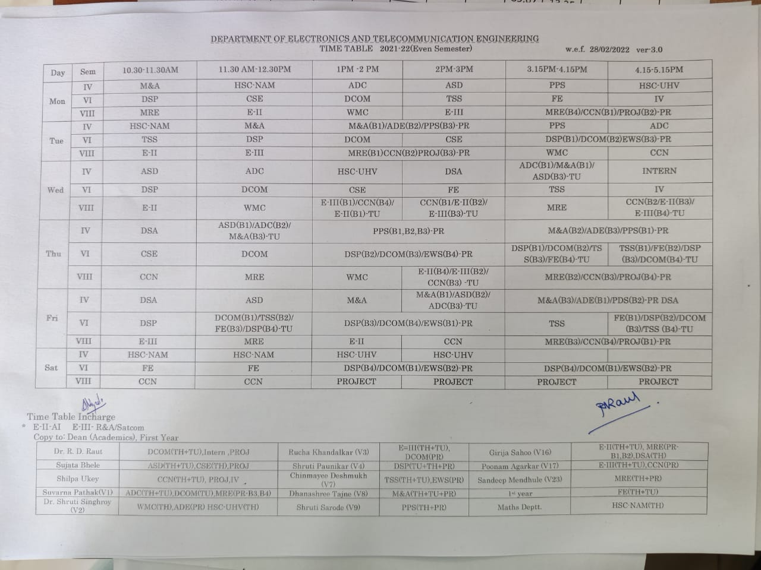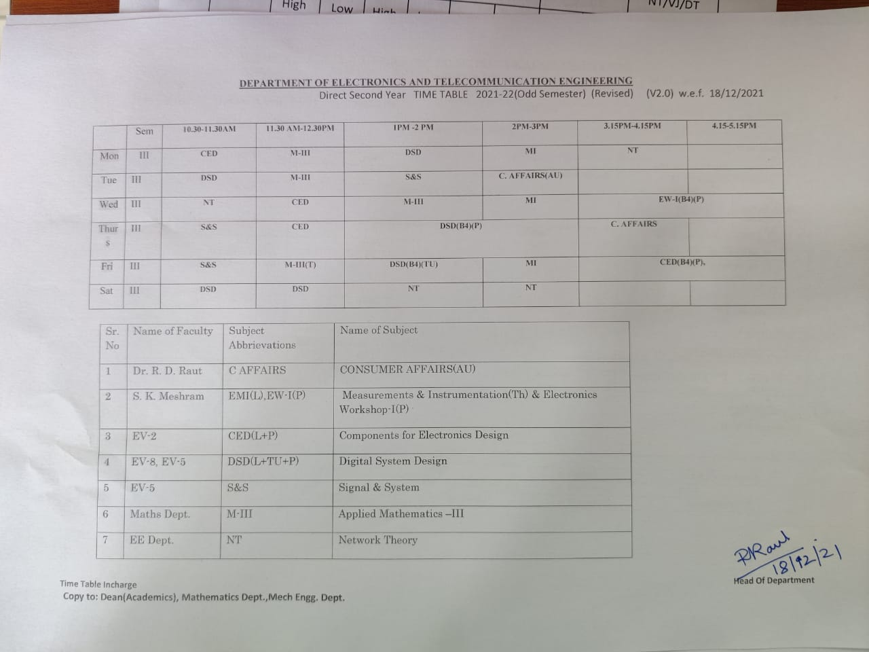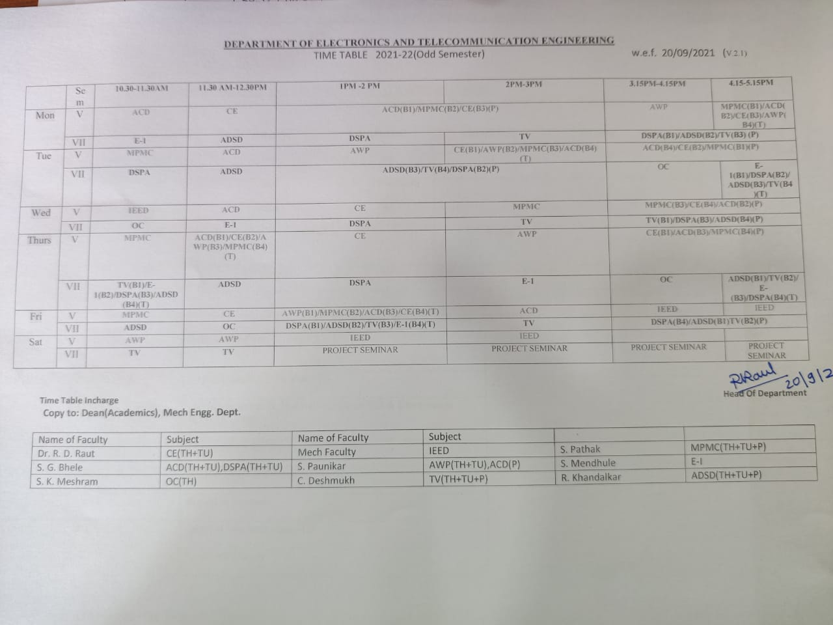

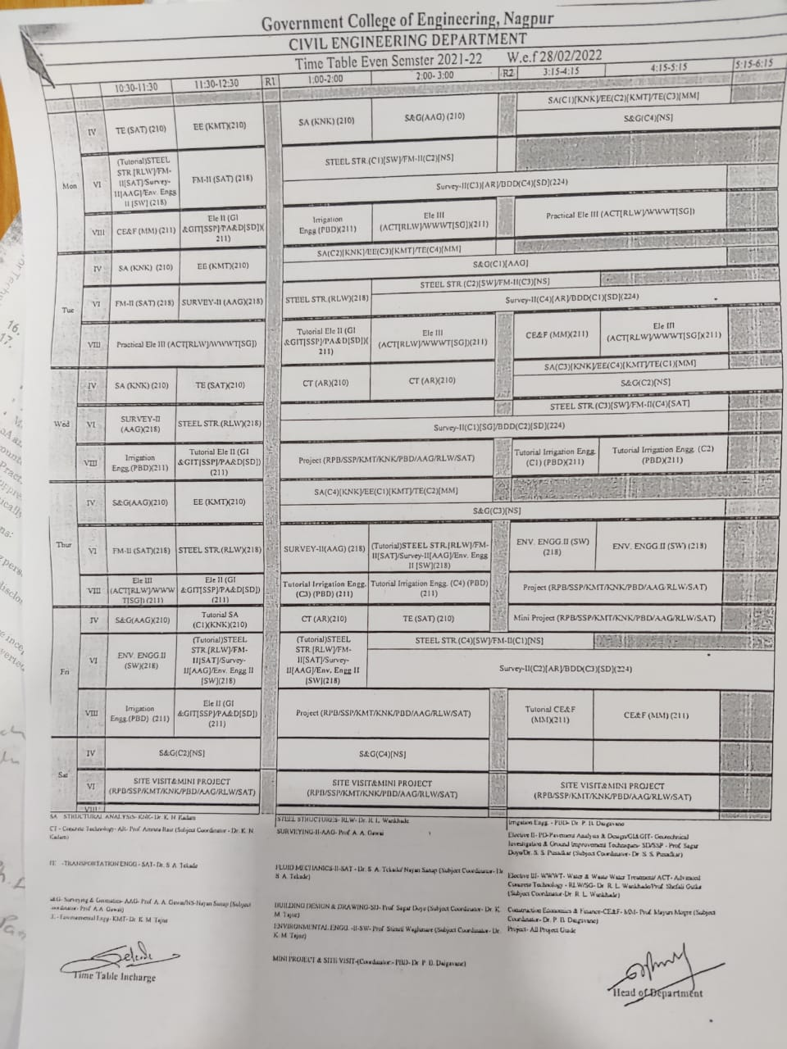

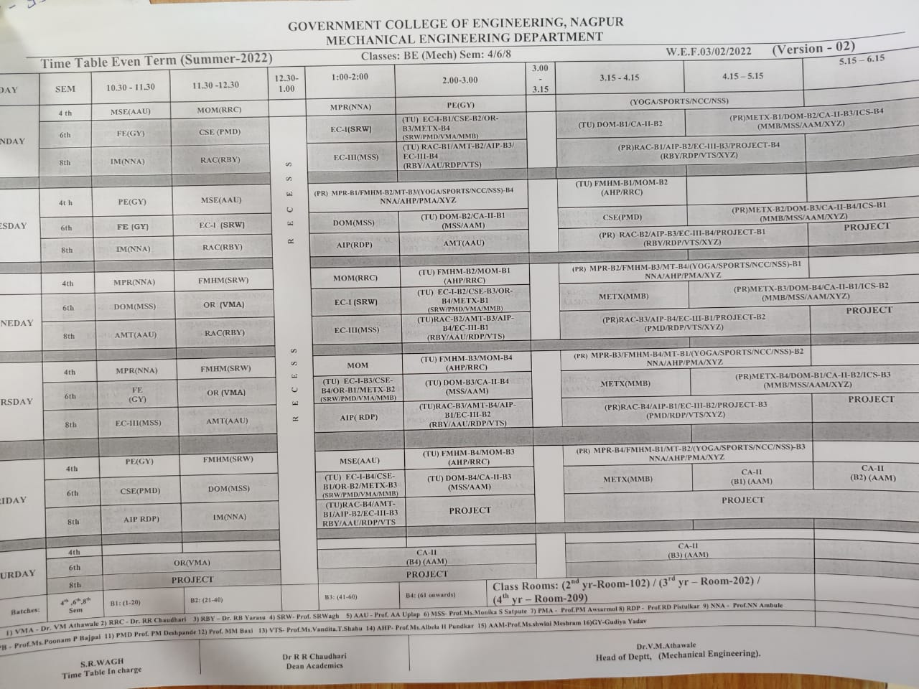

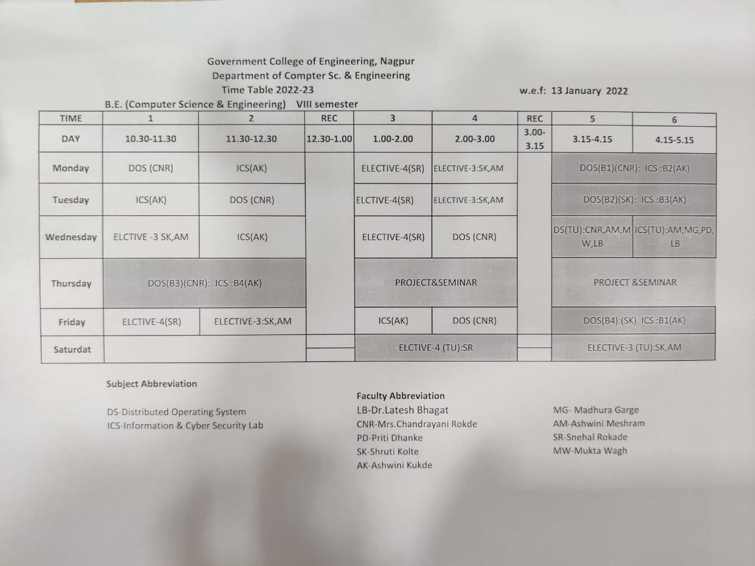

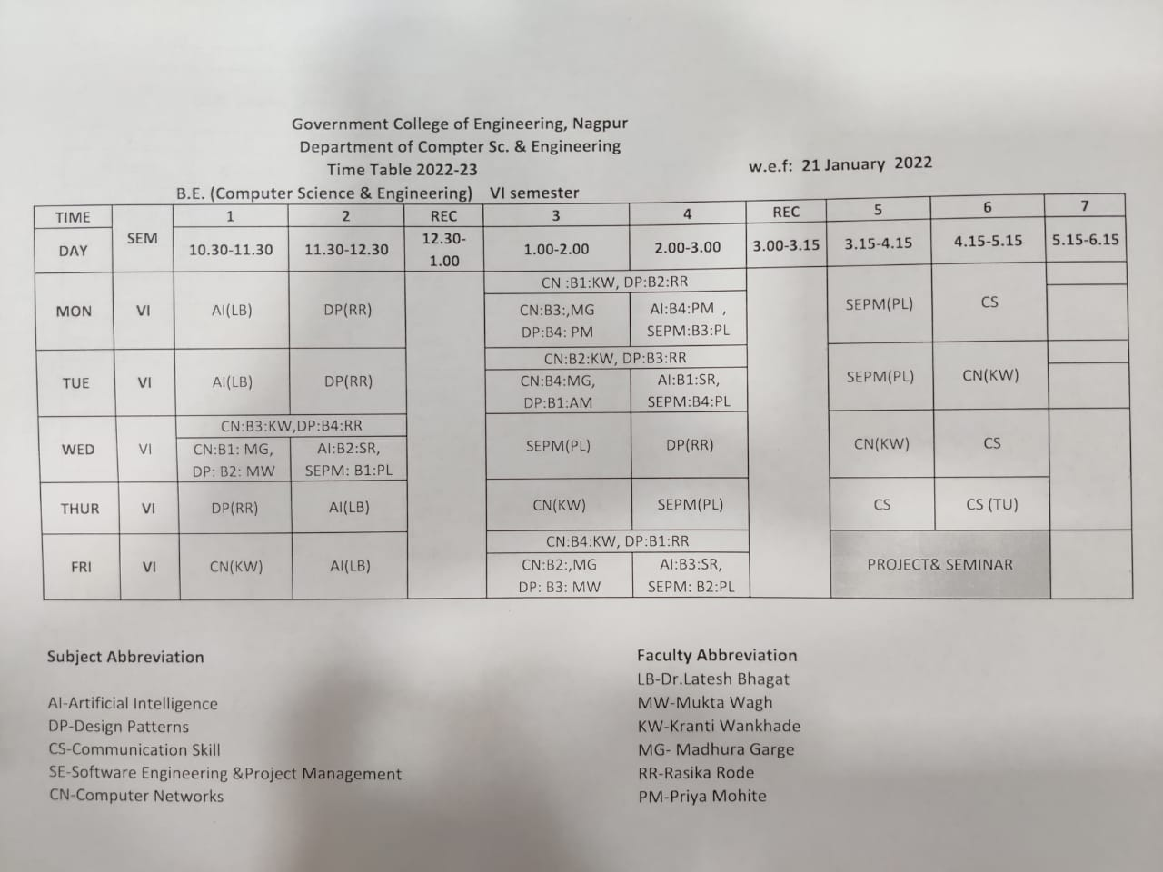

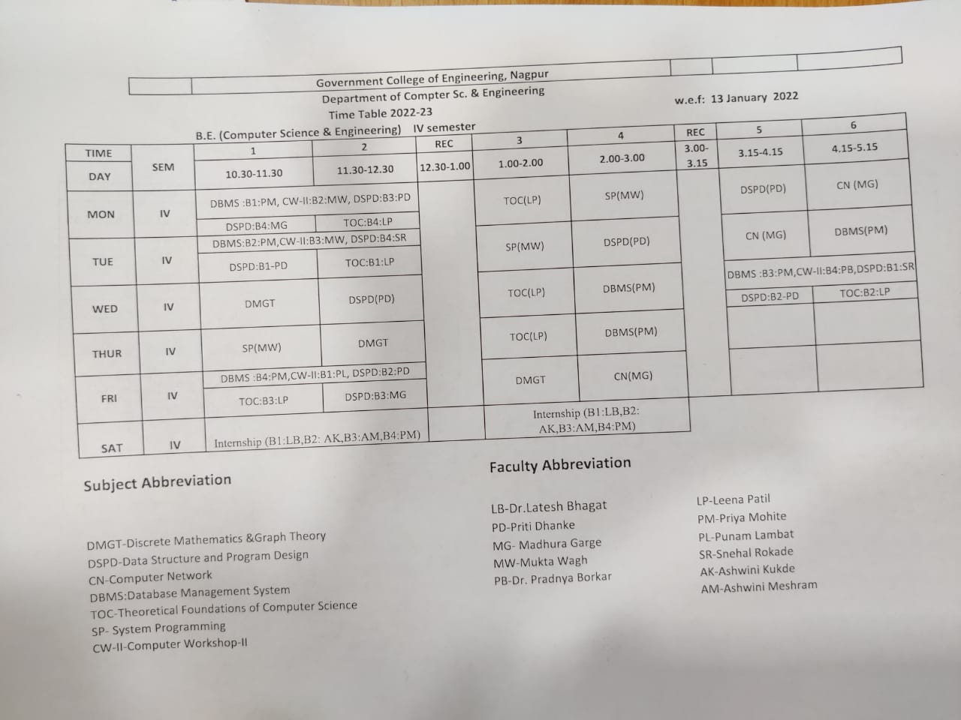

  - Teaching Load of each Faculty

Department of Electrical Engineering
Teaching load Even Semester 2021-22
Sr.  No. | Name of Faculty | Name of Subjects | TH | TU | PR | Total Load
1 | Dr. N.D.Ghawghawe | SGP | 2 | 2 | 2 | 12
 |  | Project |  |  | 6
2 | Dr.R.S.Surjuse | PE | 2 | 2 | 4 | 14
 |  | Project |  |  | 6
3 | Dr.S.P.Jolhe | EM-I | 3 |  | 4 | 16
 |  | EDC | 2 | 1
 |  | Project |  |  | 6
4 | Prof.R.M.Sahare | S&S | 3 | 4 |  | 16
 |  | DSP | 2 | 1
 |  | Project |  |  | 6
5 | Prof. N.V.Khadse | Ele-III (EDS) | 3 | 4 |  | 16
 |  | PSP | 1
 |  | IVRW |  |  | 2
 |  | Project |  |  | 6
6 | Prof. P.V.Nandankar | DE | 3 |  | 4 | 17
 |  | PE | 2 | 2
 |  | Project |  |  | 6
7 | EV1 (Prof. Ashtekar) | CAIPS | 4 | 4 | 4 | 12
8 | EV2 (Prof. Hatwar) | EMF | 3 | 4 |  | 11
 |  | CAIPS |  |  | 4
9 | EV3 (Prof. Bhawarkar) | SGP | 2 | 2 | 6 | 14
 |  | DE |  |  | 4
10 | EV4 (Dr.Shipra) | Elec-III (PSBD) | 3 | 4 |  | 12
 |  | EDC | 2 | 3
11 | EV5 | DSP | 1 | 3 |  | 12
 |  | CS-I |  | 4
 |  | EM-I |  |  | 4
12 | EV6 | EHVAC | 3 | 4 |  | 11
 |  | PE |  |  | 4
13 | EV7 (Prof. Pohekar) | CS-I | 4 |  | 8 | 12
14 | EV8 (Prof. Ingole) | PSP | 2 | 4 |  | 9
 |  | PS | 3
15 | EV9 (Prof. Rajurkar) | EEIM | 3 | 4 |  | 13
 |  | IVRW |  |  | 6

Electrical Engineering Department
Individual Teaching Load (2021-22 Odd Term)
Sr.  No. | Name of the faculty | Department | Subject | Sem. | TH | PR | TU | Total
1 | Dr. N. D. Ghawghawe | Electrical | uP | V | 2 | 2 | 1 | 8
 |  |  | Project & Seminar | VII |  | 3
2 | Dr. R.S.Surjuse | Electrical | EMC-II | V | 4 | 4 | 3 | 14
 |  |  | Project & Seminar | VII |  | 3
3 | Prof. S.P.Jolhe | Electrical | EMA (Elective-I) | VII | 3 |  | 4 | 16
 |  |  | NCES | III | 3
 |  |  | Project & Seminar | VII |  | 3
 |  |  | EMC-II |  |  |  | 1
 |  |  | AE | III |  |  | 2
4 | Prof. R.M.Sahare | Electrical | EPS-I | V | 4 |  | 2 | 16
 |  |  | EMI | III | 3 |  | 4
 |  |  | Project & Seminar | VII |  | 3
5 | Prof. N.V.Khadse | Electrical | EID | VII | 4 |  | 4 | 16
 |  |  | UEE | V | 3 |  | 2
 |  |  | Project & Seminar | VII |  | 3
6 | Prof. P.V.Nandankar | Electrical | EMD |  | 4 |  | 4 | 16
 |  |  | AE | III | 3 |  | 2
 |  |  | Project & Seminar | VII |  | 3
7 | VE-1 (Shweta Rajurkar) | Electrical | EMC-II | V |  | 2 |  | 15
 |  |  | NT | III | 3 | 8 | 2
8 | VE-2 (Dipti Bhawarkar) | Electrical | uP | V | 1 | 6 | 3 | 14
 |  |  | NT | III |  |  | 2
 |  |  | EMC-II | V |  | 2
9 | VE-4 (Shilpa Mahajan) | Electrical | EPS-II | VII | 4 |  | 4 | 12
 |  |  | EDS | V |  | 4
10 | VE-6 (Mrugsarita Borkar) | Electrical | CS-II | VII | 4 |  | 4 | 12
 |  |  | EID | VII |  | 4
11 | VE-7 (Pranali Hatwar) | Electrical | EPS-I | V |  |  | 2 | 12
 |  |  | EID | VII |  | 4
 |  |  | HVE | VII | 2 | 4 | 2
12 | VE-8 (Pavan Pohekar) | Electrical | EMI | III |  | 8 |  | 18
 |  |  | NAS | III |  |  | 2
 |  |  | EEW | V |  | 8
13 | VE-9 (Juhi Ingole) | Electrical | UEE | V |  |  | 2 | 14
 |  |  | HVE | VII | 2 | 4 | 2
 |  |  | EDS | V |  | 4
14 | VE-10 (Kumari Shipra) | Electrical | NAS | III | 4 |  | 2 | 14
 |  |  | AE | III |  | 8

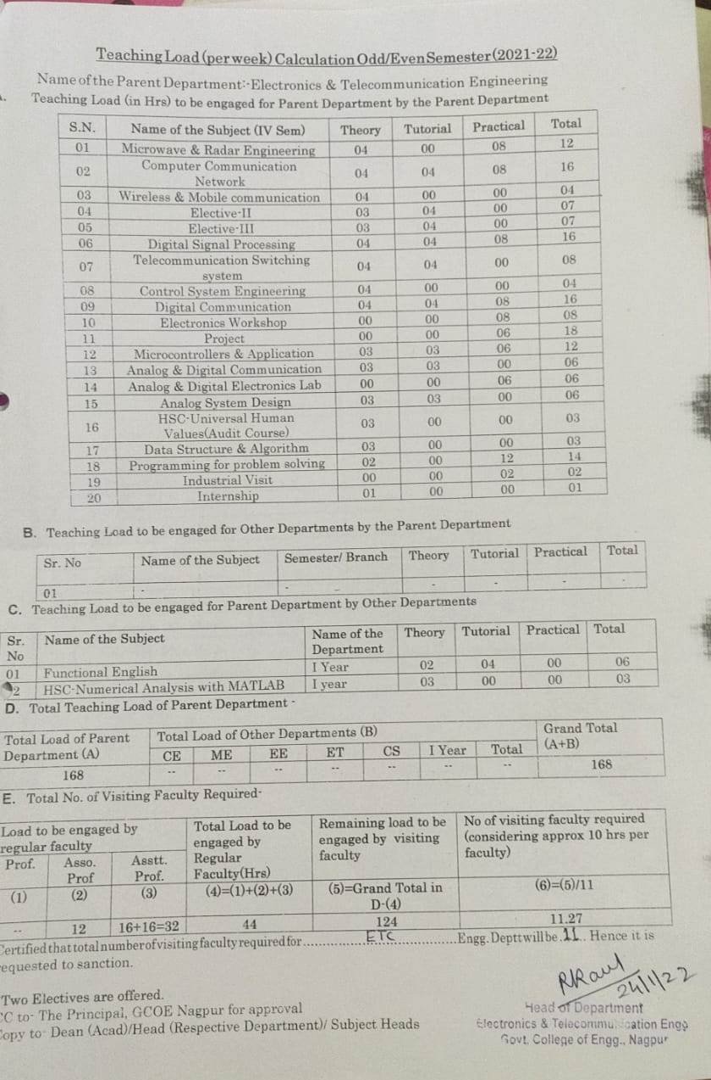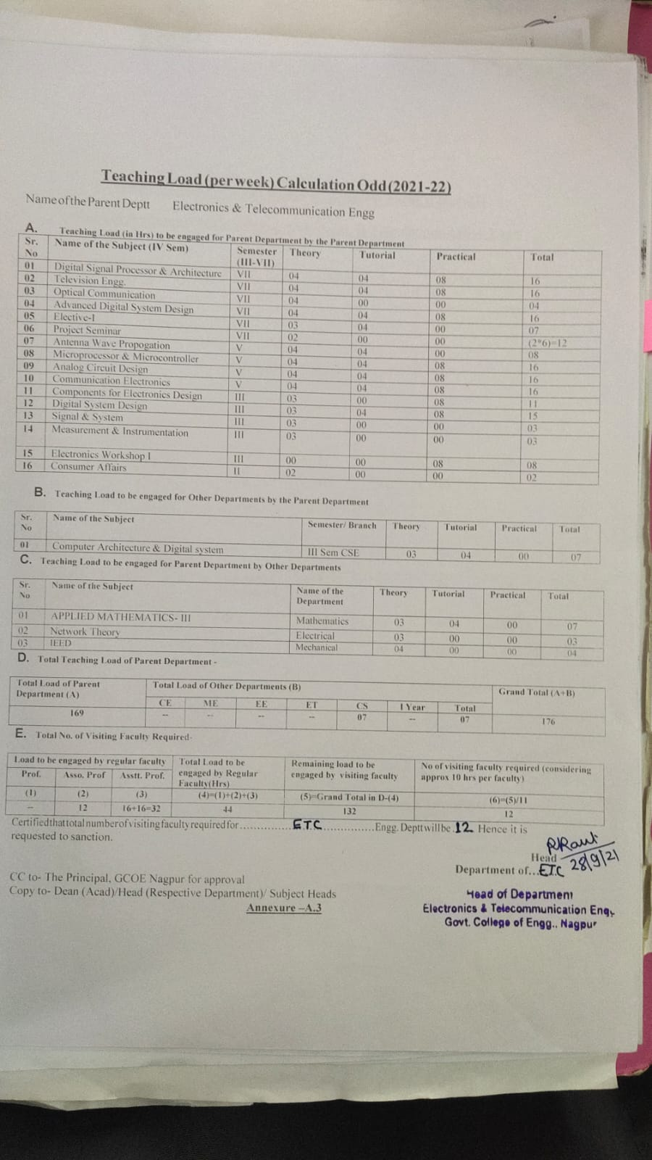
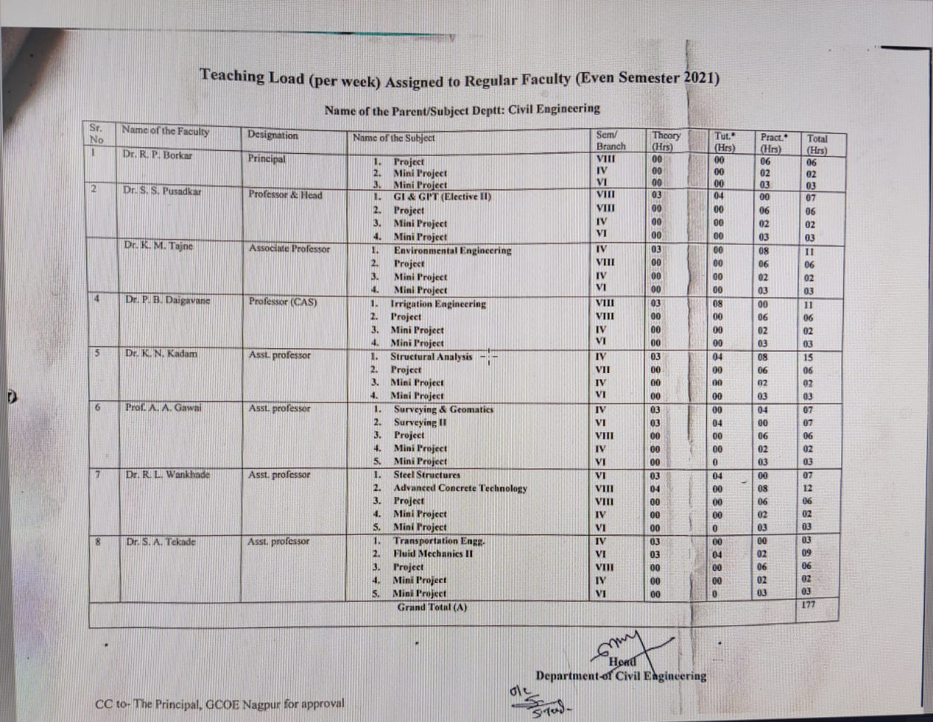

Department of Computer science & Engg
Sr. No | Name of Regular Faculty | Load for Regular Faculty |  |  | Total
 |  | Theory | Practical+  Tutorial | Project
1 | Dr. Latesh Malik | 4 | 4 | 2+5 | 15
 | Total
 | Total load of the department = |  |  |  | 208
 | Load taken by regular faculty = |  |  |  | 15
 | Load to be taken by visiting faculty = |  |  |  | 193
Sr. No | Name of Visiting Faculty | Load for Visiting Faculty |  |  | Total
 |  | Theory | Practical+  Tutorial | Project
1 | Priti Bhimrao Dhanke | 3 | 4+3 | 5 | 15
2 | Chandrayani Nikhil Rokde | 4 | 4+1 | 5 | 14
3 | Shruti Ramesh Kolte | 4 | 4+1 | 5 | 14
4 | Madhura Gunjan Garge | 3 | 7 | 5 | 15
5 | Kranti Bhaskarrao Wankhade | 4 | 8 | 2 | 14
6 | Rasika Anil Rode | 4 | 8 | 2 | 14
7 | Punam Udaramji Lambhat | 4 | 4+4 | 2 | 14
8 | Mukta Kalyan Wagh | 3 | 4+3 | 5 | 15
9 | Priya Sureshchandra Mohite | 3 | 8 | 2 | 13
10 | Snehal Diwakar Rokade | 4 | 4+4 | 2 | 14
11 | Ashwini kukade | 4 | 8 | 2 | 14
12 | Leena Patil | 3 | 4 |  | 7
13 | Ashwini Meshram | 4 | 4+(2TU-Mech) | 2 | 12
14 | Pradnya Borkar |  | 2 |  | 2
15 | Arti Ugale |  | 16 |  | 16
 | TOTAL | 47 | 105 | 41 | 193

  - Internal Continuous Evaluation System and place

ACADEMIC POLICIES 2021-22

Objectives:-
The Academic Office exists to help facilitate, initiate and co-ordinate the academic work of the Institute, particularly the teaching and assessment of students. It acts as the repository of grades and academic records of all students, both past and present.
At GCOEN, semester pattern is followed. An academic year consists of two semesters. The Odd Semester begins in June and the Even Semester in December. The academic schedule mentioned in the academic calender will be strictly followed.
Goals:-
  - Framing of Vision & Mission statements of Department by conducting stakeholders meeting & its mapping with Vision & Mission of Institute
  - Prepare Program Educational Objectives & Program Specific Outcomes & its mapping with vision & Mission
  - Prepare Course Outcomes of each course

Scope:-
- Regular monitoring of classes as per Time table
- Syllabus coverage
- Academic Review
- Conduct of Class Tests
- Conduct of University Theory & Practical Exams
- Result Analysis

Academic Policies:-
- Preparation of Personal file
Sr. No. | Title
1 | Updated Biodata
2 | Copy of all certificates
3 | Publications in National & International Conferences & Journals with date & venue
4 | Achievements/ Consultancy/ Resource person/Keynote speaker/session chair/Expert/ other if any

- Preparation of Subject/ Course File
S.N. | Title
01 | Vision & Mission of Institute
02 | Vision & Mission of Department
03 | Subject/Course Code (Year Wise)
04 | University Syllabus
05 | Teaching Plan
06 | Tutorial Plan
07 | Content beyond Syllabus
08 | Subject Notes (Hard copy)
09 | List of titles/text / reference books required or available in library , Online /subscribed Journals (National/International)
10 | Subject Time Table
11 | Class Test-I & II Question papers
12 | Assignments
13 | University Question Papers (Last 3 Years)
14 | University Paper Solution
15 | Result Analysis
16 | List of academically weak Students
17 | List of academically bright Students
18 | Corrective Measures taken to Improve the results (Includes extra classes/ Assignment/Guest Lectures/ Quiz/Industrial Visit)
19 | As a part of teaching Learning Process: Soft copy of Advanced topics/Question Bank/GATE Questions/PPTs/ICT if any
20 | Industry Interaction/ Internship (taken related to subject) if any
21 | Sample Class Test papers/ Assignments/ Journals should be preserved

- Teaching plan should be prepared for each subject
The lectures lay emphasis on the following:
- Knowledge content (topics in the curriculum)
- Utility value - application in real life
- Latest developments (Advance Topic)
Lecture  No. or topic code | Unit | Topics covered | Date
 |  |  | Planned | Engaged
1 | I | Introduction and discussion about syllabus. Definition and introduction to air pollution.
2 |  | Air pollution episodes.
3 |  | Atmosphere & Zones of Atmosphere.
4 |  | Classification of air pollutants.
5 |  | Sources of air pollutants.
6 |  | Effects of air pollutants on man, animal & plant.
7 |  | Effects of air pollutants on material & atmosphere.
8 |  | Advanced Topic-I
9 | II | Meteorology and air pollution
10 |  | Primary and Secondary air pollutants.
11 |  | Atmospheric stability.
12 |  | Plume behavior.
13 |  | Air sampling, measurement,

Course Coordinator HOD

- Attendance record should be maintained properly.
- Display of cumulative attendance on 5th day of every month.
- Academic Review should be conducted monthly by HOD & Principal.
- Two Class Tests (20 marks each for Old Scheme and 30 marks for New AICTE reformed Scheme ) to be conducted in each semester.
Class Test-I will be based on First & Second Unit. Eligibility for CT-I will be 75% attendance.
Class Test-II will be based on Third & Fourth Unit. Eligibility for CT-II will be 75% attendance.
- Attendance upto 60% may be considered only for students having medical reason certified by authentic doctor and students engaged in activities which will bring laurel to the institution.
- Two Assignments OR Unit Tests or Surprise Test or Quiz (any rubrics) may be conducted. Assignment-I based on 5th Unit. Assignment-II based on 6th Unit.
So that all Course outcomes will be achieved.
Distribution of Internal 20 marks (For Old Scheme)
Sr. No. | Parameters | Maximum Marks
01 | Class Test-I | 06
02 | Class Test-II | 06
03 | Teachers Assessment (Attendance/Assignment/UT/ST/Quiz) | 08
Total Marks |  | 20

Distribution of Internal 30 marks (For New Scheme)

Sr. No. | Parameters | Maximum Marks
01 | Class Test-I | 10
02 | Class Test-II | 10
03 | Teachers Assessment (Attendance/Assignment/UT/ST/Quiz) | 10
Total Marks |  | 30

Distribution of Internal 10 marks
Sr. No. | Parameters | Maximum Marks
01 | Class Test-I | 03
02 | Class Test-II | 03
03 | Teachers Assessment (Attendance/Assignment/UT/ST/Quiz) | 04
Total Marks |  | 10

- Feedback of students (CR only) before each Class Test by Principal supported by Dean (Student welfare)
- Practical continuous assessment should be done regularly.

Sr. No. | Parameters | Maximum Marks
01 | Performance & Viva-Voce | 15
02 | Practical record book/ Journal | 10
Total Marks |  | 25

- Question bank including Questions asked in University, GATE & competitive exam should be prepared.
- Identification of weak & bright students.
Weak student-Internal assessment / Performance in Class Test less than 50%
Bright student- Internal assessment /Performance in Class Test greater than 75%
- Remedial classes are conducted for Diploma holder students.

GOVERNMENT COLLEGE OF ENGINEERING, NAGPUR
Department of ________________________________
Monthly Academic Review (2021-22)
Sr. No. | Name of Teacher | Name of Subject | Theory planned | Theory engaged | % syllabus covered | Average attendance | Reason for lagging | Remark

Team Members 1) 2) 3)

Dean, Academics Principal
All Heads and Faculty members are hereby informed to conduct the activities as per Academic Calendar and implement Academic Policies.

- Student’s assessment of Faculty, System in place - Yes

For each Post Graduate Courses give the following: Not Applicable
  - Title of the Course
  - Curricula and Syllabi
  - Laboratory facilities exclusive to the Post Graduate Course

Special Purpose
  - Software, all design tools in case
MATLAB, E- TAP

  - Academic Calendar and framework

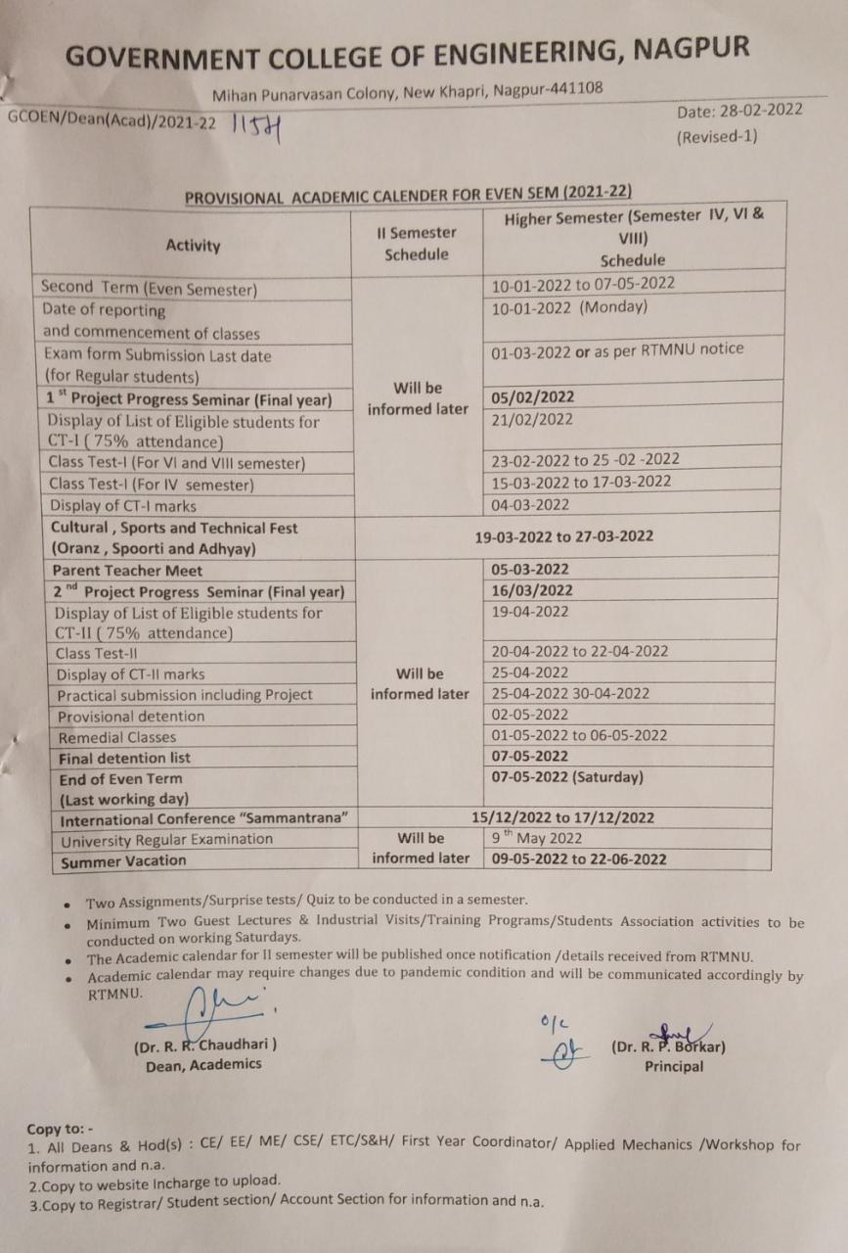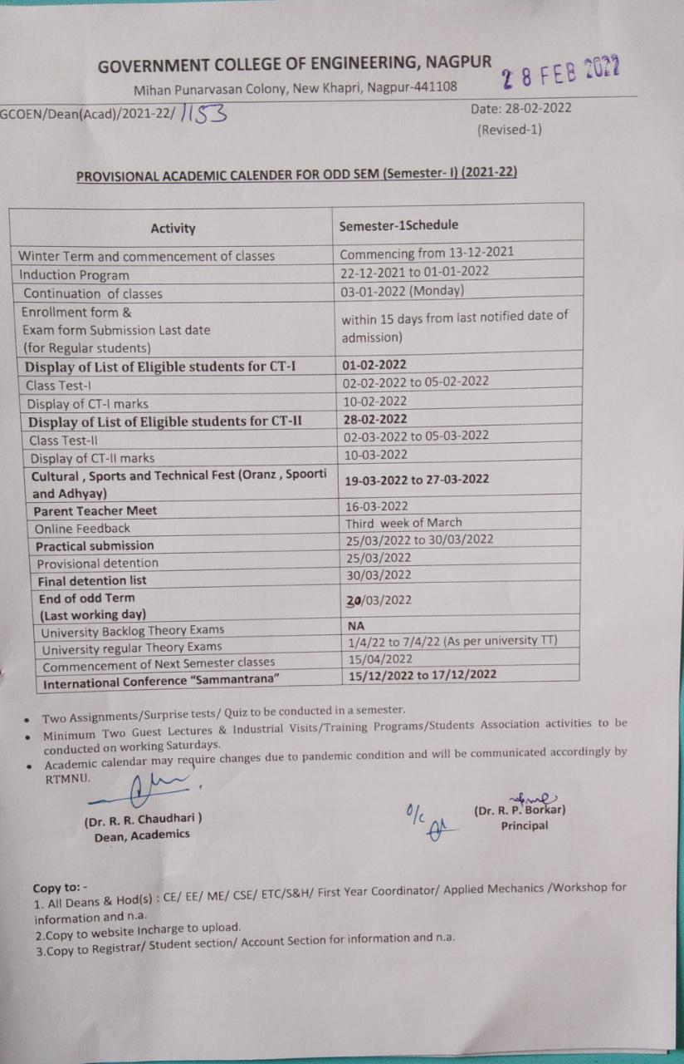

Enrolment and placement details of students in the last 3 years

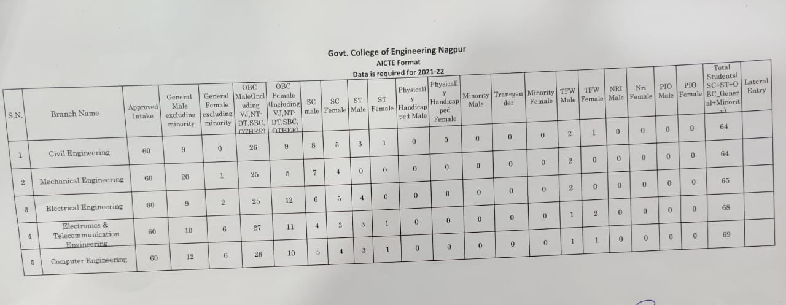

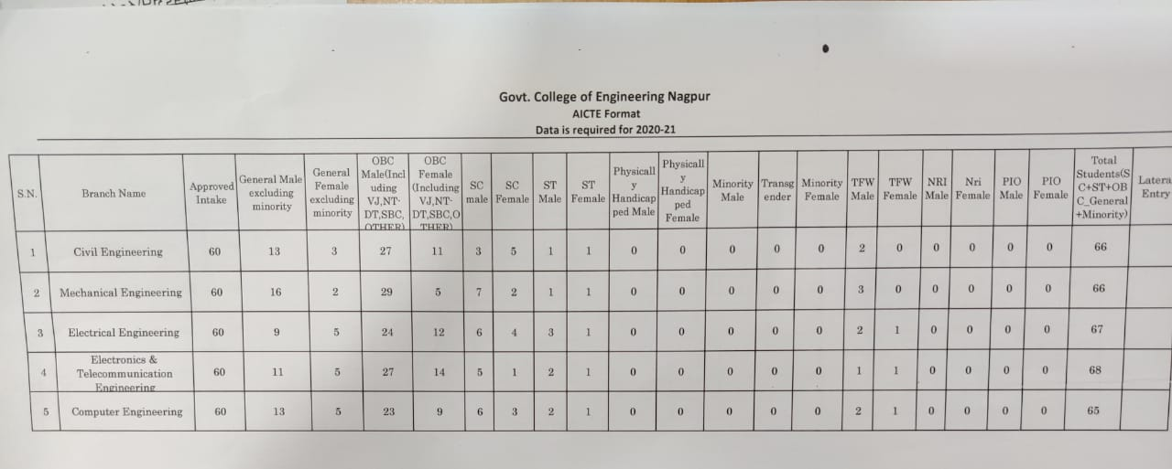

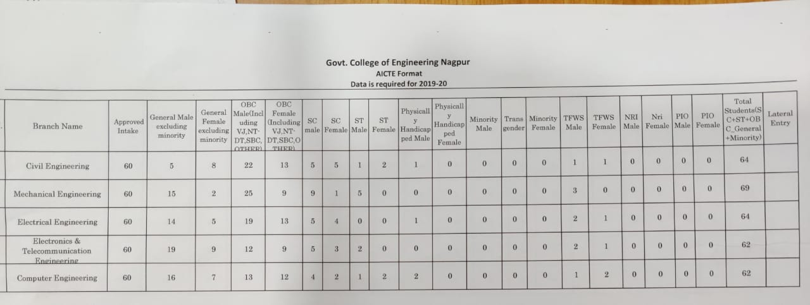

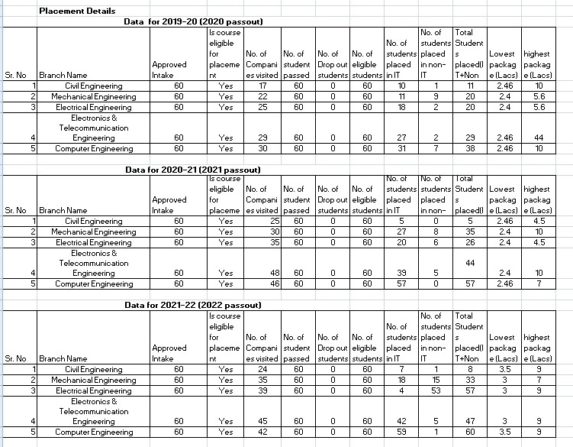

- List of Research Projects/Consultancy Works
  - Number of Projects carried out, funding agency, Grant received

UBA Projects:
- Smart Compost bin
- Mobile ON/OFF controller for 3 Phase Motor
- Cattle care system
- Solar system for community hall

- Testing and Consultancy
Government College of Engineering Nagpur has regularly generating IRG since its inception.

Major clients for consultancies are as- WAPCOS limited (A Govt of India Undertaking), Shapoorji Pallonji And Company Private Limited, Public Works Department (PWD), Ministry of Urban, National Environmental Engineering Research Institute (NEERI), District Sports Office Dhule, Amravati, Nagpur , Bhandara etc, Uttar Pradesh Jal Nigam, Maharashtra Industrial Development Corporation (MIDC), Central Public Works Dept, Maharashtra Jeevan Pradhikaran, Deputy Commissioner, Tribal Development, Nagpur
IRG Up To 31/03/2021
Financial Year | Testing | Consultancy | Training | Other Work | Total  (in Rupees)
2016-2017 | 1060 | 0 | 68200 |  | 69,260
2017-2018 | 414468 | 210249 | 30874 |  | 6,55,591
2018-2019 | 760474 | 684142 | 188800 |  | 16,33,416
2019-2020 | 3431180 | 1410651 | 216000 |  | 50,57,831
2020-2021 | 3618488 | 3801847 | 205200 | 176913 | 78,02,448
From College Establishment Up To 31/03/2021 | 8225670 | 6106889 | 709074 | 176913 | 1,52,18,546

… ranging
  - Publications(ifany)outofresearchinlastthreeyearsoutofmastersprojects : Data available on college website www.gcoen.ac.in

  - Industry Linkage

- Industrial persons are nominated on college development committee.
- Industrial persons are called for expert lectures, workshops
- Students are enrolled for internship and working on industrial problems.
- Industrial visits are regularly arranged.
- Vidarbha Industries Associations is giving platforms for students and faculties.

  - MoUs with Industries (minimum3(10))

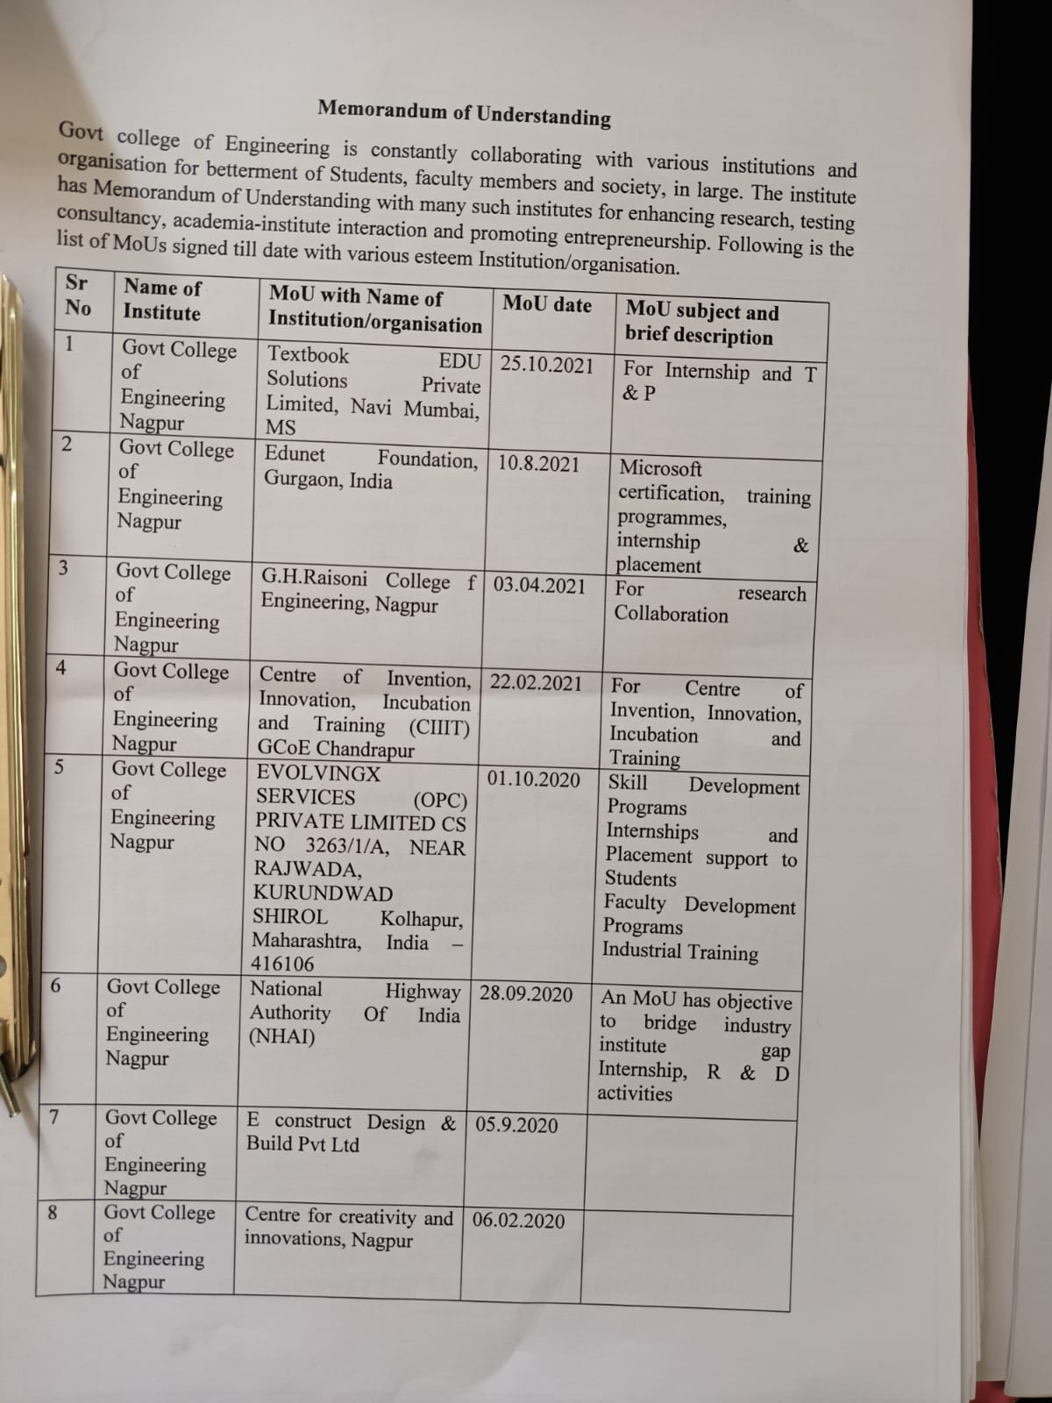

LoA and subsequent EoA till the current Academic Year

Sr No | Year of Approval | File No and Date
1 | 2016-17 | Western/2016/1-2843792671 date 30 Apr 2016
2 | 2017-18 | Western/1-3321541101/2017/EOA date 30 Mar 2017
3 | 2018-19 | Western/1-3508212549/2018/EOA date 04 Apr 2018
4 | 2019-20 | Western/1-4253204316/2019/EOA date 10 Apr 2019
5 | 2020-21 | Western/1-7014585165/2020/EOA Date: 30-Apr-2020
6 | 2021-22 | Western/1-9318383285/2021/EOA Date: 29-Jun-2021

- Accounted audited statement for the last three years

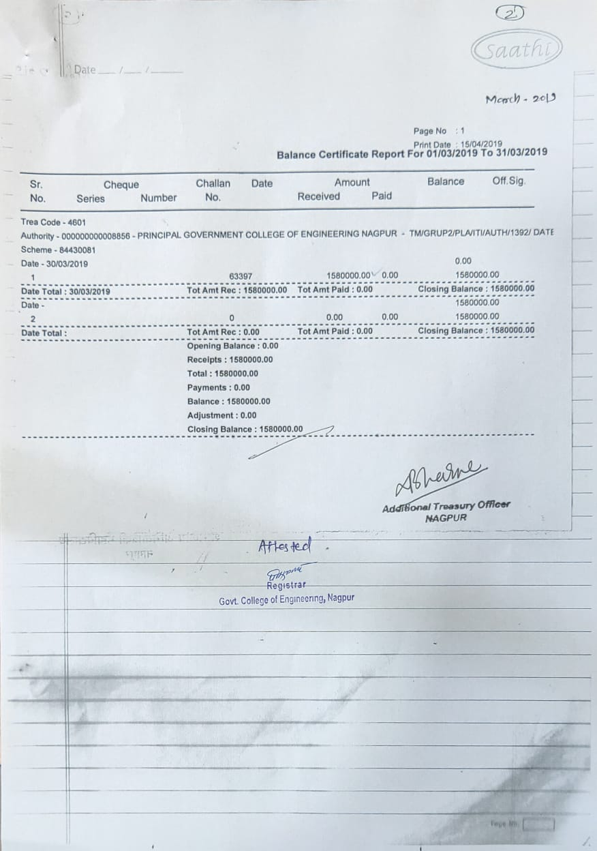

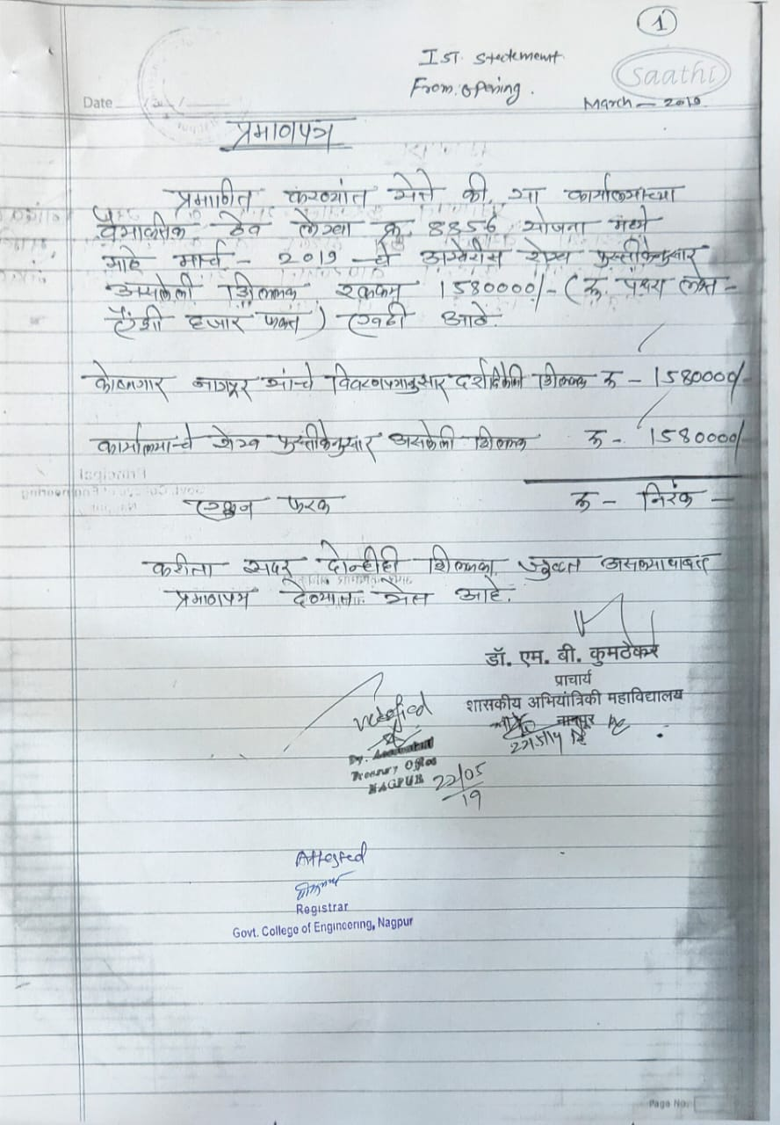

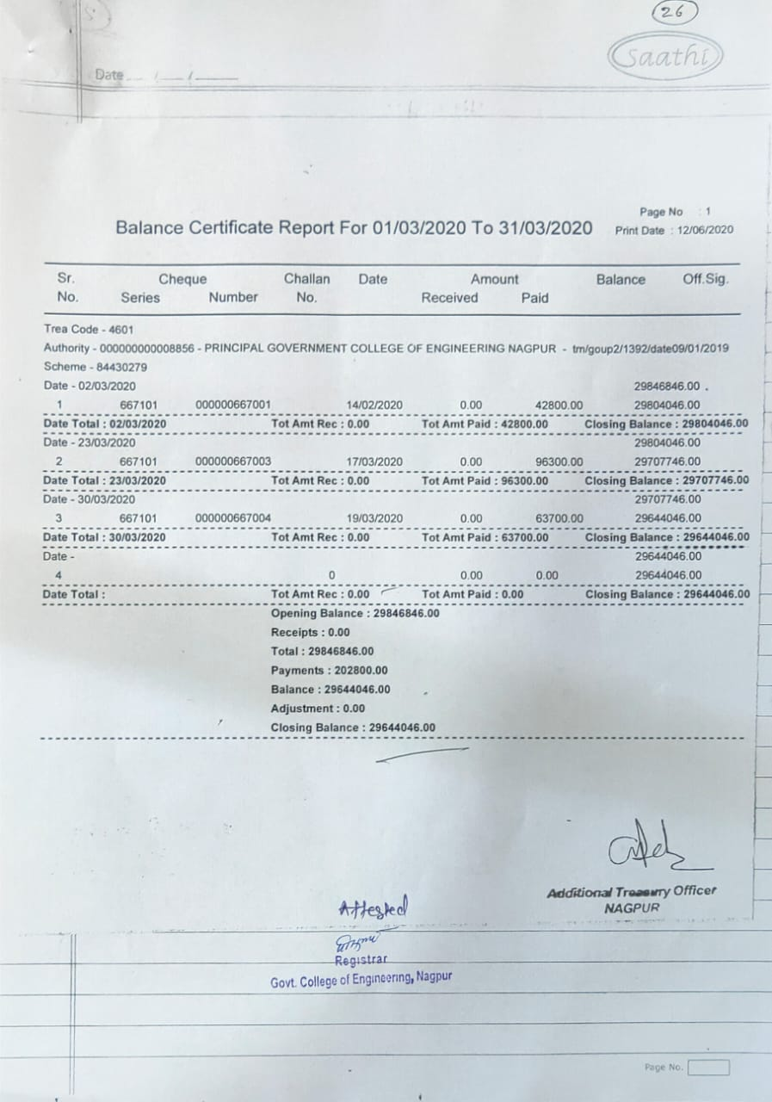

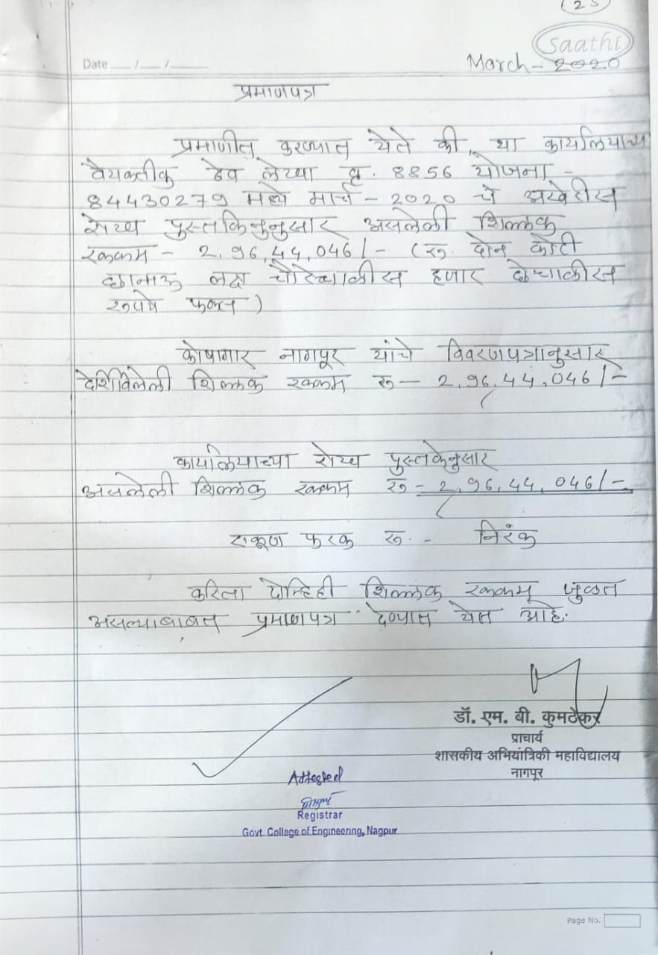

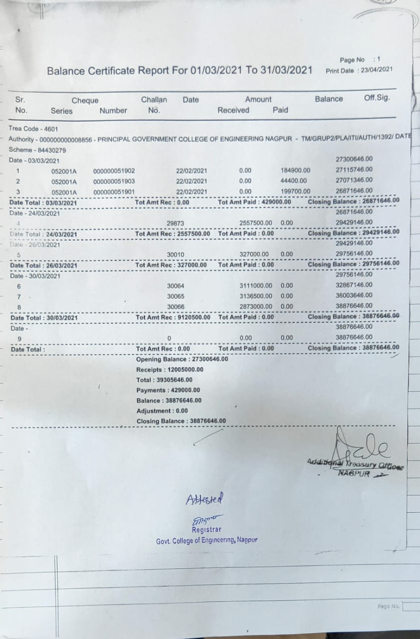

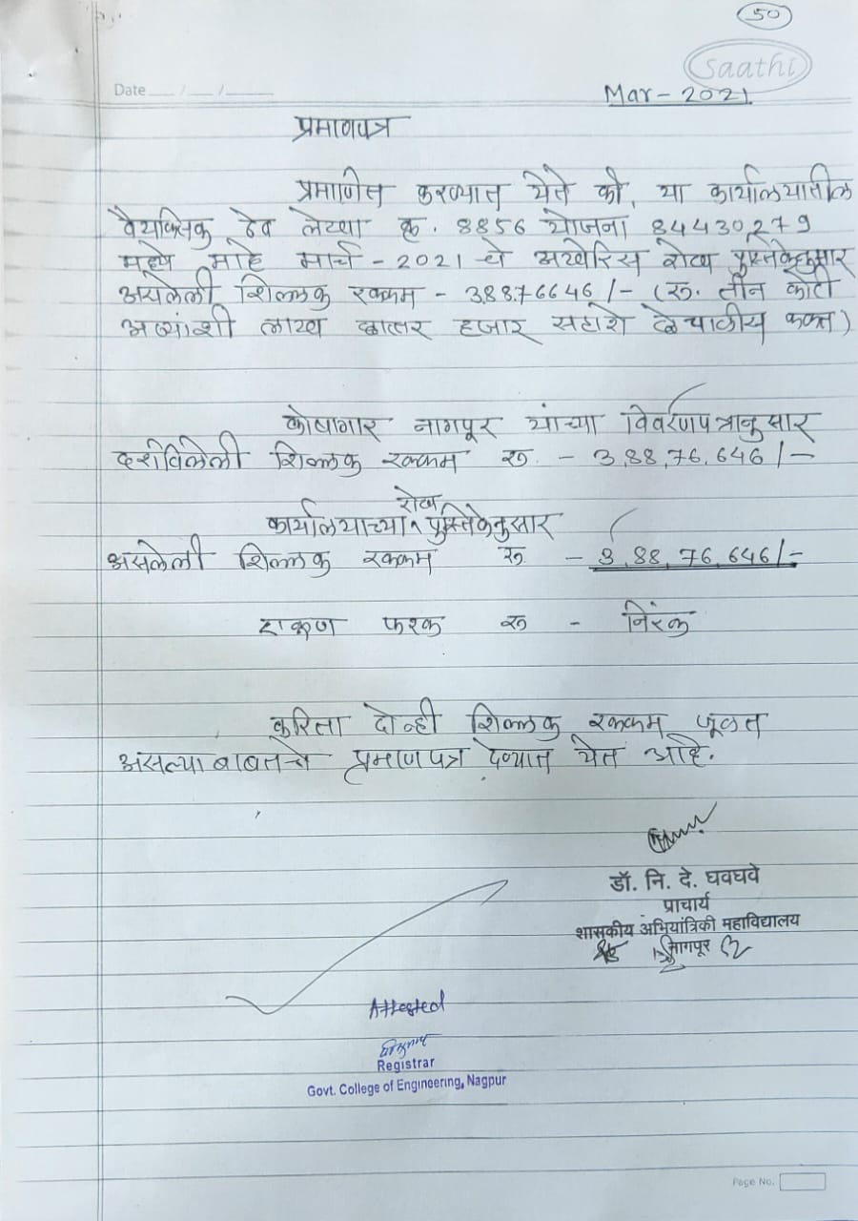

- Best Practices adopted, if any

Note: Suppression and/or misrepresentation of information shall invite appropriate penal action. The Website shall be dynamically updated with regard to Mandatory Disclosures

Best Practices

- Every classroom is digital classroom and every teacher engaging the classes regularly either online/hybrid mode or offline mode regularly
- AICTE recognized Institute Innovation Council regularly organizing the technical program/workshop/webinars by inviting experts from industry,reputed academic institutes in order to enhance the technical skills of students.
- Technology transfer and projects are taken under Unnat Bharat Abhiyan regularly

- Peer to peer teaching is being used in the college, which is an effective method in the classroom/ lab to enhance learning. This enables the students to revise their learned topics and be able to consolidate it by teaching it to fellow students. A visible difference has been observed in the class room with peer teaching. Students have improved understanding of their subject knowledge and increase in their confidence too.
- A field visit is one of the best tools that a facilitator can use to provide every student with real-world experiences. In every semester field visits to industry are organized to give a practical exposure to the students. We have conducted few field visits to project the working of various civil engineering structures

