GOVERNMENT COLLEGE
OF ENGINEERING, NAGPUR
SECTOR 27, MIHAN REHAB VASAHAT KHAPRI, NAGPUR-441108

“ To be an Institution of National Repute Creating Globally Competent Technocrats to Serve the Society”

NATIONAL CADET CORPS
CELL GCOEN

2022-23
Vision

To be an institution of national repute creating globally competent technocrafts to serve the society

Mission

- To impart quality education through need based curriculum in
academic programs
- To promote excellence by creating intellectually stimulating environment for creativity, innovation, research and professional activities
- To foster relationship with industries, other leatling institutions and alumni so as to enhance career opportunities for students.
- To inculcate sense of discipline and responsibility towards nature and society

Program Educational Objectives (PEOs)

- Reflect critical thinking and problem solving skills through their Pharmaceutical knowledge, expertise and competency in industry,higher studies and research.
- Practice ethics and values in their profession.
- Contribute effectively in various fields of social healthcare system.
- Inculcate leadership and entrepreneurship capabilities through effective communications, appropriate time management and self up gradation.

1
COMMITEE

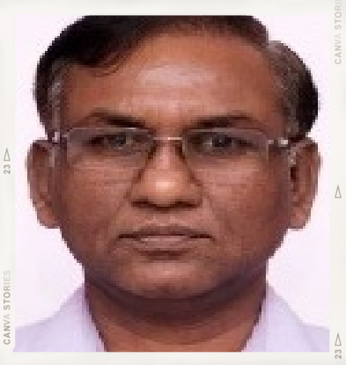
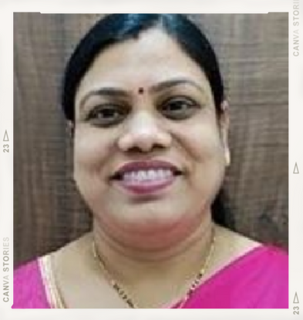
CHAIRPERSON ^{DEAN SWC}
Dr.Rewatkumar Borkar Dr.Kiran.G.Asutkar

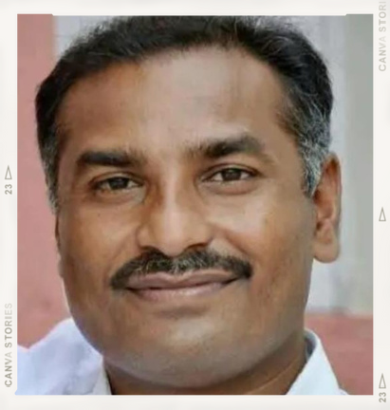

NCC CO-ORDINATOR
Prof.S.R.Wagh

NCC CO-ORDINATOR
Vibhanshu Chopde

2
NATIONAL CADET CORPS

VISION

Empower volunteer youth to become potential leaders and responsible citizens of the country.

MISSION
To develop leadership and character qualities, mould discipline and nurture social integration and cohesion through multi-faceted programs conducted in a military environment.

ABOUT NCC
National Cadet Corps is a Tri-Services Organization, comprising the Army, Navy and Air Force, engaged in grooming the youth of the country into disciplined and patriotic citizens.
The National Cadet Corps (NCC) is a youth development movement. It has enormous potential for nation building.
The NCC Provides opportunities to the youth of the country for their all- round development with a sense of Duty, Commitment, Dedication, Discipline and Moral Values so that they become able leaders and useful citizens.
The NCC provides exposure to the cadets in a wide range of activities, with a distinct emphasis on Social Services, Discipline and Adventure Training.
The NCC is open to all regular students of schools and colleges on a voluntary basis all over India.
The cadets have no liability for active military service once they complete their course but are given preference over normal candidates during selections based on the achievements in the corps.
3

OBJECTIVE
To develop good qualities like good character, commandership, discipline, leadership, secular outlook, spirit of adventure, sportsman spirit, and the ideals of selfless service amongst the youth of the country.
- To create a human resource of organized, trained and motivate youth to provide leadership in all walks of life and always available for the service of the nation.
- To provide a suitable environment to motivate the youth to take up a career in the Armed Forces like Army, Navy, Air Force and other paramilitary forces.

MOTTO
“UNITY AND DISCIPLINE”
The motto of NCC is “Unity and Discipline” which was adopted on 23 Des.1957. In living up to its motto, the NCC strive to be and is one of the greatest cohesive forces of the nation, bringing together the youth hailing from different parts of the country and moulding them into united, secular and disciplined citizens of the nation.

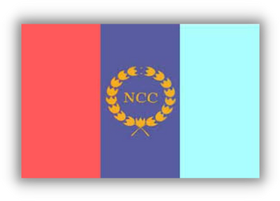
FLAG

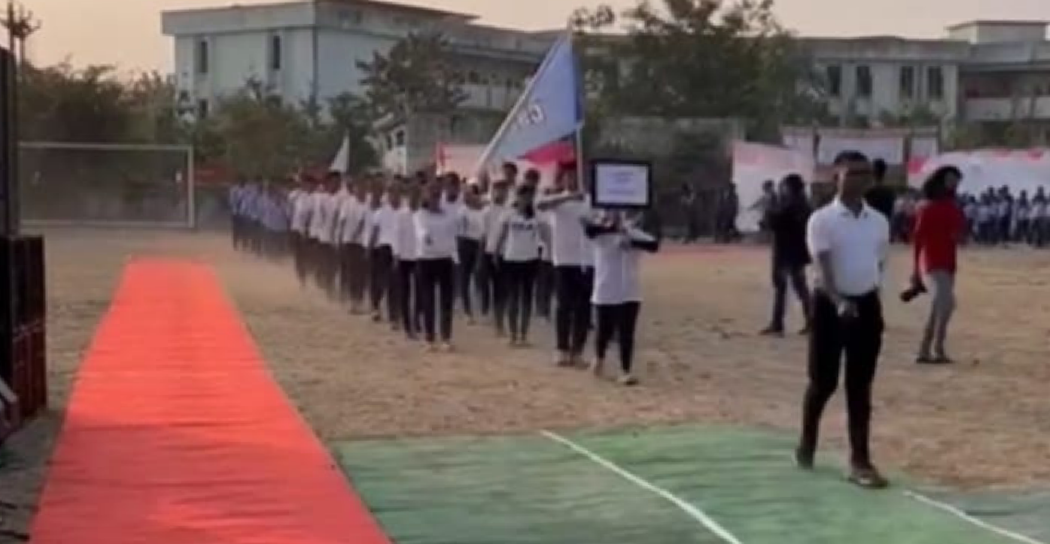
The NCC flag for various units of the NCC was first introduced in 1951. The flag was of same pattern, colour & size as was used by various regiments of the Army. The only difference was that it had the NCC badge & unit designation placed in the centre. In 1954 the existing tricolour flag was introduced. The three colours in the flag depict the three services of the Corps, red for the Army, deep blue for the Navy & light blue for the Air Force. The letters NCC & the NCC crest in gold in the middle of the flag encircled by a wreath of lotus (17Directorates), give the flag a colourful look & a distinct identity. ₄

NCC DAY
NCC was formed on July 15, 1948. However, NCC Day is celebrated on the fourth Sunday of November every year. It is observed of the fourth Sunday of November because, on that day in 1947, the first units were raised in Delhi.

EVENTS
As major of the activities are taken up by respected unit. To inspire the students of our college to enroll various units, NCC cell arrange some events in uor college are as follows
SFOORTI INAUGURATION PARADE

NCC cell arrange Parade in the inauguration ceremony of Sports Event SFOORTI'23.

5

NCC GCOEN Troop Lead the Parade Troop in Sports event SFOORTI'23.The Chief guest for the event were Mr. Sonu Watmare (Mr.Vidharbha), Principal Dr.R.P.Borkar Dean Student Welfare Committee Dr.K.G.Asutkar and other Dignitaries.

STUDENTS OF OUR COLLEGE REPRESENT
MAHARASHTRA DIRECTORATE

6
Four students represent Maharashtra directorate in All India Vayu Sainik Camp (AIVSC) 2022 which is one of the dream camp of every Air NCC cadet and Won the AIVSC BANNER for MAHARASHTRA DIRECTORATE, Best Directorate in All 17 directorate. The names of students are as follows
- Cdt KSHITIJ WANDILE
- Cdt SAYALI MOGHE
- Cdt PIYUSH DAHAKE
- Cdt ABHAS KAMBLE

Some of the achievements of NCC cadets in year 2022-23
CWO PRIYAMKUMAR OJHA (ETC - 4th year)
Represented Nagpur group in Inter Group Competition (IGC 2021) held at Pune in October 2021.(state level)
Commanded 2 MAH AIR SQUADRON unit Contingent as Contingent Commander in Republic Day Parade held at Kasturchand Park on January 26, 2023.
Represented Nagpur group in Service Selection Board Camp 2022 held at Amravati in November 2022. ( State level)
Best Drill Award in Combined Annual Training Camp 2022 held in Saoner.
Represented 2 MAH AIR SQUADRON UNIT in Gaurd Of Honour given to Additional Director General of Maharashtra.
Following cadets represented Nagpur Group in Inter Group Competition also took part in pre-VSC 1 camp
CWO MUKUL CHANDEL (ETC - 4th year) in aeromodelling (silver medal)
Cdt/Sgt SAKSHI MAHAJAN (EE – 3rd year) in drill
Cdt/Sgt PIYUSH DAHAKE (EE – 3rd year) in skeet shooting
Cdt/Cpl KSHITIJ WANDILE (ME – 3rd year) in drill
Cdt/Cpl SAYALI MOGHE (CSE – 3rd year) in health & hygiene
Cdt/Cpl NILAY GHUNGRUD (ETC – 3rd year) in tent pitching(Gold medal)
Cdt/Cpl ANSHUL MANGE (ETC – 3rd year) in health & hygiene, tent pitching (Gold medal)
Cdt RAJ SHARMA (ME – 3rd year) in tent pitching(Gold medal)
Cdt ABHAS KAMBLE (ME – 3rd year) in health & hygiene
Cdt VIBHANSHU CHOPDE (CE – 3rd year) in tent pitching (Gold medal), drill and .22 firing

Cdt/Sgt SAKSHI MAHAJAN (EE – 3rd year)
Represented Maharashtra Directorate at the Basic Skiing Course-58 (National Camp ) held at Sonmarg , Jammu and Kashmir conducted by Jawahar Institute of Mounteneering and Winter Sports (National Institute which comes under Ministry of Defence, India)
Represented MAH DTE in pre-VSC 2 camp
Was an anchor at Air show Show 2023
Petty Officer Cadet TANMAY PASALKAR (ME – 2rd year)
• Represented Maharashtra Directorate in Most Enterprising Naval Unit (MENU) Camp for RDC-2023 at Ratnagiri and Sailed a distance of 330 kms in Arabian Sea in a span of 10 days . And also emerged as the Top Enterprising directorate amongst all the 17 directorates.
• Represented Nagpur Group in Nau Sainik Camp - Inter group Competition held at Nashik in Boat- Pulling, DK Whaler Rigging, Semanship Practical and Health & Hygiene and won medal in Health & Hygiene Competition.
Cdt BHAVESH RAHATE (ETC – 3rd year)

•Represented Maharashtra directorate at All INDIA SHIP ATTACHMENT CAMP, Western Naval Command, Bombay. It was a ship attachment camp for span of 13 days where I was allocated INS TRIKHAND (F51-Frigate class) having world record of Longest sailing Ship.
Cdt ISHITA BHALADHARE (EE – 3rd year)
Represented Nagpur Group in NAU SAINIK CAMP-Inter Group Competition held at Nashik in Seamanship, Semaphore, Health and Hygiene, Drill, Rifle Drill , Won a Medal in Semaphore.
Also attended PRE -NAU- SAINIK CAMP - I ,

