Incubation Centre, Government College of Engineering Nagpur
Preamble: Govt. of India has launched a policy of Start-up India in 2016. A big number of startups are coming up. Incubation Centre is Place which give a birth to Startups. Like a new born baby, Startup is kept in incubator. Incubation Centre is a space for new age entrepreneurs and young minds to transform their innovative ideas into viable business propositions. A systematic development of new startup with utmost care in initial phase can be taken at IC. Since its establishment in 2016, Government College of Engineering Nagpur has been motivating the students for taking up the innovation activities. So as to make available a stage to carry out their activities, the Institute has trying to establish its own Incubation Centre (IC). As a part of the continuous efforts from dedicated faculty and staff, Rashtrasanta Tukadoji Maharaj Nagpur University Nagpur has granted an Incubation Sub-centre at this Institute. The centre at Government College of Engineering is affiliated to main Incubation Centre at RTM Nagpur University Nagpur. Consequently, the students of this Institute may use the Infrastructural facilities at main IC at RTM Nagpur University

Objectives: In complying to national policy, few of the objectives are set for GCOEN Incubation Centre-
- To create jobs, wealth and business aligning with national priorities
- To promote new technology/knowledge/innovation based startups
- To provide a platform for speedy commercialization of technologies developed by the host institution or by any academic/technical/R&D institution
- To build a vibrant startup ecosystem, by establishing a network between academia, financial institution, industries and other institutions.
- To provide cost effective, value added services to startups like mentoring, legal, technical, intellectual property related services
Vision and Mission: In order to serve the objectives of GCOEN-IC, vision and mission are prepared as-
VISION
To Provide Technological Assistance through Multidisciplinary Expertise and High-tech Facilities
MISSION
To nurture and empower the next generation entrepreneurs to serve the local problems
To Promote the Engineering Students to carry out their project Ideas
To Establish a Strong Bond between Industries and Academia

Expected Outcomes: Following are some expected outcomes of the IC at GCOE Nagpur
- The incubation ideas of around 5 projects each year will be supported
- Each project will be executed by a team of entrepreneurs (students/alumni/ Industry)
- Each project will be given infrastructural support such as workspace, internet etc
- The program will cater to the projects that solve problems and find solution to local needs (district and state) rather than global problems and needs
- The problem can be from any discipline but one should provide solution to the selected problem
- The funding agencies will be indentified to support the start-ups coming out of the Incubation Centre

Tentative Process of Execution:

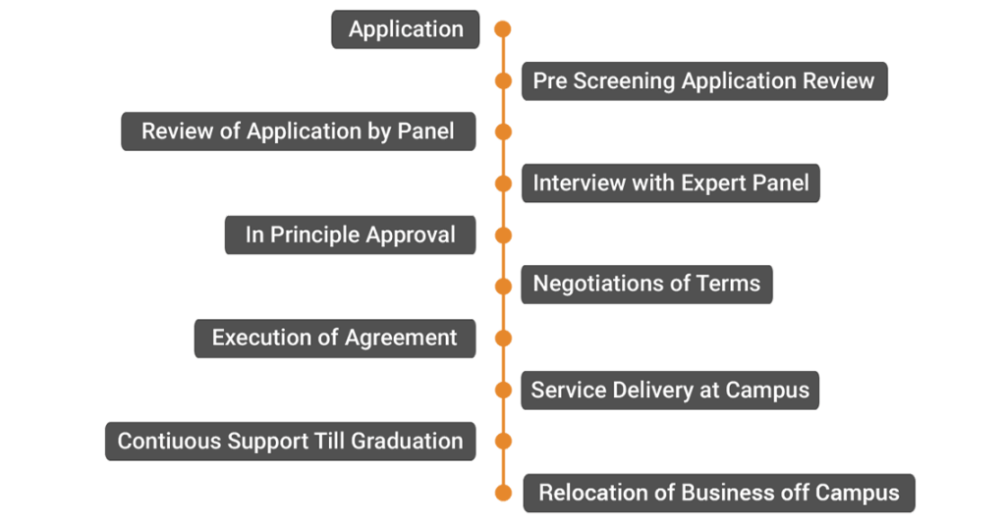
Possible Areas: Following possible areas are identified for carrying out the activities under IC at GCOEN-
- Solar PV Technologies and Application
- Electric Vehicles
- Energy Efficient Gadgets
- Mobile Application Development
- Web Development, Software Testing, Administrative Services, Software Development
- Construction Technologies
- Robotics and Automation
- Computer Aided Designs

