Astronomy Club
A National Level Online Presentation Competition named “PRESENTONOMERS” was organized from 11th to 16th January 2021 by Astronomy Club of Government College of Engineering, Nagpur on Google Meet platform. From last two years,Astronomy Club has been conductingInterschool Quiz Competition named“STARSQUEEZ” for the high school students in Nagpur but due to the Covid-19 pandemic, it wasn’t possible to conduct it fairly and the presentation competition came up as substitute. Apart from school students in Nagpur, it was open for all age groupsacross India without any participation fee with solo or duo participation. There were two groups, namely, School age group and Other age group and registrations of the event began on 26th Dec, 2020. The participants were allowed to choose from 40 different astronomy related topics and also their own topics via automated online form. The evaluation was based on certain criterions that included Content, Language, Presentation skills and Q&A.
The event was a great success and got an amazing response. From the School age group, Yash Chaitanya Diwakar (Centre Point School International) hassecured1strank followed by Prachi Singh &KhwahishNagwani(School of Scholars, Wanadongri) andAmishaBansod&GeetikaIyer(Saraswati Vidyalaya)who secured 2nd and 3rd rank respectively. Isha Rani (Jain International School)Shriya Rani (School of Scholars, Wanadongri) and Nachiket Ashish Deshpande (Somalwar High School, Nikalas Branch) secured 4th, 5th and 6th place respectively.
Whereas from Other age group, Vedanta Thapar and Hariprasad SV (St. Stephen's College, University of Delhi) has secured the 1st rank followed byNeel Lohit Dash &Binayyak Bhushan Roy (St. Stephen's College, University of Delhi)andMahakSadhwani& Trisha Debnath (St. Stephen's College, University of Delhi) who secured 2nd and 3rd rank respectively. The 4th, 5th and 6th rank was secured byMuskan Singh &Rupal Rao (Sri Venkateswara College,Delhi and Maitreyi College, Delhi),Shalika Yekkar& Sandra Elsa Sanjai(St. Stephen's College, University of Delhi) and Nivedha Sanjeev Kumar(Women's Christian College, Chennai)respectively.
Stargaze 2021
- Dates of event: 29th and 30th May, 2021
- Guest Speakers:
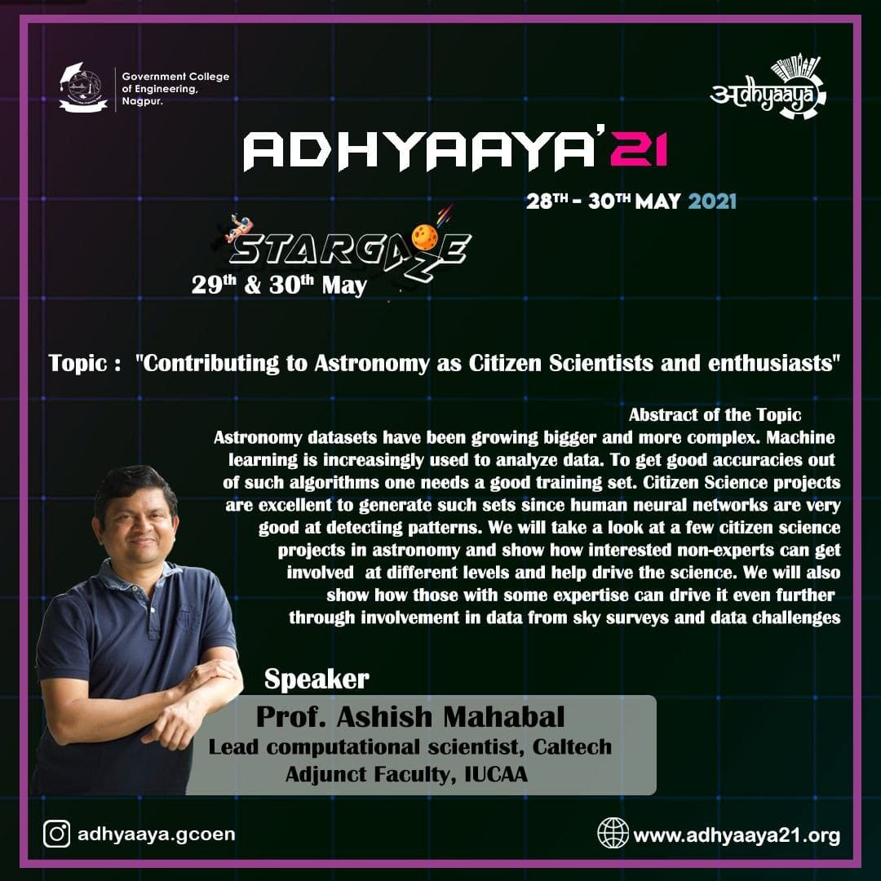 | 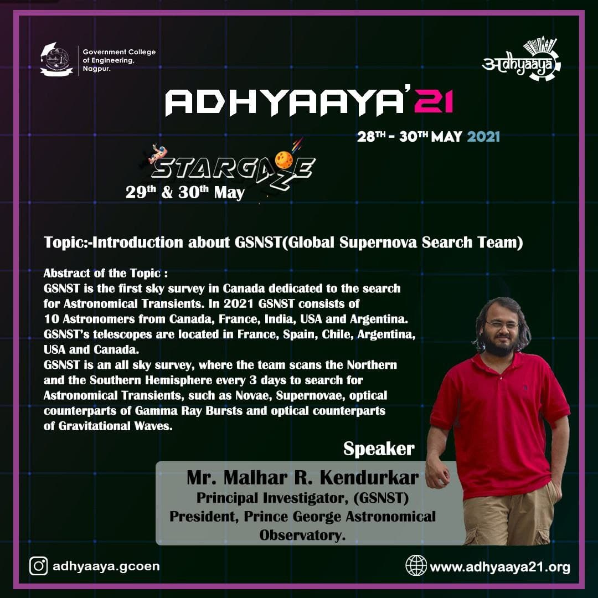
- Time duration: 9 hours (approximately)

- Mode of activity: Online via Cisco WebEx and YouTube

- No. of participants:In total Registrations for the event were 544 as per record and the total number of participants who joined the event was 216 as per records and it included attendees from various institutes and organizations across the country as well as a few from overseas.

- No participation fees were charged and was open to all age groups.

- E-certificates were given to the attendees after taking feedback.

About the event: The Astronomy Club of Government College of Engineering, Nagpur organized an online event – 2 days workshop named “STARGAZE", which is organized annually and this year too, it was conducted during thetechnical fest of the institution - “ADHYAAYA”.
The workshop covered topics that included the basics of Astrophysics and Astronomy, guest talks and guidance on how to build a career in the field of space science. It was structured such that attendees wouldacquaint with the obligation to boost their interests, career and aimed at providing knowledge.The event was entirely coordinated by the core team of the Astronomy club.
The main objective of the Astronomy Club at GCOEN in carrying out such activities is to inculcate and nurture students’ interest in the field of Astronomy and to introduce them to the Observational Astronomy and the Scientific Development at National and International levels.
- Chief guest (Speakers):
- Dr. Ashish Mahabal
Lead computational scientist, CALTECH, Adjunct Faculty, IUCAA.
Topic: "Contributing to Astronomy as Citizen Scientists and enthusiasts"

- Mr. Malhar R. Kendurkar
Principal Investigator - Global SuperNovae Search Team, President - Prince George Astronomical Observatory.
Topic: "Introduction about GSNST(Global Supernova Search Team)"

Faculty Incharge: The club events have always been supported by faculty I/C, Dr. J.B. Randhawa, and the principal of the college, Dr. N.D.Ghawghawe.

Also in this workshop, some fascinating topics of Astronomy were covered by Club Members which are as follows:
- Basics of Gravity and its Effects (Part 1) -by Shantanu Kawale
- Basics of Gravity and its Effects (Part 2) - by Nneil Patel
- Time and Calendar - bySoumit Nayak
- Career in Astronomy - by AbhiravWelekar
- Space Explorations - byAnurag Maldhure
- Observation Session andpresentation on the telescope - by Ashutosh Acharya
- Robotic telescope, Data Handling and Software - byRohit Chichwadkar

Summary:
- The session was led by the honorable speaker “Dr.AshishMahabal “ and “Mr.Malhar R. Kendurkar” under their drizzled knowledge the workshop was undertaken. This paragraph is all about compendious of the whole event. Our guest Dr.AshishMahabal sir emphasized contributing to astronomy as a citizen scientist with enthusiasm and Mr.MalharKendurkar sir explained about introduction about GSNST (Global Supernova Search Team). We were fortunate to listen to their explanation. They came up with amazing facts. The topics covered by them in the workshop were very informative.

- Members from Astronomy club alsohad their presentation on topics as mentioned above in report.

- For the organization of the event, apart from the presenters, the core team also included: Atharva Pimpalgaonkar (Supportive Coordinator), as well as Anjali Chhatbar, Ujjwal Ambulkar, Palak Kothari(Host) and Sana Sheikh. The whole team was responsible for event management, including handling public relations, technical things, and content creation. The team tried to deliver the best experience possible within a limited time.
This session was very interactive with faculty and students voicing their opinion and clearing doubts.

Conclusion: Astronomy compels the soul to look upward and encourages to explore the vast universe. The workshop gained satisfactory attention and the overall workshop was very interactive and interesting. The team tried its best to answer most of the audience's questions during the session and after the session.The feedback and response from the audience were great. Many of them asked the club to arrange more such sessions as they found them interesting as well as informative and the club is looking forward to arranging interesting events in the future too.
The recorded sessions of the workshop are available on YouTube channel of Astronomy Club. The link for the YouTube playlist of Stargaze 2021 is given below
Snapshots from the event:

